# **LockX - Automated Deadlock Detection Tool**

## **1. Project Overview**

### **Introduction**

LockX is a robust and automated tool designed to monitor, detect, and log potential deadlocks in operating systems by analyzing system processes and their associated resource allocation. In operating system and multithreaded environments, deadlocks can arise when processes compete for limited resources, leading to situations where a group of processes is indefinitely blocked. LockX aims to mitigate this by identifying such situations in real time, providing insights on deadlocks, and enabling users to visualize the problem using a graphical interface.

This project incorporates both classic and advanced deadlock detection techniques, with the Wait-For Graph (WFG) being central to identifying cycles that signify deadlocks. By integrating modern graph-based detection with a user-friendly interface, LockX not only automates detection but also makes it easier for users to analyze, understand, and troubleshoot deadlock situations.

### **Objective and Purpose**

The primary objective of LockX is to build an automated system capable of detecting potential deadlocks and displaying relevant information in real-time. Additionally, the project serves as a learning tool for understanding how deadlocks occur and how they can be detected and resolved.

The purpose includes:

1. **Detection and Visualization**: Automatically detecting deadlocks by tracking resource allocation, requests, and dependencies.
2. **Real-Time Monitoring**: Continuously monitoring active system processes and simulating deadlock-prone scenarios.
3. **Educational Use**: Providing students, engineers, and researchers with a deeper understanding of resource allocation, system monitoring, and deadlock detection techniques.
4. **Logging and Analysis**: Keeping detailed logs of deadlock incidents for further analysis and debugging.

### **Key Features**

LockX has been designed to implement the following key features:

1. **Live Process Monitoring**: Tracks active system processes and their resource allocations dynamically in real time.
2. **Wait-For Graph Construction**: Builds a directed graph representing resource dependencies to detect circular waits.
3. **Graph-Based Cycle Detection**: Utilizes Depth-First Search (DFS) on the Wait-For Graph to detect cycles, which indicate deadlocks.
4. **Automated Logging**: Logs detected deadlocks, along with timestamps, into a JSON file (e.g., deadlock_log.json) for debugging and analysis.
5. **GUI Integration**: A graphical user interface that presents process data, deadlock status, and system logs in an intuitive, visual way.
6. **Simulation Console** *(Planned)*: Allows users to simulate deadlocks by dynamically allocating and requesting resources.

### **Problem Statement**

In multi-threaded and operating system environments, resource allocation and concurrency management are critical but challenging. Deadlocks can occur when processes hold onto resources while waiting for other resources, leading to a circular wait condition. These deadlocks can result in system inefficiencies, degraded performance, and, in severe cases, system crashes.

LockX aims to address this problem by:

* Implementing algorithms to monitor and detect deadlocks automatically.
* Providing real-time data visualization to help users understand deadlock scenarios and optimize resource allocation.
* Offering recovery options and logging detected issues for post-analysis.

### **Solution Approach**

LockX uses a two-pronged approach for deadlock detection and system monitoring:

1. **System Monitoring**: Using the psutil library in Python, the tool monitors active system processes, captures their PIDs, and dynamically allocates resources to simulate real-world conditions. Process data is saved to a JSON file (system_state.json).
2. **Deadlock Detection**:  
   * **Resource Allocation Graph (RAG)**: A graph-based model representing the allocation and request of resources by processes.
   * **Wait-For Graph (WFG)**: The tool converts the RAG into a WFG by removing the resource nodes, leaving only the process nodes and their dependencies.
   * **Cycle Detection**: The WFG is traversed using Depth-First Search (DFS) to detect cycles. If a cycle exists, it signals the presence of a deadlock.

## **2. Module-Wise Breakdown**

## 

### **a. System Monitoring Module**

#### **Functionality:**

The **System Monitoring Module** is responsible for dynamically collecting live data about active system processes and their resource allocations. It tracks the state of various processes, simulates resource allocation, and constructs a mapping of allocated and requested resources. This forms the basis for analyzing potential deadlocks.

#### **Implementation Details:**

* **Library Used:** psutil
  + The module leverages the psutil library to fetch real-time information about processes running on the system. This includes details like Process IDs (PIDs), process names, CPU usage, and memory usage.
  + It simulates resource allocation to processes by mapping PIDs to resources and tracks which resources each process is waiting for, forming a dynamic process-resource table.
* **JSON File Storage:**
  + The collected process-resource mappings are periodically saved to a JSON file (system_state.json). This ensures that the state of the system can be stored, accessed, and analyzed over time.
* **Background Thread:**
  + A background thread is implemented using Python’s threading module to update the process-resource mappings at regular intervals without blocking the main application.

#### **Key Features:**

* **Simulated Resource Allocation:**
  + The module assigns simulated resources (e.g., R1, R2, R3) to active processes in a dynamic and cyclical manner. This is designed to mimic real-world resource allocation in operating systems.
* **Waiting Queue Simulation:**
  + The module also simulates a "waiting for resource" condition, where a process is shown to be requesting a resource held by another process. This helps create potential deadlock scenarios for detection.
* **Real-Time Updates:**
  + The process-resource mapping is refreshed periodically (e.g., every 5 seconds) to reflect the live system state.

### **b. Deadlock Detection Module**

#### **Functionality:**

The **Deadlock Detection Module** is the core component responsible for identifying potential deadlocks. It achieves this by analyzing process-resource dependencies and detecting cycles in the constructed Wait-For Graph (WFG). A cycle in the WFG indicates the presence of a deadlock.

#### **Implementation Details:**

* **Wait-For Graph (WFG) Construction:**
  + The module constructs a Wait-For Graph (WFG) based on the process-resource mapping data collected by the System Monitoring Module. In this graph:
    - **Nodes:** Represent processes.
    - **Directed Edges:** Indicate a dependency (i.e., a process waiting for a resource held by another process).
  + The WFG simplifies the analysis by eliminating intermediate resource nodes and focusing only on process-to-process dependencies.
* **Cycle Detection Algorithm:**
  + A cycle detection algorithm is implemented using **Depth-First Search (DFS)**. DFS is used to traverse the directed graph and detect cycles, which are a key indicator of deadlock.
  + Time Complexity: The algorithm has a time complexity of **O(V + E)**, where V represents the number of processes (nodes) and E represents the number of dependencies (edges). This makes the detection process efficient, even for larger systems.
* **Deadlock Logging:**
  + When a deadlock is detected, the module logs the details (e.g., PIDs involved, timestamp) in a JSON file called deadlock_log.json. This allows for future analysis and debugging.

#### **Key Features:**

* **Automated Deadlock Detection:**
  + The module continuously analyzes the system state and automatically detects deadlocks by checking for cycles in the WFG.
* **Deadlock Logging:**
  + Each detected deadlock is logged with detailed information, including the time of detection and the processes involved. This provides a historical record for analysis and debugging.
* **Real-Time Deadlock Status:**
  + The module communicates with the GUI module to update the real-time deadlock status, allowing users to visualize deadlock occurrences.

### **c. Graphical User Interface (GUI) Module**

#### **Functionality:**

The **GUI Module** provides a visual representation of active processes, resource allocations, and detected deadlocks. It enhances user interaction by offering an intuitive way to monitor the system state and view detected deadlocks.

#### **Implementation Details:**

* **Library Used:** tkinter
  + The GUI is built using the tkinter library, which is a standard Python library for creating graphical interfaces.
* **Interactive Widgets:**
  + The GUI includes interactive widgets like process tables, real-time status indicators, and buttons for refreshing data or triggering simulations.
* **Visualization of Deadlocks:**
  + Detected deadlocks are highlighted in the GUI using visual cues such as red nodes or edges in the process graph.

**Key Features:**

* **Interactive Process Table:**
  + Displays a real-time table of active processes, their allocated resources, and their waiting resources. This table is dynamically updated based on the data from the System Monitoring Module.
* **Real-Time Deadlock Status:**
  + Shows whether the system is currently in a safe state or if a deadlock has been detected. If a deadlock is detected, the GUI highlights the processes involved and displays relevant details.
* **Graphical Deadlock Visualization:**
  + The GUI visually represents the Wait-For Graph (WFG) and highlights any cycles that indicate a deadlock. This helps users understand the dependencies and potential resolution strategies.

### **d. Planned Enhancements (Future Scope)**

While the current implementation focuses on deadlock detection and logging, several enhancements are planned to improve the functionality and user experience:

1. **Simulation Console:**
   * A panel that allows users to create and simulate resource allocation scenarios, trigger deadlocks, and experiment with different allocation strategies.
2. **Advanced Visualization:**
   * Implementing more advanced graphical representations of the Wait-For Graph (WFG), including animations and real-time updates.
3. **Deadlock Recovery Options:**
   * Allowing users to choose and implement recovery strategies (e.g., process termination, resource preemption) to resolve detected deadlocks.

## **3. Functionalities**

The LockX project leverages several core functionalities, divided into different modules, to efficiently monitor system processes, detect potential deadlocks, and provide real-time feedback through a graphical user interface. Below is a detailed breakdown of the key functionalities used in the project:

### **1. System Monitoring Functionalities**

This functionality forms the backbone of the LockX tool by collecting, processing, and dynamically updating process-resource mappings in real time. It ensures that the system’s current state is continuously monitored for any changes in process behavior.

#### **Key Features of System Monitoring:**

* **Dynamic Process Detection:**
  + Uses the **psutil library** to detect active processes running in the system and fetches essential information, such as Process IDs (PIDs) and process names. This ensures that the tool remains updated with the latest set of active processes.
* **Simulated Resource Allocation:**
  + Simulates resource allocation and process dependencies by assigning resources (like R1, R2, etc.) to active processes. Each process may hold a resource and request another, mimicking real-world resource allocation patterns.
* **Real-Time Updates:**
  + Runs in a **background thread** to update process-resource mappings periodically. This ensures that the process data is refreshed in real time without blocking the main application.
* **JSON-Based State Storage:**
  + Saves the system state (process-resource mapping) in a file called **system_state.json** at regular intervals. This allows for seamless integration with the Deadlock Detection module and provides a historical record of process behavior.

### **2. Deadlock Detection Functionalities**

This functionality is the core component that analyzes process-resource dependencies to detect potential deadlocks. It uses advanced graph-based techniques to identify cycles in process dependencies, which indicate a deadlock condition.

#### **Key Features of Deadlock Detection:**

* **Wait-For Graph (WFG) Construction:**
  + Based on the process-resource mapping collected by the System Monitoring Module, the tool constructs a **Wait-For Graph (WFG)** to represent the dependencies between processes and resources.
  + In the WFG:
    - **Nodes** represent processes (e.g., P1, P2, P3).
    - **Directed Edges** represent dependencies (e.g., an edge from P1 to P2 indicates that P1 is waiting for a resource held by P2).
* **Cycle Detection Using Depth-First Search (DFS):**
  + Implements a **DFS-based cycle detection algorithm** to analyze the WFG for potential deadlocks.
  + If a cycle is detected, it indicates a deadlock condition, as the processes involved are waiting on each other in a circular chain.
  + This approach is computationally efficient, with a time complexity of **O(V + E)**, making it suitable for large-scale systems.
* **Deadlock Logging:**
  + When a deadlock is detected, the tool logs the following information in a file named **deadlock_log.json** for future analysis and debugging:
    - **Timestamp** – The exact time when the deadlock was detected.
    - **Processes Involved** – The list of PIDs that are part of the detected cycle.
    - **Resource Details** – Information about the resources causing the deadlock.
* **Real-Time Deadlock Status:**
  + Provides real-time feedback on whether the system is in a "safe state" or if a deadlock has been detected.
  + If a deadlock is detected, the tool alerts the user through the Graphical User Interface (GUI).

### **3. Graphical User Interface (GUI) Functionalities**

The GUI provides a visual and interactive interface for users to monitor system processes and understand deadlock scenarios. It enhances the usability of the tool by presenting process data and deadlock information in an intuitive and user-friendly format.

#### **Key Features of the GUI:**

* **Interactive Process Table:**
  + Displays a table containing the list of active processes, along with their allocated and requested resources. This table is updated periodically based on the data from the System Monitoring module.
  + The table provides a clear overview of which processes are holding or waiting for resources.
* **Real-Time Deadlock Alerts:**
  + Shows whether the system is in a safe state or if a deadlock has been detected.
  + If a deadlock is detected, the GUI displays a visual alert (e.g., a red indicator) and lists the processes involved in the deadlock.
* **Graphical Visualization of the Wait-For Graph (WFG):**
  + Provides a graphical representation of the WFG, helping users visualize process dependencies.
  + **Nodes** in the graph represent processes, and **edges** represent dependencies.
  + **Visual Highlighting of Deadlocks:** When a deadlock is detected, the GUI highlights the processes and edges involved in the cycle, making it easier for users to trace and understand the deadlock.
* **Simulation Control Panel (Optional – Future Enhancement):**
  + The GUI may include a control panel where users can manually adjust process-resource mappings to simulate different deadlock scenarios and test various recovery strategies.

### **4. Deadlock Logging and Analysis Functionalities**

This functionality focuses on logging detected deadlocks and providing users with tools for analyzing deadlock occurrences over time.

#### **Key Features of Deadlock Logging and Analysis:**

* **Deadlock Log File (deadlock_log.json):**
  + Stores detailed information about each detected deadlock, including the timestamp, processes involved, and resource details.
  + This log serves as a historical record for debugging, analysis, and learning.
* **Analysis Tools (Future Enhancement):**
  + Planned future enhancements include adding tools for analyzing the deadlock log to identify patterns, such as:
    - Which processes or resources are frequently involved in deadlocks.
    - Whether certain process behaviors are more likely to cause deadlocks.

### **Summary of Functionalities Used:**

The functionalities implemented in the LockX project work together to provide a comprehensive solution for deadlock detection. By combining real-time process monitoring, advanced graph-based cycle detection, and an intuitive graphical interface, LockX enables users to efficiently detect, log, and analyze deadlocks in dynamic systems.

The modular design ensures that each functionality operates independently while contributing to the overall goal of detecting and resolving deadlocks in real-time. Future enhancements will further improve the tool's capabilities, including advanced visualization, simulation, and recovery options.

## **4. Technology Used**

The LockX project leverages several programming languages, libraries, and technologies to achieve efficient system monitoring, deadlock detection, and user interaction. Below is a detailed breakdown of the technologies used:

### **1. Programming Languages**

* **Python:**
  + **Core Usage:**
    - Python is the primary programming language used to implement system monitoring, deadlock detection, and the graphical user interface.
  + **Why Python?**
    - Python’s simplicity, extensive library support, and ease of handling complex data structures (like graphs) make it an ideal choice for this project.

### **2. Python Libraries**

The project makes use of several Python libraries to handle different functionalities efficiently.

#### **a. psutil (Process and System Monitoring)**

* **Purpose:**
  + Used to monitor active system processes and gather real-time information such as Process IDs (PIDs), CPU usage, memory allocation, and other system resource metrics.
* **Advantages:**
  + Provides cross-platform support, making the project compatible with Windows, Linux, and macOS.
  + Handles process iteration, error management (like Zombie Processes), and process access restrictions.

#### **b. NetworkX (Graph-Based Analysis)**

* **Purpose:**
  + Used to construct and analyze the Wait-For Graph (WFG) to detect deadlocks by finding cycles in the graph.
* **Advantages:**
  + Offers built-in functions for graph traversal (e.g., Depth-First Search) and cycle detection, which simplifies the implementation of deadlock detection algorithms.
  + Efficient handling of directed, weighted graphs to represent complex process-resource dependencies.

#### **c. Matplotlib (Graph Visualization)**

* **Purpose:**
  + Used to create visual representations of the Wait-For Graph (WFG), with nodes representing processes and directed edges representing dependencies.
* **Advantages:**
  + Provides customizable graph plots, with options for highlighting nodes and edges involved in detected deadlocks.

#### **d. JSON (Data Handling)**

* **Purpose:**
  + Used to store and load system state and deadlock information in JSON format.
* **Advantages:**
  + JSON is lightweight, easy to read, and widely supported by various programming languages and tools.

#### **e. Tkinter (Graphical User Interface)**

* **Purpose:**
  + Used to build the project’s GUI for displaying real-time process data and deadlock alerts.
* **Advantages:**
  + Provides a simple and easy-to-use framework for creating desktop-based GUIs.
  + Allows for dynamic updating of UI components, like process tables and deadlock indicators, based on real-time data.

### **3. Tools and Platforms**

#### **a. Integrated Development Environment (IDE)**

* **Preferred IDE:** Visual Studio Code (VS Code) or PyCharm
* **Usage:**
  + Used for writing, testing, and debugging Python code.
  + Provides support for Python extensions, version control (Git), and efficient code navigation.

#### **b. Version Control (Git and GitHub)**

* **Purpose:**
  + Git is used for version control, enabling collaborative development and tracking of code changes.
  + GitHub serves as the remote repository for storing project files and documentation.

#### **c. JSON Log Files**

* **Usage:**
  + The project uses log files (system_state.json and deadlock_log.json) to store real-time system data and detected deadlocks. This data can be used for debugging, analysis, and simulation.

### **4. Operating System Compatibility**

* **Cross-Platform Compatibility:**
  + The project is designed to work on major operating systems, including:
    - **Windows**
    - **Linux**
    - **macOS**
  + This cross-platform support is achieved through the use of Python libraries (like psutil) that provide platform-independent APIs.

### **Summary of Technologies Used:**

By combining Python’s simplicity, powerful libraries for system monitoring and graph-based analysis, and interactive visualization tools, the LockX project achieves efficient deadlock detection with real-time updates. The choice of these technologies ensures that the tool remains modular, scalable, and user-friendly. Additionally, the use of version control and cross-platform libraries enhances the project’s maintainability and portability.

## **5. Flow Diagram**

The following section presents a flow diagram illustrating the overall workflow of the LockX project, from system monitoring to deadlock detection and visualization. The flow diagram helps users understand how the different modules interact and work together to detect and resolve deadlocks.

### **Flow of Execution**

Below is a textual breakdown of the flow, followed by a graphical representation:

1. **System Initialization:**
   * The system starts by initializing the SystemMonitor and DeadlockDetector modules.
2. **Process Monitoring:**
   * The SystemMonitor continuously collects live process-resource mappings, storing data such as process IDs (PIDs), allocated resources, and requested resources.
   * The system updates this data in system_state.json.
3. **Wait-For Graph (WFG) Construction:**
   * Based on the real-time process data, the system constructs a Wait-For Graph (WFG), where:
     + **Nodes** represent processes.
     + **Edges** represent resource dependencies between processes.
4. **Deadlock Detection (Cycle Detection):**
   * The DeadlockDetector module uses Depth-First Search (DFS) on the WFG to detect cycles.
     + If a cycle is found → Deadlock detected!
     + If no cycle is found → The system is safe.
5. **Logging and Display:**
   * Detected deadlocks are logged in deadlock_log.json with timestamps.
   * The system updates the Graphical User Interface (GUI) to display the current process table and deadlock status.
6. **User Interaction:**
   * The user can refresh the GUI to manually update the displayed data.
   * Future enhancements (like deadlock recovery options) can be triggered here.

### **Flow Diagram Representation**

1. **Start (Initialization)**
   * Begin by initializing the LockX system, which loads modules like the System Monitor and Deadlock Detector.
2. **System Monitoring Module**
   * Process Monitoring: Fetch live process-resource mappings from the system.
   * Resource Allocation: Simulate or record resource allocations (allocated vs. requested resources).
3. **Wait-For Graph (WFG) Construction**
   * Build a directed graph based on resource dependencies between processes.
4. **Deadlock Detection (Cycle Detection)**
   * Run Depth-First Search (DFS) to check for cycles in the WFG.
   * Decision Node: Is a cycle detected?
     + **Yes** → Deadlock detected! Log the deadlock and alert the GUI.
     + **No** → No deadlock detected; continue monitoring.
5. **Logging and GUI Update**
   * Log system state and detected deadlocks (if any).
   * Update the user interface with real-time process and deadlock status.
6. **Loop and Refresh**
   * Periodically refresh the system monitoring and continue checking for deadlocks.

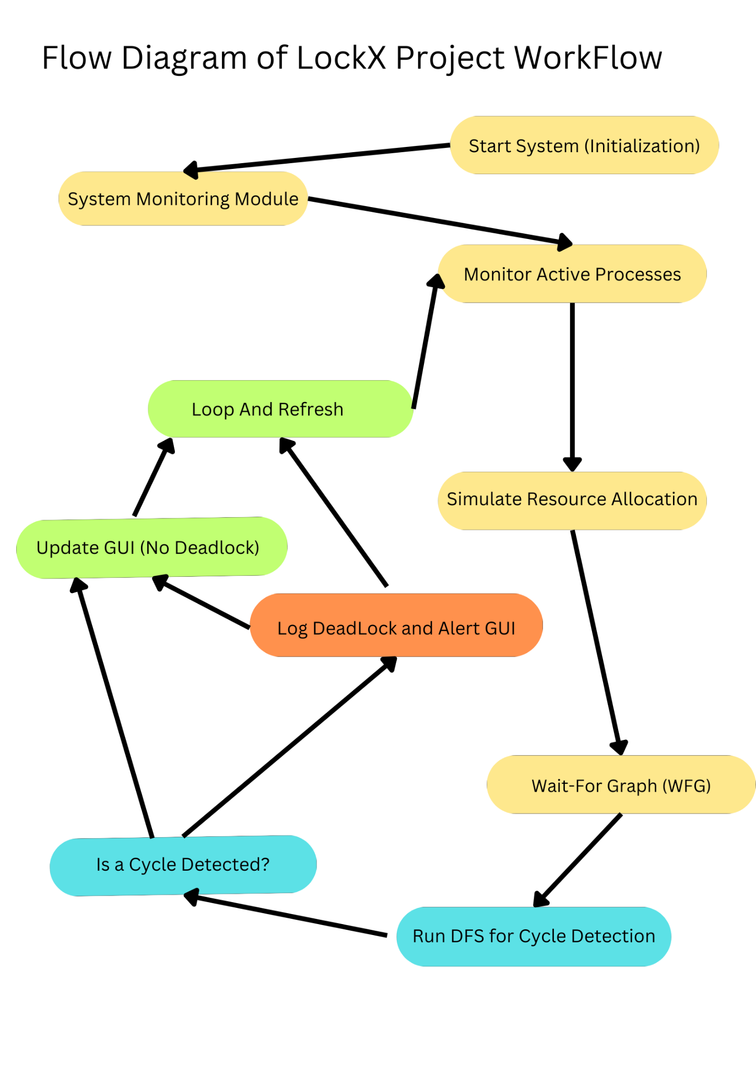

### **Example Deadlock Flow Chart:**

1. Process P1 holds Resource R1 and requests R2.
2. Process P2 holds Resource R2 and requests R3.
3. Process P3 holds Resource R3 and requests R1.
4. A circular wait occurs, causing a deadlock.

The Wait-For Graph:

P1 --> P2 --> P3 --> P1 (Cycle Detected)

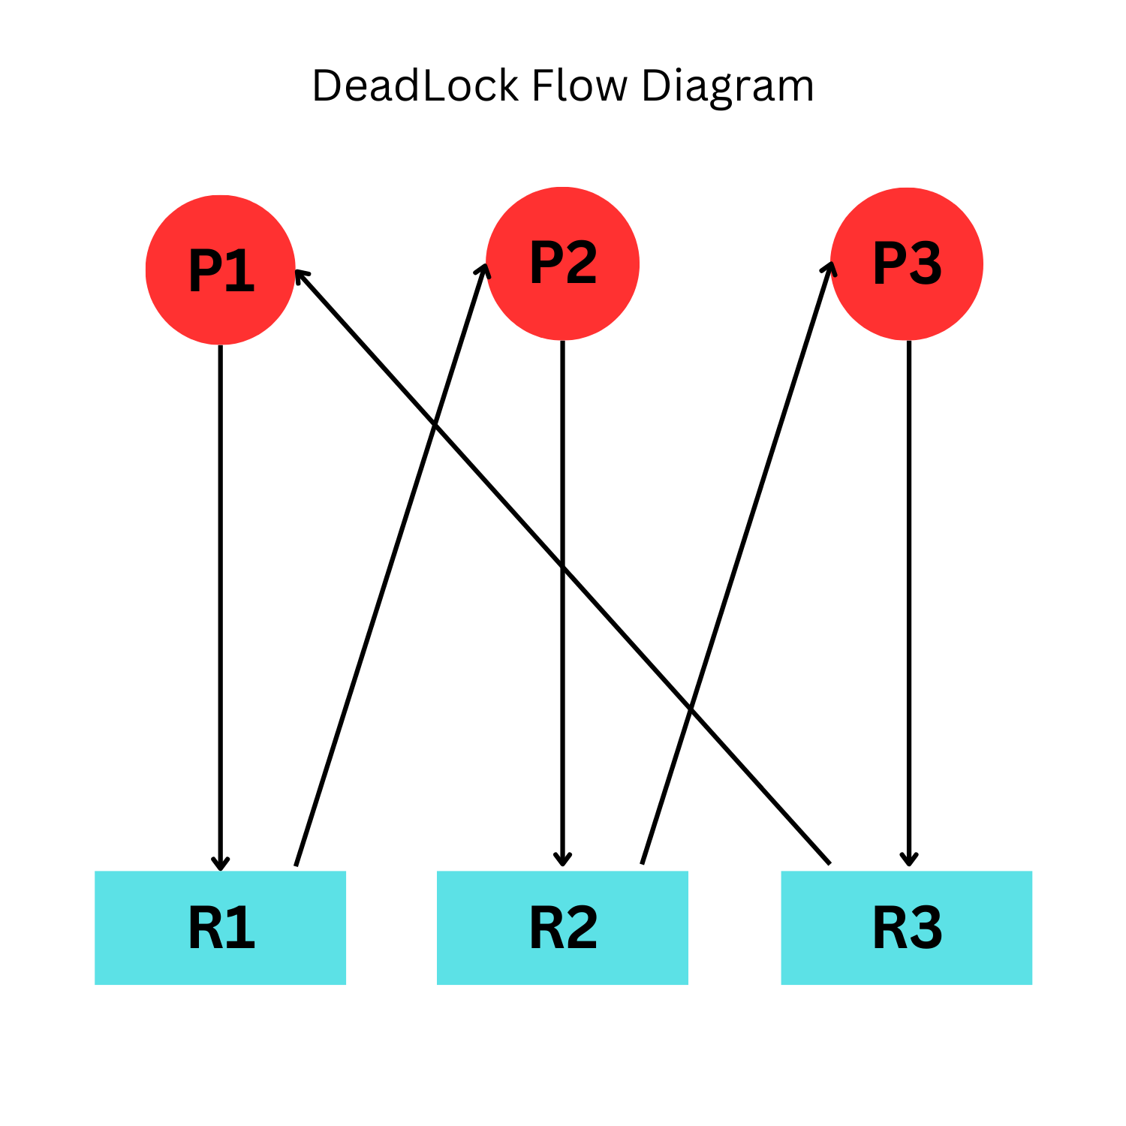

## **6. Revision Tracking on GitHub**

* **Repository Name:** LockX-Automated-Deadlock-Tool
* **GitHub Link:** [Insert Link]

## **7. Conclusion and Future Scope**

### **Conclusion:**

The LockX Deadlock Detection Tool is a comprehensive project designed to address one of the most challenging problems in concurrent systems — detecting and diagnosing deadlocks. The system successfully implements real-time process monitoring, dynamic resource allocation tracking, and deadlock detection using graph-based algorithms. By integrating an interactive Graphical User Interface (GUI), it provides users with real-time visualization of processes, resources, and deadlock status, making it not only technically sound but also user-friendly.

The project achieves its primary objective of detecting deadlocks through the construction of a Wait-For Graph (WFG) and applying Depth-First Search (DFS) to detect cycles in the graph. It also logs detected deadlocks in JSON format, providing an audit trail for debugging and analysis. Overall, the project demonstrates a strong understanding of operating system concepts, including process synchronization, resource allocation, and concurrency control, while also leveraging modern software development techniques like modular programming, threading, and GUI development.

Key achievements of the project include:

* **Real-Time System Monitoring:** The ability to dynamically monitor active processes and simulate resource allocations.
* **Cycle Detection in Wait-For Graph:** Efficient DFS-based implementation to detect deadlocks by identifying cycles in the WFG.
* **User-Friendly GUI:** An interactive interface that displays active processes and detected deadlocks in real-time.
* **Automated Logging:** The tool logs all detected deadlocks in a JSON file for future reference and debugging.

By successfully combining theoretical concepts with practical implementation, LockX serves as both an educational tool and a practical solution to detect deadlocks in real-world systems.

### **Future Scope:**

The current implementation of LockX lays a solid foundation for further enhancements and can be expanded in various ways to improve its functionality, efficiency, and usability. Below are some potential areas for future development:

1. **Advanced Deadlock Detection Algorithms:**
   * Incorporate advanced algorithms for deadlock detection, such as hybrid approaches that combine cycle detection and Banker’s Algorithm to improve accuracy and reduce detection time.
   * Optimize the DFS-based cycle detection algorithm to handle large-scale systems with thousands of processes and resources.
2. **Deadlock Prevention and Recovery Mechanisms:**
   * **Prevention Strategies:** Implement classic deadlock prevention techniques, such as circular wait prevention or hold-and-wait avoidance, to proactively minimize the risk of deadlocks.
   * **Recovery Mechanisms:** Introduce options for deadlock recovery, such as process termination or resource preemption, and allow users to choose their preferred recovery strategy.
3. **Enhanced GUI Features:**
   * Develop advanced visualization features, such as real-time graph-based representations of the Wait-For Graph (WFG) or Resource Allocation Graph (RAG), to provide users with a clearer understanding of process dependencies.
   * Add drag-and-drop functionality to simulate resource allocation and adjust process priorities dynamically.
   * Display real-time logs and diagnostic information on the GUI to provide more transparency into the tool’s operations.
4. **Simulation Panel:**
   * Create a simulation console where users can manually trigger different resource allocation scenarios, including potential deadlock scenarios, to test the tool’s performance under various conditions.
   * Provide users with interactive controls to add processes, allocate resources, and simulate deadlocks in a controlled environment.
5. **Improved Performance and Scalability:**
   * Optimize the system monitoring and deadlock detection modules to handle large-scale systems with minimal performance overhead.
   * Implement asynchronous processing and load balancing techniques to improve scalability.
6. **Integration with Distributed Systems:**
   * Extend the project to detect deadlocks in distributed systems, where processes and resources may be spread across multiple machines.
   * Implement distributed deadlock detection algorithms, such as edge-chasing or timestamp-based approaches, to handle the complexities of distributed environments.
7. **Cross-Platform Support:**
   * Enhance the tool’s compatibility with different operating systems (e.g., Linux, macOS) to make it more versatile.
8. **Real-Time Notifications and Alerts:**
   * Implement a notification system that sends real-time alerts to users (e.g., via email or SMS) when a deadlock is detected.
9. **Version Control and Cloud Integration:**
   * Integrate version control features to track changes in process-resource mappings over time.
   * Allow users to save and access deadlock logs and system state files in the cloud for remote monitoring and analysis.
10. **Educational Enhancements:**
    * Add interactive tutorials and documentation within the tool to help users understand key concepts like deadlock conditions, Wait-For Graphs, and cycle detection algorithms.
    * Provide detailed step-by-step explanations of how the tool detects deadlocks, with visual aids and animations.

By implementing these enhancements, LockX can evolve from a basic deadlock detection tool into a comprehensive deadlock management system, capable of handling large-scale and distributed environments while offering advanced prevention, detection, and recovery features.

## **8. References**

The following resources, documentation, and research papers were consulted and used during the development of the LockX Deadlock Detection Tool:

1. **Books and Academic References:**
   * **Abraham Silberschatz, Peter B. Galvin, Greg Gagne,** *Operating System Concepts*, 10th Edition.
     + This book provided an in-depth understanding of deadlock concepts, conditions, and detection techniques, including the Wait-For Graph (WFG) and cycle detection in process-resource systems.
   * **Andrew S. Tanenbaum,** *Modern Operating Systems*, 4th Edition.
     + This resource contributed to the understanding of concurrency, resource allocation, and process synchronization in modern operating systems.
2. **Python Libraries and Documentation:**
   * **psutil Library Documentation**:
     + Official documentation:<https://psutil.readthedocs.io/>
     + Used to understand the APIs for process monitoring, including fetching process IDs, CPU usage, and resource allocation.
   * **NetworkX Documentation**:
     + Official documentation:<https://networkx.org/documentation/stable/>
     + Used for constructing and manipulating directed graphs to implement the Wait-For Graph and detect cycles in real-time.
   * **Tkinter Documentation (Python’s GUI Library)**:
     + Reference:<https://docs.python.org/3/library/tkinter.html>
     + Consulted to build and refine the graphical user interface (GUI) for displaying process tables and deadlock detection status.
3. **Research Papers and Articles:**
   * Coffman, E. G., Elphick, M. J., & Shoshani, A. (1971). *System Deadlocks*. ACM Computing Surveys.
     + This paper outlines the necessary conditions for deadlock and forms the theoretical basis for deadlock detection and prevention mechanisms.
   * Knuth, D. E. (1966). *Additional Comments on a Problem in Concurrent Programming Control*. Communications of the ACM.
     + This reference contributed insights into concurrency and deadlock issues in multiprogramming systems.
4. **Web Tutorials and Resources:**
   * GeeksforGeeks Tutorial on Deadlock Detection:<https://www.geeksforgeeks.org/deadlock-detection-algorithm-in-operating-system/>
     + Provided examples and pseudocode for deadlock detection algorithms, including DFS-based cycle detection in the Wait-For Graph (WFG).
   * Real Python (GUI Development with Tkinter):<https://realpython.com/python-gui-tkinter/>
     + Helped in understanding Tkinter and designing an interactive, user-friendly GUI.
   * Python JSON Module Documentation:<https://docs.python.org/3/library/json.html>
     + Used for saving and reading system state and deadlock logs in JSON format.
5. **Stack Overflow and GitHub Discussions:**
   * Various discussions on Stack Overflow related to Python threading, process monitoring, and graph-based algorithms were instrumental in troubleshooting and refining the project.
   * GitHub repositories on deadlock detection provided useful code snippets and design inspirations.
6. **Multimedia Resources:**
   * Educational YouTube Channels (e.g., Neso Academy, The Net Ninja) covering operating system concepts, Python programming, and GUI development.

This diverse set of references played a crucial role in the successful implementation of the LockX Deadlock Detection Tool. Each resource contributed valuable theoretical and practical knowledge, enabling a deeper understanding of deadlock detection, process monitoring, and software development best practices.

## **Appendix**

This appendix provides additional information and supplementary details that support the main content of the report. It includes key terminologies, sample code snippets, simulation inputs, and other relevant information that help users and readers better understand the LockX Deadlock Detection Tool.

#### **A. Terminologies and Definitions**

1. **Deadlock:** A situation in which two or more processes are unable to proceed because each is waiting for a resource held by the other, forming a circular wait.
2. **Wait-For Graph (WFG):** A directed graph where nodes represent processes, and directed edges represent resource requests or allocations. A cycle in the WFG indicates a potential deadlock.
3. **Deadlock Detection Algorithm:** An algorithm designed to detect cycles in the Wait-For Graph. LockX implements a Depth-First Search (DFS)-based approach to detect cycles in the graph.
4. **Resource Allocation Graph (RAG):** A directed graph used in resource allocation to model the current state of resource distribution among processes. Unlike the Wait-For Graph, it includes both resources and processes as nodes.

#### **B. Sample Code Snippet**

Below is a sample Python code snippet used for deadlock detection in the LockX system:

import networkx as nx

def detect_deadlock(graph):

try:

# Check for cycles in the directed graph using NetworkX's cycle detection

cycles = list(nx.find_cycle(graph, orientation='original'))

return cycles if cycles else "No Deadlock Detected"

except nx.NetworkXNoCycle:

return "✅ No Deadlock Detected!"

This function constructs a directed graph representing process dependencies and checks for cycles to detect deadlocks.

#### **C. Simulation Example**

Consider the following scenario for deadlock simulation:

* **Processes:** P1, P2, P3
* **Resources:** R1, R2
* **Initial State:**
  + P1 holds R1 and requests R2.
  + P2 holds R2 and requests R1.

In this scenario, a circular wait forms, causing a deadlock. LockX's detection algorithm would detect this cycle and report the deadlock with appropriate logs and visual alerts on the GUI.

#### **D. File Descriptions**

* **system_state.json:** Stores real-time process-resource mappings, including allocated resources and requested resources.
* **deadlock_log.json:** A log file that records detected deadlocks along with timestamps for future analysis.
* **main.py:** The main Python script that runs the LockX Deadlock Detection Tool. It initializes system monitoring, deadlock detection, and the graphical user interface (GUI).
* **process_monitor.py:** Implements the system monitoring module, which dynamically tracks live processes and simulates resource allocation.
* **deadlock_detection.py:** Contains the algorithm for detecting deadlocks by analyzing the Wait-For Graph (WFG).

#### **E. Future Enhancements Summary**

This appendix also lists potential future improvements:

* Enhanced GUI with better visualization tools (e.g., real-time animated graphs).
* Advanced algorithms for deadlock recovery (e.g., resource preemption).
* Integration with cloud-based systems for monitoring distributed processes.

### **A. AI-Generated Project Elaboration/Breakdown Report**

This project leverages AI-based analysis to provide a structured, detailed explanation of the modules, functionalities, and technical implementations. The LockX project aims to create an efficient automated deadlock detection tool that dynamically monitors system processes, builds dependency graphs, and detects deadlocks using advanced cycle detection algorithms.

### **B. Problem Statement**

**Goal:** To design and implement an automated tool for detecting and logging deadlocks in a system by analyzing resource allocation and process dependencies in real-time.

**Key Challenges:**

* Tracking live processes and simulating resource allocation.
* Building and analyzing Wait-For Graphs (WFGs) to detect circular waits.
* Providing real-time detection updates and user alerts via a GUI.

### **C. Solution/Code**

The complete solution is broken down into key modules and includes the following full project code:

### **1. System Monitoring Module – process_monitor.py**

# Monitor active system processes in real-time

# Track allocated & requested resources dynamically

# Efficiently fetch process-resource mappings

# Prepare data for deadlock detection

import psutil

import time

import json

import threading

class SystemMonitor:

def __init__(self, update_interval=5):

"""

Initializes the system monitor.

:param update_interval: Time interval (seconds) for refreshing process data.

"""

self.process_data = {} # Stores live process-resource data

self.update_interval = update_interval

self.monitoring_thread = threading.Thread(target=self.update_processes, daemon=True)

def get_active_processes(self):

"""

Fetches currently running system processes.

:return: List of tuples (PID, process name)

"""

process_list = []

for proc in psutil.process_iter(['pid', 'name']):

try:

process_list.append((proc.info['pid'], proc.info['name']))

except (psutil.NoSuchProcess, psutil.AccessDenied, psutil.ZombieProcess):

continue

return process_list

def get_resource_allocation(self):

"""

Simulates or retrieves resource allocation for each process.

:return: Dictionary {PID: {'process_name': name, 'allocated': resource, 'waiting_for': resource}}

"""

resources = ["R1", "R2", "R3", "R4", "R5"]

allocation = {}

for pid, pname in self.get_active_processes()[:5]:

allocated = resources[pid % len(resources)]

waiting_for = resources[(pid + 1) % len(resources)]

allocation[pid] = {

"process_name": pname,

"allocated": allocated,

"waiting_for": waiting_for

}

self.process_data = allocation

return allocation

def update_processes(self):

""" Continuously updates the process-resource allocation data. """

while True:

self.get_resource_allocation()

self.save_to_json()

time.sleep(self.update_interval)

def save_to_json(self):

""" Saves the latest process-resource allocation to a JSON file. """

with open("system_state.json", "w") as file:

json.dump(self.process_data, file, indent=4)

def start_monitoring(self):

""" Starts the system monitoring thread. """

print("🔍 Starting live system monitoring...")

self.monitoring_thread.start()

if __name__ == "__main__":

monitor = SystemMonitor()

monitor.start_monitoring()

while True:

time.sleep(5)

print(json.dumps(monitor.process_data, indent=4))

### **2. Deadlock Detection Module – deadlock_detection.py**

import networkx as nx

import json

import time

class DeadlockDetector:

def __init__(self, check_interval=5):

""" Initializes the Deadlock Detector with a check interval. """

self.deadlocks = []

self.check_interval = check_interval

def load_graph(self):

""" Reads process-resource data and constructs the Wait-For Graph (WFG). """

with open("system_state.json", "r") as file:

data = json.load(file)

G = nx.DiGraph()

for pid, details in data.items():

allocated = details["allocated"]

waiting_for = details["waiting_for"]

G.add_edge(allocated, waiting_for)

return G

def detect_deadlock(self, G):

""" Detects cycles in the graph (potential deadlocks). """

try:

cycles = list(nx.find_cycle(G, orientation="original"))

if cycles:

self.deadlocks.append(cycles)

print(f"🔴 Deadlock Detected: {cycles}")

self.log_deadlock(cycles)

except nx.NetworkXNoCycle:

print("✅ No Deadlock Detected.")

def log_deadlock(self, cycle):

""" Logs detected deadlocks to deadlock_log.json. """

log_entry = {

"timestamp": time.strftime("%Y-%m-%d %H:%M:%S"),

"deadlock": cycle

}

with open("deadlock_log.json", "a") as log_file:

json.dump(log_entry, log_file, indent=4)

def start_monitoring(self):

""" Continuously monitors for deadlocks. """

print("🔍 Deadlock Detection Running...")

while True:

G = self.load_graph()

self.detect_deadlock(G)

time.sleep(self.check_interval)

if __name__ == "__main__":

detector = DeadlockDetector()

detector.start_monitoring()

### **Graph Usage in Deadlock Detection: Detailed Explanation**

In the context of deadlock detection, graph-based modeling plays a pivotal role in analyzing resource allocation and process dependencies. In this project, two types of graphs are considered:

1. **Resource Allocation Graph (RAG)**
2. **Wait-For Graph (WFG)**

Each graph has distinct characteristics, functionality, and relevance to deadlock detection. Below is a detailed explanation of both graph types and how they relate to the project.

### **1. Resource Allocation Graph (RAG)**

The **Resource Allocation Graph (RAG)** is a directed bipartite graph that models resource allocation and requests made by processes in a system.

In the RAG:

* **Nodes** are of two types:
  + **Process Nodes (P1, P2, P3, etc.)**: Represent processes currently running in the system.
  + **Resource Nodes (R1, R2, R3, etc.)**: Represent system resources like CPU cycles, memory blocks, or printers. Each resource may have several instances.
* **Edges** are also of two types:
  + **Allocation Edge (Resource to Process)**: An edge from a resource node (R) to a process node (P) means that the resource is allocated to the process.
  + **Request Edge (Process to Resource)**: An edge from a process node (P) to a resource node (R) means that the process is requesting that resource.

#### **Example of RAG Usage**

Consider a scenario with two processes (P1, P2) and two resources (R1, R2).

* **P1** is allocated resource **R1** and is requesting **R2**.
* **P2** is allocated resource **R2** and is requesting **R1**.

This can be represented in a RAG as follows:

* + P1 → R2 (request edge)
  + R1 → P1 (allocation edge)
  + P2 → R1 (request edge)
  + R2 → P2 (allocation edge)

If a cycle forms in this graph (P1 → R2 → P2 → R1 → P1), it indicates a circular wait and therefore a potential deadlock. This is a key part of theoretical deadlock analysis.

### **2. Wait-For Graph (WFG)**

The **Wait-For Graph (WFG)** is a simplified version of the Resource Allocation Graph (RAG) that focuses only on processes and their dependencies. It removes resource nodes from the graph and instead models direct dependencies between processes.

In the WFG:

* **Nodes** represent processes (P1, P2, P3, etc.).
* **Edges** represent dependencies between processes (P1 → P2), where P1 is waiting for P2 to release a resource.

#### **Why Use WFG in This Project?**

The WFG is more practical for deadlock detection because it directly shows which processes are waiting on each other. Instead of considering individual resources, it focuses on the overall process dependencies, making it easier to identify cycles that indicate deadlocks.

### **Detecting Deadlocks Using the Wait-For Graph (WFG)**

The key idea behind deadlock detection using the WFG is to identify **cycles** in the graph:

* If there is a cycle in the graph, a deadlock exists because the involved processes are in a circular wait (each process is waiting for a resource held by another process in the cycle).
* If there is no cycle, the system is in a safe state, and no deadlock is detected.

### **How WFG Works in This Project**

In the project code:

* The WFG is constructed dynamically by reading process-resource mappings from a JSON file (system_state.json).
* The system monitors which process is waiting for which resource and simplifies the information into process-to-process dependencies.
* A **cycle detection algorithm (Depth-First Search)** is then applied to the WFG to check for potential deadlocks.

### **Advantages of Using WFG over RAG**

1. **Simplicity**: WFG has fewer nodes and edges since it omits the resource nodes, making it easier to implement and analyze.
2. **Efficiency**: Cycle detection in WFG is faster due to its simpler structure.
3. **Practicality**: Since the main concern in deadlock detection is process dependencies, WFG provides a more direct view of circular waits.

### **Flow Diagram for Wait-For Graph Deadlock Detection**

To further illustrate how the WFG is used in deadlock detection

#### **Example Scenario**

Assume we have three processes (P1, P2, P3) and three resources (R1, R2, R3). The following dependencies exist:

* P1 is waiting for a resource held by P2.
* P2 is waiting for a resource held by P3.
* P3 is waiting for a resource held by P1.

This forms a cycle:

* + P1 → P2 → P3 → P1

The flow diagram below shows how this cycle is detected using the WFG.

### **Flow Diagram (Simplified Process)**

1. **Step 1**: Construct the Wait-For Graph by reading process-resource mappings.
2. **Step 2**: Identify process dependencies and add directed edges accordingly.
3. **Step 3**: Apply the cycle detection algorithm (DFS).
   * If a cycle is found, log the deadlock and notify the user.
   * If no cycle is found, continue monitoring the system.

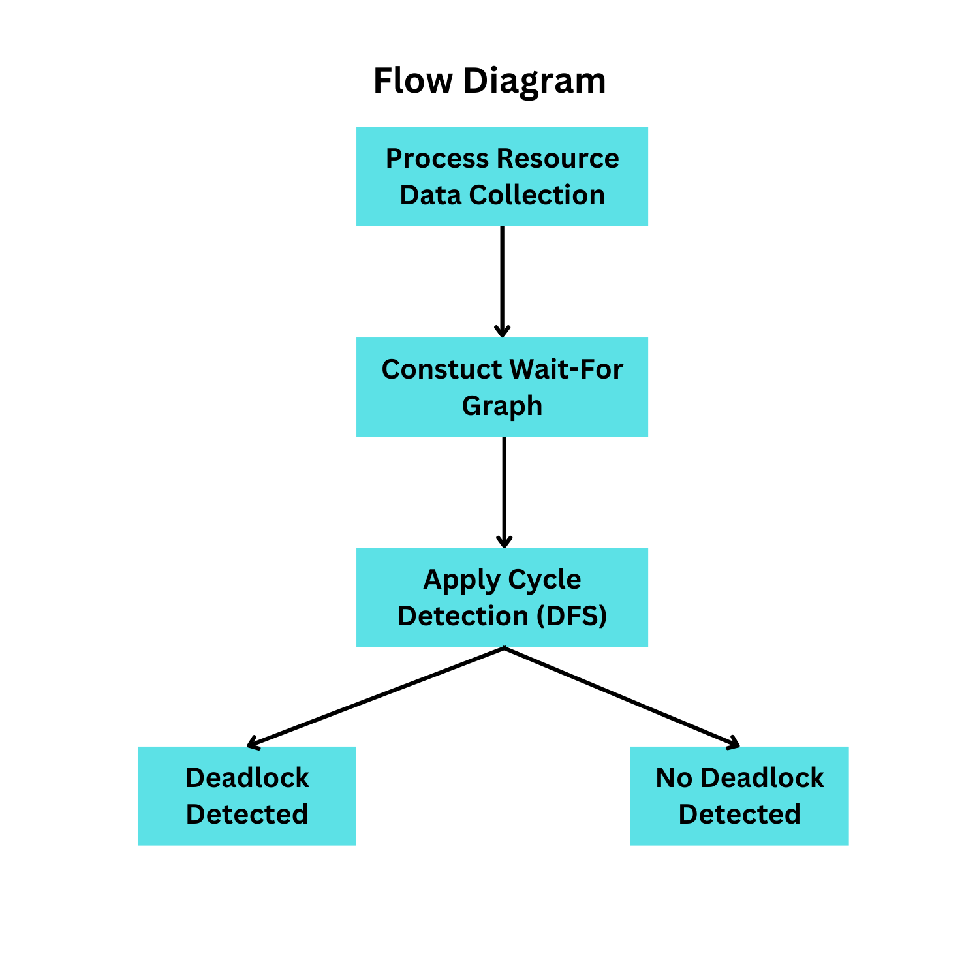

### **Summary of Graph Usage**

* The **Resource Allocation Graph (RAG)** is a more detailed, theoretical representation that includes both processes and resources.
* The **Wait-For Graph (WFG)** simplifies the RAG by focusing only on process dependencies, making it more practical for real-time deadlock detection.
* In this project, the WFG is constructed dynamically, and cycles in the graph are detected using a Depth-First Search (DFS) algorithm to identify deadlocks.

This graph-based approach provides an efficient and scalable solution for monitoring and detecting deadlocks in a system.