Student ID: 102151272

Name: BEN GARDINER

# Setup Screenshot

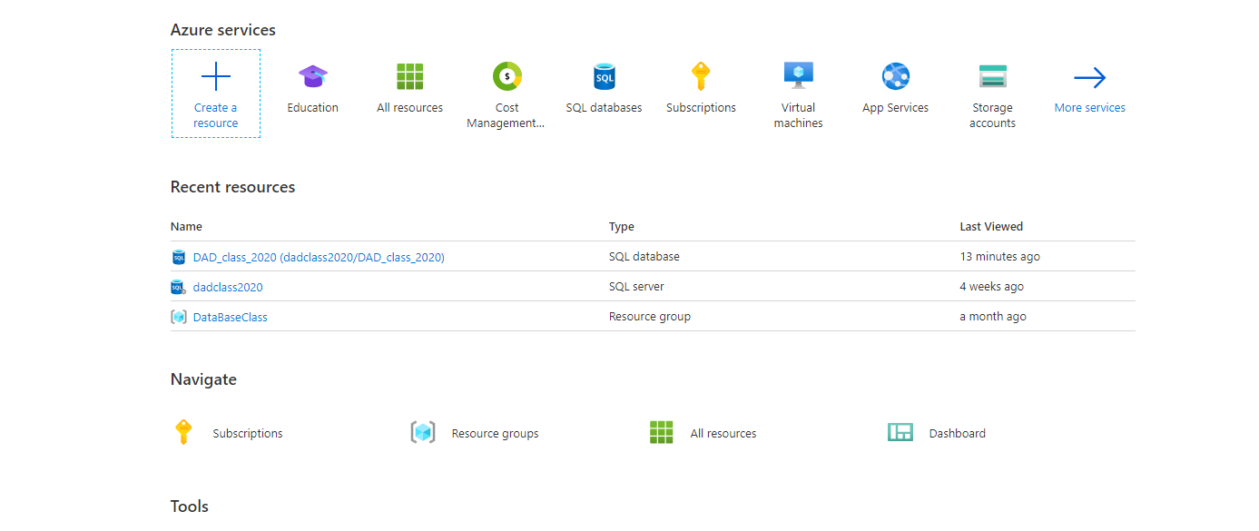

# Task 2 Screenshot

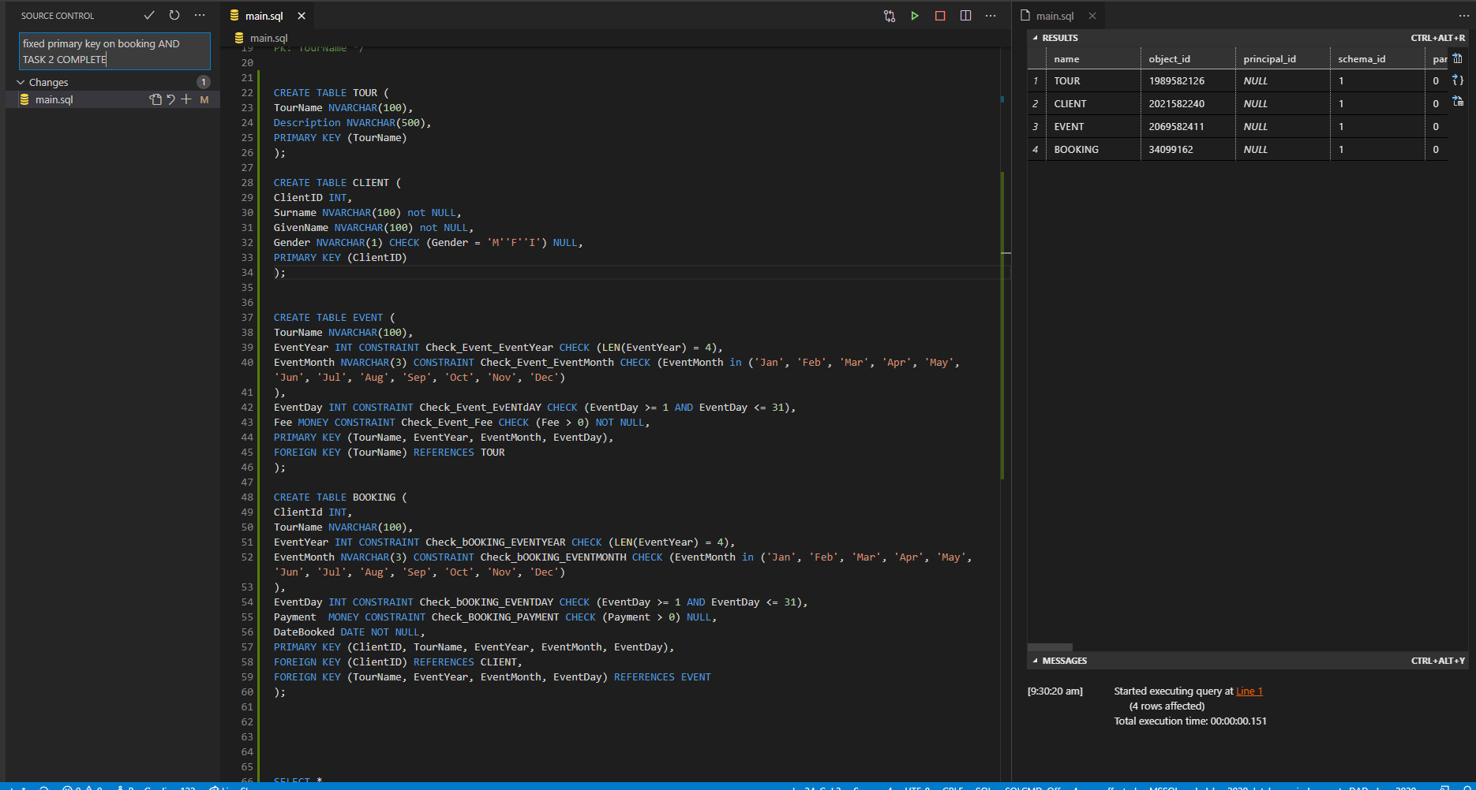

# Task 3 Screenshot

