Student ID:102151272

Name: Ben Gardiner

# Setup Screenshot

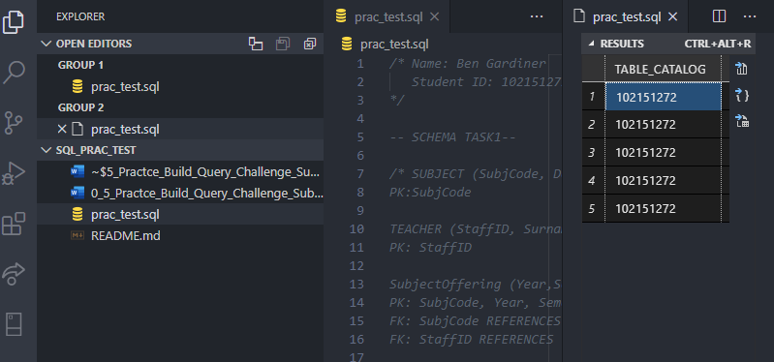

# Task 2 Screenshot

# Task 3 Screenshot

