

SCHOOL OF ADVANCED TECHNOLOGY

ICT - Applications & Programming

Computer Engineering Technology – Computing Science



A21
Model Definitions (RE/Automaton)

Lab Professor / Lab Session:
[302]

Team:
[Benjamin Gilstorf] - Id: [04102509] / [Bikku Byju Varughese] - Id: [041067021]

Language Name [Atys]

This template is suggested (not mandatory) to answer A11 Specification.

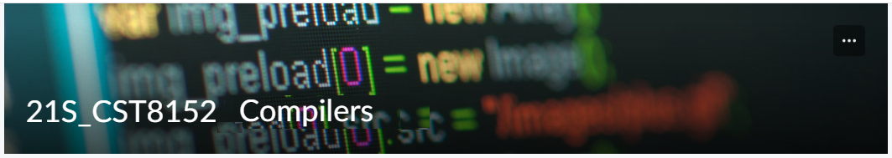

MODEL TASK FOR ASSIGNMENT 2.1 – YOUR LANGUAGE

- Note: This task is part of the Assignment 2 from Compilers Course. Any problem, contact your lab professor.

Task 1: Language Symbols (2.0 marks)

List examples: Define main symbols to be used:
- Special symbols (ex: “{“, “(“, “<=”, etc.)
- Comments
- Variables
- Functions
- Literals (numbers, strings)
- Keywords
- Datatypes

Answer:
Special symbols: ( { }, ( ), <=, =, +, -, *, / )
Comments: #
Variables: (Ex. data, val, num, testVal)
Functions: (Ex. input(num1), int(valTest)
Literals: (Numerical = , 0 ,3.14159265, ‘test’, ‘STATEMENT!!!!’ )
Keywords: (if, else, while, for, def, class, True, False, None, return, etc.)
Datatypes: int, float, str, list, tuple, dict, set

Task 2: RE – Regular Expression (3.0 mark)

Lexeme Classes: Define the classes to be used in your regular expression:

Answer:

Letters: L = [A-Za-z]
Digits: D = [0-9]
Period: P = [.]
Space: S = [ ]
Comment: CM = [#]
New Line: NL = [\n]
Quote: Q = [‘”]
Underscore: U = [_]
Open Parenthesis: OP = [(]
Closed Parenthesis: CP = [)]
E = [:]
U = _ (Underscore)
Other Characters: O = ^LDPSCMNLQEUOPU

Define the RE to be used for: variables, literals and keywords:

Answer:
* Comments: Begin with ‘#’
RE: CM[^CM]*NL
* Variables: Must start with letter, followed by any combination of letters, digits, and underscores.
RE: L(L|D|U)+

* Functions: L(L|D|U)*OP
* Literals:
- Integers: D+
- Floats: D+PD* | D*PD+
- Strings: String Literal(SL): Q[^Q]*Q
* Keywords:
RE(KEYWORDS): ‘def’ (=SequenceOfLetters)

Task 3: TD – Transition Diagram (3.0 marks)

Activity: Starting from the previous lexeme classes and obeying the RE, it is possible to define the automata for your language:

Answer (draw / copy image of the automata):

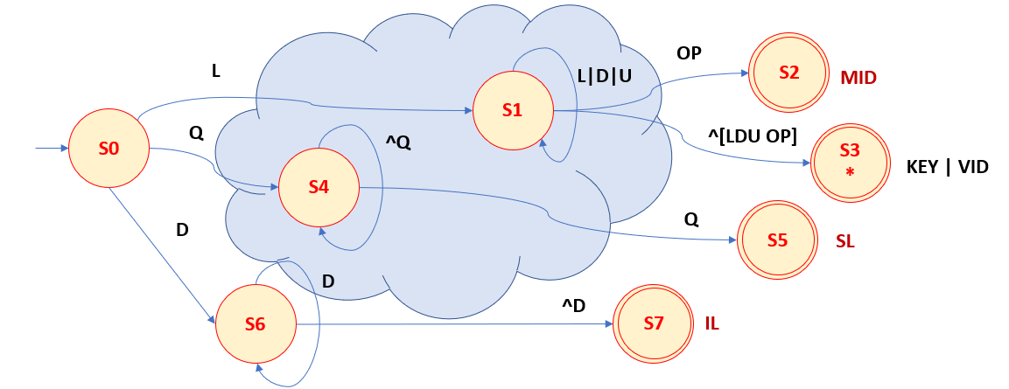

Task 4: TT – Transition Table (2.0 marks)

Activity: Now, it is possible to define the TT for these lexemes:

Answer (Transition Table):
Input | Input Symbol |  |  |  |  |  | Output
State/  Classes | 0 | 1 | 2 | 3 | 4 | 5 | Type
 | L(A-Z) | D(0-9) | U(_) | M(&) | Q(‘) | O | TYPE
S0 | 1 | 6 | ES | ES | 4 | ES | NOFS
S1 | 1 | 1 | 1 | 2 | 3 | 3 | ID/KEY
S2 | FS | FS | FS | FS | FS | FS | MID
S3 | FS | FS | FS | FS | FS | FS | KEY | VID
S4 | 4 | 4 | 4 | 4 | 5 | 4 | COMMENT
S5 | FS | FS | FS | FS | FS | FS | SL
S6 | FS | 6 | FS | FS | FS | 7 | IL
S7 | FS | FS | FS | FS | FS | FS | IL

Update: Feb 4th 2024.

Adapted from resources developed by Prof. Svillen Ranev (Algonquin College, 2019)

