**The impact of the two-child limit on children entering social care**

**Rationale**

* The two-child limit on tax credits reduced the resources available to parents after 2017
  + Specifically targeting large families with low incomes.
* [Economic resources are a predictor of entering care](https://www.sciencedirect.com/science/article/pii/S003335062300330X)
  + Lots of literature on this.
  + With concerns over bias in the removal of children in low-income households
* …so did the two-child limit increase the number of children in need of social support and those entering care?!

**Then, we know the answer…obvs yes… why do we care? (framing options)**

* Entering care system is an extreme form of impact
  + Maybe one of the most extreme
  + Not clear if two-child limit would have caused this much harm
* Effect size is unclear (how many children are affected in this way)
* An argument to be made against the cost savings made from these reforms
  + (And an argument justifying keeping these reforms)
  + Any savings on UC could be off-set by costs on children in care
    - We could maybe even calculate this number?
* “Dark logic” vibes

**What data do we have**

* Number of households impacted by two-child limit, by LA, by year 2018-23
  + Adding together those impacted via UC or CTC
* Any information you could dream of on children in care, by LA, by year 2011-23
  + Number, age, starting, ceasing, reasons, demographics, type of service
* The number of children in need
* Demographic data (total populations, populations of children born after 2017 etc.)

**What methods will we use**

* Not sure…
* But I maybe we can do something quasi-experimental… maybe?
  + We have a period of zero intervention… then an intervention applied at varying scales in different LAs at roughly the same rate over time.
  + Some kind of [diff-in-diff with no control group and continuous treatment](https://mixtape-sessions.github.io/Frontiers-in-DID/Slides/More-Complicated-Treatment-Regimes.html#/positive-side-comments-no-untreated-units)
  + Which might not calculate a treatment effect size but might test some version of “do areas worse affected have higher changes”.

**What I want help with:**

* Analysis Ideas
  + Eg. is covid an issue, which children are likely to be impacted
* Model specification
  + Controls, quasi-experiment, best outcomes.

**What does the descriptive analysis tell us?**

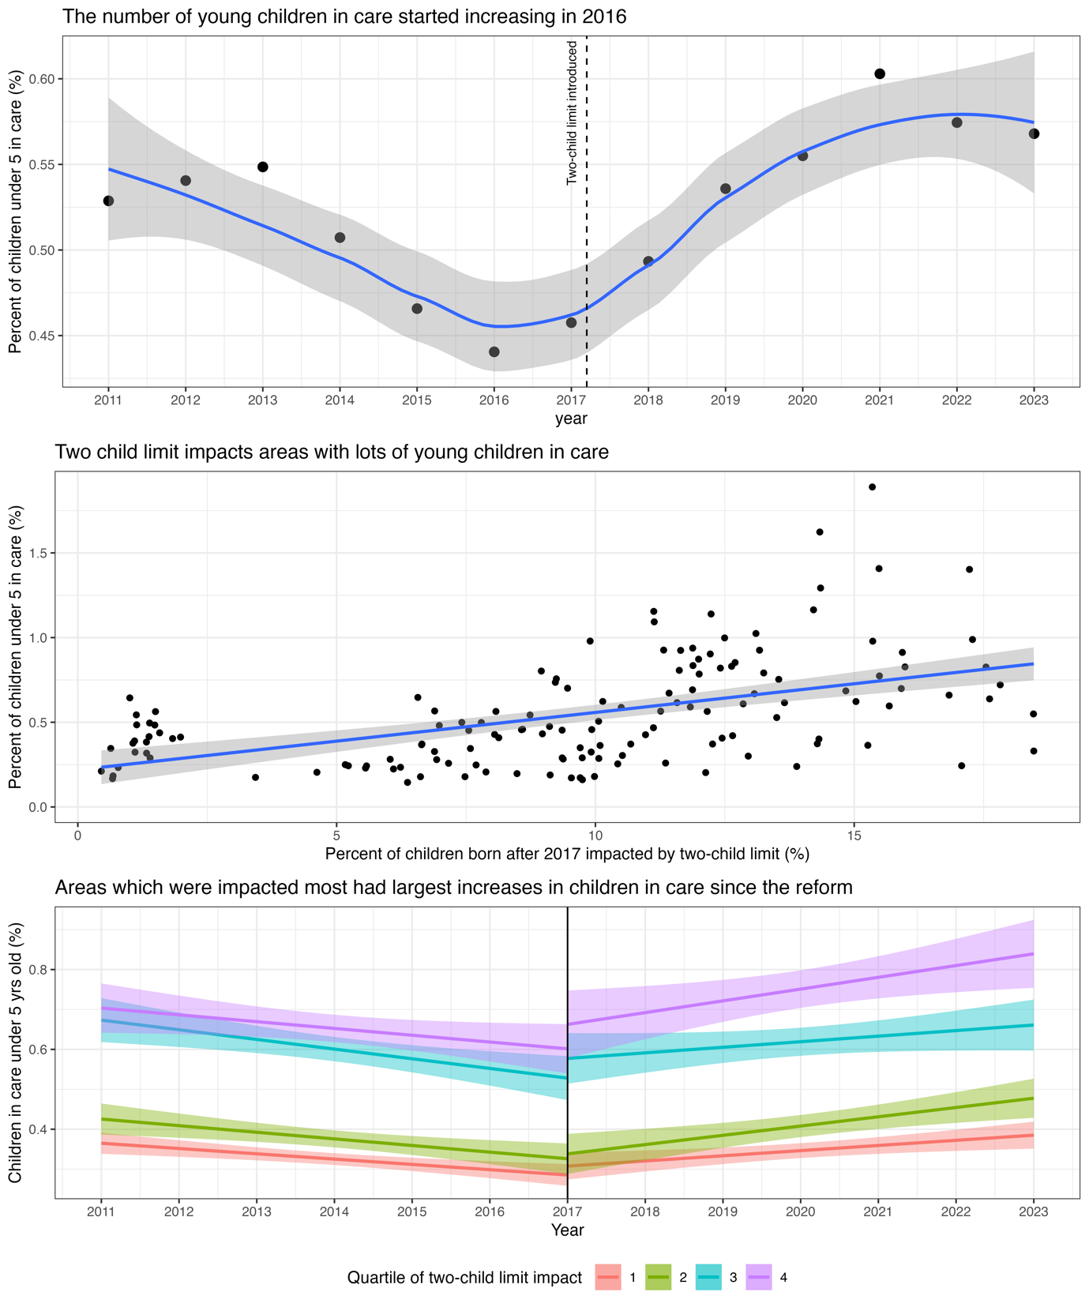

**Current specification:**

Two things: a) our exposure varies but doesn’t really change and b) we have repeat observations (sometimes monthly)

So. I think we want a specification on how our outcome changes – ideally utilising all the observations we have and regressed against a stable exposure.

So probably some kind of growth curve/ time series thing. DiD is fine but misses a bunch of obvs (and we only have 140 odd units)?

**Children in care:**

**Children in need:**