**Requirements – necessary python modules:**

Please install miniconda:

<https://docs.conda.io/en/latest/miniconda.html>

Open Anaconda PowerShell prompt via windows search bar

Using the provided requirements.txt found in the root directory of the project type the following command

conda create --name tensorflow python=3.6 --file DIRECTORY_TO_REQUIREMENTS.TXT

Once installation is complete, you should be good to go please run the BuildingGeneratorTool project. In this tool you will be asked to specify the miniconda install location, by default this should be at:

C:\Users\USERNAME\Miniconda3

You will also be asked to provide a building blueprint, of which I have left examples in root directory \Test Images folder.

**Please maintain the file structure of the project, for they are interlinked with one another.**

**Should know:**

Once you generate data in the BuildingGeneratorTool, run the DirectX tool in the following location:

BuildingGenerator\BuildingGenerationTool\DirectXTool

In the DirectX project, camera movement happens with the mouse scroll and WSAD. The user should also click to interact with objects in the world space.

**When exporting the obj it saves to the following directory:**

BuildingGenerator\BuildingGenerationTool\DirectXTool\DirectXTool\objFile.obj

If you see a cmd window popup looking something like this, do not worry it is processing in the background and has not stalled:

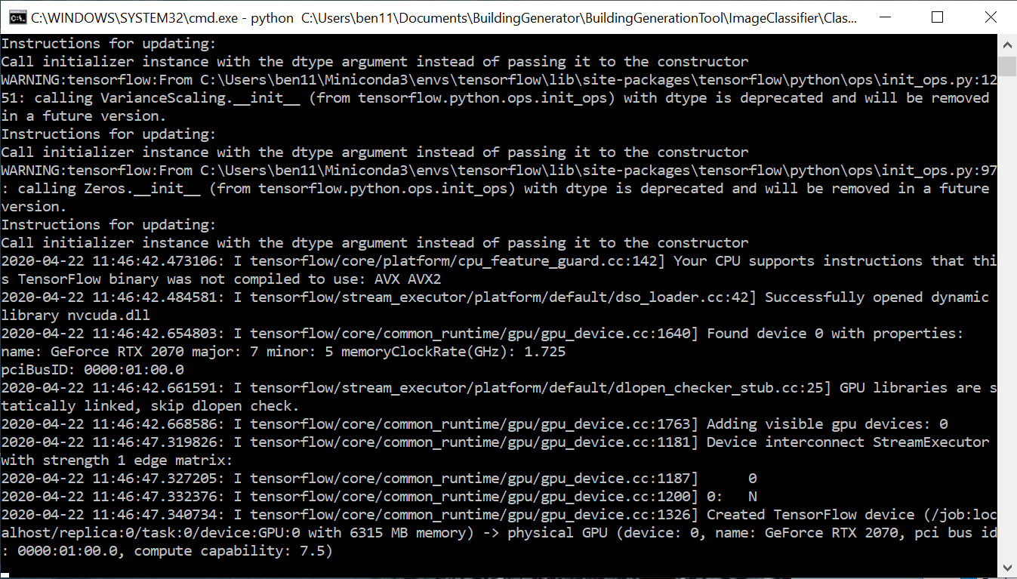

I am afraid for reasons unbeknownst to me, conda keeps the python script on a thread during runtime, and I am uncertain how to dismiss it via code. A result of this, the tool cannot be ran again during runtime. If you wish to alter variables to achieve different results / analyse another image, please restart the application.

If you have any issues, feel free to email me here:

Benjamin6.green@live.uwe.ac.uk