Change TCP/IP settings

Applies to Windows 7

TCP/IP defines how your computer communicates with other computers.

To make it easier to manage TCP/IP settings, we recommend using automated Dynamic Host Configuration Protocol (DHCP). DHCP automatically assigns Internet Protocol (IP) addresses to the computers on your network, if your network supports it. If you use DHCP, then you don't have to change your TCP/IP settings if you move your computer to another location, and DHCP doesn't require you to manually configure TCP/IP settings, such as Domain Name System (DNS) and Windows Internet Name Service (WINS). To enable DHCP or change other TCP/IP settings, follow these steps:

1. Open Network Connections by clicking the **Start** button , and then clicking **Control Panel**. In the search box, type **adapter**, and then, under Network and Sharing Center, click **View network connections**.
2. Right-click the connection that you want to change, and then click **Properties**.  If you're prompted for an administrator password or confirmation, type the password or provide confirmation.
3. Click the **Networking** tab. Under **This connection uses the following items**, click either **Internet Protocol Version 4 (TCP/IPv4)** or **Internet Protocol Version 6 (TCP/IPv6)**, and then click **Properties**. 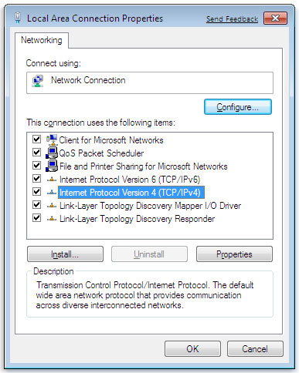The Network Connection Properties dialog box
4. To specify IPv4 IP address settings, do one of the following:
   * To get IP settings automatically using DHCP, click **Obtain an IP address automatically**, and then click **OK**.
   * To specify an IP address, click **Use the following IP address**, and then, in the **IP address**, **Subnet mask**, and **Default gateway** boxes, type the IP address settings.
5. To specify IPv6 IP address settings, do one of the following:
   * To get IP settings automatically using DHCP, click **Obtain an IPv6 address automatically**, and then click **OK**.
   * To specify an IP address, click **Use the following IPv6 address**, and then, in the **IPv6 address**, **Subnet prefix length**, and **Default gateway** boxes, type the IP address settings.
6. To specify DNS server address settings, do one of the following:
   * To get a DNS server address automatically using DHCP, click **Obtain DNS server address automatically**, and then click **OK**.
   * To specify a DNS server address, click **Use the following DNS server addresses**, and then, in the **Preferred DNS server** and **Alternate DNS server** boxes, type the addresses of the primary and secondary DNS servers.
7. 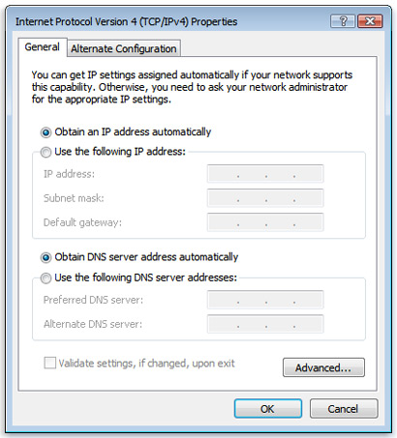The Internet Protocol Version 4 (TCP/IPv4)Properties dialog box
8. To change advanced DNS, WINS, and IP settings, click **Advanced**.

Note

* To install IPv4, run Command Prompt as an administrator, type **netsh interface ipv4 install**, and then press Enter.