8597375

Abstract

A report documenting the design, testing and implementation of a website for the case study Cristina’s kitchen

Human COmputer Interaction and web development

Assignment 2



Contents

Introduction 2

Propsed Timeline / schedule 3

Personas 4

journey maps 5

Wire Frames and testing 7

website and testing 9

final product 10

refrences 11

Figures Table 12

# Introduction

This report will explore in detail the steps taken to design and produce the website for the case study Cristina’s kitchen. The supporting documentation as well as the artefact itself will be uploaded with this report, it can also be located at the following GitHub: <https://github.com/BunForFun/Assignment-Website-Final>

# Propsed Timeline / schedule

The proposed timeline facilitates the completion of the project over a three-week period. This schedule gives ample time for the test clients to respond with feedback and for the feedback to be processed and acted upon. As this section relies on the most outside sources it was given the largest portion of dedicated time to facilitate for any delays. The Gantt chart (Figure 1) was the first element off the project to be completed; this was to create a structured timeline that all parties involved could strategies around. The Gantt chart also allows the designers to see if they are on track for the client. (2020)

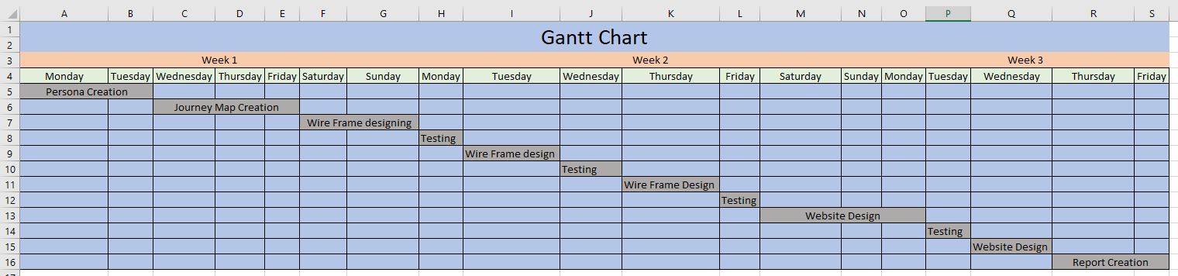

Figure 1: Gantt Chart

# Personas

Four personas were created in order to simulate a realistic environment. These personas consisted of three students and one member of staff; the three students were divided into three separate types of customer:  
Researcher: An individual who knows exactly what they want to purchase before entering the site. In the case of the example given, this would be a student who is a regular and buys the same thing regularly. This individual wants a fast shopping experience with plenty of accelerators to further decrease the time required to place an order

Browser: A leisurely shopper who is looking to gain entertainment, inspiration or kill time on a site. This type of customer wants to be able to easily view the latest products and offers without having to search through multiple pages.

Researcher: A researcher is driven by the goal to gain knowledge on a product or service. If they do not achieve this goal, they will leave a site with a sense of dissatisfaction, resulting in them not returning to the site. It is vital key information is clearly displayed in order for the user to retrieve the key facts as quickly as possible.

The Personas created will be referenced throughout the design and creation of the site. This will result in the site being tailored to all the common issues faced by the common user.

The personas were created using the PACT methodology (People, activities, context, technologies). This means that during each personas creation. The individuals were set goals within the context of the café. The personas will only be satisfied once these goals have been achieved.

In the case of the example persona given below (Figure 2), Tommy will only be satisfied if he is able to see what food items are new and be able to purchase an item. The personas also contain the users frustrations and motivations, this adds a further level of complexity in regards to satisfying a customer. In the case of Tommy, even if new items are clearly displayed, he will not purchase an item if there is no easy way to pay.

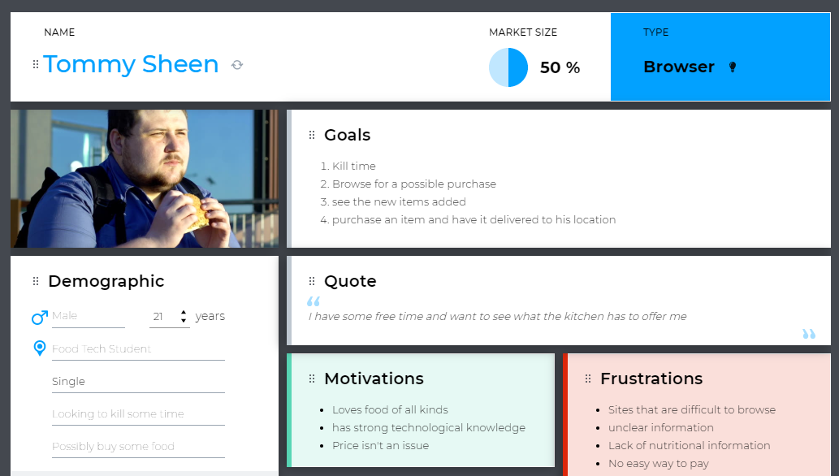

Figure 2: Persona Example

# journey maps

Journey maps are a crucial tool in the effort of predicting customer behaviour and addressing issues before they arise. A journey map plots the journey a customer takes when completing a set of tasks. In the instance of Cristina’s kitchen, it maps the journey a customer will undertake in order to purchase food from the site and have it delivered to their location. (Top 5 Benefits Of Customer Journey Mapping - Knexus, 2020)

The journey map below follows the steps the persona (Figure 3), Emily Simon (typical student), would undertake when purchasing an item from the site. The map allows for the visualisation of the students thought process and emotions as they traverse the site. By visualising every step in a customer’s experience, it is possible to view every single possible point of failure. By using the journey map two possible areas of emotional distress can be identified; the process of filling out information and waiting for the food. This insight enables the website designer to keep these factors in mind when designing the wire frames. Requiring as little information as possible with a rapid response system would help alleviate both of these issues. Without the journey map neither of these issues could be brought to light.

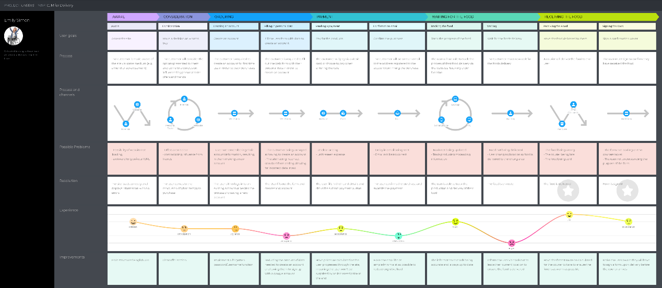

Figure 3: Customer Journey Map

The second Journey map created (Figure 4) analyses the staffs back end system and how a member of staff would operate the site. Not only is it vital for the customers to have their needs addressed, but the staff members must also be able to use the site quickly and with little issue. The main issue brought to light through this is the uncertainty brought on by transporting the food from the café to the client. This unease can be reduced by implementing a system that allows the courier to immediately update the site as to when the food has been delivered. Not only will this put the staff at ease, but it will allow them to start work on the next order much sooner than before. Allowing for increased productivity.

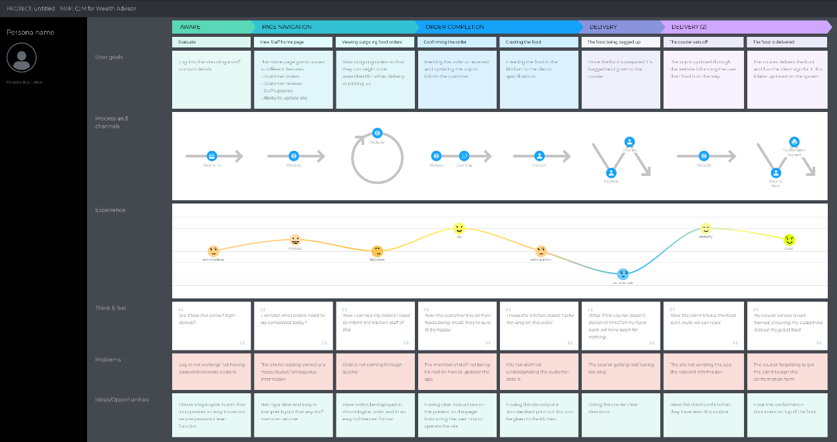

Figure 4: Staff Journey Map

# Wire Frames and testing

The development and testing of the wire frames took place over a 10-day period. The amount of time committed to this procedure was so significant due to the importance of user feedback. By running multiple tests over multiple days on the same site it is possible to identify more issues than what would be discovered by running one large test on one day. Tom Landauer and Jakob Nielson demonstrated that number of problems located in a test with *n* users is: N(1-(1-L)^n) where N is the total number of problems in the design and L is the proportion of problems discovered while testing a single user. The most common value of L is 31% averaged across a wide test field. (Why You Only Need to Test with 5 Users, 2020)

The graph below is the plotting of L =31% (Figure 5). This graph shows that the optimum number of test subjects to conduct a test is between 4 and 5. This is due to increased test subjects locating the same problems that previous individuals have found without contributing any new issues. This is the reason a testing field of 4 was chosen. This allowed for in-depth testing resulting in many improvements being implemented.

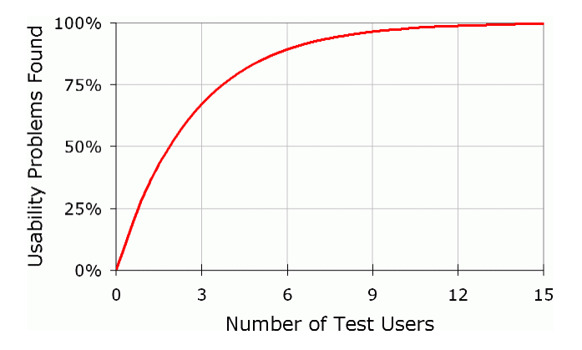

Figure 5: L = 31% chart

The individuals testing the site were asked 10 questions, each one of these questions relating to a different Heuristic devised by Jakob Neilson (10 Heuristics for User Interface Design: Article by Jakob Nielsen, 2020). If the user answered negatively to a question, they had the facility to provide an explanation as to why they believed the wireframe didn’t satisfy the requirement. (Figure 6)

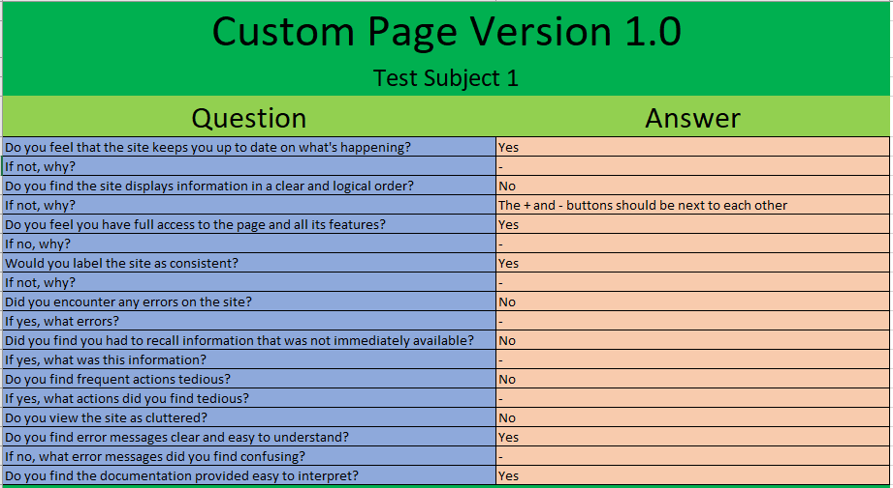

Figure 6: Testing for wireframes

When ever a test was conducted the feed back would be gathered and acted upon in a revision to the wireframe. The revised wire frame would then be shown to the testers and examine under the same heuristics. Only once a wire frame satisfied all heuristics in the eyes of all test subjects would the wire frame be deemed as successful and passed onto the next stage. The number of revisions required to create a successful varied, the average case was one initial wire frame leading to two revisions.

During the testing process, questions relating to Heuristic 1 (Visibility of system status), Heuristic 3 (User control and freedom) and Heuristic 7 (flexibility and efficiency of use) presented the most issues. Testers found that the wireframes were too tightly packed together and were missing quality of life features such as an easily interpreted basket. Once these features had been added, the testers believed the 10 heuristics to be satisfied.

# website and testing

The second batch of testing took place using the website prototypes that had been constructed using the approved wire frames (Figure 7). The testing followed the exact same format as the previous batch of testing conducted on the wire frames. The testers were presented with the initial model of the website and asked to answer the ten Heuristic based questions. Answers provided by the test subjects enlightened areas requiring improvement such as buttons being to close together and a lack of direction for new or none English-speaking customers. All tests that took place were conducted using the Google Chrome web browser version 80.0.3987.132. This browser was chosen as it is the most commonly used browser by the general public (W3Counter: Global Web Stats, 2020). Other browsers were tested, however not to the extent of the testing conducted in Chrome. All browsers tested produced the same rendering of the site, so no further testing was conducted in alternative browsers.

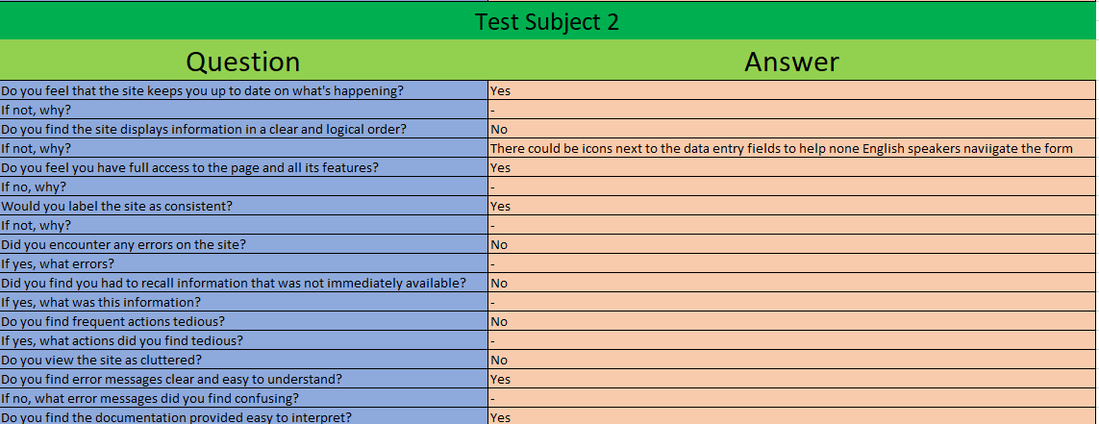

Figure 7: Website Testing

Thanks to the in-depth testing conducted on the wire frames the website protypes only required one revision on average. By committing so much time in the initial testing, vast amounts of time are saved in the long run. Allowing the client to receive a finished product much sooner.

The website prototypes incorporated the use of HTML, CSS and JavaScript. This gave the testers the most accurate representation of what the final product would resemble, the alternative being images engineered to resemble the site itself.

# final product

The final product was engineered through the use of the finalised wire frame designs and finalised website prototype. The product consists of a homepage, food customising page, checkout page, confirmation page and a staff page. All pages are linked to each other through the use of links within the site excluding the staff page which most be opened manually by a member of staff. The final product was constructed with a minimalist design with plenty of accelerants to increase ease and flexibility of use. By adhering to Jakob Nielsen 10 heuristics as well as the social conventions of other websites, the effectivity off the site is ensured. Thorough testing at all stages through the use of multiple personas guarantees an unbiased dictation of the site and its effectiveness. Further revisions to the site could be made such as the implementation of an easy to use GUI for SQL. These however would need to be completed with in the university guide lines to prevent breaches of the data protection act.

# refrences

Nielsen Norman Group. 2020. *10 Heuristics For User Interface Design: Article By Jakob Nielsen*. [online] Available at: <https://www.nngroup.com/articles/ten-usability-heuristics/> [Accessed 17 April 2020].

Proofhub.com. 2020. [online] Available at: <https://www.proofhub.com/articles/benefits-of-gantt-charts> [Accessed 17 April 2020].

Knexus. 2020. *Top 5 Benefits Of Customer Journey Mapping - Knexus*. [online] Available at: <https://www.knexusgroup.com/show/blog/top-5-benefits-customer-journey-mapping/> [Accessed 17 April 2020].

W3counter.com. 2020. *W3counter: Global Web Stats*. [online] Available at: <https://www.w3counter.com/globalstats.php> [Accessed 17 April 2020].

Nielsen Norman Group. 2020. *Why You Only Need To Test With 5 Users*. [online] Available at: <https://www.nngroup.com/articles/why-you-only-need-to-test-with-5-users/> [Accessed 17 April 2020].

# Figures Table

Figure 1: Gantt Chart 3

Figure 2: Persona Example 4

Figure 3: Customer Journey Map 5

Figure 4: Staff Journey Map 6

Figure 5: L = 31% chart 7

Figure 6: Testing for wireframes 8

Figure 7: Website Testing 9