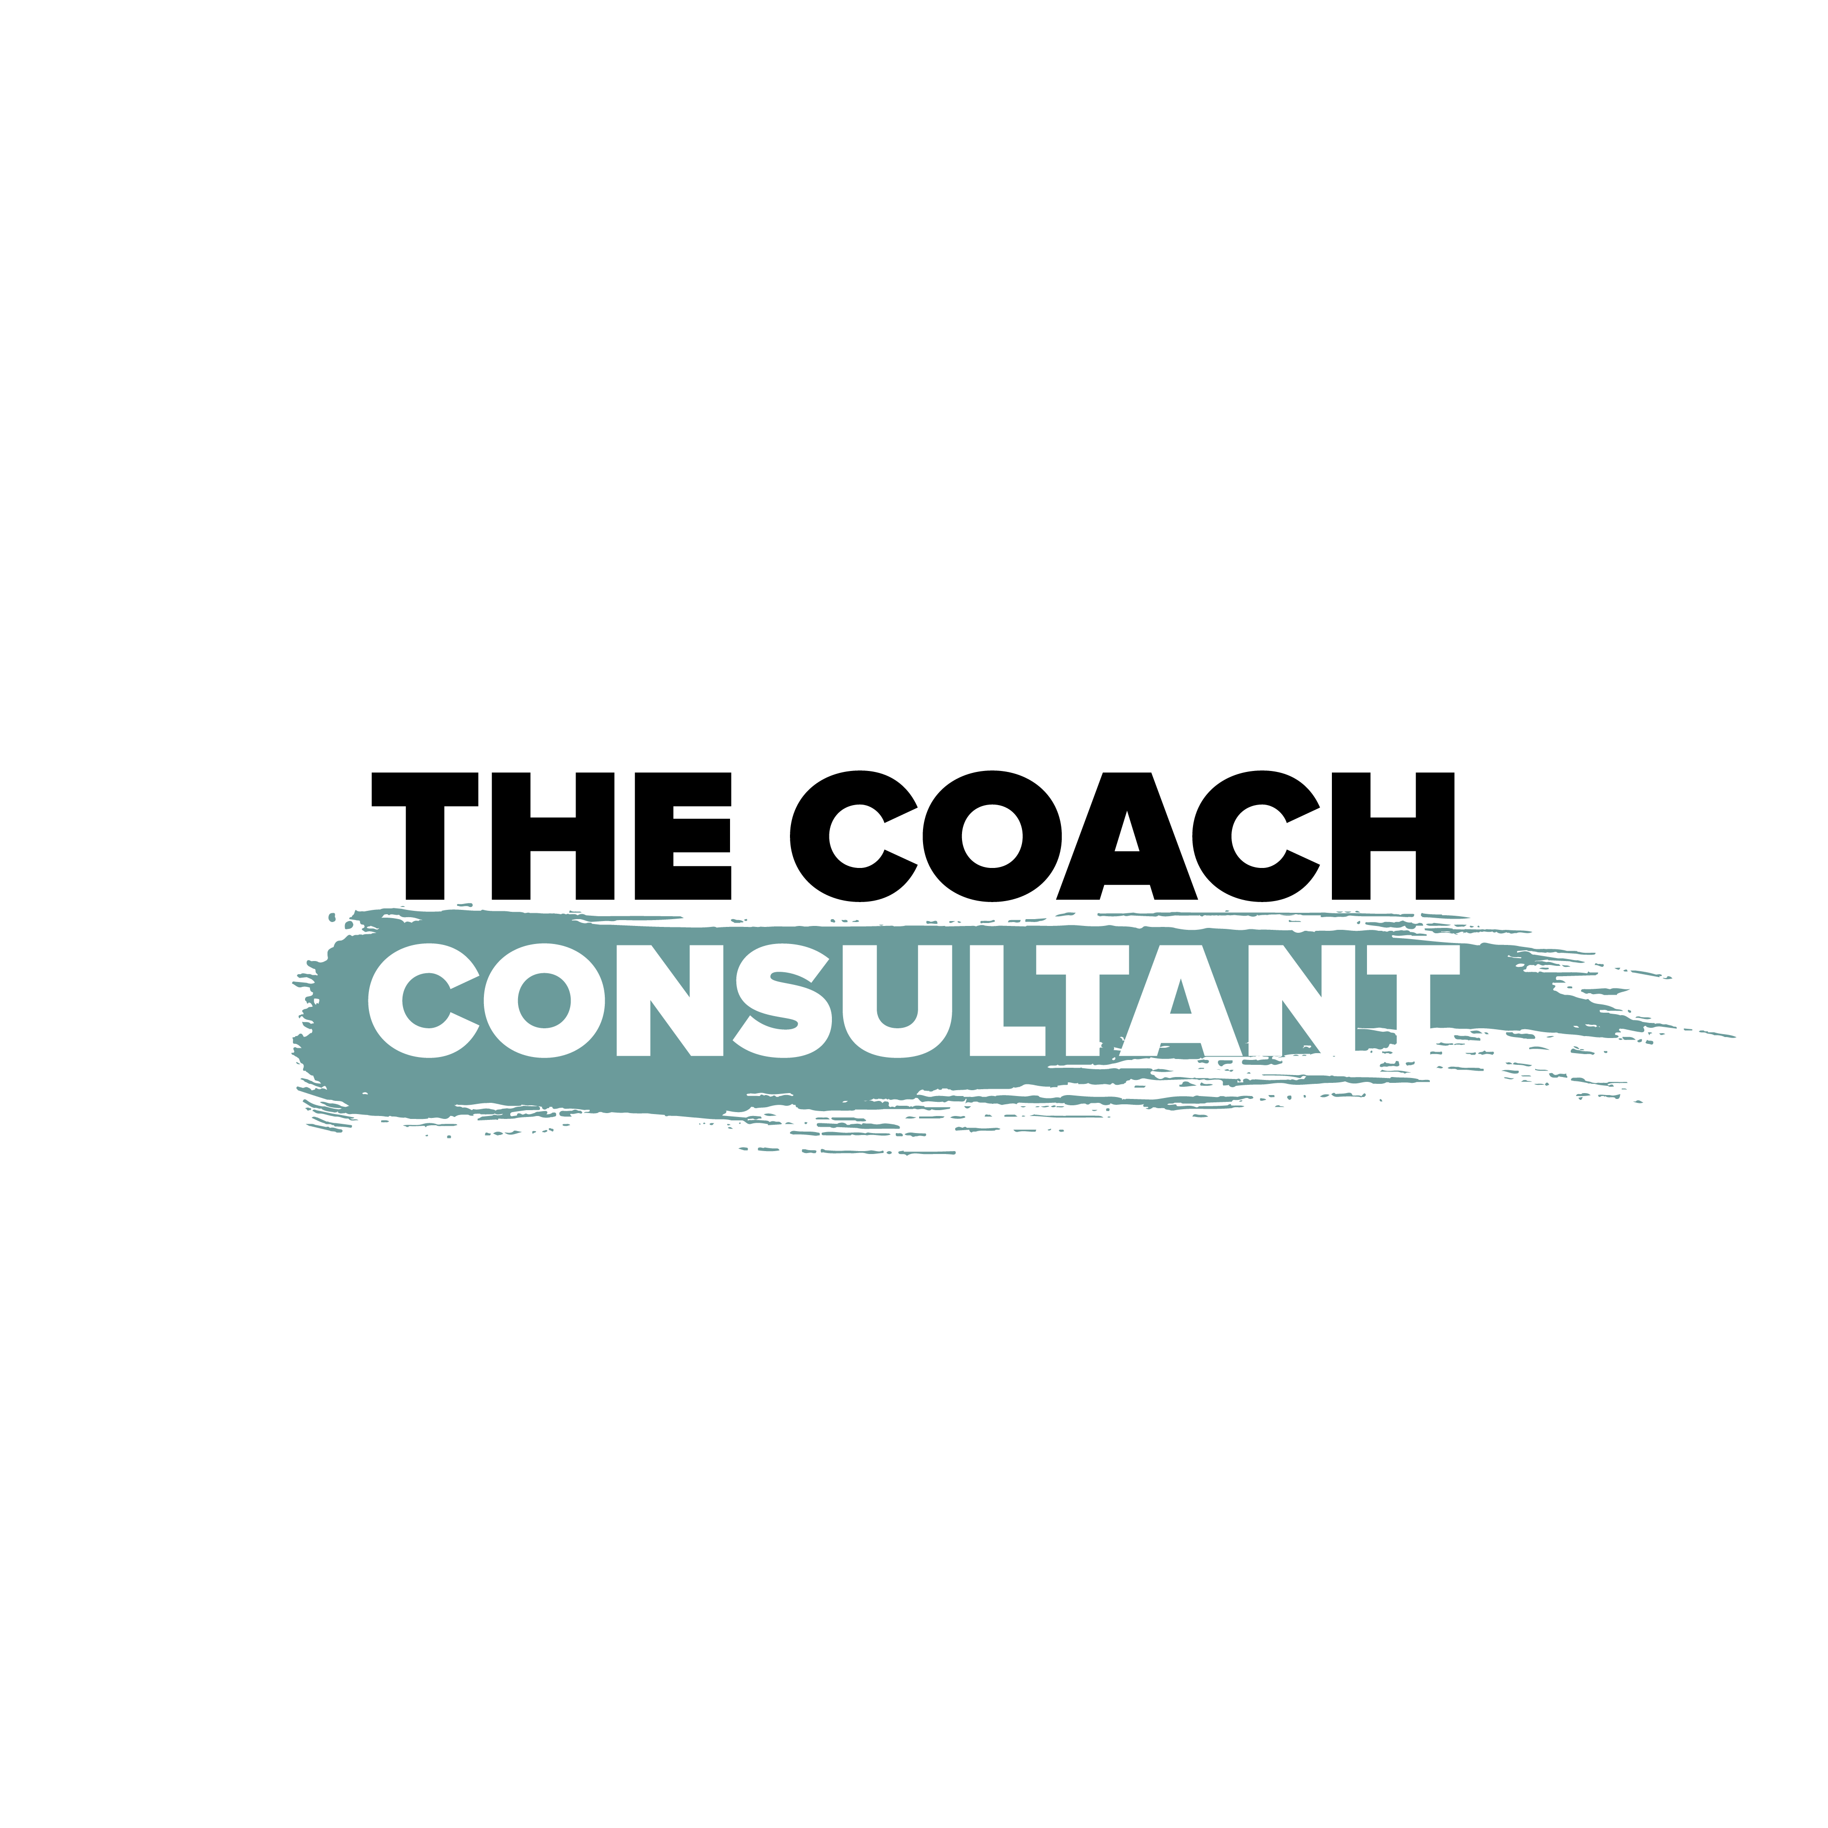

Chief Operating Officer
Role & Responsibility Framework

Business Overview

Company Performance
Current monthly revenue: £100,000/month (£1.2M annualised)

Programmes
1. Smart Scaling System — Info course product (scalable, lower ticket)
2. Propel Programme — Done-with-you 1-to-1 coaching (mid ticket)
3. Titans Programme — Done-for-you and done-with-you 1-to-1 (high ticket, premium)

Team Structure
1. CEO / Founder — Vision, content, brand, new initiatives
2. COO — Operations, systems, team management
3. Client Success Director — Retention, results, client journey
4. Sales Manager — Pipeline, conversion, revenue
5. 2 x Success Coaches — Client delivery and coaching sessions
6. Admin & EA Support Team — Administration, scheduling, operations support
7. Content Production Team — Editing, design, scheduling, publishing

Current Activity Audit
Complete this section honestly. List everything you currently do on a daily and weekly basis — no matter how small. This will be reviewed to identify what should stay, what should be delegated, and what should stop.

Daily Tasks — What do you do every day (or most days)?
# | Task / Activity | Time Spent (mins) | Could Someone Else Do This?
1
2
3
4
5
6
7
8
9
10

Weekly Tasks — What do you do on a weekly basis?
# | Task / Activity | Time Spent (mins) | Could Someone Else Do This?
1
2
3
4
5
6
7
8
9
10

Role Purpose
The COO is the operational backbone of the business. At £100k/month with multiple programmes and a growing team, the COO ensures delivery, operations, and team management run without the CEO having to get involved.

A key part of this role is actively removing tasks from the founder’s plate, building systems that scale, and continuously improving the three programmes.

Core Focus Areas

Systems, SOPs & Process Building
Creating new SOPs every week. Documenting processes across all three programmes so the business runs on systems, not people.

Founder Task Removal
Actively identifying tasks the CEO is doing that can be systematised, delegated, or eliminated. The COO’s job is to free up the founder’s time for content, brand, and innovation.

Programme Improvements
Presenting improvements to Smart Scaling System, Propel, and Titans — better onboarding, smoother delivery, tighter handoffs, improved client experience.

Team Initiatives & Financial Oversight
Driving new initiatives for the core team, managing operational costs, and ensuring the business stays lean as it scales.

Key Responsibilities

Daily
1. Review team task boards — check progress across admin, content, and coaching teams
2. Respond to operational questions and unblock the team
3. Identify at least one task that can be removed from the founder’s plate

Weekly
1. Attend the higher management team meeting with operational KPIs
2. Create or update at least one SOP
3. Present founder tasks removed and programme improvement ideas
4. Check in with Success Coaches, admin team, and content team
5. Progress at least one new core team initiative

Monthly
1. Compile monthly operational report — costs as % of revenue, team performance
2. Present programme improvements for Smart Scaling, Propel, and Titans
3. Audit the tech stack and automations
4. Review founder’s task list and identify next batch to remove

Quarterly
1. Full operational audit — systems, processes, costs, team capacity
2. Present quarterly operations review to CEO with recommendations
3. Plan next quarter’s SOP targets, programme improvements, and team initiatives

Key Performance Indicators

1. New SOPs Created
Target: 1/week
New standard operating procedures documented per week.

2. Operational Cost (% of Revenue)
Target: ≤35%
Total operational spend as a percentage of £100k monthly revenue.

3. New Core Team Initiatives
Target: 1/month
New projects or improvements initiated for the team per month.

4. Founder Tasks Removed
Target: 1-2/week
Tasks taken off the CEO’s plate through delegation, automation, or elimination.

5. Programme Improvements Presented
Target: 1/month
Improvements to Smart Scaling, Propel, or Titans formally presented per month.

What This Role Is NOT Responsible For

1. Closing sales or leading sales conversations (CEO and Sales Manager own this)
2. Delivering coaching sessions (Success Coaches own this, Client Success Director oversees)
3. Creating content or managing social media strategy (CEO and Content Team own this)
4. Making strategic decisions about business direction or offers (CEO owns this)
5. Doing the tasks — the COO manages the system, not the workload itself

The Coach Consultant — thecoachconsultant.uk — Confidential

