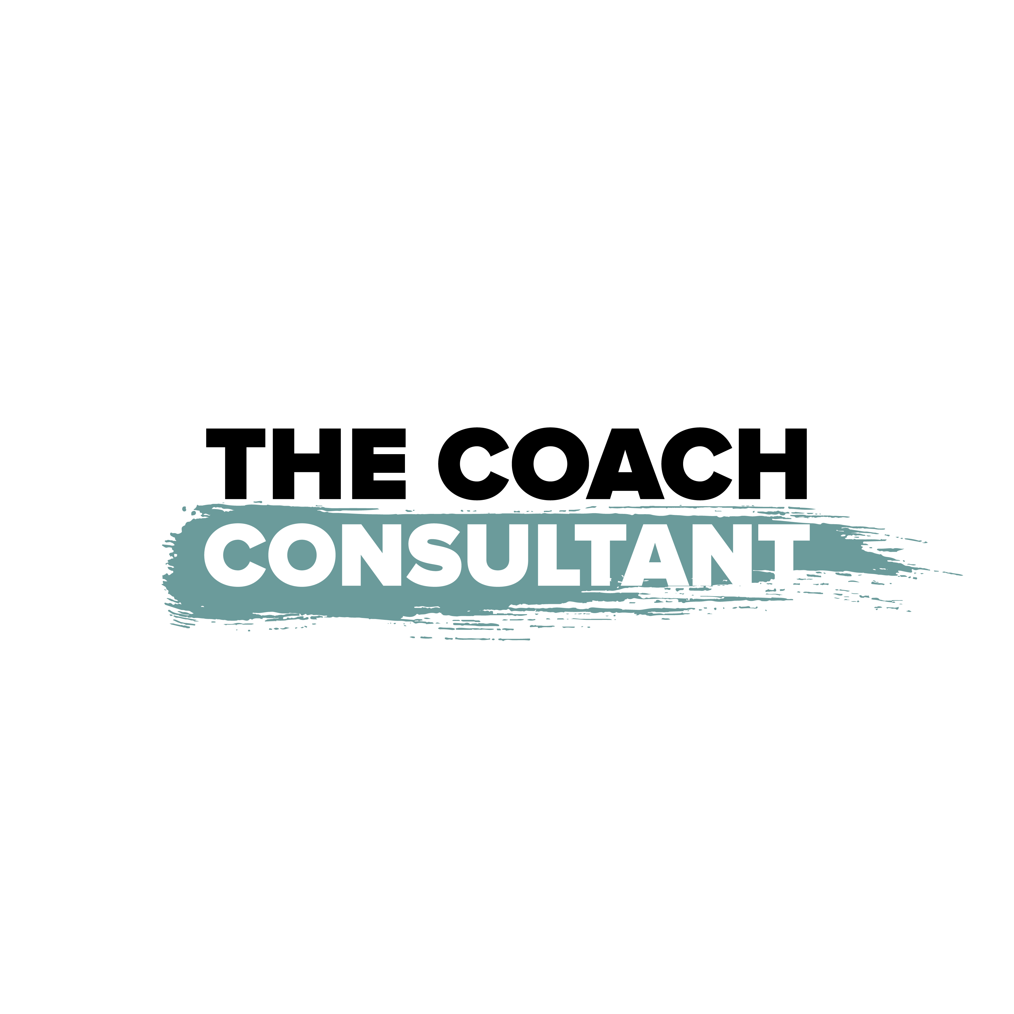

Client Success Director
Role & Responsibility Framework

Business Overview

Company Performance
Current monthly revenue: £100,000/month (£1.2M annualised)

Programmes
1. Smart Scaling System — Info course product (scalable, lower ticket)
2. Propel Programme — Done-with-you 1-to-1 coaching (mid ticket)
3. Titans Programme — Done-for-you and done-with-you 1-to-1 (high ticket, premium)

Team Structure
1. CEO / Founder — Vision, content, brand, new initiatives
2. COO — Operations, systems, team management
3. Client Success Director — Retention, results, client journey
4. Sales Manager — Pipeline, conversion, revenue
5. 2 x Success Coaches — Client delivery and coaching sessions
6. Admin & EA Support Team — Administration, scheduling, operations support
7. Content Production Team — Editing, design, scheduling, publishing

Current Activity Audit
Complete this section honestly. List everything you currently do on a daily and weekly basis — no matter how small. This will be reviewed to identify what should stay, what should be delegated, and what should stop.

Daily Tasks — What do you do every day (or most days)?
# | Task / Activity | Time Spent (mins) | Could Someone Else Do This?
1
2
3
4
5
6
7
8
9
10

Weekly Tasks — What do you do on a weekly basis?
# | Task / Activity | Time Spent (mins) | Could Someone Else Do This?
1
2
3
4
5
6
7
8
9
10

Role Purpose
The Client Success Director ensures every client across Smart Scaling System, Propel, and Titans gets results, stays engaged, and becomes a source of social proof and referrals. This role oversees the two Success Coaches and owns the client journey end to end.

At £100k/month, retention and social proof are the difference between growth and a leaky bucket. Every testimonial video, case study carousel, and referral generated by this role directly feeds the marketing and sales engine.

Core Focus Areas

Testimonials & Social Proof
Systematically collecting video testimonials from clients getting results. These are the most valuable marketing assets the business has.

Case Study Content
Processing client success stories into carousel-format case studies that the content team can publish. Turning results into content.

Referral Generation
Building a consistent system for generating warm referrals from satisfied clients across all three programmes.

Success Team Innovation
Presenting new initiatives to improve client delivery, coaching quality, and team performance. Continuously raising the standard.

Key Responsibilities

Daily
1. Review client engagement across all three programmes — who is active, who has gone quiet
2. Manage the Success Coaches — ensure check-ins are happening and standards are met
3. Flag at-risk clients immediately and create intervention plans

Weekly
1. Attend the higher management meeting with client success data
2. Collect 1-2 video testimonials from clients hitting milestones
3. Process at least 1 case study carousel for the content team
4. Generate at least 2 referrals from existing clients
5. Review the full client roster with Success Coaches

Monthly
1. Present a new success initiative or team improvement to the CEO
2. Compile monthly client success report — testimonials, case studies, referrals, retention
3. Review client journey by programme and propose improvements
4. Coordinate with content team on case study publishing schedule

Quarterly
1. Full client satisfaction review across all programmes
2. Present quarterly success review to CEO — trends, wins, risks
3. Plan next quarter’s testimonial and case study targets

Key Performance Indicators

1. Testimonial Videos Collected
Target: 1-2/week
Video testimonials from clients who have achieved results. The most powerful marketing asset.

2. Case Study Carousels Processed
Target: 1/week
Client success stories formatted as carousel content, ready for the content team to publish.

3. Referrals Generated
Target: 2/week
Warm referrals from existing clients. The cheapest, highest-converting lead source.

4. New Success Initiatives
Target: 1/month
New ideas or projects to improve client delivery, coaching quality, or the client experience.

5. New Team Improvements
Target: 1/month
Improvements to the Success Coach team — better processes, training, tools, or accountability systems.

What This Role Is NOT Responsible For

1. Selling or closing new clients (CEO and Sales Manager own this)
2. Building SOPs, managing tech, or fixing operational systems (COO owns this)
3. Setting business strategy, pricing, or offer design (CEO owns this)
4. Qualifying leads or managing the sales pipeline (Sales Manager owns this)
5. Creating marketing content or running ads (CEO and Content Team own this)

The Coach Consultant — thecoachconsultant.uk — Confidential

