Name: Song Yangyu

Matric Number: A0077863N

Working Environment: VIM + commend line

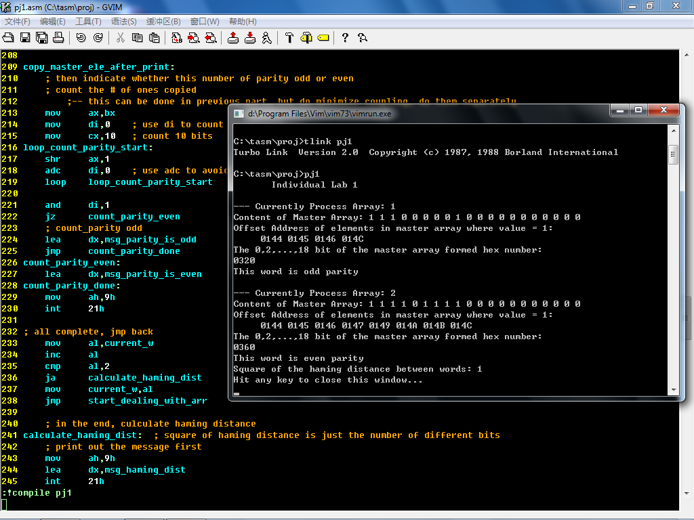

Solely the screen (output):

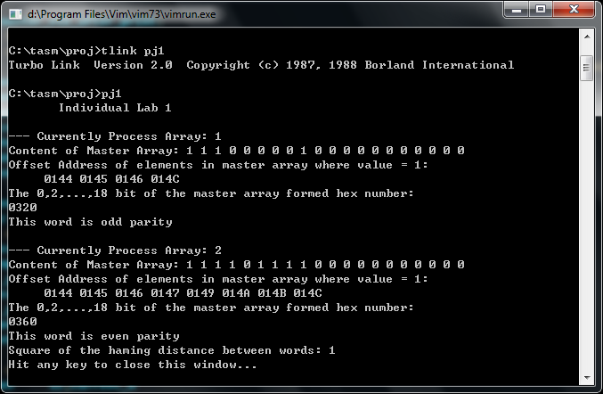

## How to test the code:

For easier testing, I defined the array1 and array2 as follows:

arr1 db 1,3,4,6,8,10,15

arr2 db 1,2,3,5,8,9,10,11,12,13,14,15,16,17,18,2

Compile and run the code, then I can get the output as follow:

## Output:

Individual Lab 1 -- Song Yangyu -- A0077863N

--- Currently Process Array: 1

Content of Master Array: 1 0 1 1 0 1 0 1 0 0 0 0 0 0 0 0 0 0 0 0

Offset Address of elements in master array where value = 1:

0161 0163 0164 0166 0168

The 0,2,...,18 bit of the master array formed hex number:

0300

This word is even parity

--- Currently Process Array: 2

Content of Master Array: 1 1 1 0 1 0 0 1 1 0 0 0 0 0 0 0 0 0 0 0

Offset Address of elements in master array where value = 1:

0161 0162 0163 0165 0168 0169

The 0,2,...,18 bit of the master array formed hex number:

03A0

This word is even parity

Square of the hamming distance between words: 5

## Basic Logic of the code:

1. Meaning of the variables:
   1. I used “msg_*” to store the message showing to the user. Following this naming standard is a good practice of software engineering.
   2. I used “M_SIZE”, “A1_SIZE”, and “A2_SIZE” to define the size of the array; later if one want to change the size of array, one can easily do so by changing the defined variable here.
   3. “word1”,”word2” are the 2 word formed by the two words
   4. current_w: Because we do all the tasks to array1 and array2 separately, it’s the beat if we can reuse the repeated code. The variable current_w is for storing which array we’re currently handling: either array1, or array 2. Later in the code when I need to differentiate, I can do so by refer to this variable.
   5. param_list: I used procedure to print number. This param_list is supposed to be called by all procedure who want to print number
2. The procedure proc_print_num:

I use this procedure to print out number in hex form. It takes three parameters:

* Number to print
* Number of digits to display: it would display the left most (MSB) that number of digits
* Separator: the letter to print after printing the number. This is useful when one wants to print out a list of numbers

Note that one can also use stack to pass the parameters. By doing so, we can actually allow recursion. But in this piece of code, for clarity I used parameter table instead (Note that the con of using a parameter table is that. one can only call one level of function; if one call another function inside the procedure, the parameter would be overwritten)

## Code:

NOTE: I suggest to refer to the code.asm for the details of the code.

stk segment stack

db 128 dup(?)

tos label word

stk ends

; data segment

data segment

msg_welcome db " Individual Lab 1",10,"$"

msg_current_processing_arr db 10,"--- Currently Process Array: ","$"

msg_prompt_marr_content db "Content of Master Array: ","$"

msg_show_offset_addr db "Offset Address of elements in master array where value = 1:",10," ","$"

msg_show_copied_content db "The 0,2,...,18 bit of the master array formed hex number: ","$"

msg_debug_pass db " DEBUG: pass here.",10,"$"

msg_parity_is_odd db "This word is odd parity",10,"$"

msg_parity_is_even db "This word is even parity",10,"$"

msg_haming_dist db "Square of the hamming distance between words: ","$"

M_SIZE equ 20

A1_SIZE equ 7

A2_SIZE equ 16

PARAM_L_SiZE equ 10

master_arr db M_SIZE dup(0)

arr1 db 1,3,4,6,8,10,15

arr2 db 1,2,3,5,8,9,10,11,12,13,14,15,16,17,18,20

word1 dw ?

word2 dw ?

current_w db 1

param_list dw PARAM_L_SiZE dup(?) ; support up to 10 word of parameters

data ends

; code segment

code segment

assume cs:code, ss:stk, ds:data

start:

; jump the read input part -- for testing simply define

; update the ds

mov ax,data

mov ds,ax

; update the ss

mov ax,stk

mov ss,ax

; and update the stack pointer

mov sp,offset tos

; print out msg

mov ah,9h

lea dx,msg_welcome

int 21h

start_dealing_with_arr:

; init the master array -- set it all 0

mov si,0

loop_start_dealing_with_arr_init:

mov master_arr + si,0

inc si

cmp si,M_SIZE

jb loop_start_dealing_with_arr_init

; then the welcome message for array specific

mov ah,9h

lea dx,msg_current_processing_arr

int 21h

; finish the welcome str

mov ah,2 ; put array num

mov dl,current_w

add dl,'0'

int 21h

mov ah,2 ; then print a new line

mov dl,10

int 21h

; fill in master array using appropriate

; this part to load appropriate address into bx, and size into al

; bx - offset address of the corresponding array

; al - size of array

cmp current_w,1

je loop_start_copying_arr1

cmp current_w,2

je loop_start_copying_arr2

loop_start_copying_arr1:

mov bx,offset arr1

mov ax,A1_SIZE

jmp loop_start_copying_end_jmp

loop_start_copying_arr2:

mov bx,offset arr2

mov ax,A2_SIZE

jmp loop_start_copying_end_jmp ; can ignore this jump, but for systematic, put it

loop_start_copying_end_jmp:

mov si,0

loop_start_copying:

mov cl,byte ptr [bx] + si ; get the element in array

cmp cl,10

jae after_assigning

mov ch,0

mov di,cx

dec di ; need to decrease element cuz the first index is 1

mov master_arr + di,1 ; copy number 1 to master[di]

after_assigning:

inc si

cmp si,ax ; al stores the size of array

jb loop_start_copying ; if there's no loop

; display the content of the master array

mov ah,9h

lea dx,msg_prompt_marr_content

int 21h

mov si,0

loop_show_marr_content:

cmp byte ptr [offset master_arr] + si,1

jb cmp_assign_ascii0

mov dl,'1' ; didn't jump, so content is 1

jmp cmp_assign_complete

cmp_assign_ascii0:

mov dl,'0'

cmp_assign_complete:

mov ah,02 ; then print out the res

int 21h

inc si

mov dl,' ' ; use a space to separate

mov ah,02

int 21h

cmp si,M_SIZE

jb loop_show_marr_content

; print a new line char to complete this part

mov dl,10

mov ah,02

int 21h

; display the offset address of the maste array that are 1s

; show message first

mov ah,9h

lea dx,msg_show_offset_addr

int 21h

mov cx,0

loop_disp_marr_offset_content_1:

mov bx,offset master_arr

add bx,cx

cmp [bx],byte ptr 1

jb loop_disp_marr_offset_done_print

; then call the print method to print addrss

mov param_list,bx

mov param_list[2],4 ; print 4 digits

mov byte ptr param_list[4],' ' ; separate by space char

call proc_print_num

loop_disp_marr_offset_done_print:

inc cx

cmp cx,M_SIZE

jb loop_disp_marr_offset_content_1

; in the end, print a new line

mov ah,2h

mov dl,10

int 21h

; form a word from the master array

; print out message first

mov ah,9h

lea dx,msg_show_copied_content

int 21h

;-- copy the content to bl

mov cx,10

mov si,0

mov bx,0

loop_copy_master_ele_start:

shl bx,1

cmp byte ptr [offset master_arr] + si,1 ; need to copy form MSB to LSB, cuz using shift

jb copy_master_ele_on_0

or bx,1 ; set the bl bit to be 1

copy_master_ele_on_0: ; no need to copy actually, cuz it's 0 by default

add si,2

loop loop_copy_master_ele_start ; jump on no sign -- when cx has sign, means < 0

; then print out a new line afterwards

mov ah,2

mov dl,10

int 21h

; then print out the num

mov param_list,bx

mov param_list[2],4 ; display 4 digits, cuz it's a 10 bit number

mov byte ptr param_list[4],10 ; print a new line

call proc_print_num

; save the word

cmp current_w,1

jmp save_word_1_jmp

cmp current_w,2

jmp save_word_2_jmp

save_word_1_jmp:

mov word1,bx

jmp end_save_word_jmp

save_word_2_jmp:

mov word2,bx

jmp end_save_word_jmp

end_save_word_jmp:

copy_master_ele_after_print:

; then indicate whether this number of parity odd or even

; count the # of ones copied

;-- this can be done in previous part, but do minimize coupling, do them separately

mov ax,bx

mov di,0 ; use di to count

mov cx,10 ; count 10 bits

loop_count_parity_start:

shr ax,1

adc di,0 ; use adc to avoid jump -- therefore increase efficiency

loop loop_count_parity_start

and di,1

jz count_parity_even

; count_parity odd

lea dx,msg_parity_is_odd

jmp count_parity_done

count_parity_even:

lea dx,msg_parity_is_even

count_parity_done:

mov ah,9h

int 21h

; all complete, jmp back

mov al,current_w

inc al

cmp al,2

ja calculate_haming_dist

mov current_w,al

jmp start_dealing_with_arr

; in the end, culculate haming distance

calculate_haming_dist: ; square of haming distance is just the number of different bits

; print out the message first

mov ah,9h

lea dx,msg_haming_dist

int 21h

mov ax,word1

xor ax,word2

mov dl,1 ; use dl to count

mov cx,10

count_bits_haming_dist:

shr ax,1

adc dl,0

loop count_bits_haming_dist

; 1 bit digit, can print out directly -- cuz certainly less than 10 bits of difference

add dl,'0'

mov ah,2h

int 21h

; then print out a new line char

mov dl,10

mov ah,2h

int 21h

end_proc:

mov ah,4ch

mov al,0h ; the return value

int 21h

; use this procedure to print a number

; use the param_list to pass parameter:

; the following elements are stored in the stack:

; number to print -- param_list

; # of digits to display -- param_list[2]

; separator -- param_list[4]

; caller is in charge of saving and restoring the bp

proc_print_num proc

push bp

mov bp,sp

push ax ; save register

push bx

push cx

push dx

push si

push di

; read the papameter list from the parameter table

mov bx,param_list

mov si,param_list[2]

print_loop:

mov dl,bh

; value to print, dl cuz calling int 21,2

mov cl,4

shr dl,cl ; leave the 4 higher bit only

cmp dl,10

jb add_to_char

add dl,'A'-'0' - 10

add_to_char:

add dl,'0'

mov ah,02

int 21h ; print one character

; update the bx

mov cl,4 ; 4 bit to shift each time

shl bx,cl

dec si

jnz print_loop

; then print out the separator -- the char to print after each number

mov dl,byte ptr param_list[4]

and dl,dl

jz proc_print_separator_done

mov ah,02

int 21h

proc_print_separator_done:

; clean up

pop di

pop si

pop dx

pop cx

pop bx

pop ax

pop bp

; then shift by 2*3 parameters passed by the caller

ret

proc_print_num endp

; the end prec

code ends

end start