Cost of maintaining an SUV, for te specific SUV we've selected:

<http://www.motortrend.com/cars/2012/ford/escape/hybrid_limited_sport_utility/3044/cost_of_ownership/>

Date accessed: 2/23/12

Cars.com, California Averages, 2013, Base 4dr 4x4

http://www.cars.com/ford/escape-hybrid/2012/pricing/

Date accessed: 2/23/12

Oil Price:

<http://energyalmanac.ca.gov/gasoline/>

Date Accessed: 2/23/12

The links below are used for making assumption of the engineering consulting firm, all Accessed on 24th, Feb, 2012:

BIM Consulting and Services Introduction: <http://www.hcseonline.com/bimconsulting.html>

HCSE projects: <http://www.hcseonline.com/projects.html>

Week Day: <http://wiki.answers.com/Q/How_many_work_days_are_in_a_year>

The BRUI Case Study: [http://emp.byui.edu/EarlJ/Structural%20Engineering%20Firm.pdf](http://emp.byui.edu/EarlJ/Structural Engineering Firm.pdf)

The TKJ projects: <http://www.tkjse.com/projects.php>

The SGE projects: <http://www.sgeconsulting.com/projects>

Used in Calculating Salvage Value parameters by doing linear regression, all accessed on 24th/Feb/2012

Car Purchase Price:

<http://autos.aol.com/cars-Ford-Escape+Hybrid-2012-Base__4dr_4x4/overview/>

Avg miles/yr:

[www.fhwa.dot.gov/ohim/onh00/bar8.htm](http://www.fhwa.dot.gov/ohim/onh00/bar8.htm)

Salvage prices

<http://autos.aol.com/used/kbb/Ford/Escape-Hybrid_Sport_Utility_4D/2012/resale-value/>

Bank's Loan Rate for buying Automobiles:

URL: <https://lfgs.usbank.com/solutions/usbank/goal/financeavehicle>

Date of Access: 24 Feb 2013

Info Got:

|  |  |  |  |  |  |  |  |  |
| --- | --- | --- | --- | --- | --- | --- | --- | --- |
|  | Type of Loan | Rate | APR | Term | Down-  payment | Loan Amount | Monthly Payment |  |
|  | 48-Month Auto Loan | 3.87% | 4.34% | 48 | $13,000 | $8,000 | $182 | Apply |
|  | 36-Month Auto Loan | 3.53% | 4.15% | 36 | $13,000 | $8,000 | $237 | Apply |

**Your Financing Need:**

**Type of Financing:** New

**Price:** $21,000

**Downpayment:** $13,000

Tax caused when buying a new AutoMobiles, can be used for calculating tax rate, as well as the extra-charge when buying a new SUV:

URL: <https://www.dmv.ca.gov/wasapp/FeeCalculatorWeb/newVehicleFees.do>

Date Accessed: 24th, Feb, 2012

Used for Calculating Car Insurance, From: [http://www.allstate.com](http://www.allstate.com/)

Date Accessed: 2/23/12

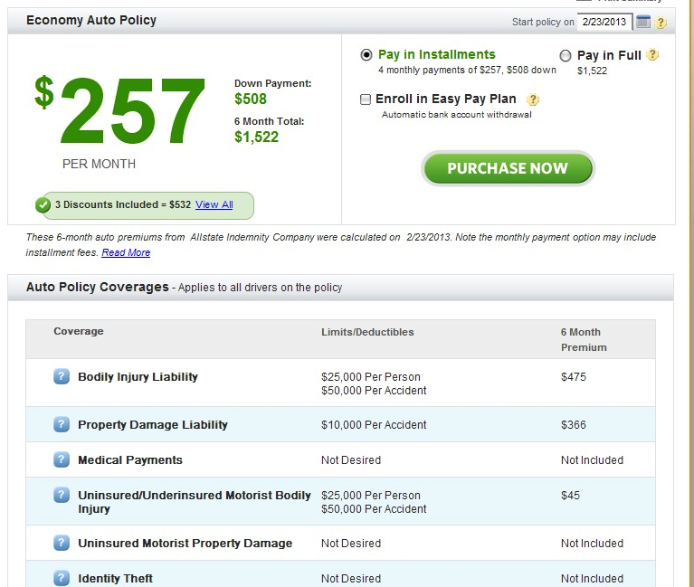

Addiitonal one for calculating car-insurance: [http://www.progressive.com](http://www.progressive.com/) ; 2/23/12 accessed

