Problem 1: 3 input NOR layout

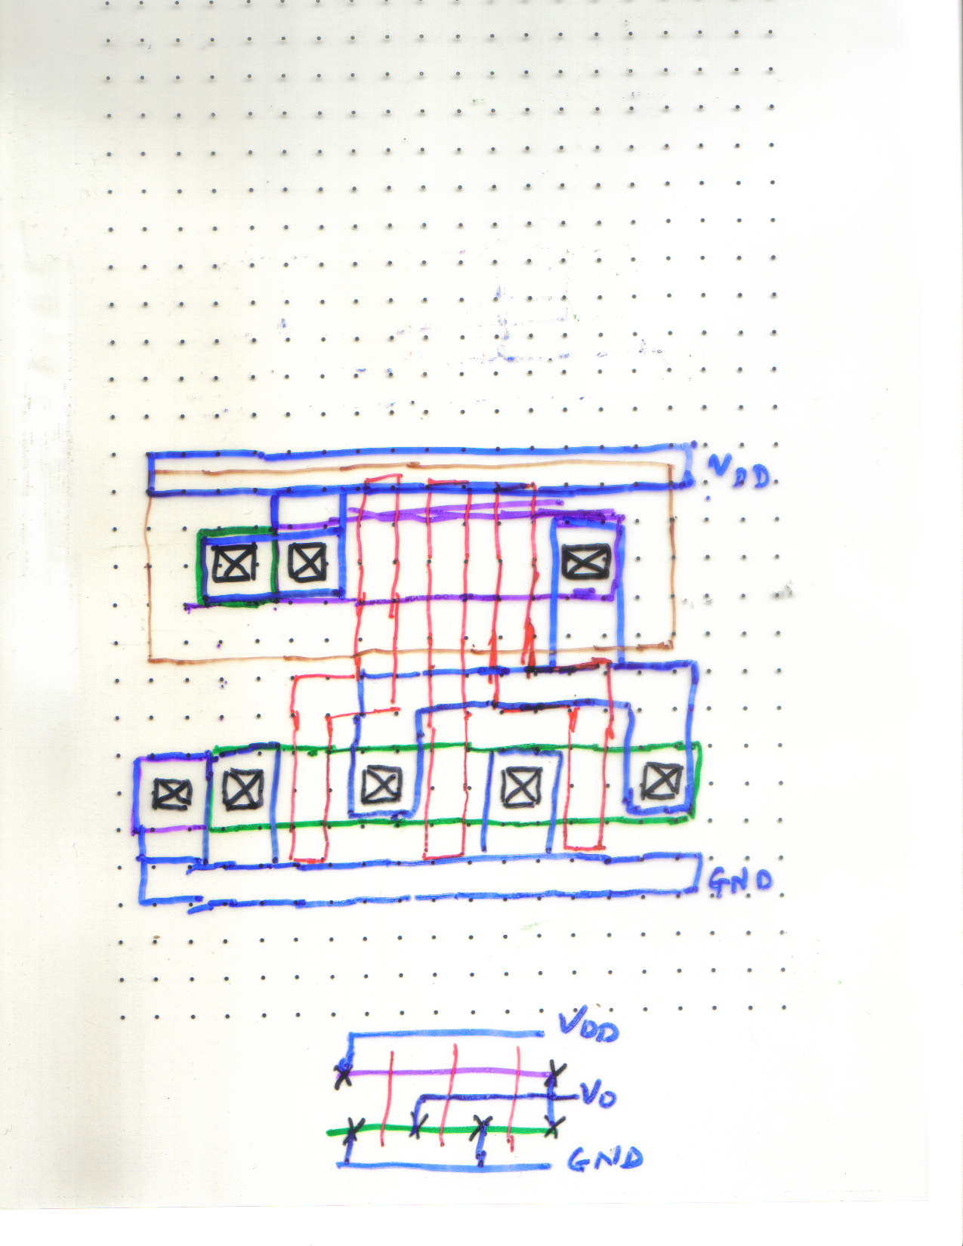

Problem 2:
Normally, the inverter has to drive a load. This could be an external load or loading from inverter’s own diffusion capacitance, capacitance from gates driven or interconnect capacitance. You already know the recipes to find and estimate these capacitances. Due to the presence of this load, a step edge pulse at the input will have rounded edges at the output. The timing quantities fall time t_{f} , rise time t_{r} and delay time t_{d} are defined in the next figure like in the notes.

time
t_{d} (n)
t_{d} (p)
t_{f}
t_{r}
V_{inv}
V_{DD}
0.9 V_{DD}
0.1 V_{DD}
V_{OUT}
0 V
V_{DD}
V_{in}
0 V

Loaded CMOS inverter

D
S
B
D
G
V_{DD}
S
B
G
V_{O}
V_{in}

C_{L}

GND

Initially, when input switches from 0 to V_{DD}, n transistor is turned on as V_{DS} = V_{DD} and V_{GSn} = V_{DD} > V_{tn} for it. At V_{in} = V_{DD}, p channel transistor is totally off. Hence the n-channel device is pulling the output down.

The n-channel device is in saturation if
V_{DS} ≥ (V_{GSn} – V_{tn}) / (1 + δ_{n}),
i.e. 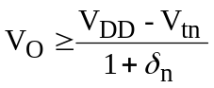
Hence for output voltages from V_{DD} to (V_{DD} – V_{tn}) / (1 + δ_{n}), the n-channel device is in saturation.
For the capacitor this forms the discharge current. If it takes time t_{d1} for the output voltage to fall from V_{DD} to (V_{DD} – V_{tn}) / (1 + δ_{n}), charge balancing yields
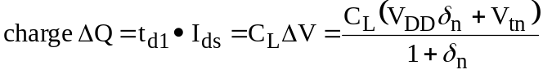,
as the change in capacitor voltage is
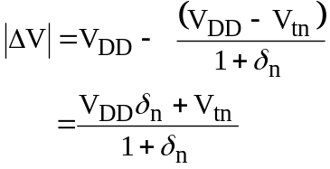
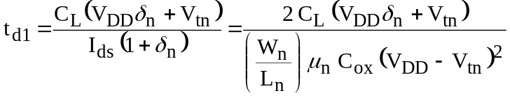
after substituting saturation current expression for the n-channel device current.
For typical V_{tn} = 0.2 V_{DD} and δ_{n} ≈ 0, we have
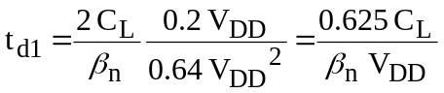
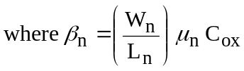
For V_{O} between 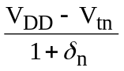 and the switching voltage V_{inv}, the n-channel device is in the linear region. Hence the pull down current (linear region n-channel device current) is a function of V_{O}. Hence we have to integrate incremental delays to get total delay t_{d2} in this region.
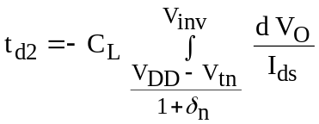
But for any V_{O} in this region,
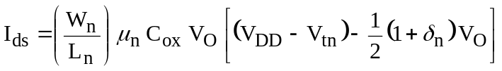
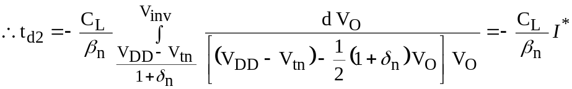
Here 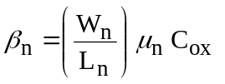.
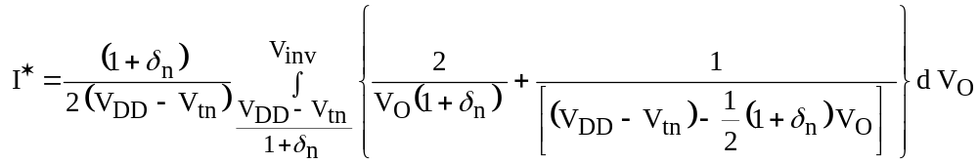
using method of partial fractions.

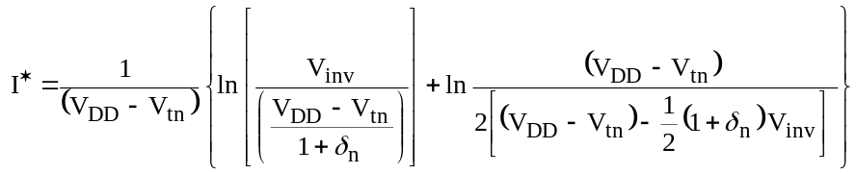
where
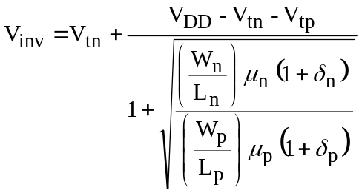
Which can be found by equating saturation currents of the two devices when V_{in} = V_{inv}. Thus, t_{d2} can, in principle be found.

Under simplified assumption that
V_{tn} = 0.2 V_{DD}, V_{inv} ≈ 0.5 V_{DD},
δ_{n} ≈ δ_{p} ≈ 0, we have
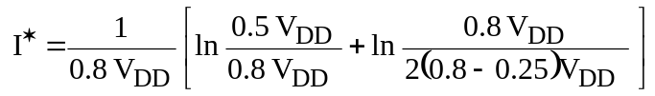
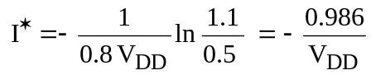
Hence,
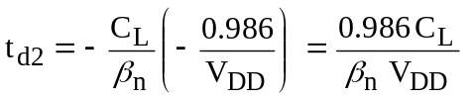

Thus, accurate estimation of load is needed to get the delay. The total delay t_{d} is given by
t_{d} = t_{d1} + t_{d2} = 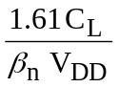
To calculate fall time t_{f}, notice that we need to account for voltage fall from 0.9 V_{DD} to 0.1 V_{DD} for the output voltage. Hence in the first region where 0.9V_{DD} ≤ V_{O} ≤ 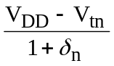 and n-channel device is in saturation, the method for t_{d1} calculation can be applied to give

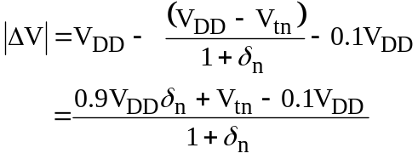
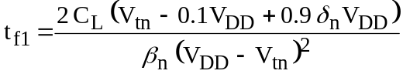
Hence for simplified case of
V_{tn} = 0.2 V_{DD} and δ_{n} = 0, we have
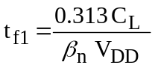
t_{f2} can be calculated with the same technique as that of t_{d2} except for lower limit changing to 0.1 V_{DD} from the switching voltage V_{inv}.
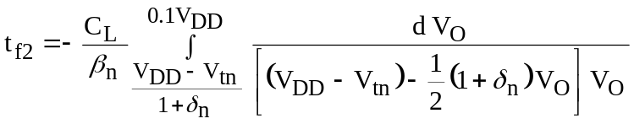
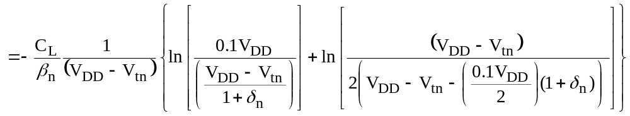
Again for simplified case of
V_{tn} = 0.2 V_{DD} and δ_{n} = 0, we have
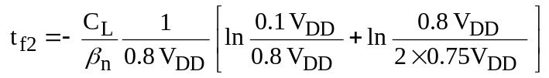
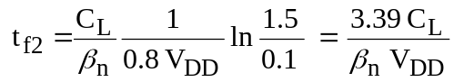
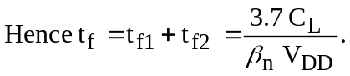
Hence accurate estimation of C_{L} is the key to obtain accurate delay estimation.
The similar expressions can be derived for t_{r} with δ_{n} → δ_{p}, V_{tn} → V_{tp}, V_{inv} → V_{inv}, V_{tp} ≈ -0.2 V_{DD}.
We have 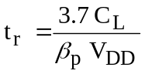.
Hence for equal rise and fall time, 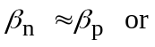
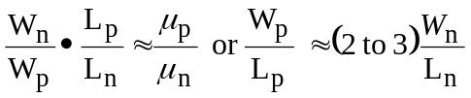
which is a fairly well known result.

Problem 3: From problem 2, t_{d} = t_{d1} + t_{d2} = .
Here C_{L} = 100fF, V_{DD} = 1.5V, .
Also, 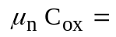1.4mA/V², t_{d} = 10ps. As technology is 65 nm, we expect L = 2λ = 65nm.
Therefore 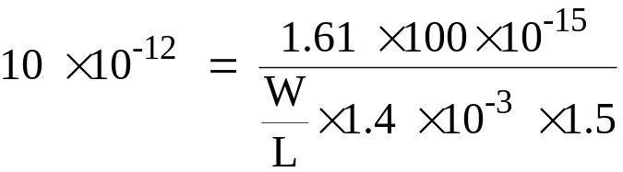. Hence 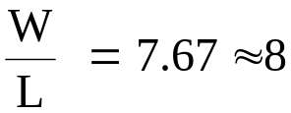as widths are normally restricted to an integer multiple of L in design. Hence W = 520 nm.

To estimate diffusion parasitic, we neglect interconnect capacitance as it is small and in absence of bias, use zero bias to get conservative load value. Both area capacitance and peripheral capacitance that depend on perimeter of the drain needs to be considered. A simple layout will be as shown both transistors.

5λ = 2.5 X 65nm
520nm

Hence Area of drain for each transistor = 0.52 X 2.5 X 0.065 square microns and perimeter = 2(0.52 + 2.5X0.065) micron.
Hence zero bias C
= 2 X 0.52 X 2.5 X 0.065 X0.1 + 2(0.52 + 2.5X0.065)X0.8 + 2(0.52 + 2.5X0.065)X0.9
= 0.0169+2.3205=2.3374 fF which is only a small contribution.
At the input end, the capacitance will be WL*poly over gate area cap
= 2X0.52 X 0.065 X 1.918 = 0.13 fF which is also quite low.

