Cost of maintaining an SUV, for te specific SUV we've selected:
http://www.motortrend.com/cars/2012/ford/escape/hybrid_limited_sport_utility/3044/cost_of_ownership/
Date accessed: 2/23/12

Cars.com, California Averages, 2013, Base 4dr 4x4
http://www.cars.com/ford/escape-hybrid/2012/pricing/
Date accessed: 2/23/12

Oil Price:
http://energyalmanac.ca.gov/gasoline/
Date Accessed: 2/23/12

The links below are used for making assumption of the engineering consulting firm, all Accessed on 24th, Feb, 2012:
BIM Consulting and Services Introduction: http://www.hcseonline.com/bimconsulting.html
HCSE projects: http://www.hcseonline.com/projects.html
Week Day: http://wiki.answers.com/Q/How_many_work_days_are_in_a_year
The BRUI Case Study: http://emp.byui.edu/EarlJ/Structural%20Engineering%20Firm.pdf
The TKJ projects: http://www.tkjse.com/projects.php
The SGE projects: http://www.sgeconsulting.com/projects

Used in Calculating Salvage Value parameters by doing linear regression, all accessed on 24th/Feb/2012
Car Purchase Price:
http://autos.aol.com/cars-Ford-Escape+Hybrid-2012-Base__4dr_4x4/overview/
Avg miles/yr:
www.fhwa.dot.gov/ohim/onh00/bar8.htm
Salvage prices
http://autos.aol.com/used/kbb/Ford/Escape-Hybrid_Sport_Utility_4D/2012/resale-value/

Bank's Loan Rate for buying Automobiles:
URL: https://lfgs.usbank.com/solutions/usbank/goal/financeavehicle
Date of Access: 24 Feb 2013
Info Got:
 | Type of Loan | Rate | APR | Term | Down-  payment | Loan Amount | Monthly Payment
 | 48-Month Auto Loan | 3.87% | 4.34% | 48 | $13,000 | $8,000 | $182 | Apply
 | 36-Month Auto Loan | 3.53% | 4.15% | 36 | $13,000 | $8,000 | $237 | Apply
Your Financing Need:
Type of Financing: New
Price: $21,000
Downpayment: $13,000

Tax caused when buying a new AutoMobiles, can be used for calculating tax rate, as well as the extra-charge when buying a new SUV:
URL: https://www.dmv.ca.gov/wasapp/FeeCalculatorWeb/newVehicleFees.do
Date Accessed: 24th, Feb, 2012

Used for Calculating Car Insurance, From: http://www.allstate.com
Date Accessed: 2/23/12
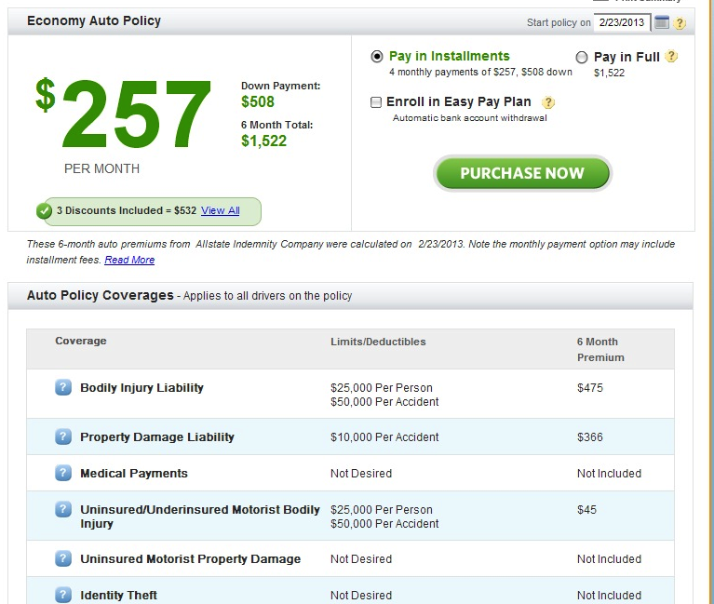

Addiitonal one for calculating car-insurance: http://www.progressive.com ; 2/23/12 accessed
