SSU Data Dash 2026: CatBoosters
Flora Yu, Ben Rudin, Hannah Xu, Caitlin Daley
Video (YouTube, unlisted): https://www.youtube.com/watch?v=96UYkVGed-g
Code and submission files (GitHub): https://github.com/BenIIVVI/datadashstats

Summary
Off-market, we value each home in two parts:
- What it's worth at an average market level, learned with gradient-boosted trees from 52 features.
- Where the market will be in the summer it sells, projected from our own monthly price index.
A last step corrects each estimate by how the model has been missing on nearby homes of the same type. List-aware, we use a weighted ridge regression and CatBoost, trained separately for condos and houses, that combine the list price with the home's features.
On walk-forward validation (December 2025 to May 2026, 10,069 homes), our median absolute percentage error (MdAPE) is 7.31% off-market and 4.19% list-aware, against 17.7% for the organisers' simple baseline. Most of what's left is home quality the data doesn't record, which is why condos are much easier than houses on both tracks.

1. Data and features
We train on the 150,000 sales from January 2021 to May 2026, and predict the 3,974 off-market and 4,064 list-aware test homes, which sold between June and September 2026. Anything only known after a sale (sale price, sale date, days on market, the external AVM) is removed from every home we predict. The off-market model never sees the list price, and days on market from past sales is only used to guess when a home will sell.
Off-market: the market index. First we needed a fair way to compare a 2022 sale with a 2025 sale. So we ran a ridge regression of log price on community × type, size, bedrooms, washrooms, parking and one dummy for each sale month. The month coefficients give us a monthly market level that doesn't depend on which homes happened to sell that month. It peaks in March 2022, ends up about 25% lower by December 2025, and dips from spring into summer every year. We divide every training price by its month's level, so the trees only learn what a home is worth at an average market level, and the index handles time on its own.
Off-market: the 52 features. Each home gets four groups of features:
- The home itself: size (the midpoint if it's given as a range, plus a flag), bedrooms, washrooms, parking, garage, lot frontage, depth and area, type, style, municipality, community, latitude and longitude.
- Same building: earlier sales at the exact same coordinates, as a count and an average adjusted price per sq ft.
- Nearest sales: the median adjusted price per sq ft of the 10 nearest earlier sales of the same type, times this home's size, plus how far away they are.
- Listing text: a ridge regression on TF-IDF word and word-pair counts that predicts how far a home's price per sq ft sits above its community-and-type average, plus 30 SVD topics.
To keep out leakage, a training sale only ever sees sales from earlier months, building stats leave out the sale itself, and training rows get out-of-fold text scores.
List-aware features. The weighted ridge model uses the plain numerical features: list price, location, size, room counts, months since January 2021 and property type, all standardized to mean 0 and standard deviation 1 with scikit-learn's StandardScaler. CatBoost can read raw categories, so it also gets municipality, community, house style, garage type, lot dimensions and community_property, which joins neighbourhood and property type to pick up more specific pricing patterns. We tried adding seasonal features to CatBoost, but MdAPE went up noticeably, so we dropped them.

2. Models
Off-market. We predict the market-adjusted log price, and a sale's weight halves every 12 months, so recent sales count more. The value comes from averaging four histogram gradient-boosting models (scikit-learn): two with 2,000 trees at learning rate 0.025 and two with 800 trees at 0.05. Every leaf holds at least 20 sales, each split tries 30% of the features, and each model has its own seed. On the 2024 summer, one tree on its own misses by 11.1%, and the average of the four misses by 6.85%. Then there are two more steps:
- Market level: we average the projected index over the dates the home is likely to sell (its listing date plus 100 typical times on market from past sales), keeping only the ones inside June to September. For months past May, we take the last level plus the median change for that calendar month in earlier years.
- Local fix: five-fold out-of-fold predictions give an honest miss for every training sale. For a new home, we average the misses of its 5, 10, 20 and 40 nearest earlier sales of the same type, and combine those four averages with weights fitted per property type by ridge regression.
The final price is exp(value + market level + local fix), so the three parts multiply in dollars. For example, one house in the 2024 backtest: $898,771 × 0.990 (the June market) × 1.121 (its area keeps selling above our guesses) = $997,309. It sold for $994,600.
List-aware. Ridge regression predicts the sale price directly, and CatBoost predicts the log of sale price over list price, which we turn back into dollars. Condos (condo apartments, condo townhouses, co-ops) and houses get their own models. For condos we weight the two 50/50; for houses it's 30% ridge and 70% CatBoost. Ridge is good at general price relationships, and CatBoost picks up more complex patterns. Ridge weights each sale by 1 / price³ and CatBoost by (median price / price)^1.5, so cheaper homes count more in training and errors count more evenly in percent.
Why the two models are different. The list price already tells you the current price level and what the seller's agent knows about the home's condition. So the list-aware model only has to learn the gap between sale and list price, and doesn't need a market index or comparable sales. The off-market model isn't allowed to use the list price, so it has to rebuild the value from scratch: the index, the nearest-sale and same-building features, the listing text and the local fix all stand in for what the list price would have told it. That's why its error is about twice as big.

3. Validation
We tested both models two ways, and never with a random split:
- Walk-forward (the numbers we report, both tracks): each month from December 2025 to May 2026 is predicted by a model trained only on sales from before that month, so six full refits per track. The list-aware model uses this same procedure from the starter repository: sale price and sale date are never prediction features, historical prices are only used for training, and validation prices are only used for scoring.
- Summer backtests, which copy the real test: train on sales before June 1, predict June to September. We made every off-market modelling choice on the 2023 and 2024 summers and held 2025 back. We did check 2025 once, and again after the last two changes, so we treat it as a confirmation, not a perfectly clean holdout. We also ran 2021 and 2022 off-market with the final model.

4. Results
Walk-forward, Dec 2025–May 2026 | Homes | MdAPE % (95% CI) | MAPE % (95% CI) | Median signed error %
Off-market | 10,069 | 7.31 (7.14–7.50) | 9.44 (9.28–9.61) | +1.38
List-aware | 10,069 | 4.19 (4.09–4.31) | 5.33 (5.24–5.42) | −0.62
Table 1: Walk-forward validation. Brackets: bootstrap 95% interval (homes treated as independent).
Summer (train before June 1) | 2021 | 2022 | 2023 | 2024 | 2025
Off-market MdAPE / MAPE % | 7.56 / 10.07 | 8.30 / 11.60 | 6.62 / 8.88 | 6.64 / 8.96 | 6.84 / 9.08
Off-market median signed error % | +0.4 | +5.1 | +0.9 | +1.5 | +0.9
List-aware MdAPE / MAPE % |  |  | 5.50 / 6.66 | 5.06 / 6.21 | 4.30 / 5.37
List-aware median signed error % |  |  | +1.2 | +1.4 | +0.8
Table 2: Summer backtests. 2021 had five months of training data; 2022 is the year prices fell fast.
Off-market, the typical miss drops from 17.7% (simple baseline) and 20.8% (the starter's 10 nearest sales) to 7.31%. Validation comes out higher than the summers because March and April 2026 were hard months (7.9% and 7.7%) with prices rising fast; the other four months were 6.8–7.2%. The hidden test is a summer, so we expect about 6.7–7.0% off-market, unless the summer market turns sharply like it did in 2022.
List-aware, MdAPE drops from 7.26% for the list-price baseline to 4.19%, a 3.07-point cut (about 42%), and it stays steady across the six months (4.0–4.4%). Its summers run worse than validation, though (4.3–5.5%, leaning about 1% high), so on the hidden test we expect about 4.5–5% list-aware, not 4.19%. Across all 54,991 off-market predictions made only from earlier sales, 64% land within 10% of the sale price and 89% within 20% (figure 1).
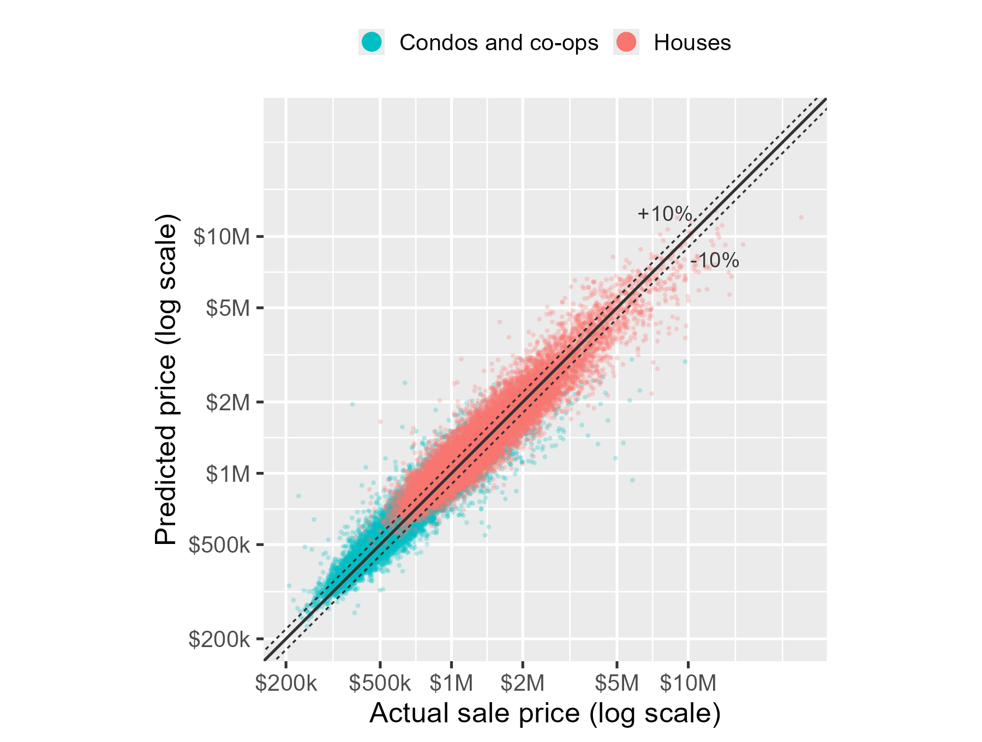
Figure 1: Off-market predicted against actual price for every out-of-sample prediction, log scales. Solid: perfect; dotted: ±10%.

5. Where the model fails
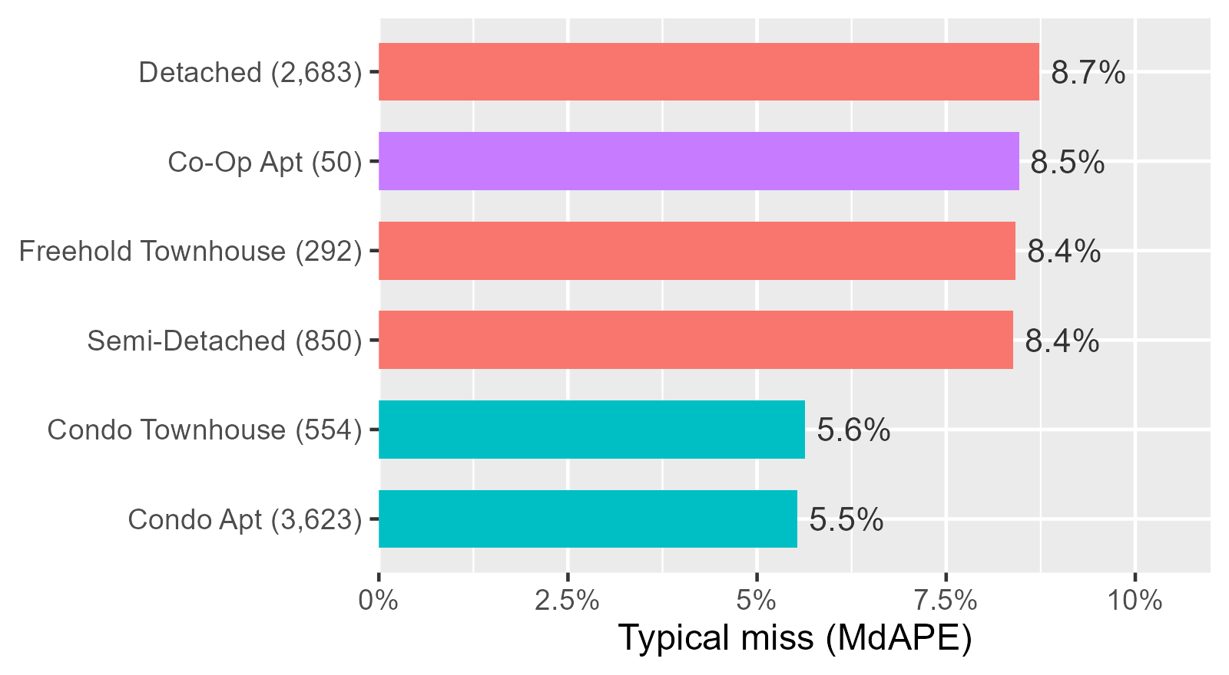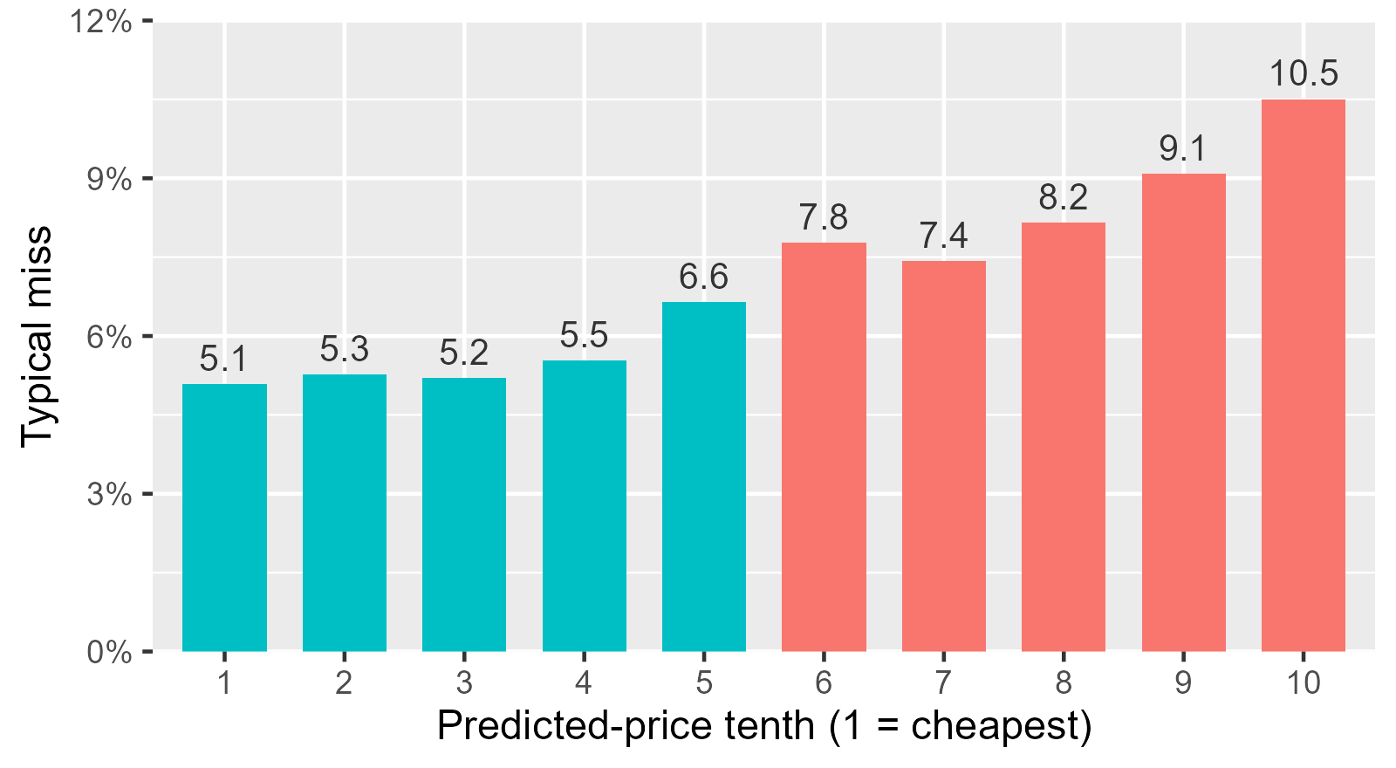
Figure 2: Off-market typical miss on the 2025 summer by property type (homes in brackets) and by tenth of predicted price.
Off-market.
- Type: condos miss by about 5.5%, houses by 8.4–8.7%. Condos in the same building are basically copies, so building history pins them down. Two houses with the same size, rooms and street can still differ in age, renovation, lot and finish, and the data doesn't record any of that.
- Price: the cheapest tenth misses by 5.1% and the most expensive by 10.5%. Expensive homes are rarer, more varied and mostly houses.
- Neighbourhood: across the 97 communities with at least 40 sales in 2025, the typical miss goes from 3.9% (Cedarglen, condos) to 13.5% (Lindencliffe, 73% houses), with the middle half at 6.1–8.0%. It's worse where more sales are houses (correlation 0.39) and where prices are higher (0.43).
- Time: estimates run about 2% high in July and August, when the summer dip goes deeper than we projected, and 5% high in 2022, when prices fell after the spring peak.
How sure we are: we give each estimate an 80% range, from the 10th to 90th percentile of the 2023–24 misses for its property type. It covered 79.5% of the 2025 homes, and it's typically 22.6% of the price wide (about ±11%).
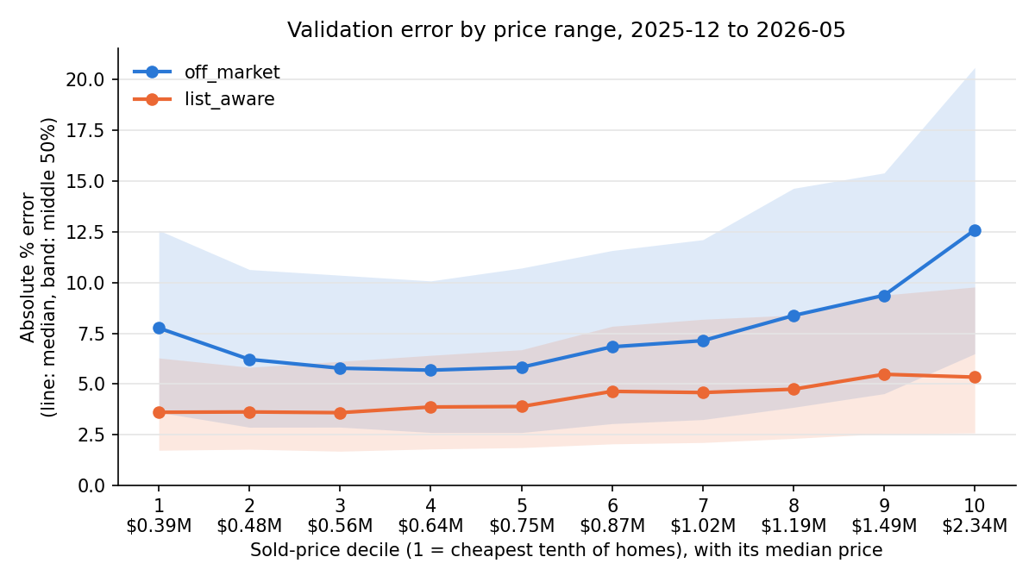
Figure 3: Walk-forward validation error by sold-price decile, both tracks (line: median; band: middle 50%).
List-aware. Condo apartments have the lowest MdAPE at about 3.6%, and semi-detached homes the highest at 5.7%. Condo apartments often share layouts and building features, so they're easier to price, while houses differ more in condition, renovation and location. Errors also tend to be higher for more expensive homes (figure 3), maybe because they have more unusual features, and because training gives cheaper homes more weight. Those are possible explanations; we haven't tested them. The blend should be used with care: ridge tends to predict too low and CatBoost too high, so their average lands closer to the real price.

6. Limitations
What didn't help (off-market, judged on the 2023 and 2024 summers):
- separate indexes for houses and condos (the extra projection noise outweighed the bias it fixed);
- following each community's price trend (trends have autocorrelation −0.41, so they reverse instead of continuing);
- blending in a random forest (9.2% on its own), and separate tree models for houses and condos;
- a fixed summer bias correction (the best shift changed from 0 to 1.75% depending on the year).
For list-aware, seasonal features in CatBoost made it worse.
When not to trust it. Off-market, don't trust it for expensive or unusual houses, thin groups like co-ops (50 test homes in 2025) or rarely traded communities, or a summer when the market turns sharply. List-aware relies on the list price, which can reflect marketing or selling strategy rather than value, and it knows nothing about renovations, staging or foundation condition. Neither model can see a sudden market change coming. Data on age, renovation, floor level and condo fees would help both models most. Next, we'd test condition data and compare sample weights and ridge/CatBoost blend weights on the same validation months, especially for expensive homes.

Outside data
None. We didn't use any outside data or sources.

Reproducing our results
From a fresh copy of the repository: pip install -r requirements.txt (this includes catboost; on its own it's pip install catboost), then python run.py backtest, python run.py validate, python run.py report, python run.py predict and python run.py check. Seeds are fixed, so this rebuilds both submission files exactly.

