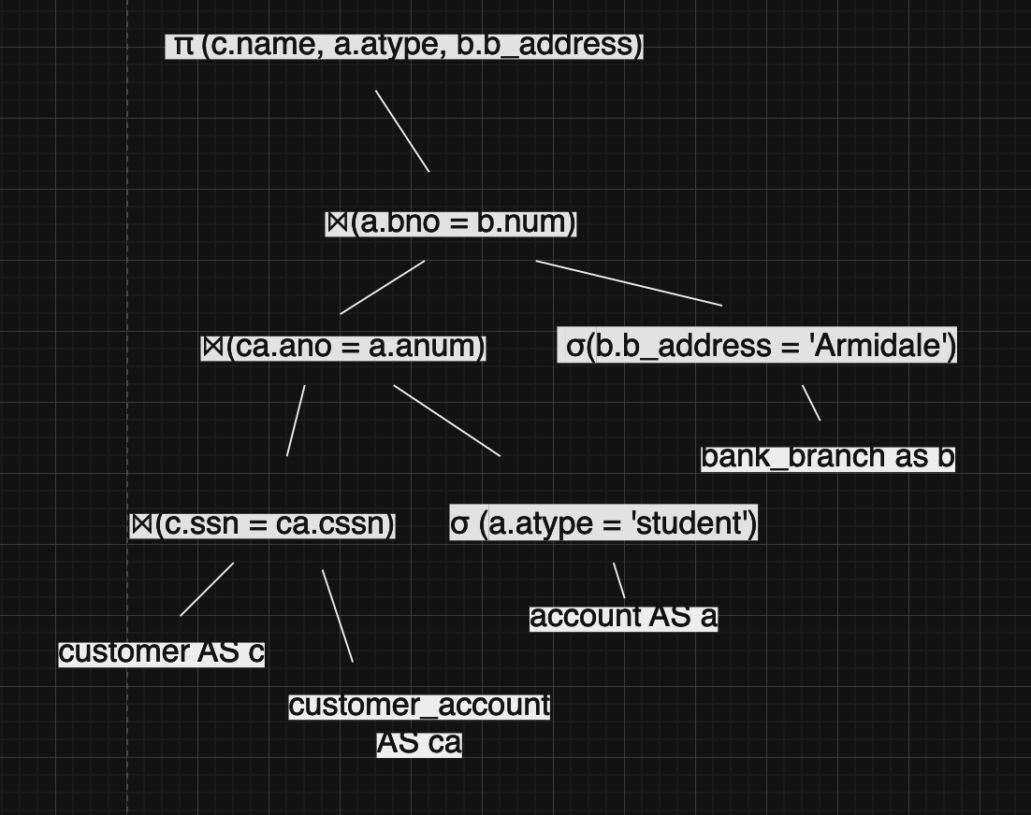

**Step 1 Split selection and move down the tree:**

Split account type and bank address filter statements and moved them down the tree.