**Weekly Sales Report**

**Report Date: 11/08/2024**

**Prepared By: Ben Murarotto**

**For: Senior Management (COSC572)**

1. **Comparative Sales (Revenue) for Each Store**

Store 1: 184k, Store 2: 168k, Store 3: 172k, Store 4: 167k, Store 5: 165k

All of our stores are receiving similar sales numbers however Store 1 is generating the most sales (See barchart 1 in appendix).

1. **Top Five Products for the Store with the Highest Sales**

Looking deeper into Store 1, our 5 best selling products by net sales was Product 1240 at 2.18k, followed by Product 1453 at 1.98k, Product 1126 at 1.86k, Product 1806 at 1.79k and Product 1449 at 1.69k (See barchart 2 in appendix).

1. **Bottom Five Products for the Store with the Highest Sales**

Looking deeper into Store 1, our 5 worst selling products by net sales was Product 1151 at $16.2, followed by Product 1823 at $24.5, Product 1514 at $24.9, Product 1373 at $27.5 and Product 1076 at $30.7 (See barchart 3 in appendix).

1. **Comparative Gross Profit for Each Store**

All stores for the week reached at least 90k in gross profit (See barchart 4 in appendix).

1. **Biggest Trender**

The product with the greatest trend ratio was Product 1659 which improved its day one volume 10.3 times by the end of the week (See barchart 5 in appendix).

Appendix

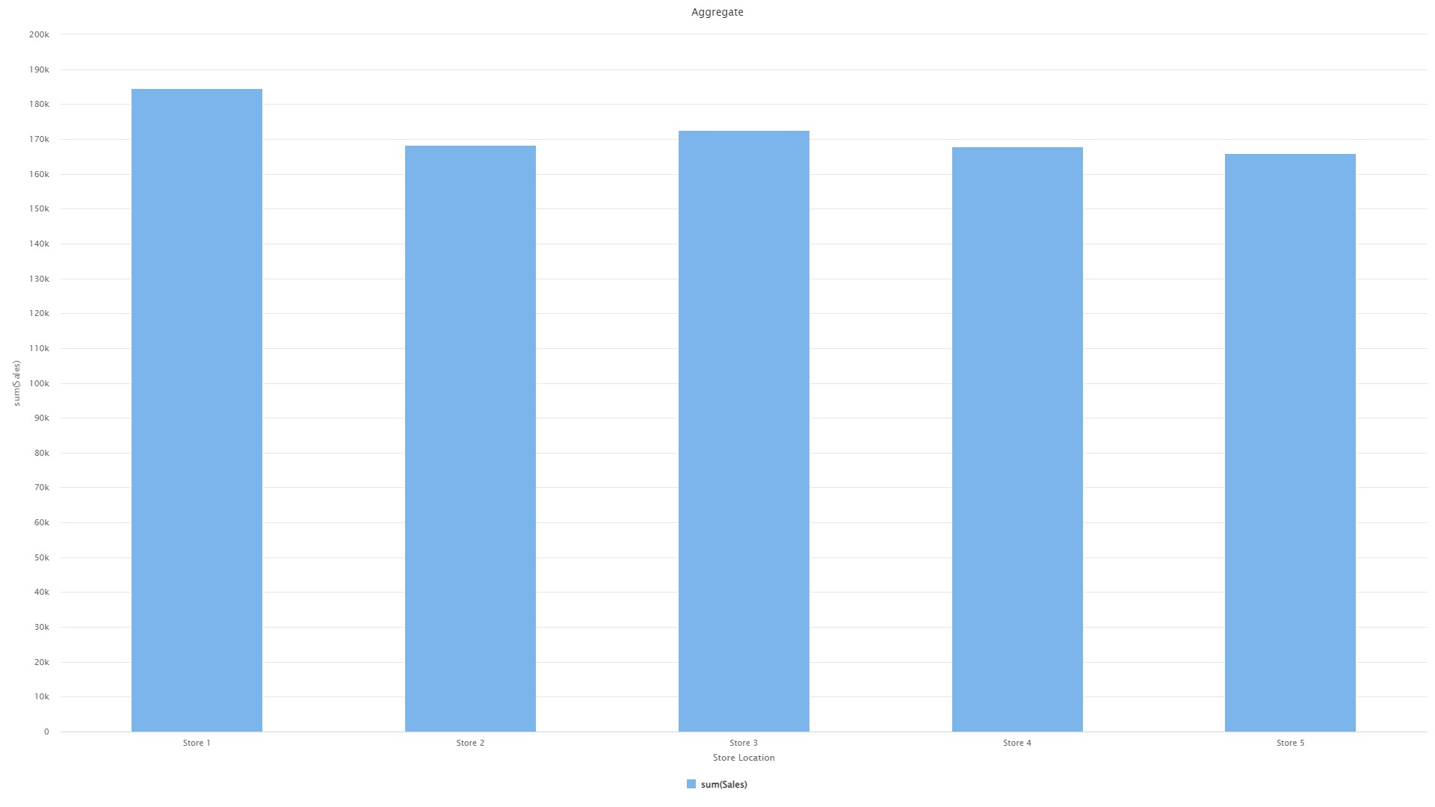

Bar Chart 1 and Process 1

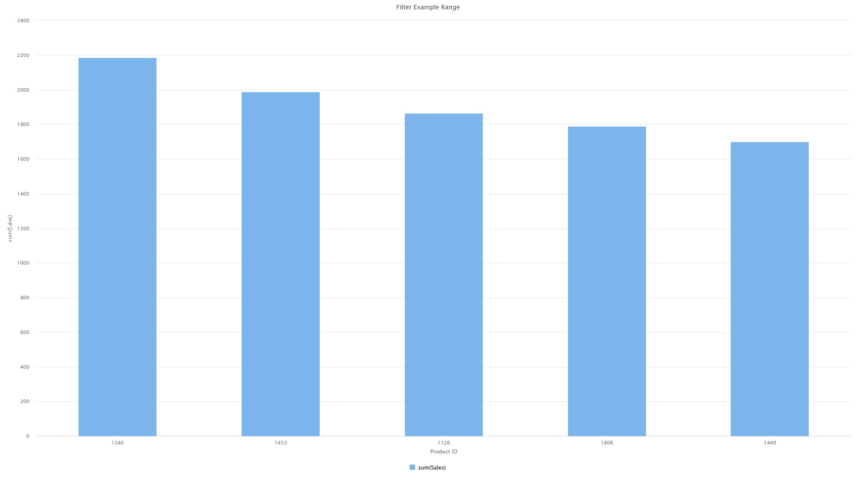

Bar Chart 2 and Process 2

Bar Chart 3 and Process 3

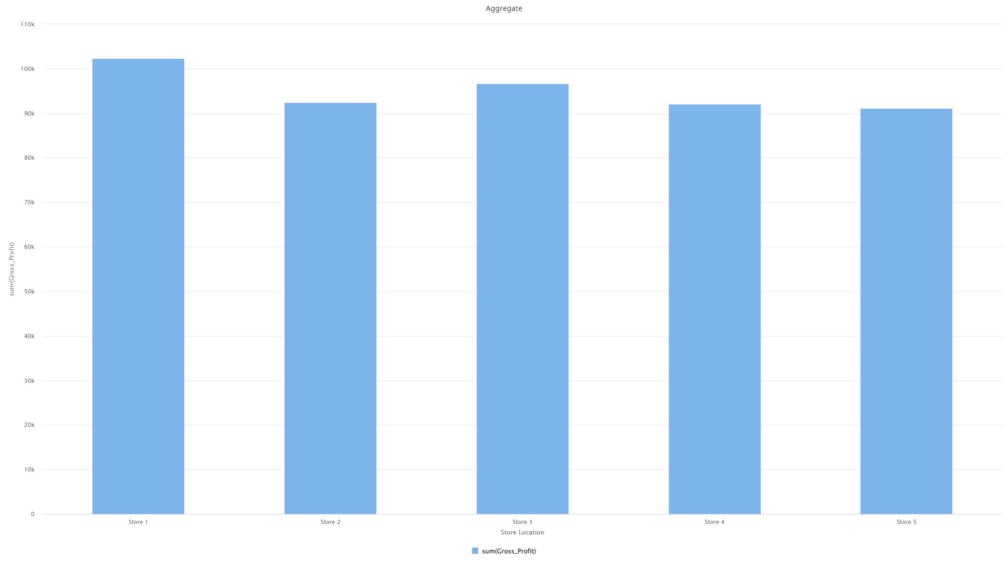

Bar Chart 4 and Process 4

Bar Chart 5 and Process 5