My Name Is Ben Panackal If I Were a Package I’d Be pandas
Benjamin Panackal
2026-09-08
Abstract
An introduction to my personal and professional life
Table of contents

1. Introduction

1.1 Hello it is very nice to meet all of you; I look forward to learning and working with all of you!

1.2 Here is Some General Information About Me
- Name: Benjamin Panackal
- Grade: Sophomore
- Majors: Computer Science and Data Science
- Motivation for taking class:
  - I have an interest in Data Science and Machine Learning
  - I want to contribute to research during my undergrad here at UW Madison.
  - I thought this class would be a good way to pursue my passion and chase my goals
  - I hope to come out of this course knowing how to research and get good at data science

2. More About Me

2.1 My Hobbies
- Physical Activity
  - Playing Volleyball
-  Note
  - I started playing in 6th grade

  - Climbing
- Note
  - I started about two years ago

  - Weightlifting
- Note
  - I started about five years ago

- Everything Else
  - Building CS Projects
- Note
  - I started about a year ago

  - Playing Guitar
- Note
  - I started about a two years ago

  - Hanging Out With Friends
  - Cooking
  - Gaming
    - My preferred game of choice is League of Legends
-  Important
  - I hit masters this summer and swore to stop playing

2.2 My Background

2.2.1 Where I’m from:
Burlington, Wisconsin

2.2.2 Where’s my family from:
Kerala, India

3. My Professional Career

3.1 Classes

3.1.1 My highest completed stats course at UW Madison is STAT240

3.1.2 My highest completed computer science course at UW Madison is CS400

3.2 My Links

3.2.1 My Github

3.2.2 My LinkedIn

4. What Python Library Describes Me?

4.1 Pandas
I identify with the pandas library (McKinney 2010) because, like pandas, I strive to organize and clarify data. Pandas provides tools for manipulating structured data, and I believe in bringing structure and clarity to complex problems as well as tidyness.
_{Source: Article Notebook}
Table 1: Student data before and after cleaning with pandas
Raw Data (with issues):
Student Math_Score Science_Score GPA
0 Alice 85.0 78 3.5
1 Bob 90.0 82 3.8
2 NaN 88.0 85 3.6
3 Diana NaN 88 3.7
4 Eve 92.0 91 3.9
Missing value counts:
Student 1
Math_Score 1
Science_Score 0
GPA 0
dtype: int64
Cleaned Data:
Student Math_Score Science_Score GPA Average_Score
0 Alice 85.0 78 3.5 81.5
1 Bob 90.0 82 3.8 86.0
2 Eve 92.0 91 3.9 91.5
As shown in Table 1, pandas easily handles data cleaning by removing incomplete records and adding calculated columns. This demonstrates how I approach problems: identifying issues, removing insignificant details, and deriving meaningful insights.
_{Source: Article Notebook}
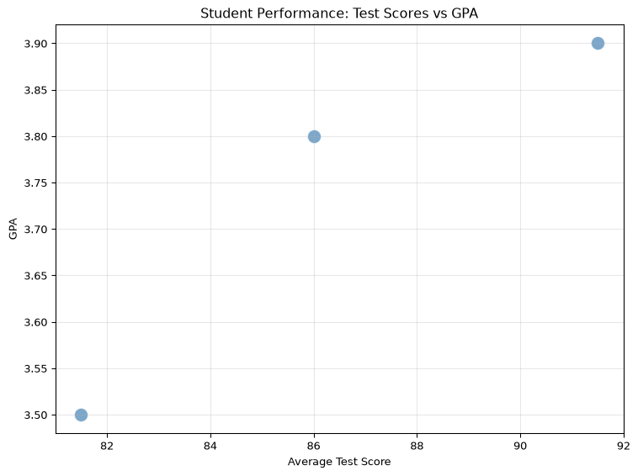
Figure 1: Relationship between GPA and average test scores
_{Source: Article Notebook}
The visualization in Figure 1 shows the strong correlation between academic performance metrics, illustrating how organized data reveals patterns that raw, messy data obscures.
_{Source: Article Notebook}
McKinney, Wes. 2010. “Data Structures for Statistical Computing in Python.” Proceedings of the Python in Science Conference, 56–61. https://pandas.pydata.org/.

By: Ben Panackal

