Presented by: Old But Gold Development

Tuesday, May 7, 2019

Vision document for:

Macro Welding Supply System



Contents

Problem Statement: 2

Stakeholders Analysis: 3

Stakeholders (Primary/Internal) 3

High Level Requirements: 4

Scope: 4

In Scope 4

Out of scope 4

Candidate use case names: 4

Use Cases Diagram: 5

Risks List: 6

Non-Functional Specs: 7

Constraints: 7

Appendices 7

# 

Macro Welding Supply is a top market player in retailing welding supplies to contractors. Macro Welding Supply has 40 office spaces around the region with 1000 employees.

# Problem Statement:

# 

The Problem of: Using outdated paper system to keep track of their payroll, purchase orders, and employee information.

Affects: HR, supervisors and employees

The impact of which is: Effort and time wasted on keeping track of information. Lost of information. Company is wasting money on time wasted when searching for information. Purchase orders often get lost or stay at the bottom of the pile.

A successful solution would be: to create a database to keep track of the information, an application where an employee can fill out a purchase request and have it sent to their manager. This application will also keep track of contact information with an easy to use search function. The system will also streamline the payroll system for the company and instigate direct deposits for all employees and generate electronic pay stubs.

# Stakeholders Analysis:

## Stakeholders (Primary/Internal)

|  |  |  |
| --- | --- | --- |
| Role | Nominations | Responsibility |
| Presidents | Bonnie and Callie | Run the business and make decisions. Has final say on everything. |
| HR Employee |  | Change employee’s information and add new employee. |
| Supervisor of Finances |  | Handles finances of the company and oversees the employee’s pay systems. Generate payroll bi-weekly |
| Supervisors |  | processing purchase orders requests |
| Finances employee |  | Change some of the employee’s payment information like their bank information and salary. |
| Employee |  | Search Contact info of other employees and update some of their information. |
| Purchase department |  | Purchase items from approved purchase order and report on what has been bought or any issues during the process. |

## Stakeholders (Second/External)

|  |  |  |
| --- | --- | --- |
| Vendors |  | Handle wholesale of wielding supply and equipment. |
| Customer |  | Purchases welding supplies and equipment from macro wielding. |

# High level Requirements:

* Store employee information in a database
  + Includes employee information and contact information.
* Digitise purchase orders
* Digitise payments

# Scope:

## In Scope

* Creating a program to digitise purchase orders.
* Digitise payments and eliminate physical payments.
* Creating a digital storage and a program to access employee information and contact lines with an easy to use search option.

## Out of scope

* Hire a dedicated barista to keep morale up.
* Make online purchases
* Implement chat system inside our service
* Allow users to send emails directly from the system
* Allow users to sign up with their social networks
* Make calculations of week/month/year money spend for the purchases

# Candidate use case names:

* Add new employee H
* Modify employee record H
* Delete employee record H
* Generate payroll H
* Manage pay info H
* Create purchase order H
* Modify Purchase order H
* Search trough PO M
* Search employee contact L

# Use cases diagram:

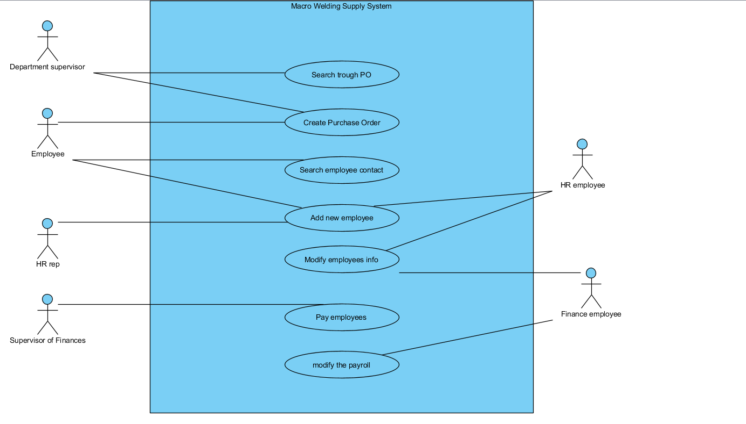

# Risks List:

|  |  |  |  |  |
| --- | --- | --- | --- | --- |
| Rank | Risk Description | Contact Person | Reduction strategy | Reduction Progress |
| 1 | Technical difficulties with current tech |  | Research compatibility of programs with store-owned hardware. | N/A |
| 2 | Not enough funds to create all crucial features of the project |  | Create budget plan. | N/A |
| 3 | Employees technical knowledge to start using newly created system |  | Teach employees how to use the new software. | N/A |
| 4 | Unforeseen staffing or resources issues |  | Adding buffer time to the work plan. | N/A |
| 5 | hardware wont support the volume of load for the system |  | Have a “safety net” to be able to afford handling unforeseen hardware issues. | N/A |
| 6 | project team understaffed |  | Hire new employees or outsource. | N/A |
| 7 | Project team might lack skills to perform certain tasks |  | Outsourcing to other company. | N/A |
| 8 | Problem with transfer of data |  | Can be handled by dedicating an employee to it. | N/A |

# Non-Functional Specs:

Operating System: Windows 10 for user terminals

Scalability: Should be able to accommodate up to 5000 employees.

# Constraints:

The maximum total budget is $30,000 with a strict deadline for rollout of June 12.

Glossary – see appendix A

Business Rules – see appendix B

Use Case Skeletons – see appendix C