Summary memo

From initial interview

|  |
| --- |
| Macro Welding Supply |

|  |  |
| --- | --- |
| To: | Bonnie Ryan, VP |
| From: | Old But Gold Development |
| CC: |  |
| Date: | 2019-05-01 |
| Re: | Summary of information from initial interview. |
|  |  |

* We at Old But Gold Development met with Bonnie Ryan, VP of Operations to discuss the technological requirements of Macro Welding Supply. Thank you for your time and input.
* Currently the Macro Welding Company is using primarily a paper system for payroll, purchase orders, and employee information. We met to discuss the design of an application and database to automate and digitize this process.
* All employees information should be stored in a database. All their personal info, such as phone and address will be included as well as pay information.
* Different employees of the company will have different levels of authorization to the data in the database through the application. HR and department supervisors will have full access to all info, but others will only be able to access the employee directory, which will just include the necessary contact information.
* Employees will be able to change their basic personal information, but not their work phone or email or SIN. Any changes necessary to the restricted fields will be handled by HR.
* The employees should have an ID#.
* Purchase orders will be accessed and filled out digitally by any employee and submitted to their department supervisor. The PO will be in a pending state. While in a pending state, the employee will have the ability to check on the status of the PO. The supervisor will approve or deny each item putting the PO in a closed state. The system will notify the employee as to the decision and approved purchases will be sent to the purchasing department.
* Purchase order will have a “location” field added. Employee will enter a suggested location where the item can be purchased and the price listed for that item. The supervisor can decide to buy the item or an alternate item at that location, or may choose a different location.
* Purchase order will have certain fields auto-populated when the user logs in.
* Any further questions about purchase orders will be directed to Janice Brown.
* Pay information will be automated. The Supervisor of Finances will run the pay system bi-weekly on Friday. Employees will be paid with direct deposits, eliminating cheques. Pay stubs will be pdf documents stored on the system. The employee will receive an email with a link to the pdf. We will interview someone from finance at a later date to learn further information.

Thank you again for your time. If you have any questions or clarifications about this information, please feel free to contact us.

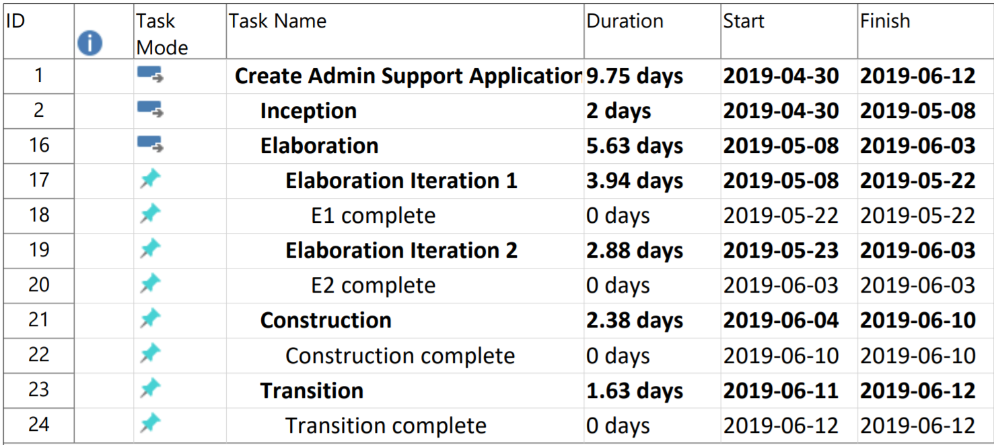Phase Plan

Inception Iteration plan

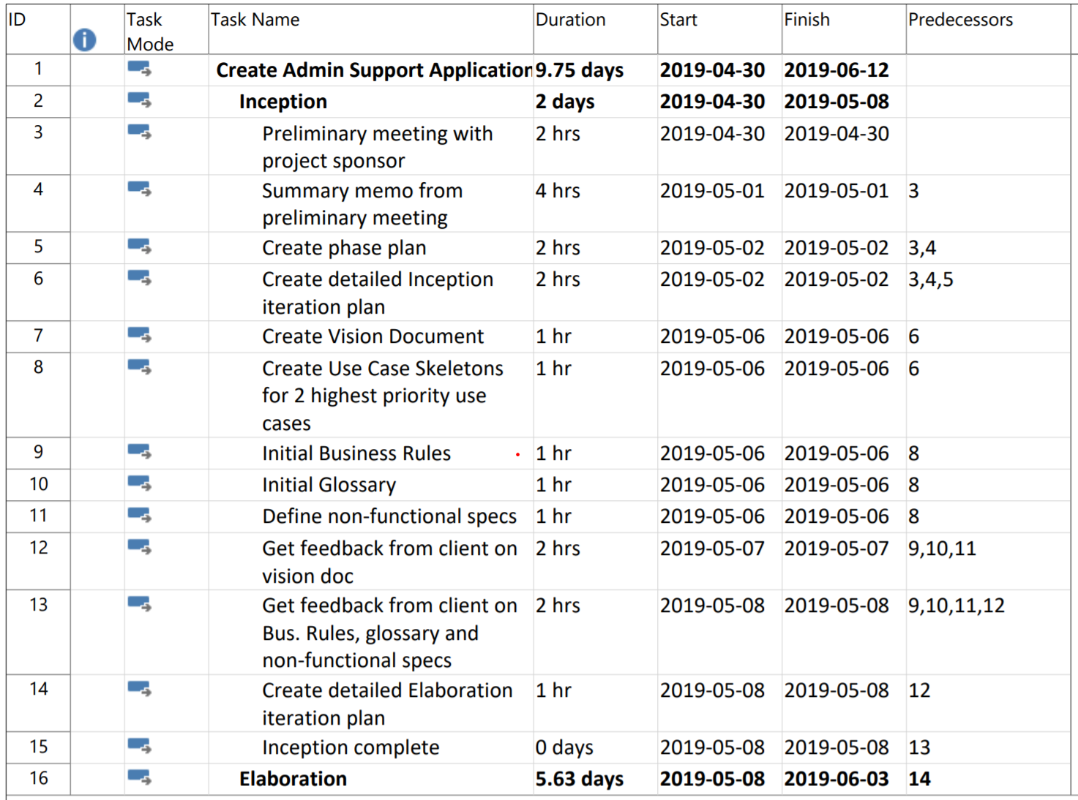

Mathieu Richardson

Tuesday, May 7, 2019



Contents

Problem Statement: 2

Stakeholders Analysis: 3

Stakeholders (Primary/Internal) 3

High Level Requirements: 4

Scope: 4

In Scope 4

Out of scope 4

Candidate use case names: 4

Use Cases Diagram: 5

Risks List: 6

Non-Functional Specs: 7

Constraints: 7

Appendices 7

# 

Macro Welding Supply is a top market player in retailing welding supplies to contractors. Macro Welding Supply has 40 office spaces around the region with 1000 employees.

# Problem Statement:

# 

The Problem of: Using outdated paper system to keep track of their payroll, purchase orders, and employee information.

Affects: HR, supervisors and employees

The impact of which is: Effort and time wasted on keeping track of information. Lost of information. Company is wasting money on time wasted when searching for information. Purchase orders often get lost or stay at the bottom of the pile.

A successful solution would be: to create a database to keep track of the information, an application where an employee can fill out a purchase request and have it sent to their manager. This application will also keep track of contact information with an easy to use search function. The system will also streamline the payroll system for the company and instigate direct deposits for all employees and generate electronic pay stubs.

# Stakeholders Analysis:

## Stakeholders (Primary/Internal)

|  |  |  |
| --- | --- | --- |
| Role | Nominations | Responsibility |
| Presidents | Bonnie and Callie | Run the business and make decisions. Has final say on everything. |
| HR Employee |  | Change employee’s information and add new employee. |
| Supervisor of Finances |  | Handles finances of the company and oversees the employee’s pay systems. Generate payroll bi-weekly |
| Supervisors |  | processing purchase orders requests |
| Finances employee |  | Change some of the employee’s payment information like their bank information and salary. |
| Employee |  | Search Contact info of other employees and update some of their information. |
| Purchase department |  | Purchase items from approved purchase order and report on what has been bought or any issues during the process. |

## Stakeholders (Second/External)

|  |  |  |
| --- | --- | --- |
| Vendors |  | Handle wholesale of wielding supply and equipment. |
| Customer |  | Purchases welding supplies and equipment from macro wielding. |

# High level Requirements:

* Store employee information in a database
  + Includes employee information and contact information.
* Digitize purchase orders
* Digitize payments

# Scope:

## In Scope

* Creating a program to digitise purchase orders.
* Digitise payments and eliminate physical payments.
* Creating a digital storage and a program to access employee information and contact lines with an easy to use search option.

## Out of scope

* Hire a dedicated barista to keep morale up.
* Make online purchases
* Implement chat system inside our service
* Allow users to send emails directly from the system
* Allow users to sign up with their social networks
* Make calculations of week/month/year money spend for the purchases

# Candidate use case names:

* Add new employee H
* Pay employees H
* Create purchase order H
* Modify pay info M
* Modify employee record M
* Archive employee record M
* Modify Purchase order L
* Search through PO L
* Search employee contact L

# Use cases diagram:

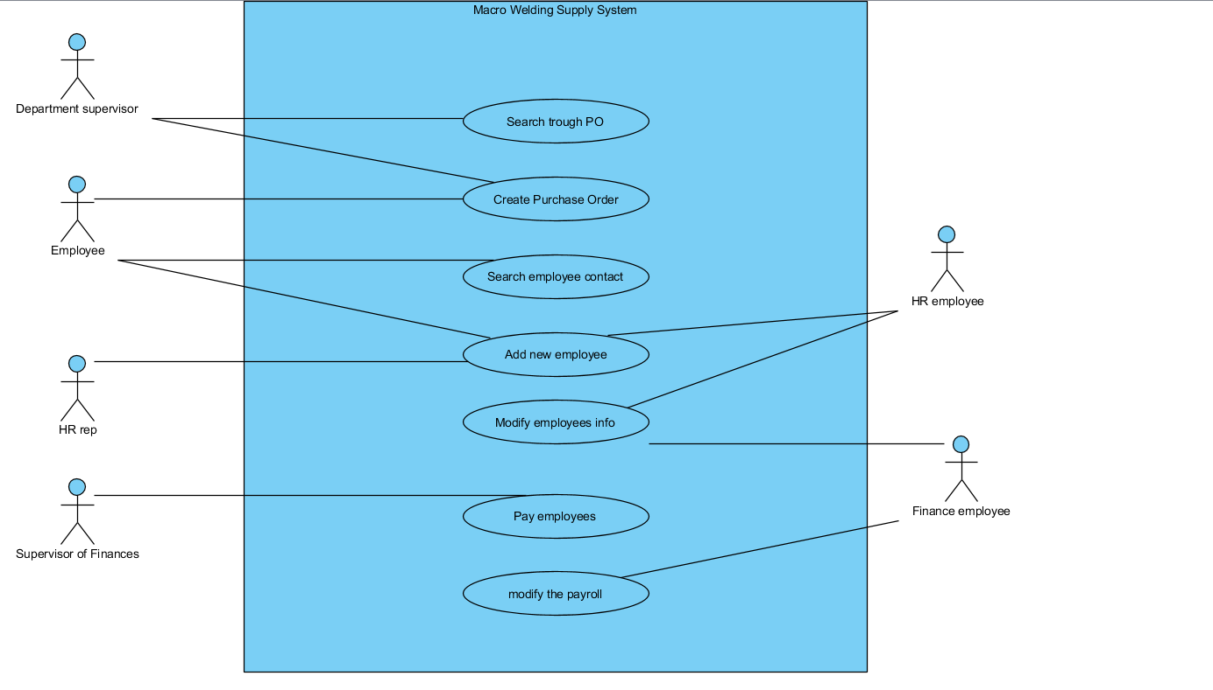

# Risks List:

|  |  |  |  |  |
| --- | --- | --- | --- | --- |
| Rank | Risk Description | Contact Person | Reduction strategy | Reduction Progress |
| 1 | Technical difficulties with current tech |  | Research compatibility of programs with store-owned hardware. | N/A |
| 2 | Not enough funds to create all crucial features of the project |  | Create budget plan. | N/A |
| 3 | Employees technical knowledge to start using newly created system |  | Teach employees how to use the new software. | N/A |
| 4 | Unforeseen staffing or resources issues |  | Adding buffer time to the work plan. | N/A |
| 5 | hardware wont support the volume of load for the system |  | Have a “safety net” to be able to afford handling unforeseen hardware issues. | N/A |
| 6 | project team understaffed |  | Hire new employees or outsource. | N/A |
| 7 | Project team might lack skills to perform certain tasks |  | Outsourcing to other company. | N/A |
| 8 | Problem with transfer of data |  | Can be handled by dedicating an employee to it. | N/A |

# Non-Functional Specs:

Operating System: Windows 10 for user terminals

Scalability: Should be able to accommodate up to 5000 employees.

# Constraints:

The maximum total budget is $30,000 with a strict deadline for rollout of June 12.

Glossary – see appendix A

Business Rules – see appendix B

Use Case Skeletons – see appendix C

# Macro Welding Supply System – Appendix A

# Glossary

Employee Directory – scaled down version of the full employee database with only the name, work phone, and work email.

HR – Human Resources

PO – Purchase Order

PO request – Purchase Order Request – an electronic form that can be filled out and submitted by an employee requiring new equipment or materials. This document may have multiple lines or ‘it

PO items – Purchase Order Items – each individual line on a purchase order request form.

# Macro Welding Supply System – Appendix B

# Business Rules:

**001 – Employee Information Required**

**Date Discovered: April 30, 2019, updated May 13, 2019**

**Category: Structural Fact Type: Static**

**Description:**

An employee of Macro Welding must provide the company with their full name, SIN, banking info, home address, personal phone number and personal email and a photo.

**Discovery Details:**

Interview with project sponsor: Bonnie Ryan

**002 – Purchase Order Submission Process**

**Date Discovered: April 30, 2019, Updated May 13, 2019**

**Category: Structural Fact Type: Static**

**Description:**

An employee of Macro Welding wishing to have any material or equipment purchased on their behalf, must fill out an electronic PO on the system. The PO will go to their department supervisor in a ‘pending’ state. The employee cannot see the decision(s) until the entire PO is closed. The employee cannot change an item that the supervisor has already decided on.

**Discovery Details:**

Interview with project sponsor: Bonnie Ryan

**003 – Employee Information Updating/Editing**

**Date Discovered: April 30, 2019, updated May 16, 2019**

**Category: Structural Fact Type: Static**

**Description:**

An employee can edit their own basic personal information: personal phone number, address, personal email.

If an error has been made in the entry of an employee’s name, date of birth, SIN or banking information, that must be updated by an HR rep.

Only an HR rep is authorized to change an employee’s name, date of birth, work phone, work email, or office location.

Only finance department employees can add pay bonuses or change salary.

**Discovery Details:**

Interview with project sponsor: Bonnie Ryan

**004 – Levels of Authorization to Data**

**Date Discovered: April 30, 2019, updated May 13, 2019**

**Category: Structural Fact Type: Static**

**Description:**

Different employees of Macro Welding have different levels of authorization to the company database.

Standard employees can create purchase order requests, view their pending purchase orders, search the employee directory for employees’ contact information, and change their own basic contact info.

HR employees have full access to all info, but others will only be able to access the employee directory, which will just include the necessary contact information.

Finance department employees can create and modify payroll info.

Finance department supervisor can run the payroll system.

Department Supervisors can process purchase orders.

Only HR employees can archive a record of an employee after employment ceases.

**Discovery Details:** Interview with project sponsor: Bonnie Ryan

**005 – Employee Pay**

**Date Discovered: April 30, 2019, updated May 13, 2019**

**Category: Structural Fact Type: Static**

**Description:**

Employees of Macro Welding will be paid every 2nd Friday by direct deposit into their bank account. This process is administrated by the Supervisor of Finances. In the case of the Supervisor of Finances unable to perform the task, another executive (the CEO or the CFO) will know the passcode and run the payroll system. The employees will receive a notification of pay with a link to a digital pay stub.

**Discovery Details:**

Interview with project sponsor: Bonnie Ryan

**006 – Purchase Order Approval Protocol**

**Date Discovered: April 30, 2019, updated May 13, 2019**

**Category: Structural Fact Type: Static**

**Description:**

Departmental Supervisors of Macro Welding may approve items on purchase orders at their discretion according to their own departmental budgets. They may approve the purchase of the items at the suggested location or an alternate location. They may also approve the purchase of an alternate item to the one requested. The Supervisor may approve a different quantity than was requested. Each item will have a status of ‘pending’, ‘approved’, or ‘denied’. Supervisors must give a reason for any denial. Supervisors must give a reason for any change in quantity.

When a supervisor looks in the system for pending PO, they will see the oldest first, but they are not obliged to process the oldest first. They can filter by date or by employee.

**Discovery Details:**

Interview with project sponsor: Bonnie Ryan

**007 – Archival of Employee Records**

**Date Discovered: May 13, 2019**

**Category: Structural Fact Type: Static**

**Description:**

When an employee of Macro Welding ceases their employment, their records of personal information and pay will be archived in the system. This process will be performed by the HR department. Their information will no longer be searchable by other employees. They will be removed from payroll. An archived record can be reactivated.

**Discovery Details:**

Interview with project sponsor: Bonnie Ryan

# Macro Welding Supply System – Appendix C

# Skeleton Use Cases

Use Case - Add New Employee

Iteration I1.

Version 1.0

Date: 2019-05-06

Priority: High

Description/Overview:

An HR rep wishes to enter all the new employee’s information into the system. The new employee provides the HR rep with all necessary information. The HR rep provides the system with all the new employee’s information, and the new employee is added to the directory. The employee is assigned a unique identifier. The employee is added to the company payroll.

Actors:

* HR rep
* New employee

Pre-conditions:

* The HR rep must be logged on to Macro Welding system.
* The new employee must have all personal info available including SIN, banking account #, and personal contact info.

Use Case - Pay employees

Iteration I1

Version 1.0

Date: 2019-05-06

Priority: High

Description/Overview:

The supervisor of finances wishes to pay all company employees. The supervisor runs the automated pay system and the funds are electronically sent to all the various bank accounts of the employees. The system generates a digital pay stub for each employee and stores them. The system sends a notification of pay to each employee with a link to their digital pay stub.

Actors:

* Supervisor of finances

Pre-conditions:

* The supervisor of finances must be logged on to the Macro Welding system.
* The system has all the necessary banking information for the employees.
* The system has the salary stored for each employee.

Use Case - Create purchase order

Iteration: l1

Version: 1.0

Date: 2019-05-06

Priority: High

Description/Overview:

An employee wishes to create a purchase order. The employee opens a template and fill in all required fields like: Item name, Quantity, Description, Justification. The employee submits it to his/her department supervisor for review. The purchase order’s status is ‘pending’. While in a ‘pending’ state, the employee will have the ability to check on the status of the PO. The supervisor will approve or deny each item putting the PO in a closed state. The system will notify the employee as to the decision and approved purchases will be sent to the purchasing department.

Actors:

* Supervisor
* Employee

Pre-conditions:

* The employee and supervisor must be logged on to the Macro Welding system.

E1 Use cases:

Use Case - Add New Employee

Iteration E1.

Version 3.0

Date: 2019-05-08

Priority: High

**Description/Overview:**

An HR rep wishes to enter all the new employee’s information into the system. The new employee provides the HR rep with all necessary information. The HR rep provides the system with all the new employee’s information, and the new employee is added to the directory. The employee is assigned a unique identifier. The employee is added to the company payroll.

Actors:

* HR rep
* New employee

Pre-conditions:

* The HR rep must be logged on to Macro Welding system.
* The new employee must have all personal info available including SIN, banking account #, and personal contact info.

**Typical course of events:**

This use case begins with a new employee being hired.

1. The new employee provides HR with the required information: First name, Last name, Middle Name or Middle Initial, Address, City, State/Province , Country, Postal Code, bank account #, personal email, personal phone number, SIN, and photo. *001
2. HR creates a work phone number and work email address for the new employee. *003
3. HR logs in into the system and go to add new employee section. *004
4. HR creates new employee profile and enters all the provided information into it as well as generated phone number and email.
5. HR saves employee profile info into the system
   1. System response: Data is valid and message is displayed that new employee is added to the system
   2. System sends employee an email with auto generated credentials to enter into the system
   3. System automatically adds employee into company payroll

**Alternative course of events:**

Line 4 – Information doesn’t follow the examples provided. The user is prompted to retry.

Line 4 – not all the required information is provided and new employee profile has status pending without moving to Line 5. The use case ends without the new employee being added to the system.

Line 5 - Information that is provided is not valid. The user is prompted to retry.

**Business rules application:**

001 – Employee Information Required

003 – Employee Information Updating/Editing

004 – Levels of Authorization to Data

**Use Case - Create purchase order**

**Iteration: E1**

**Version: 3.0**

**Date: 2019-05-09**

**Priority: High**

**Description/Overview:**

An employee wishes to create a purchase order. The employee opens a template and fill in all required fields like: Item name, Quantity, Description, Justification. The employee submits it to his/her department supervisor for review. The purchase order’s status is ‘pending’. While in a ‘pending’ state, the employee will have the ability to check on the status of the PO. The supervisor will approve or deny each item putting the PO in a closed state. The system will notify the employee as to the decision and approved purchases will be sent to the purchasing department.

**Actors:**

* Supervisor
* Employee
* Purchasing department

**Pre-conditions:**

* The employee and supervisor must be logged on to the Macro Welding system.

**Typical Course of Events:**

The use case begins when an employee of Macro Welding wishes to create a purchase order request.

1. The employee opens up the electronic purchase order form. *002

**System Response** – the form is auto-completed with the employee’s name, department, date, and supervisor name.

1. The employee enters all the necessary information.
2. When finished, the request is automatically forwarded to the department supervisor

**a. System Response** – The system confirms that the PO has been submitted.

**b. System Response** – The system indicates that the PO is in a ‘pending’ state.

1. The supervisor receives the PO and reviews it.
2. The supervisor approves or denies each item (giving a reason for any denial) and closes the PO. *006

**a. System Response** – any approved items are sent to the purchasing department.

**b. System Response** – the submitting employee is notified of the decision(s).

**c. System Response** – The system indicates that the PO is in a ‘closed’ state.

**Alternate Course of Events**:

Line 2 – The employee does not provide all the necessary information. The use case ends without a PO being submitted.

**Business Rule Applications:**

*002 – Purchase Order Submission Process

*006 – Purchase Order Approval Protocol

**Use Case - Pay employees**

**Iteration E1**

**Version 2.0**

**Date: 2019-05-08**

**Priority: High**

**Description/Overview:**

The supervisor of finances wishes to pay all company employees. The supervisor runs the automated pay system and the funds are electronically sent to all the various bank accounts of the employees. The system generates a digital pay stub for each employee and stores them. The system sends a notification of pay to each employee with a link to their digital pay stub.

**Actors:**

* Supervisor of finances
* Employee

**Pre-conditions:**

* The supervisor of finances must be logged on to the Macro Welding system.
* The system has all the necessary banking information for the employees.
* The system has the salary stored for each employee.

**Typical course of events:**

This use case begins when the supervisor of finances desires to pay the employees (on Friday, bi-weekly)

1. Supervisor of finances runs the automated pay system using every employee’s information*001 *004
   * **System response:** funds are electronically sent to the bank accounts of the employees
   * **System response:** A digital pay stub is generated for each employee and is stored in the system.
   * **System response:** A notification containing a link to their pay stub is sent to each employee.

**Alternate course of events:**

Line 1 – The information of the employee was wrongly entered*001. The employee will be asked to provide the correct information and the system will be run for only the employee in question.

**Business Rules Applications:**

*001 – Employee information required

*004 – Levels of Authorization to Data

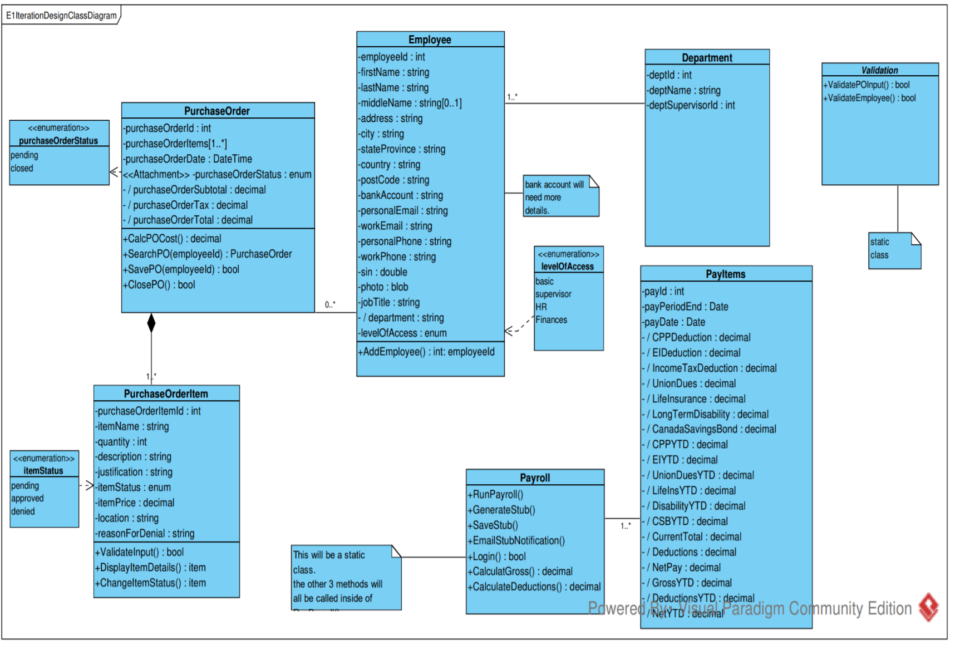

E1 Front ends

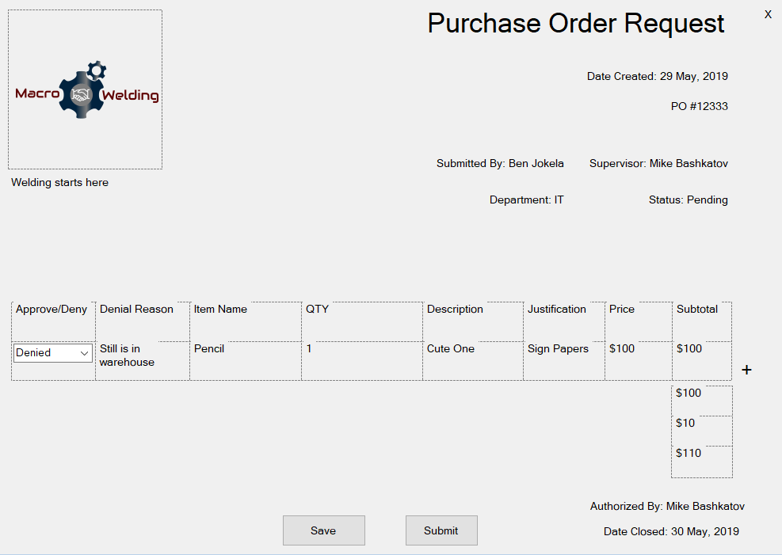

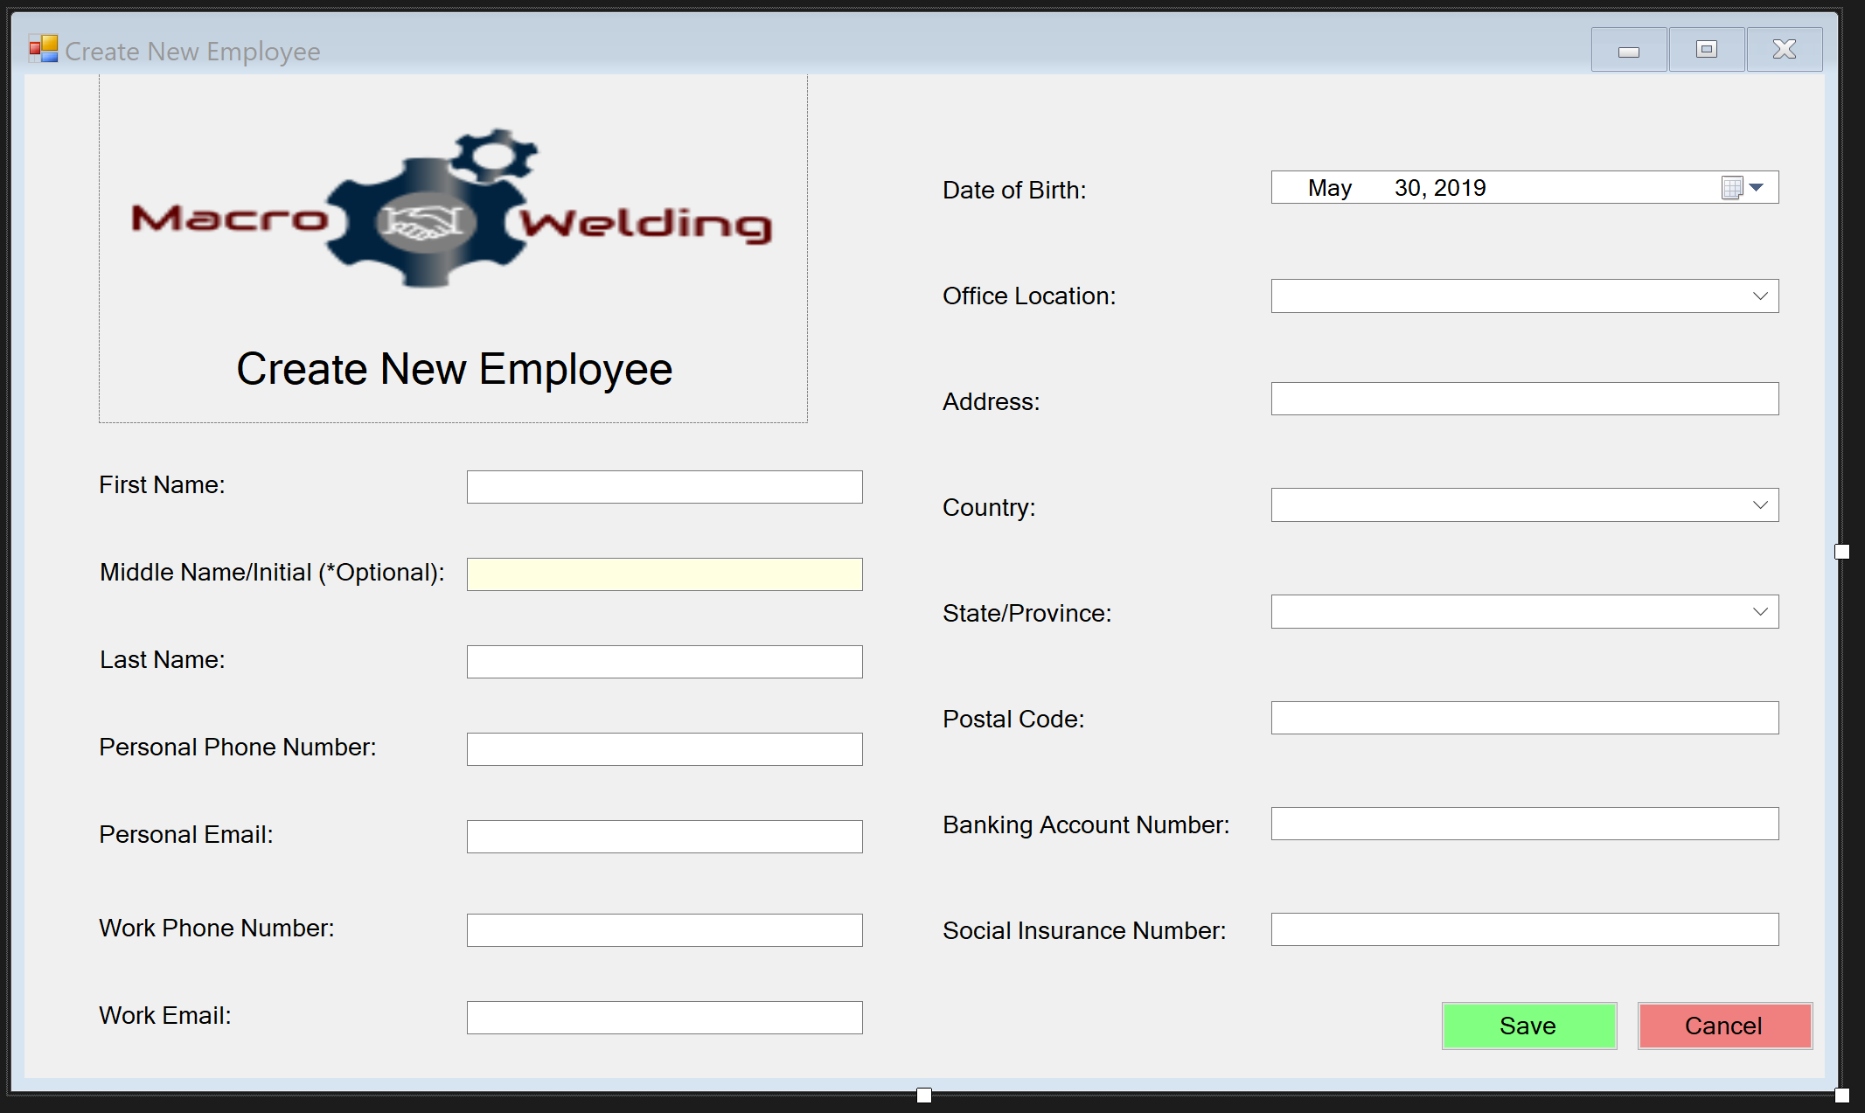

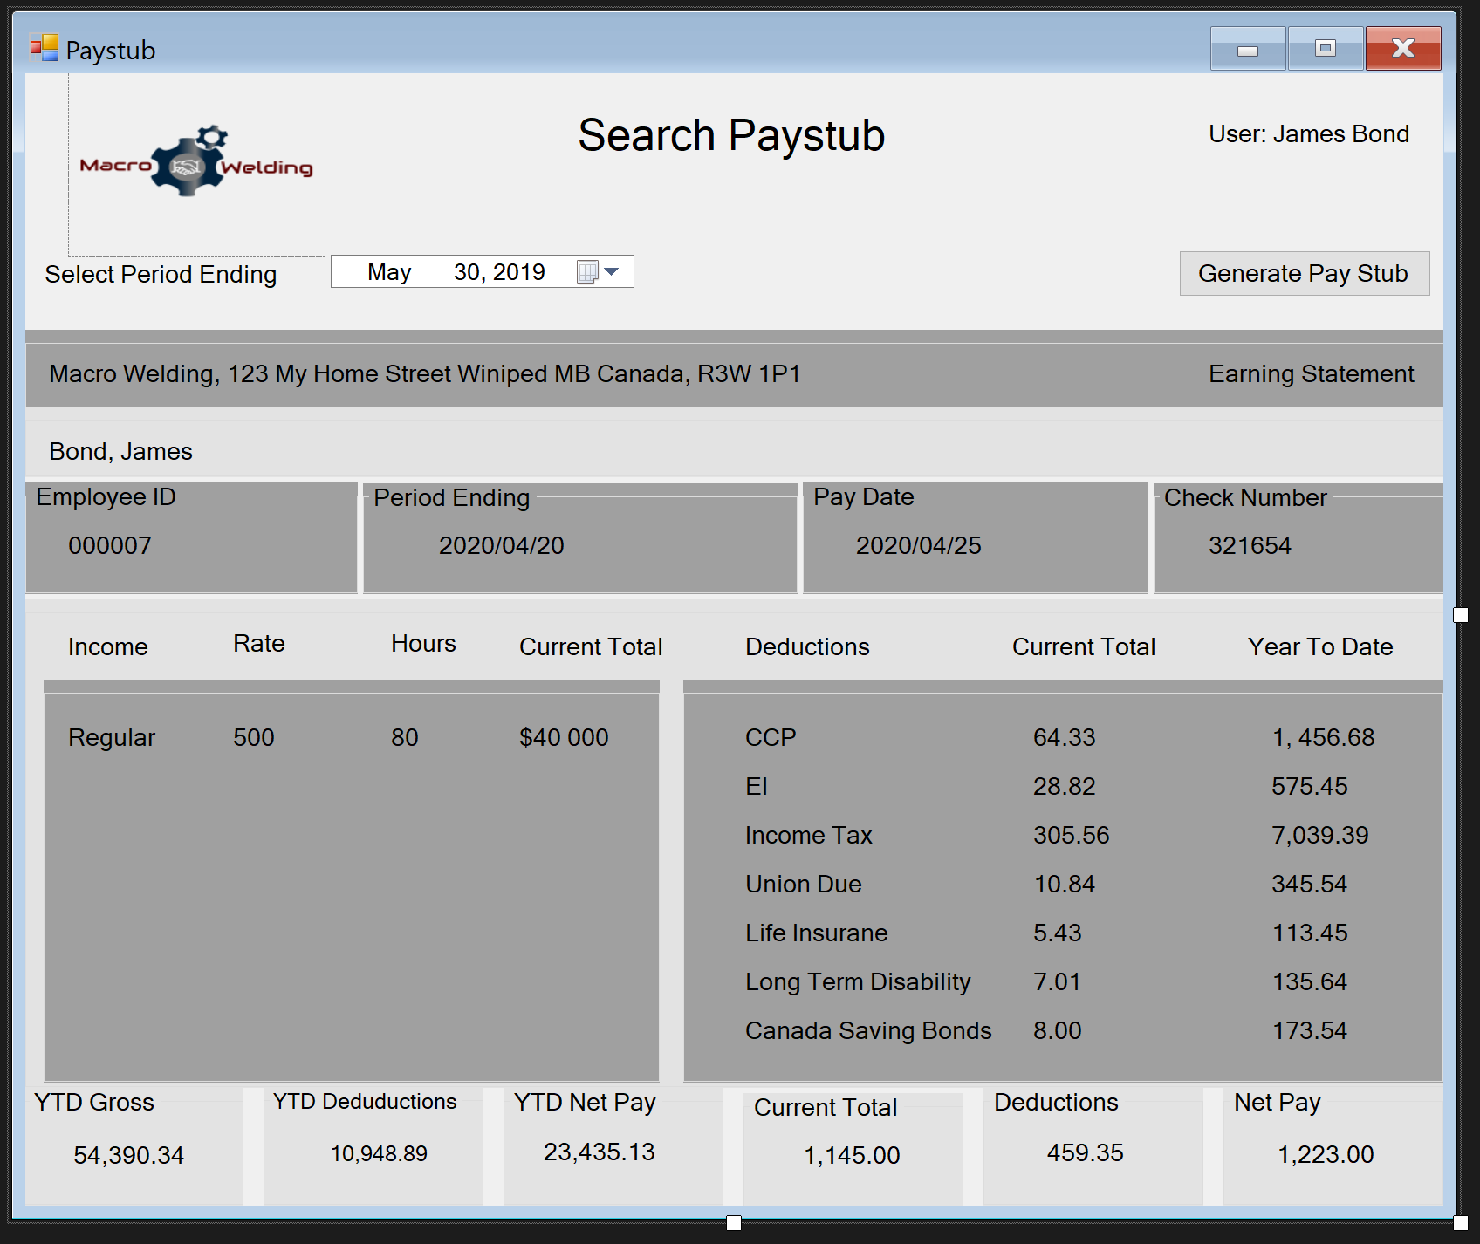

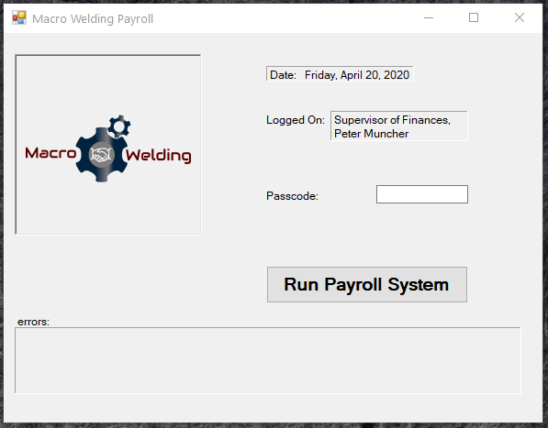

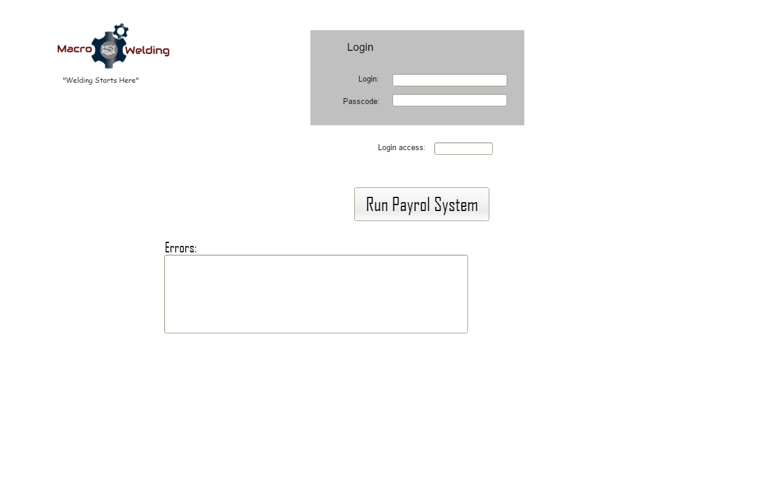

memo

From interview

|  |  |  |  |  |  |  |  |  |  |  |  |
| --- | --- | --- | --- | --- | --- | --- | --- | --- | --- | --- | --- |
| |  | | --- | | Macro Welding Supply |  |  |  | | --- | --- | | To: | Bonnie Ryan, VP | | From: | Old But Gold Development | | CC: |  | | Date: | 2019-05-30 | | Re: | Summary of information from interview. | |

|  |  |
| --- | --- |
| - | We met with Bonnie Ryan, VP of Operations to discuss the forms from the E1 Iteration   1. Purchase Order Request Form 2. Create New Employee Form 3. Pay Stub Search Form – both desktop and web versions.   **Regarding Purchase Order Request Form.**   * The form needs buttons for ‘save’ and ‘close’ * We will create 2 separate views – one for the submitting employee and one for the processing supervisor. The employee will not see the field for approved/denied and will not see the ‘reason’ field unless an item is denied. * The form needs to display the names of the submitting employee and the supervisor. * Dropdown boxes for approval status, rather than a checkbox. * General alignment of items at the top of the form. |
|  |  |
|  | **Regarding Create New Employee Form**   * Province/State and Country should be dropdowns, Country defaults to Canada, loading the provinces. If user selects US, the states are loaded into the Province/State dropdown. * Middle Initial Optional * Add work email and work phone, Date of Birth, and office location. * Reverse the cancel and save buttons and find another colour for cancel, so the text is more readable. * Textboxes on right should be aligned Left. * Address needs capital A * The form needs a title: “Create New Employee”   **Regarding Pay Employees Form**   * The supervisor of finances will be already logged in, display this name, but don’t require another field for username. * Show the date (which should be a Friday) * General alignment of items.   **Regarding Search Pay Stubs Forms**   * Show who is logged in * Desktop version needs title “Search Pay Stubs” * Desktop version needs logo |
|  |  |
|  | Thank you for your time today. Please feel free to contact us at any time for questions or clarification. |

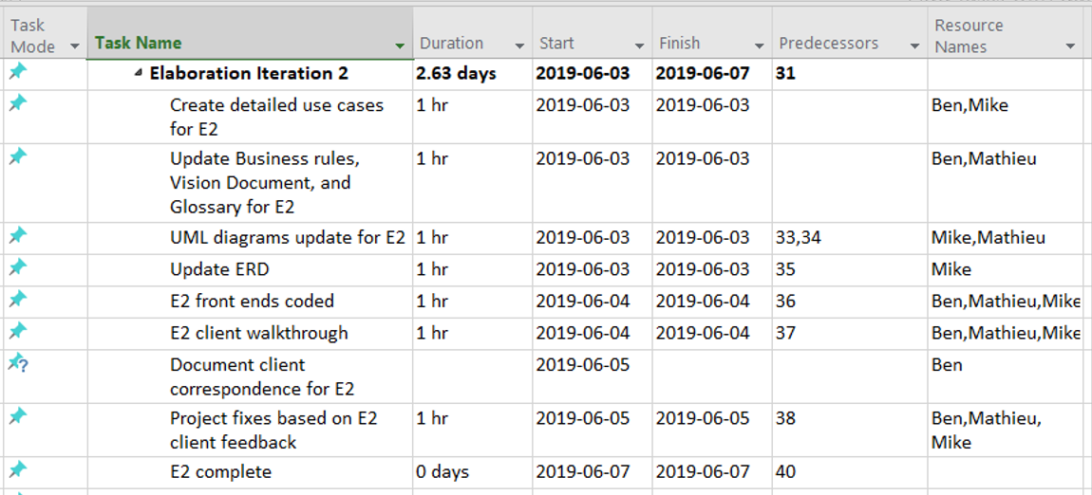Elaboration iteration plan E2

E2 Detailed use Cases:

**Macro Welding System**

Use Case – Archive Employee

Iteration E2.

Version 3.1

Date: 2019-06-01

Priority: High

**Description/Overview:**

An HR rep wishes to archive employee’s information in the system. HR picks a desired employee profile and choose to archive it. Employees profile is hidden from the main list of employees and migrate to archived employees list.

Actors:

* HR rep

Pre-conditions:

* The HR rep must be logged on to Macro Welding system.

**Typical course of events:**

This use case begins when an employee no longer works for the organization.

1. HR rep searches for the employee’s profile * 004

**System Response:** The system returns a list of employees matching the search criteria.

1. HR rep indicates his desire to edit the employee profile.
2. HR choose archive employee profile in a system

**System response**: a prompt to confirm the desire to archive the selected profile.

1. HR rep chooses the positive answer

**System response**: Employee has been archived and can now be found in the archived employees section *007

1. The archived profile is no longer visible in the employee directory.
2. The archived profile is no longer in the active payroll.

**Alternative course of events:**

Line 2 – The following employee profile cannot be found. The HR rep is prompted to try again.

Line 4 – HR chooses not to archive employee profile. The use case ends without the profile being archived.

**Business rules application:**

004 – Levels of Authorization to Data

007 – Archival of Employee Records

**Macro Welding System**

**Use Case –** Modify banking info

**Iteration E2**

**Version 3.0**

**Date: 2019-06-02**

**Priority: Medium**

**Description/Overview:**

A Finance department employee wishes to change an employee’s banking information. The Finance department employee changes the employee’s payment information. The new information is saved in the system.

**Actors:**

* Finance department employee

**Pre-conditions**:

* The finance department employee must be logged into the system.

**Typical course of events:**

This use case begins when changes need to be made to an employee’s bank account information.

1. The finance department employee searches for the employee requiring changes.

**System Response:** The system returns a list of employees matching the search criteria.

1. The finance department employee indicates which employee from the list he/she intends to edit.

**System Response:** The system displays the selected employee’s information.

1. The finance department employee changes the employee’s payment information. *004
2. The finance department employee indicates his desire to update the changes.
   * **System Response:** The payment information is updated and saved in the system.
   * **System Response:** The Finances employee is prompted with a message indicating the changes were successful.

**Alternate course of events:**

Line 2 – If the information provided is incorrect or missing *001. A message is relayed to the user showing what information needs re-entry and prompting them to try again.

**Error conditions:**

Line 2 - Invalid or absent data *001. Prompt for retry and re-entry.

**Business Rules Applications:**

*001 – Employee Information Required

*004 – Levels of Authorization to Data

**Macro Welding System**

**Use Case –** Modify employee records

**Iteration E2**

**Version 3.1**

**Date: 2019-06-04**

**Priority: Medium**

**Description/Overview:**

A HR employee wishes to change an employee’s information. The HR employee changes the employee’s information. Once the changes are made, the HR employee indicates the desire to update the changes and the new info will be saved in the system.

**Actors:**

* HR employee

**Pre-conditions:**

* The HR employee must be logged into the system.

**Typical course of events:**

This use case begins when changes need to be made to an employee’s information.

1. The HR employee searches for the employee requiring changes.

**System Response:** The system returns a list of employees matching the search criteria.

1. The HR employee indicates which employee from the list he/she intends to edit.

**System Response:** The system displays the selected employee’s information.

1. The HR employee changes the employee’s information.
2. The HR employee indicates its desire to update the information.
   1. **System Response:** The Employee information is updated and saved in the system.
   2. **System Response:** The user is prompted with a message indicating that the changes were successful.

**Alternate course of events:**

Line 2 – If the information provided is incorrect or missing*001. A message is relayed to the user showing what information needs re-entry and prompting them to try again.

**Error conditions:**

Line 2 - Invalid or absent data*001. Prompt for re-entry.

**Business Rules Applications:**

*001 – Employee Information Required

**Macro Welding System**

**Use Case –** Modify paygrade

**Iteration E2**

**Version 3.0**

**Date: 2019-06-04**

**Priority: Medium**

**Description/Overview:**

A Finance department employee wishes to change an employee’s salary, job title or bonuses. The finance department employee changes the appropriate information and the new information is saved in the system.

**Actors:**

* Finance department employee

**Pre-conditions**:

* The finance department employee must be logged into the system.

**Typical course of events:**

This use case begins when a finance department wishes to change an employee’s salary and/or job title, or add a bonus.

1. The finance department employee searches for the employee requiring changes.

**System Response:** The system returns a list of employees matching the search criteria.

1. The finance department employee indicates which employee from the list he/she intends to edit.

**System Response:** The system displays the selected employee’s information.

1. The finance department employee changes the employee’s information.*004
2. The finance department employee indicates his desire to update the changes.
   * **System Response:** The payment information is updated and saved in the system.
   * **System Response:** The Finances employee is prompted with a message indicating the changes were successful.

**Alternate course of events:**

Line 2 – If the information provided is incorrect or missing *001. A message is relayed to the user showing what information needs re-entry and prompting them to try again.

**Error conditions:**

Line 2 - Invalid or absent data *001. Prompt for retry and re-entry.

**Business Rules Applications:**

*001 – Employee Information Required

*004 – Levels of Authorization to Data

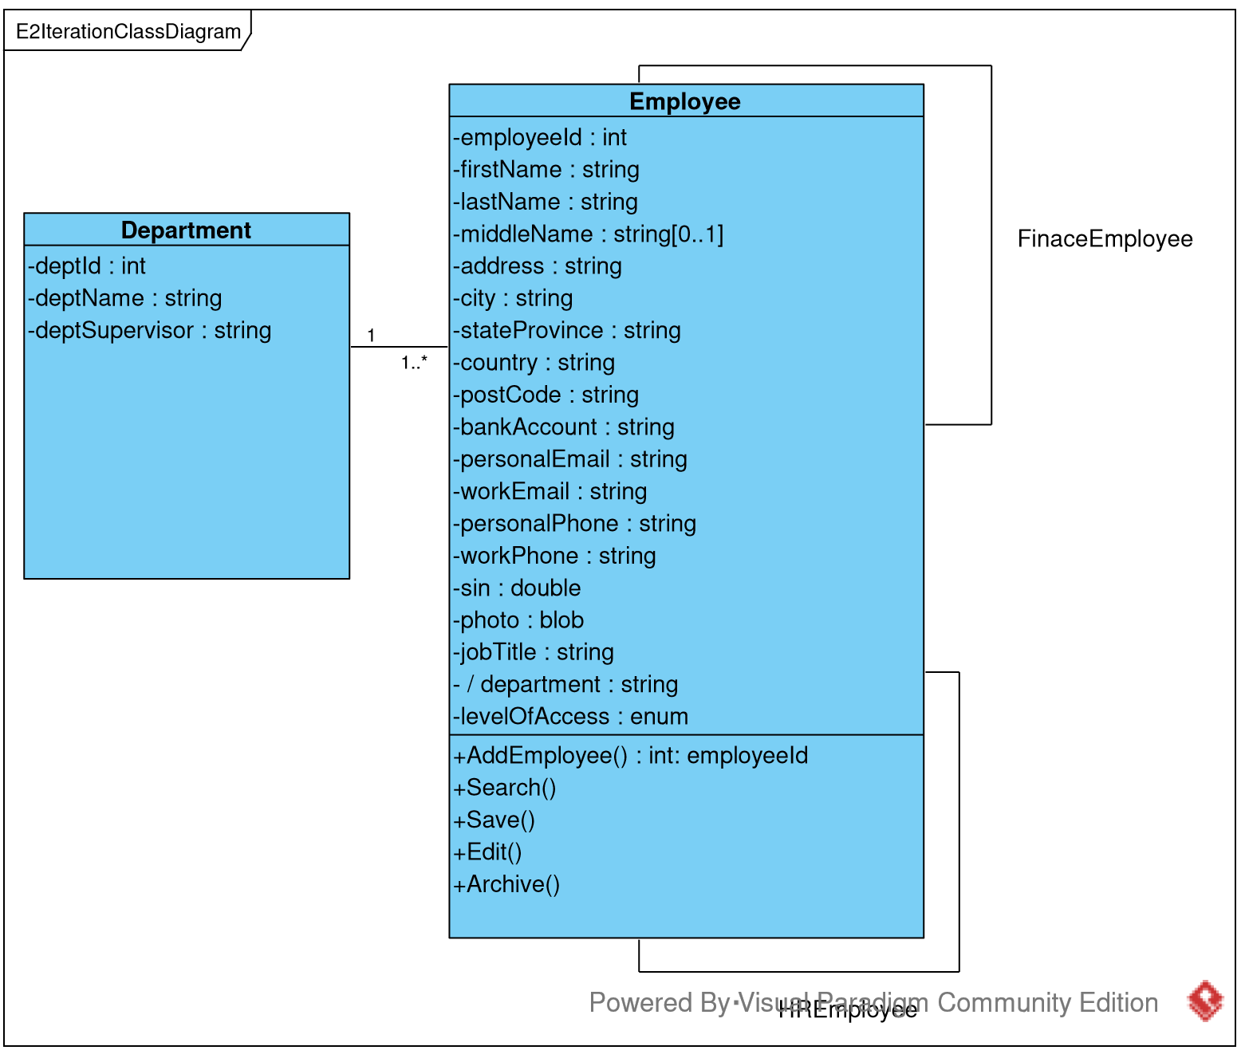

E2 Front ends:

