How the Radio and Hands Free Phone Calls While Driving Affects Reaction Times in Young Drivers

**Preliminary Test #1 – Which Program to use?**

I carried out this test so that I will be able to use a program which provides reliable and valid data as well as ease of access for me (the experimenter) as well as ease of access for the participants of my experiment. To find my programs I used the search engine ‘google’ and used the top 3 rated reaction time testing programs, and from that I have decided to carry out my own research into the best program to use. I wish to find out which one of the top 3 programs is in fact the best program to use to accurately measure reaction times.

The top three programs for measuring reaction times were:

1. The Human Benchmark Program (REFERENCE)
2. Sheep Dash Program (REFERENCE)
3. Traffic Light Program (REFERENCE)

For my preliminary test I used 5 participants for each program and took 5 repeats of each participant. I did this so that I could test the reliability and the validity of the program. From this I hypothesised that the program with the lowest average range would be the most desirable program; however if the programs drew in range values I would take into consideration the participants preference of the program. Below are tables showing the pros and cons for each individual program:

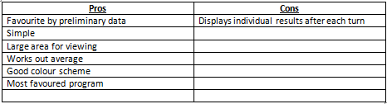Human Benchmark Program

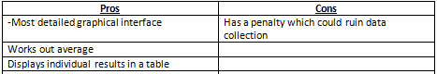Sheep Dash Program  
  
  
  
  
Traffic Light Program

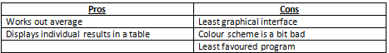

From these tables without precise data you can see that the Human benchmark Program has the most pros and the least cons whereas at the other end of the spectrum the Traffic Light Program has the least pros and the most cons. I predicted from this that the Human Benchmark Program was the program that I was more likely to use, and the program that was going to get the best results.  
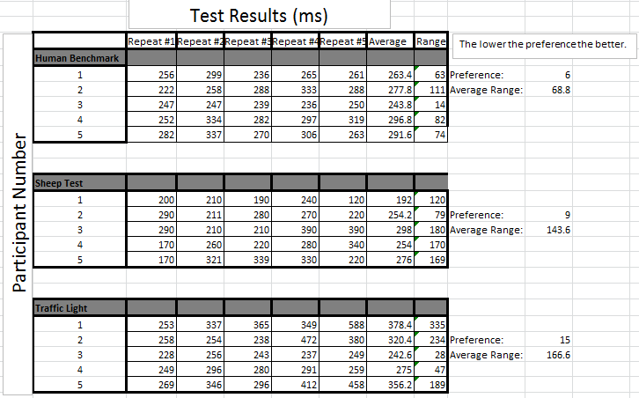My experiment results are shown above. From this I can depict that not only does the program with the lowest range of values (thus giving the most reliable results) but the participants also prefer the programs in the same order. From this I can see that my original prediction for the best program was correct, and the human benchmark program is in fact the best program to use due to it producing the most reliable data (Lowest range, 68.8 in comparison to 143.6 and 166.6).

**Preliminary Test #2 – Does Gender Affect Reaction Time?**

For my second preliminary experiment I decided to start narrowing down my variables by starting to test certain factors. Seeing as the human population is derived by the chance (50%) of offspring being male and female, it seems reasonable to test this to see if in fact there is any difference between reaction times of male or female humans. I will be testing 5 individual males and females using the program that I’m using for my final experiment (Human benchmark program) as I decided which program I am using in the previous trial. Again I will be using 5 repeats to work out the average and range of the reaction time.I hope that this preliminary test will give me a clear/no distinction as to the reliability of reaction times between males and females. If there is a clear distinction between range and average reaction time, in my final experiment I will have to control the gender of my participants in order to get the most accurate and reliable data.

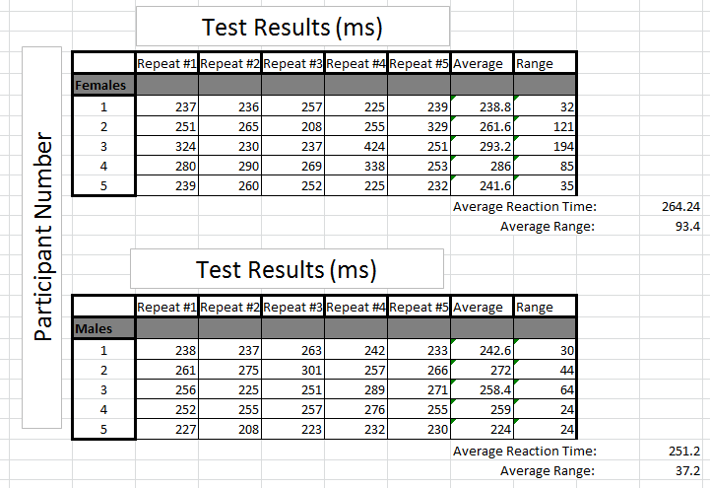

This preliminary experiment suggests that males have a faster reaction time and also that males have a more similar reaction time to each other compared to female individuals. Due to my results I will have to control gender as a variable.

**Preliminary Test #3 – Does Smoking Affect Reaction Time?**

My second preliminary test will be a comparison between smokers and non-smokers and their reaction times. I will be testing 5 individual smokers and non-smokers using the program that I’m using for my final experiment as decided in preliminary experiment 1. I hope that this preliminary test will give me a clear/no distinction as to the reliability of reaction times between smokers and non-smokers. If there is a clear distinction between range and average reaction time, in my final experiment I will have to control the lifestyle factor of smoking in my participants in order to get the most valid and reliable data. For my experiment I defined a smoker as an individual who smoked one or more cigarette a day.

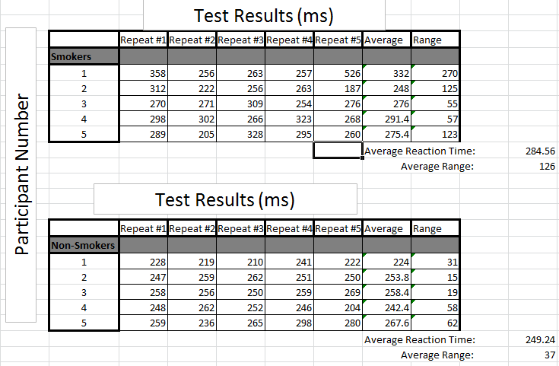Unfortunately I will not be able to measure the immediate effect of smoking on reaction times as our college and its surrounding area is a no-smoking site. Therefore my data reflects individuals that have had a cigarette in the past hour of taking the reaction test.

This preliminary experiment suggests that non-smokers have a faster reaction time and also that they have a more similar reaction time to each other as individuals compared to smoking individuals. Due to my results I will have to control smoking cigarettes as a variable.

**Preliminary Test #4 – Does Being a Gamer Affect Reaction Time?**

In this experiment I measured the how being a gamer ultimately affects reaction time, ultimately my prediction would be that PC gamers would have the fastest reaction time due to the ease of use of the mouse and the fact that they regularly use the mouse. Followed by console gamers and then followed by non-gamers. I defined the individuals as ‘gamers’ by playing on the device for an hour or longer every day, if the participant didn’t play on either for longer than an hour each day they are classified as a non-gamer. From this experiment I wished to find out whether playing games regularly on a specific console would affect reaction time, and if it did then I would have to control whether my participants for my final experiment were gamers or not.

For my experiment I took 5 repeats of each participant. Unfortunately in the sample of participants available to use, only 2 were classified as ‘PC gamers’ and only 4 were classified as ‘Console gamers’ compared to my usual use of 5 participants. I acknowledge that this may affect the validity of my results.

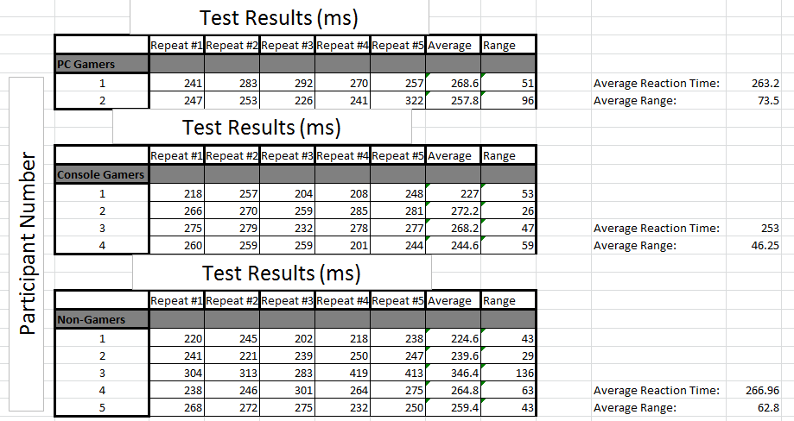  
My data for this experiment shows that in contrast to my prediction, console gamers were faster than PC gamers (by 10.2ms) and had less variation in the reaction time results; however my prediction of non-gamers was correct as they were the slowest. My data also shows that there is no significant difference between the results of Gamers and Non-Gamers as all the data overlaps. *Will insert range bars here to show*

**Preliminary Test #5 – Does Being Left/Right Handed Affect Reaction Time?**

I decided to test out how being left or right handed affected reaction time as apparently being left handed gives you an advantage over reaction time due to interactions with the left hemisphere of the brain *REFERENCE*. I was sceptical of this so I decided to test this out myself to see if this holds true.

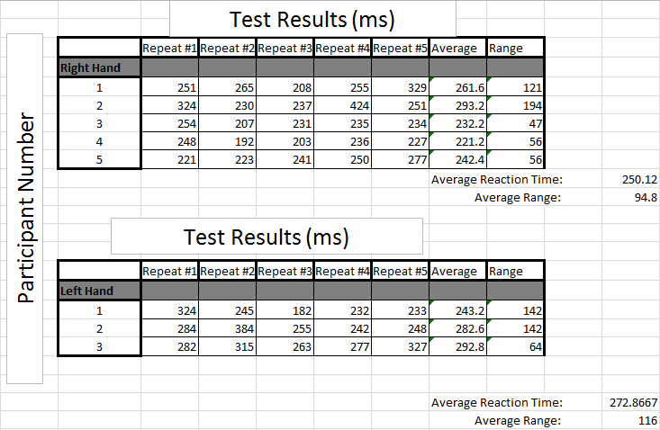I defined a person as left handed by asking them if they used the left hand for the majority of tasks, and also asked them to use the mouse with their left hand. I could easily find 5 participants that used their right hand; however I could only find 3 participants that used their left hand. I understand that this may affect the reliability of my results. I used 5 repeats for each participant and calculated the average reaction time and the average range.  
Contrary to what I had researched my data shows that in fact right handed people are faster in this sample of people and also have a lower range. This difference in reaction time is not a significant difference and therefore I will not be controlling left handed and right handed people.