**Etude 10 – Pushing Buttons**

Ben Knox and Daniel Bohinc

Our approach for this etude was initially have a look at the game understand how it works and to get down strategy. Quickly we realised that the ideal way to finish a game was to have a corner piece and all adjacent squares in the unpressed position so that pushing the corner piece would end the game. Other than this our tactics weren’t more based on learning the game at this point and other tactics may be used for other levels.

**Level 8**

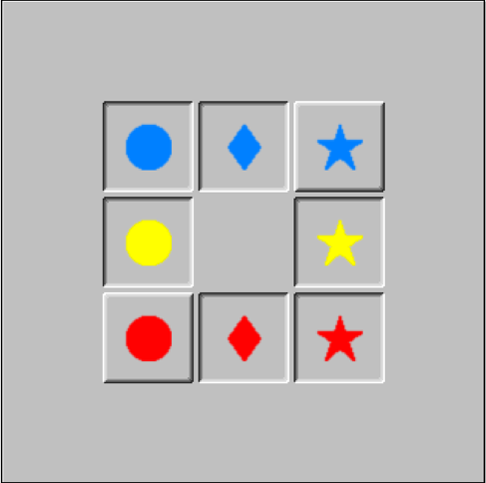

Above is a capture of the starting position of level 8, as you can see all buttons are pressed down except the blue star and the red circle. One thing we noticed initially was the symmetry present in this puzzle, meaning the resulting solution we may find wouldn’t be the only solution which completes the game with the most optimal number of moves.

**First attempt:**

To begin this puzzle we first tried clicking the blue star. This presented us with the following result.

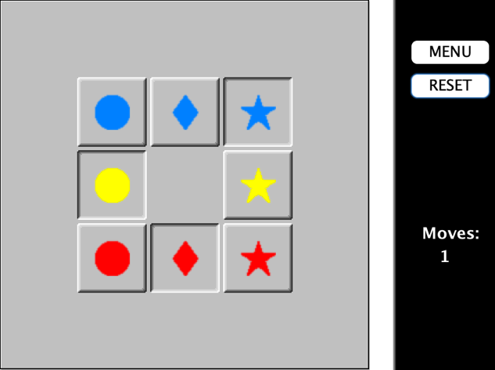

From here we made the following sequence of moves: red circle, red diamond, red circle, blue circle, red circle. This sequence of moves left us in the position pictured below. This is also where we realised that ideally we would have a corner piece and all adjacent squares in the unpressed position as early as possible.

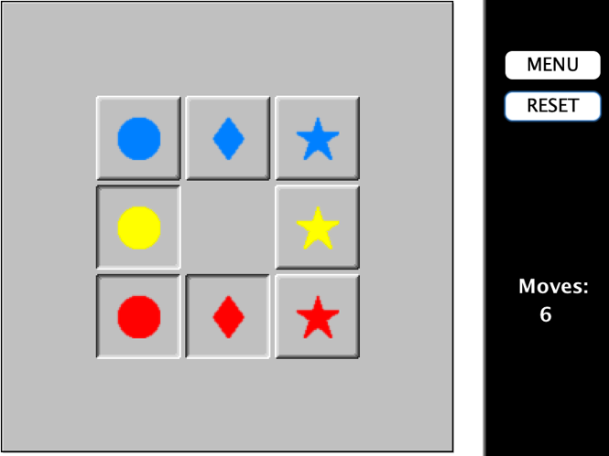

The moves selected for this attempt were: **blue star, red circle, red diamond, red circle, blue circle, red circle, blue star**. This completed the puzzle in **7 moves** but we knew we could do better.

**Second Attempt:**

The second attempt started the same way with the blue star, but here we decided blue diamond next. These two moves left us already with two sides unpressed, the same as in the photo above. So, our second attempt was completed in a mere **3 moves: blue star, blue diamond, red star.**

**Following Attempts:**

We made numerous attempts to beat 3 moves for this puzzle but soon realised that, although you could match 3 moves with many different combinations of moves, there is no way to complete the puzzle in 2 moves. To figure this out we made countless attempts at two move combinations but never solving the puzzle using these two moves. One thing we did find is another optimum solution which follows a different structure to the one initially found. Of course, there are many variations of our initial solution which will leave us with the L shape after two moves. After these two moves: blue star, red star, we are presented with the pattern shown in the picture below. By clicking the blue diamond in this picture, the level is completed in three moves. So, the buttons pressed for this **new 3 move solution were blue star, red star, blue diamond.**

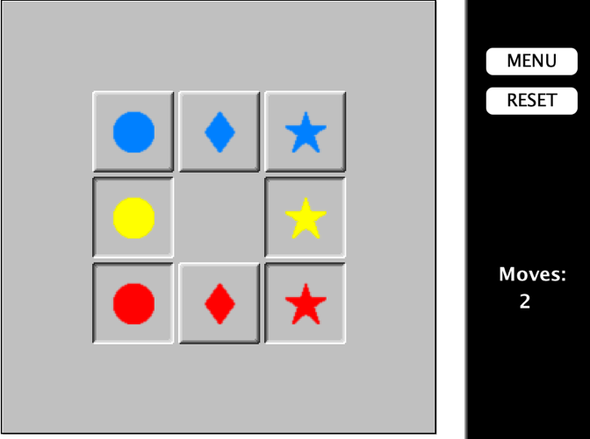

**Level 17**

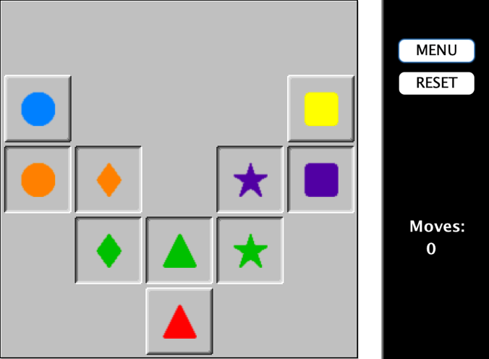

Above is the starting positions for the buttons in level 17. One thing to note is that the puzzle is symmetrical and so any solution found will have an equal and opposite solution.

One thing that we noticed very quickly for this puzzle was that if we could get both sides into the position shown below, on the left side we had the L and on the right side the line (referring to the unpressed buttons), then we could press all buttons down. This would be done by pressing the orange circle on the left and by pressing the yellow square on the right. Although there may be other ways in which we can solve the puzzle this is a good place to start.

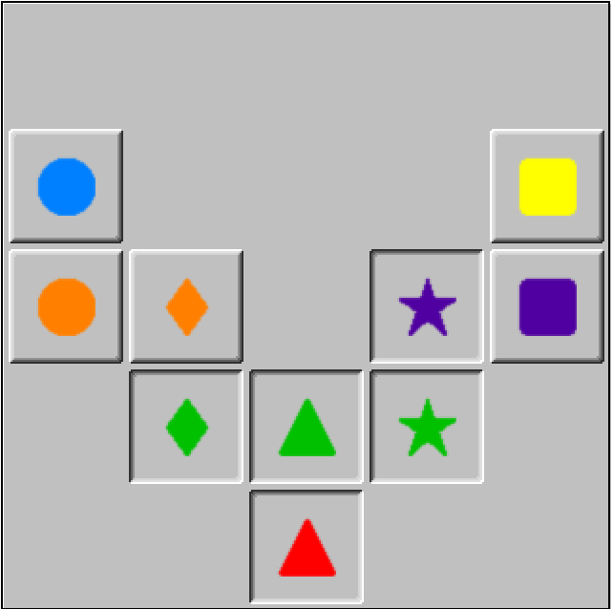

**First Attempt:**

We decided to start from the middle and work our way out to each side. For this attempt we started with: red triangle, green triangle, green star, purple star. This combination led us to the position pictured below after 4 moves. This is already one side of our proposed solution sorted.

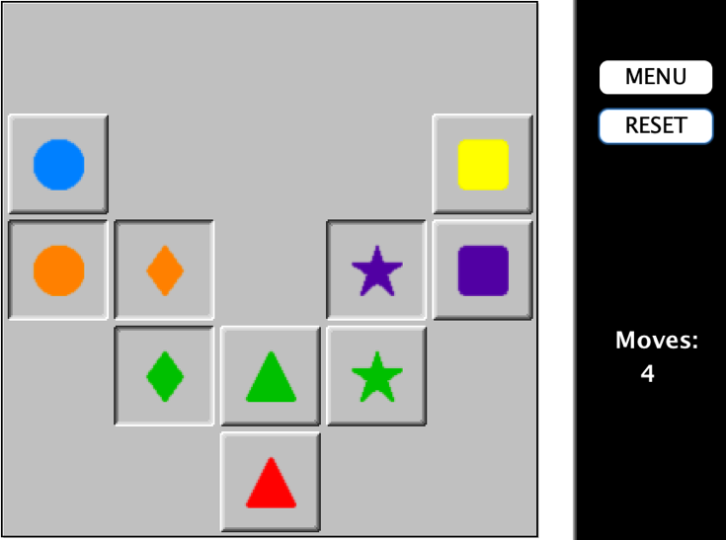

From here we just need to work our way up the left side now. The next moves we chose were green triangle, green diamond, orange diamond.

This left us at the position pictured below.

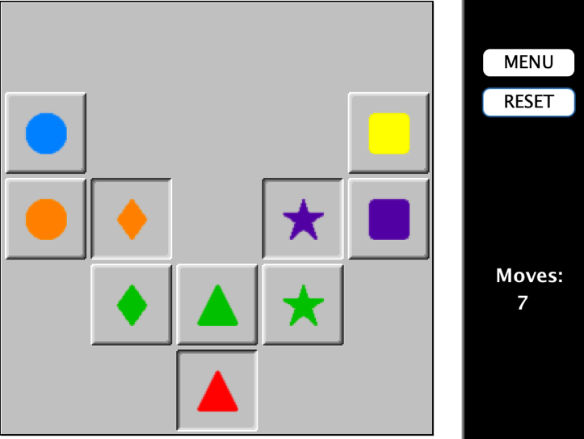

Here we made the mistake of pressing blue circle, and then yellow square which ruined our attempt as we were well over 15 moves and decided to just reset and start back at the position pictured above. So far, we are at 7 moves and the moves made are as follows: red triangle, green triangle, green star, purple star, green triangle, green diamond, orange diamond. We see that pressing green diamond again will leave us with a the perfect position to finish the game. **A 10 move solution by pressing buttons: red triangle, green triangle, green star, purple star, green triangle, green diamond, orange diamond, green diamond, orange circle, yellow square.**

**Following Attempts:**

For this puzzle we made countless attempts to improve our solution however every attempt failed to improve on our best of 10 moves. We did however find another solution which worked in a similar way but instead of working from the middle out we worked from right to left. This **alternative solution** is as follows: **yellow square, purple square, purple star, green star, green diamond, orange diamond, green diamond, orange circle, purple square, red triangle.**

**Level 24**

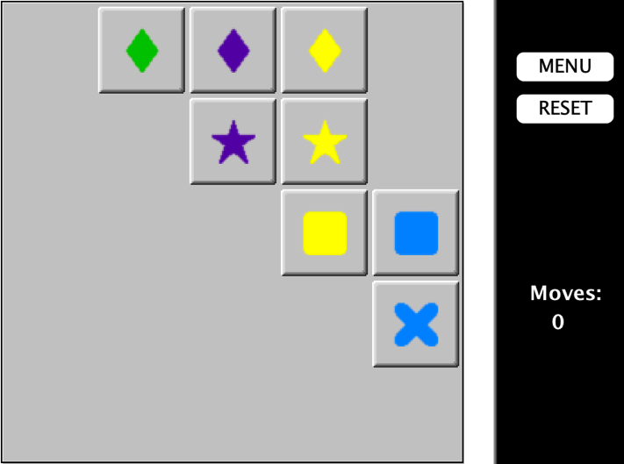

Pictured above is the initial state of level 24. One thing we noted was that all buttons started in the unpressed position.

**First Attempt:**

Our initial strategy was to get as many buttons down as possible. In two moves we could have all buttons pressed except for the purple star. These two moves were yellow diamond and blue cross, leaving us with the pattern shown below.

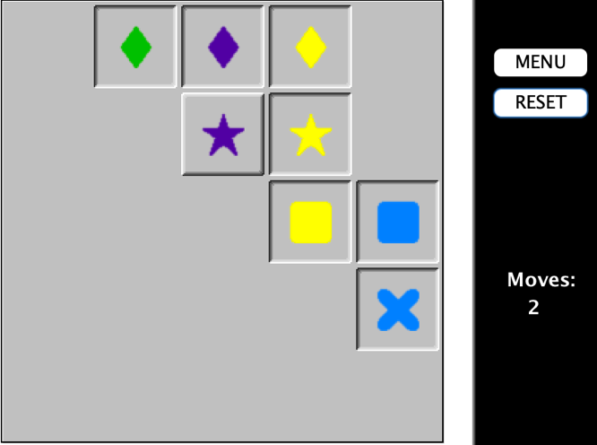

From here we had numerous attempts at completing the puzzle however each attempt would leave us with more moves than we felt would be used for the optimum solution. One of these attempts was the following: **yellow diamond, blue cross, purple star, yellow star, purple star, yellow star, purple star, yellow star, purple diamond, green diamond, yellow diamond, yellow star, purple star, yellow diamond.** This solution was a 14 move solution but we knew it would not be the most optimum. For starters in this solution we had the move (purple star, yellow star) repeated three times in a row.

**Second Attempt:**

Although this isn’t our second attempt it is our second completed attempt. We decided to improve on the previous attempt and get rid of moves which had no real effect. From the previous attempt we got rid of **purple star, yellow star, purple star, yellow star** from the start of the attempt. This left us with a 10 move solution, but we still thought we could do better. Here is our **10 move solution: yellow diamond, blue cross, purple star, yellow star, purple diamond, green diamond, yellow diamond, yellow star, purple star, yellow diamond.** Both our first and second attempts had the same final button press, the pattern pictured below is our final move where we select yellow diamond.

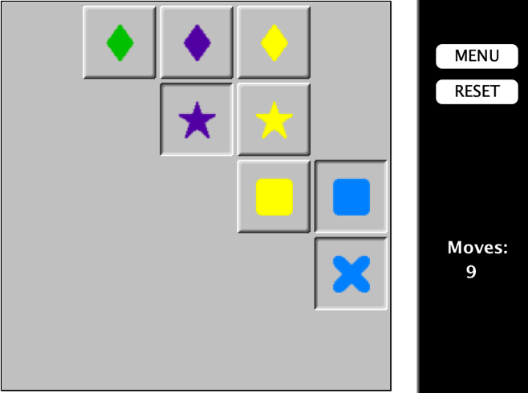

**Final Attempts:**

After multiple more attempts we finally got a solution better than 10 moves. We started again at the position pictured below, and started looking for a new solution. We figured maybe the end position we are looking for (pictured above) is not the most optimal.



For this attempt we tried the buttons: **yellow diamond, blue cross, purple star, purple diamond, green diamond, purple star.** We had now improved our solution to **just 6 moves.**

This solution had the pattern pictured below as the final move.

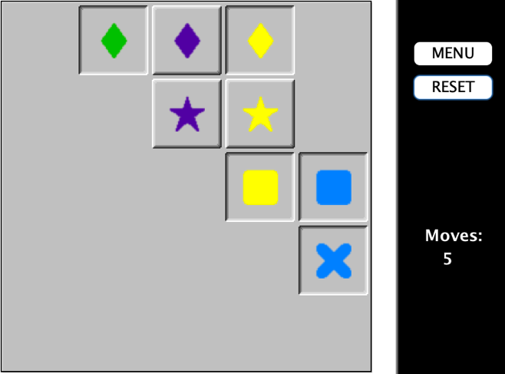

Perhaps our determination to find a solution which started with yellow diamond, blue cross (pictured below) was the wrong idea, meaning we took much longer to find the optimal solution.



However, we believe there is no solution which can solve this puzzle in less than 6 moves. Hence our solution, or one of the same number of moves is the optimum solution. Overall here are the results we found for each puzzle, **Level 8: 3 moves, Level 17: 10 moves, Level 24: 6 moves.**