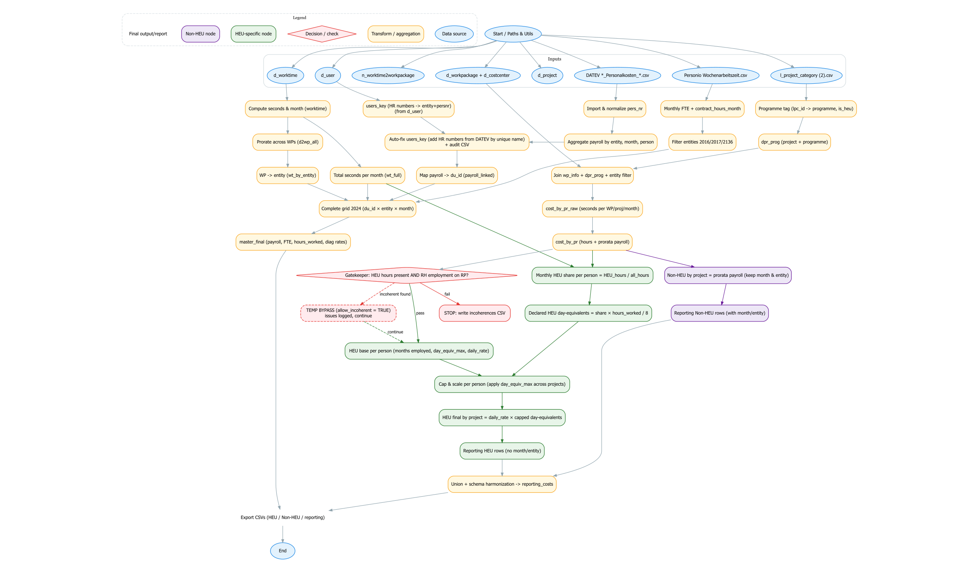

- Inputs: d_user, d_worktime, n_worktime2workpackage, d_workpackage, d_project, d_costcenter, l_project_category (2), DATEV Personalkosten.csv, Personio Wochenarbeitszeit.csv.
- Payroll is normalized and aggregated by entity/person/month.
- users_key is built from d_user HR numbers and auto-fixed using DATEV (unique name match) to add missing (entity, pers_nr) pairs; an audit CSV is written.
- Worktime is prorated across WPs; entity minutes and total minutes are computed.
- Personio provides monthly FTE and contract hours (entities 2016/2017/2136 only).
- All streams are merged into a 2024 grid (master_final).
- Projects are tagged to programmes (HEU flag).
- Gatekeeper blocks HEU if no RH employment months (unless bypassed).
- HEU daily-rate cost uses capped day-equivalents; Non-HEU is pure prorata payroll.
- Final unified report exports HEU and Non-HEU views.

Databases and files used:
d_user.csv, d_worktime.csv, n_worktime2workpackage.csv, d_workpackage.csv, d_project.csv, d_costcenter.csv, l_project_category.csv, DATEV payroll (*_Personalkosten_*.csv), and Personio (Wochenarbeitszeit.csv).

We begin with payroll. DATEV files are ingested, personnel numbers normalized, entity codes extracted from filenames, and months parsed. Payroll is then aggregated per entity and person by month. In parallel, HR user keys from d_user.csv are expanded into (entity_code, pers_nr_short) pairs so payroll rows can be mapped to internal du_id.
Correction applied: if DATEV shows a person in two entities but d_user lists only one HR number, the missing pair is inferred by a unique (surname+givenname) match in DATEV. The inferred keys are added to users_key and logged in an audit file (inferred_hr_numbers_from_DATEV.csv). After this enrichment, payroll rows successfully map to du_id, forming payroll_linked.
Worktime is derived from d_worktime.csv. Each entry becomes seconds worked, prorated across workpackages using n_worktime2workpackage.csv. Joining with d_workpackage.csv and d_costcenter.csv assigns each WP to an entity. We then compute two views: entity-level seconds per month (wt_by_entity) and total seconds across all entities per person/month (wt_full) to avoid later double counting.
From Personio (Wochenarbeitszeit.csv), a monthly FTE and contractual hours series is built per person and entity. The file is completed forward in time so each month has values for contract_hours_month and weekly FTE. Only target entities (2016, 2017, 2136) are retained.
These three data streams -payroll, worktime, and FTE- are merged on a complete grid of du_id × entity × month for 2024 to form master_final. Each row carries payroll cost, FTE, contractual hours, and realized hours (entity hours if available, otherwise total). Two diagnostic rates are also calculated: cost per realized hour and cost per contractual hour.
Projects are categorized via l_project_category.csv. Each d_project.lpc_id is mapped to a normalized programme and is_heu flag, then joined to WPs and prorated worktime. Summing WP seconds by du_id × project × month yields cost_by_pr_raw. These seconds are converted to hours, and monthly payroll is distributed across projects in proportion to seconds worked, producing cost_by_pr.
Before HEU calculations, a gatekeeper check enforces coherence: if a person has HEU hours in 2024 but no month with FTE > 0 or payroll > 0 in master_final, the system writes an “incoherences” CSV and stops (unless bypassed). This ensures HEU cannot be claimed for people with no recorded employment.
The HEU daily-rate base (heu_base) is computed per person for the reporting period:
- Months employed (any month with FTE > 0 or payroll > 0)
- Average FTE across employed months
- Theoretical day-equivalents: (215/12 × months_employed × avg FTE), rounded to the nearest half-day (day_equiv_max)
- Daily rate: total payroll in 2024 divided by day_equiv_max
To prevent double counting across WPs and entities, HEU hours are capped monthly against realized hours: the HEU share of total hours is applied to hours_worked from wt_full. Summed across months, this yields declared HEU day-equivalents, which are compared to day_equiv_max for cap control.
Outputs are generated along two tracks.
- HEU: de-duplicated day-equivalents are aggregated by du_id × project and multiplied by the person’s daily rate to produce heu_final_by_project.
- Non-HEU: cost_by_pr is aggregated by du_id × project to report prorated payroll cost and hours.
Finally, both are merged into a unified reporting table:
- Non-HEU rows retain month and entity and show prorata payroll costs (no rate, no day-equivalents).
- HEU rows are person–project lines (no month or entity) showing capped day-equivalents, the daily rate, and the computed HEU cost.

