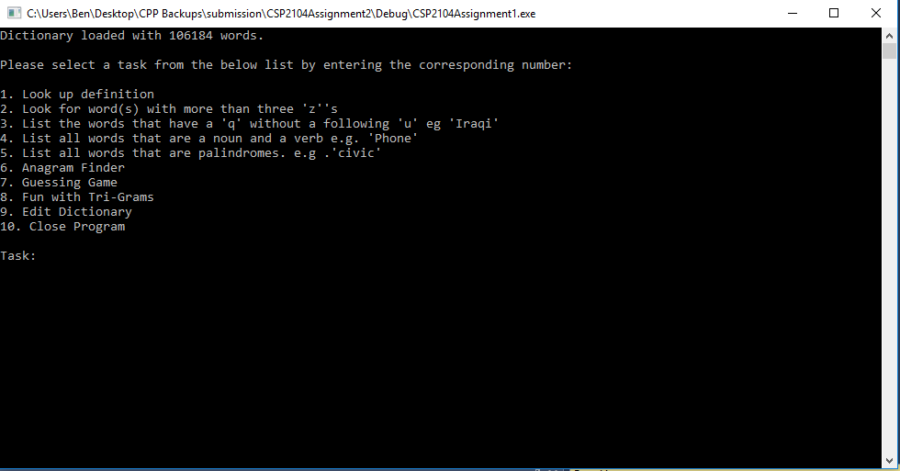

Dictionary console application created in C++ for university assignment. Dictionary file dictionary.txt was provided. The code had to read in this provided text file and perform a number of functions as shown in the above screenshot of the main menu of the application. Any changes made through the edit function must then be saved back in appropriate format to the text document for subsequent runs of the program.

The largest portion of code resides in Dictionary.cpp as the bulk of the work is done by the methods that are part of the Dictionary class.