



AI Racing Market

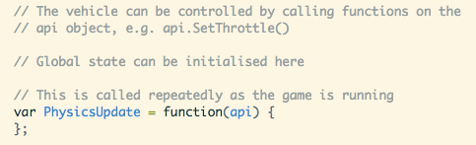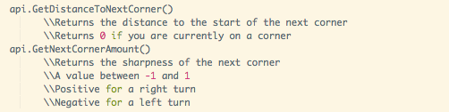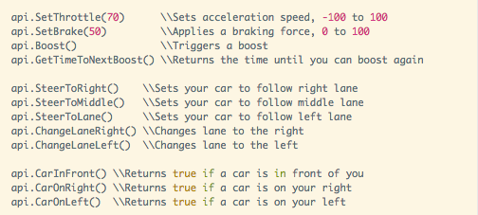

API

Event API

During a race the PhysicsUpdate loop is run a fixed number of times per second. On every run, all code within the loop is executed. Make sure anything you don't want running constantly is conditional!

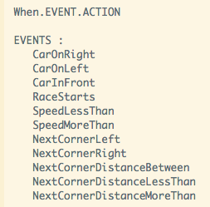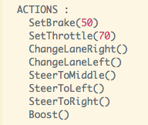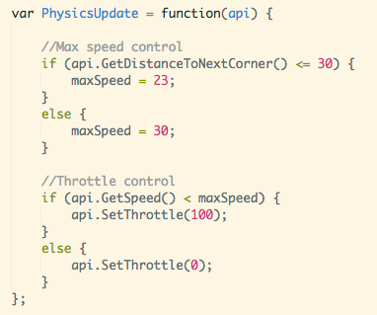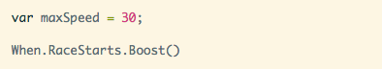

**Example**

This example script boosts at the start of the race, using an event.  
  
  
If the car is close to a corner, the maximum speed is lowered to avoid flipping over.

It maintains a maximum speed using the throttle.



You should use this space to make notes!

**Script**

