Sage 300 Web Screens SDK

Upgrade Guide for 2017.2 to 2018

July 2017

The MIT License (MIT)

Copyright © 2017 The Sage Group plc or its licensors. All rights reserved.

Permission is hereby granted, free of charge, to any person obtaining a copy of this software and associated documentation files (the “Software”), to deal in the Software without restriction, including without limitation the rights to use, copy, modify, merge, publish, distribute, sublicense, and/or sell copies of the Software, and to permit persons to whom the Software is furnished to do so, subject to the following conditions:

The above copyright notice and this permission notice shall be included in all copies or substantial portions of the Software.

THE SOFTWARE IS PROVIDED “AS IS”, WITHOUT WARRANTY OF ANY KIND, EXPRESS OR IMPLIED, INCLUDING BUT NOT LIMITED TO THE WARRANTIES OF MERCHANTABILITY, FITNESS FOR A PARTICULAR PURPOSE AND NONINFRINGEMENT. IN NO EVENT SHALL THE AUTHORS OR COPYRIGHT HOLDERS BE LIABLE FOR ANY CLAIM, DAMAGES OR OTHER LIABILITY, WHETHER IN AN ACTION OF CONTRACT, TORT OR OTHERWISE, ARISING FROM, OUT OF OR IN CONNECTION WITH THE SOFTWARE OR THE USE OR OTHER DEALINGS IN THE SOFTWARE.

Contents

1. Overview 4

1.1 Required Version of Sage 300 4

2. Installing the Sage 300 Upgrade Wizard 5

3. Accessing the Sage 300 2018 Upgrade Wizard 6

4. Using the Sage 300 Upgrade Wizard 7

4.1 Step 1 – Synchronize Web Files 8

4.2 Step 2 – Synchronize Accpac Libraries 9

4.3 Step 3 – Modify LoginResult Function 10

4.4 Step 4 – Import/Export Common Component 11

4.5 Step 5 – Enable XML Documentation Property (optional) 12

4.6 Step 6 – Confirmation 13

4.7 Step 7 - Recompile 14

5. Modify LoginResult Function 15

6. Compilation Troubleshooting 16

1. Overview

This document is intended to serve as a guide for illustrating how to use the Sage 300 Upgrade Wizard to upgrade Visual Studio solutions and projects that are compatible with the Web Screens SDK 2017.2 to Web Screens SDK 2018.

Since Web Screens SDK 2017.2 was released, code changes were made to CSS, HTML, JavaScript, and other source files. To be compatible with Sage 300 2018, some folders and files require updates.

**Note:** The steps in this document are required only for solutions and projects that are compatible with Web Screens SDK 2017.2. The Solution Wizard and Code Generation Wizard have the updated code files and libraries, so solutions and projects that were generated recently will have the latest files and libraries.

The wizard will upgrade the solution and projects in following steps:

* Synchronize Web Files
* Synchronize Accpac Libraries
* Modify LoginResult Function (manual modifications required)
* Import/Export Common Component (manual modifications required)
* Enable XML Documentation Property (optional)
  1. Required Version of Sage 300

To get started, install Sage 300 2018 with the Web Screens option selected.

1. Installing the Sage 300 Upgrade Wizard

The Upgrade Wizard is a Visual Studio Plugin that was developed in Visual Studio 2015 and is compatible with Visual Studio 2013.

To install the wizard:

1. Run Sage300UpgradeWizardPackage.vsix.
2. Select the Install the Wizard Package option.
3. Accessing the Sage 300 2018 Upgrade Wizard

The **Sage 300 2018 Upgrade Wizard** is a Visual Studio Plugin. To open it, right-click the solution, and on the context menu, click Sage 300 2018 Upgrade Wizard.

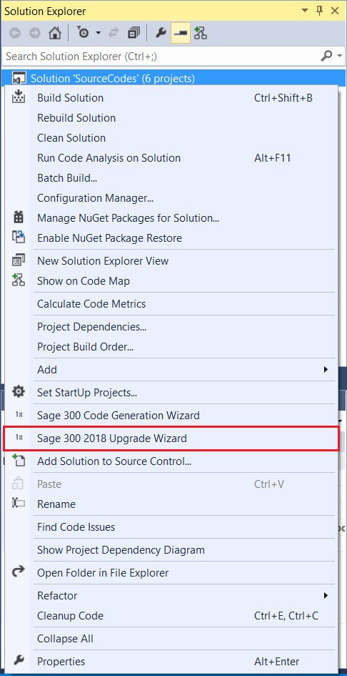

1. Using the Sage 300 Upgrade Wizard

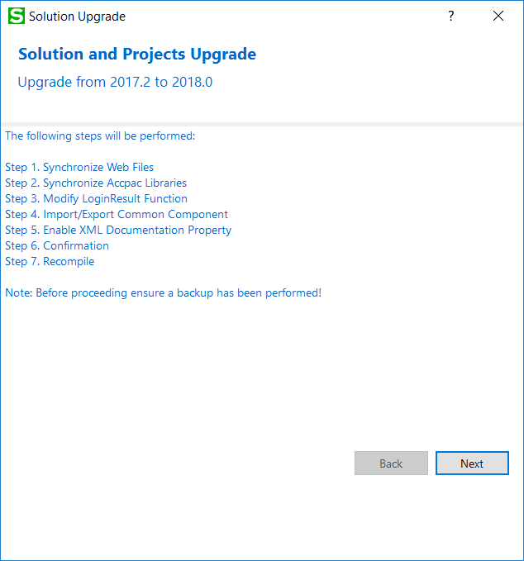

**Important:** Please backup the solution and projects before proceeding with the upgrade.

**Select Next to continue to the next step.**

* 1. Step 1 – Synchronize Web Files

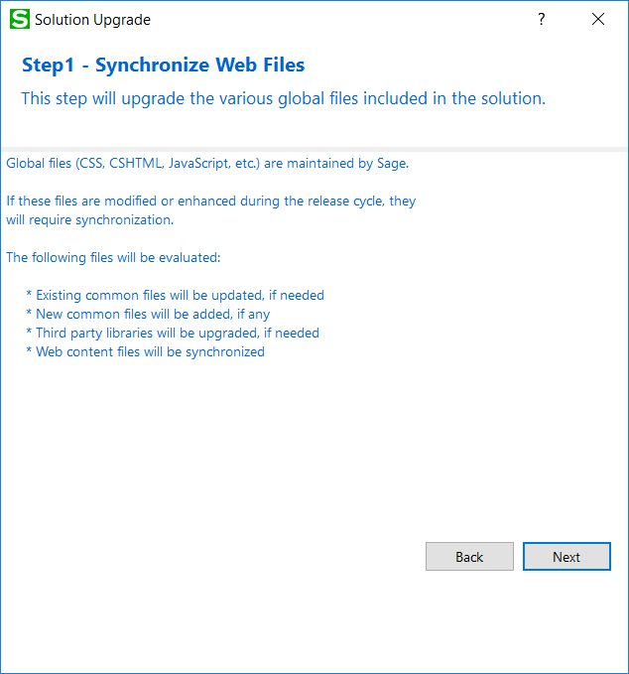

Contents in the Web Projects Areas\Shared, Areas\Core, Views, Scripts, Content, and Assets folders are upgraded in this step.

Click Next to proceed or Back to go back to the previous step.

* 1. Step 2 – Synchronize Accpac Libraries

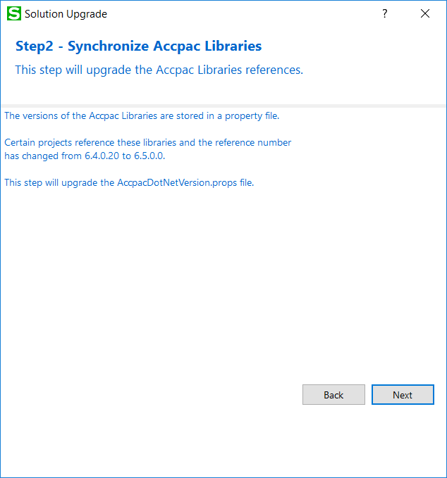

Click Next to proceed or Back to go back to the previous step.

* 1. Step 3 – Modify LoginResult Function

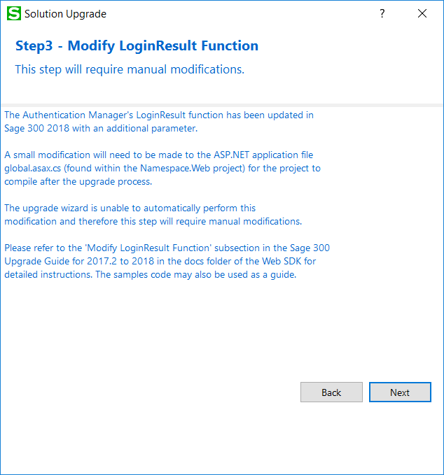

**Important:** This step requires manual modifications. The Sage 300 Upgrade Wizard is unable to automatically perform these changes. For specific instructions, refer to Section 5 – Modify LoginResult Function.

Click Next to proceed or Back to go back to the previous step.

* 1. Step 4 – Import/Export Common Component

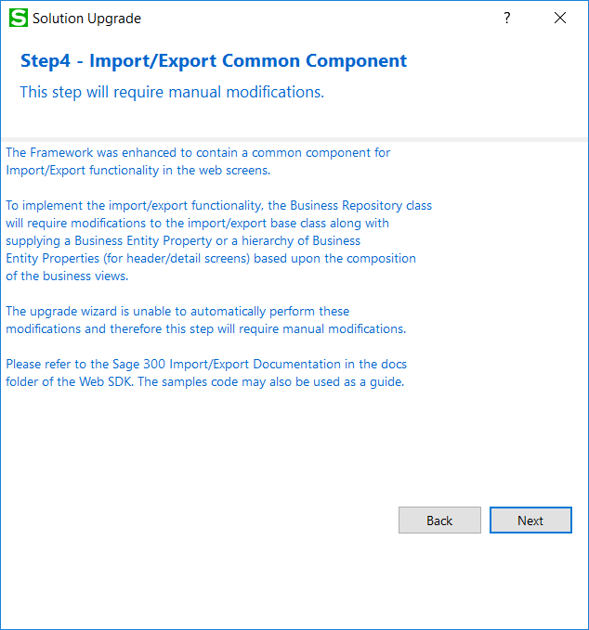

**Important:** This step requires manual modifications. The Sage 300 Upgrade Wizard is unable to automatically perform these changes. For specific details, refer to **Sage300SDK_ImportExport.docx** located in the docs\upgrades folder**.**

Click Next to proceed or Back to go back to the previous step.

* 1. Step 5 – Enable XML Documentation Property (optional)

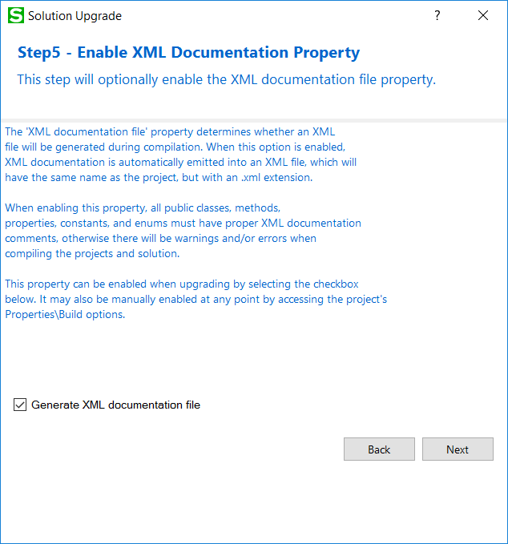

Optionally select the checkbox for generating an XML documentation file.

Click Next to proceed or Back to go back to the previous step.

* 1. Step 6 – Confirmation

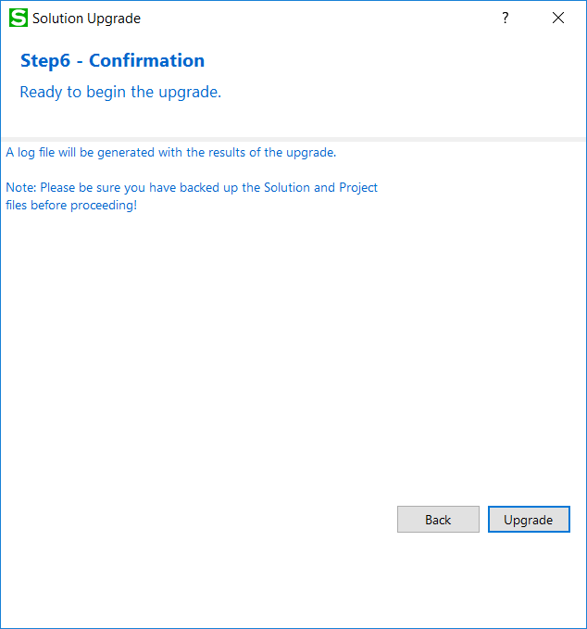

The solution and projects are ready to be upgraded.

Click Upgrade to upgrade the solution and projects or Back to go back to the previous step.

* 1. Step 7 - Recompile

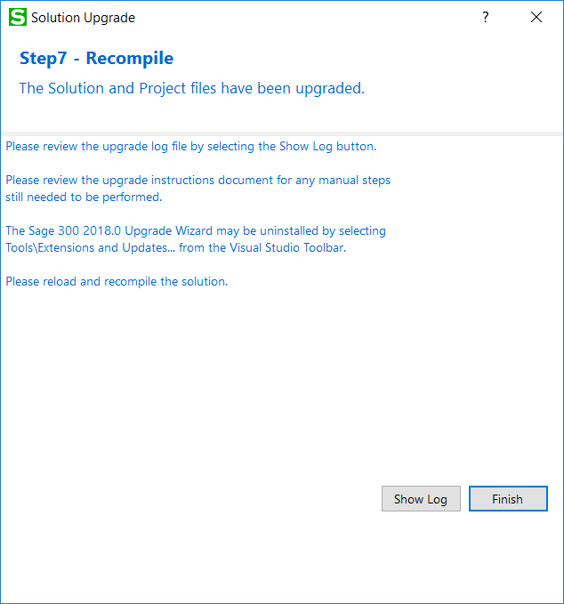

Click **Show Log** to display log file. The log file displays what files have been upgraded or modified. At this point, the upgrade is now complete.

Click **Finish** to exit the wizard.

After the solution that supported the Sage 300 2017.2 version has been upgraded to support 2018, you need to reload and recompile the solution. For compilation troubleshooting, see the next section.

**Note:** Before running the new solution, clear the browser cache to replace cached JavaScript and CSS files.

1. Modify LoginResult Function

* **Files affected**

{Namespace.Web}\Global.asax.cs

* **Description**

Add an extra parameter to the LoginResult function call. You now need to pass in a list of companies as the last parameter.

* **Before Change**



* **After Change**

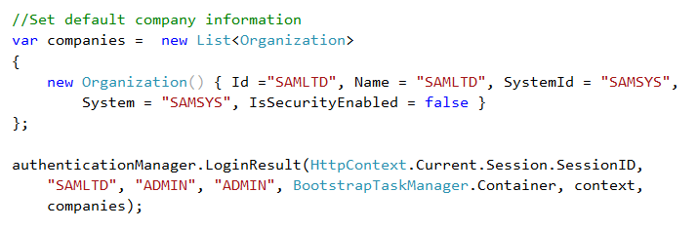

1. Compilation Troubleshooting

**Parser Error when loading Web project in browser**

* Clean solution
* In Web project folder:
  + delete bin and obj folders
  + delete *csproj.user file