Sage 300 Web Screens SDK

Upgrade Guide for 2020.1 to 2020.2

December 2019

The MIT License (MIT)

Copyright © 1994-2019 The Sage Group plc or its licensors. All rights reserved.

Permission is hereby granted, free of charge, to any person obtaining a copy of this software and associated documentation files (the “Software”), to deal in the Software without restriction, including without limitation the rights to use, copy, modify, merge, publish, distribute, sublicense, and/or sell copies of the Software, and to permit persons to whom the Software is furnished to do so, subject to the following conditions:

The above copyright notice and this permission notice shall be included in all copies or substantial portions of the Software.

THE SOFTWARE IS PROVIDED “AS IS”, WITHOUT WARRANTY OF ANY KIND, EXPRESS OR IMPLIED, INCLUDING BUT NOT LIMITED TO THE WARRANTIES OF MERCHANTABILITY, FITNESS FOR A PARTICULAR PURPOSE AND NONINFRINGEMENT. IN NO EVENT SHALL THE AUTHORS OR COPYRIGHT HOLDERS BE LIABLE FOR ANY CLAIM, DAMAGES OR OTHER LIABILITY, WHETHER IN AN ACTION OF CONTRACT, TORT OR OTHERWISE, ARISING FROM, OUT OF OR IN CONNECTION WITH THE SOFTWARE OR THE USE OR OTHER DEALINGS IN THE SOFTWARE.

Contents

1. Overview 4

1.1 Required Version of Sage 300 5

2. Installing the Sage 300 Upgrade Wizard 6

3. Accessing the Sage 300 2020.2 Upgrade Wizard 7

4. Using the Sage 300 Upgrade Wizard 8

4.1 Step 1 – Synchronize Kendo Files 9

4.2 Step 2 – Synchronize Web Files 10

4.3 Step 3 – Theme color changes 11

4.4 Step 3 – Confirmation 12

4.5 Step 4 – Recompile 13

5. Upgrade Log 14

6. Theme Color changes 15

7. Compilation Troubleshooting 16

1. Overview

This document is intended to serve as a guide for illustrating how to use the Sage 300 Upgrade Wizard to upgrade Visual Studio solutions and projects that are compatible with the Web Screens SDK 2020.0to Web Screens SDK 2020.1.

The wizard will upgrade the solution and projects in following steps:

* Synchronize Kendo Files
* Synchronize Web Files
  1. Required Version of Sage 300

To get started, install Sage 300 2020.2 with the Web Screens option selected.

1. Installing the Sage 300 Upgrade Wizard

The Upgrade Wizard is a Visual Studio Plugin that was developed in Visual Studio 2017 and is compatible with Visual Studio 2017 and Visual Studio 2019.

**Note:** If the previous Upgrade Wizard is installed, it must be uninstalled first (In Visual Studio - Tools, Components and Extensions, Uninstall option once the Upgrade Wizard is selected).

To install the wizard:

1. Run Sage300UpgradeWizardPackage.vsix.
2. Select the Install the Wizard Package option.
3. Accessing the Sage 300 2020.2 Upgrade Wizard

The **Sage 300 2020.2 Upgrade Wizard** is a Visual Studio Plugin. To open it, with the partner solution loaded in Visual Studio, right-click the solution, and on the context menu, click Sage 300 2020.2 Upgrade Wizard.

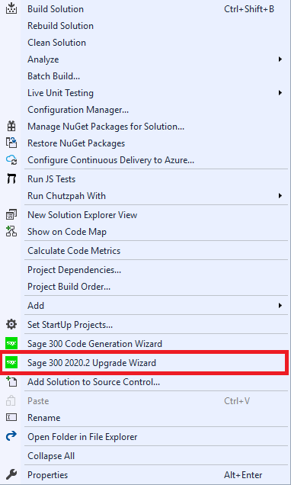

1. Using the Sage 300 Upgrade Wizard

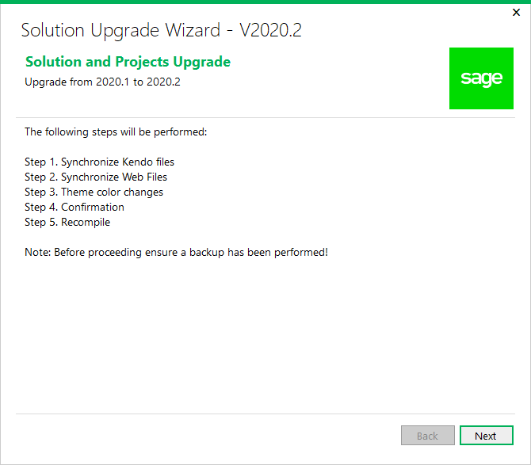

**Important:** Please backup the solution and projects before proceeding with the upgrade.

**Select Next to continue to the next step.**

* 1. Step 1 – Synchronize Kendo Files

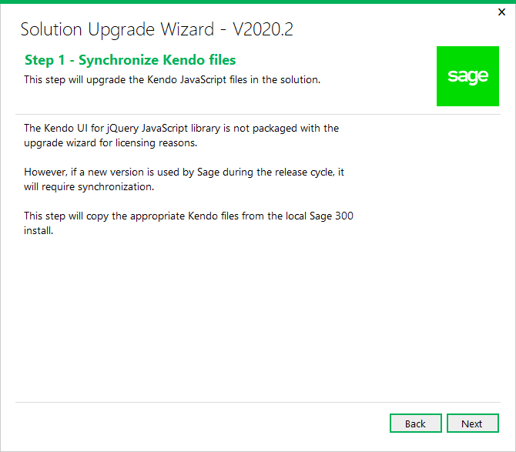

A copy of the Kendo UI for jQuery JavaScript library will be copied into the solution from the local Sage 300 installation.

Click Next to proceed or Back to go back to the previous step.

* 1. Step 2 – Synchronize Web Files

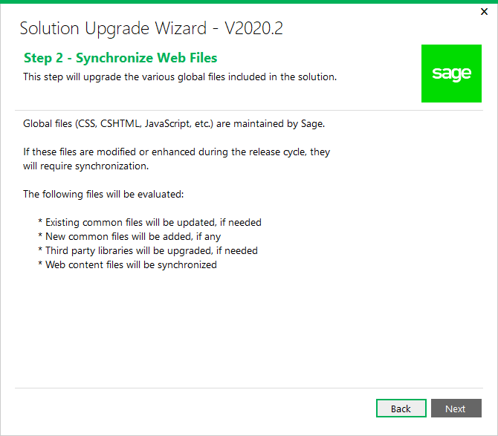

Contents in the Web Projects Areas\Shared, Areas\Core, Views, Scripts, Content, and Assets folders are upgraded in this step.

Click Next to proceed or Back to go back to the previous step.

* 1. Step 3 – Theme color changes

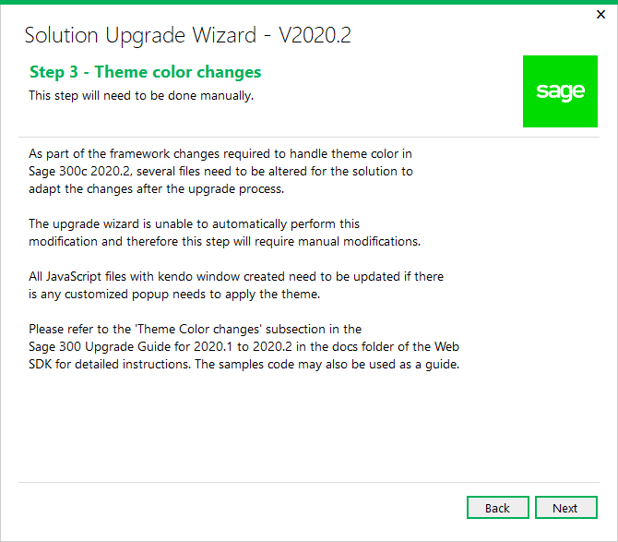

This is simply an informational step. See Section 6 – Theme color changes for full details on the manual modifications required.

Click Next to proceed or Back to go back to the previous step.

* 1. Step 3 – Confirmation

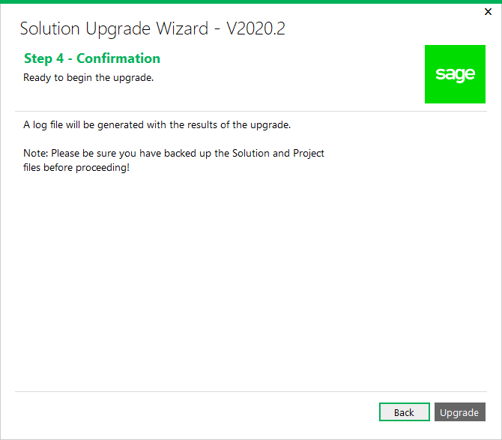

The solution and projects are ready to be upgraded.

Click Upgrade to upgrade the solution and projects or Back to go back to the previous step.

* 1. Step 4 – Recompile

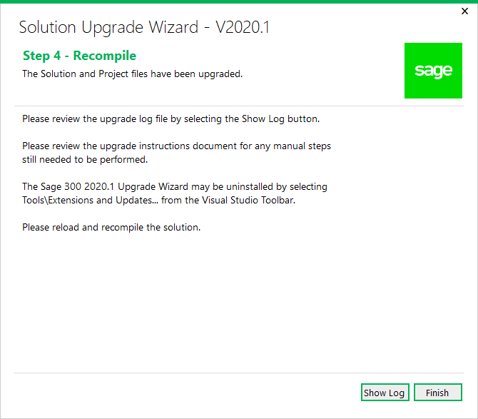

Click **Show Log** to display log file. The log file displays what files have been upgraded or modified. At this point, the upgrade is now complete.

Click **Finish** to exit the wizard.

After the solution that supported Sage 300 2020.0 has been upgraded to support 2020.1, you need to reload and recompile the solution. For compilation troubleshooting, see the next section.

**Note:** Before running the new solution, clear the browser cache to replace cached JavaScript and CSS files.

1. Upgrade Log

Once the Upgrade Wizard has completed you have the option to ‘Show Log’ to view the upgrade log. The following is a screenshot of a typical upgrade log.

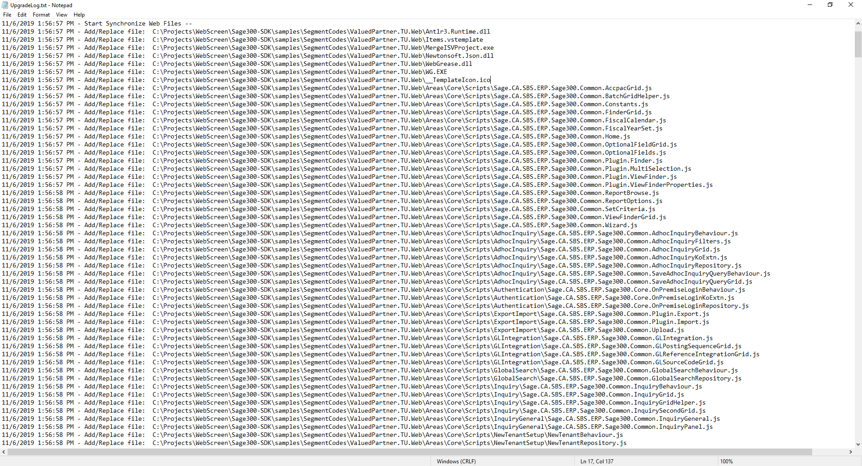

1. Theme Color changes

* **Files affected**

All the JavaScript files that have customized kendoWindow defined.

* **Description**

Add an open method to set the background color of the title of the popup window when the kendoWindow is opened (see example).

If the open function already declared, please add the setBackgroundColor function to it.

* **Before Change**

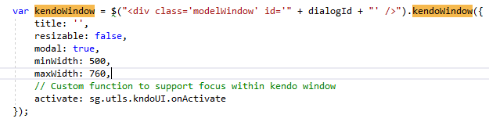

* **After Change**

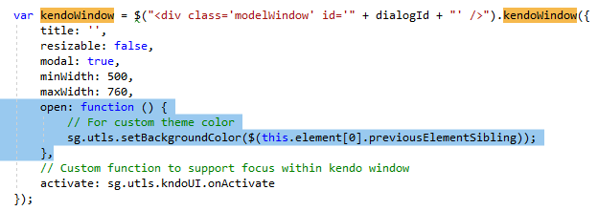

1. Compilation Troubleshooting

**Parser Error when loading Web project in browser**

* Clean solution
* In Web project folder:
  + delete bin and obj folders
  + delete *csproj.user file