Sage 300 Web Screens SDK

Upgrade Guide for 2021.2 to 2022.0

August 2021

The MIT License (MIT)

Copyright © 1994-2021 The Sage Group plc or its licensors. All rights reserved.

Permission is hereby granted, free of charge, to any person obtaining a copy of this software and associated documentation files (the “Software”), to deal in the Software without restriction, including without limitation the rights to use, copy, modify, merge, publish, distribute, sublicense, and/or sell copies of the Software, and to permit persons to whom the Software is furnished to do so, subject to the following conditions:

The above copyright notice and this permission notice shall be included in all copies or substantial portions of the Software.

THE SOFTWARE IS PROVIDED “AS IS”, WITHOUT WARRANTY OF ANY KIND, EXPRESS OR IMPLIED, INCLUDING BUT NOT LIMITED TO THE WARRANTIES OF MERCHANTABILITY, FITNESS FOR A PARTICULAR PURPOSE AND NONINFRINGEMENT. IN NO EVENT SHALL THE AUTHORS OR COPYRIGHT HOLDERS BE LIABLE FOR ANY CLAIM, DAMAGES OR OTHER LIABILITY, WHETHER IN AN ACTION OF CONTRACT, TORT OR OTHERWISE, ARISING FROM, OUT OF OR IN CONNECTION WITH THE SOFTWARE OR THE USE OR OTHER DEALINGS IN THE SOFTWARE.

Contents

1. Overview 4

1.1 Required Version of Sage 300 5

2. Installing the Sage 300 Upgrade Wizard 6

3. Accessing the Sage 300 2022.0 Upgrade Wizard 7

4. Using the Sage 300 Upgrade Wizard 8

4.1 Step 1 – Synchronize Kendo Files 9

4.2 Step 2 – Synchronize Web Files 10

4.3 Step 3 – Synchronize Accpac Libraries 11

4.4 Step 4 – Remove previous version of jQuery libraries 12

4.5 Step 5 – Namespace and Web Project Updates 13

4.6 Step 6 – Finder Alterations 14

4.7 Step 7 – Javascript Minification Updates 15

4.8 Step 8 – Confirmation 16

4.9 Step 9 – Recompile 17

5. Upgrade Log 18

6. Finder Alterations 19

7. Javascript Minification Updates 20

8. Compilation Troubleshooting 21

1. Overview

This document is intended to serve as a guide for illustrating how to use the Sage 300 Upgrade Wizard to upgrade Visual Studio solutions and projects that are compatible with the Web Screens SDK 2021.2 to Web Screens SDK 2022.0.

The wizard will upgrade the solution and projects in following steps:

* Synchronize Kendo Files
* Synchronize Web Files
* Synchronize Accpac Libraries
* Remove previous version of jQuery libraries
* Namespace and Web Project Updates
* Finder Alterations
* Javascript Minification Updates
  1. Required Version of Sage 300

To get started, install Sage 300 2022.0 with the Web Screens option selected.

1. Installing the Sage 300 Upgrade Wizard

The Upgrade Wizard is a Visual Studio Plugin and is compatible with Visual Studio 2019.

**Note:** If the previous Upgrade Wizard is installed, it must be uninstalled first (In Visual Studio - Tools, Components and Extensions, Uninstall option once the Upgrade Wizard is selected).

To install the wizard:

1. Run Sage300UpgradeWizardPackage.vsix.
2. Select the Install the Wizard Package option.
3. Accessing the Sage 300 2022.0 Upgrade Wizard

The **Sage 300 2022.0 Upgrade Wizard** is a Visual Studio Plugin. To open it, with the partner solution loaded in Visual Studio, right-click the solution, and on the context menu, click Sage 300 2022.0 Upgrade Wizard.

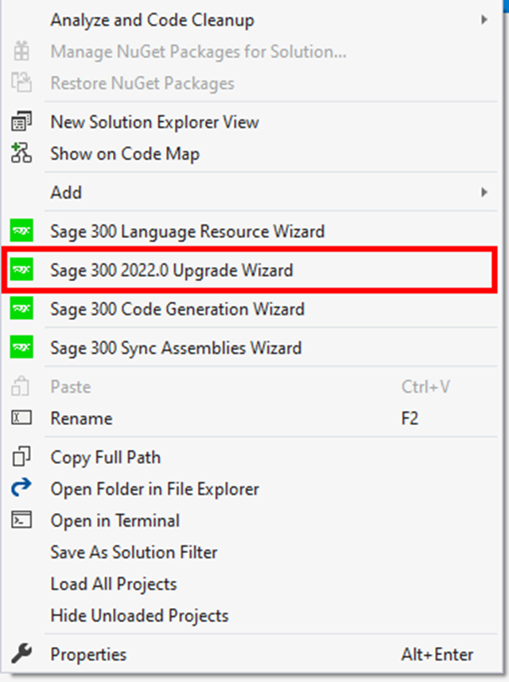

1. Using the Sage 300 Upgrade Wizard

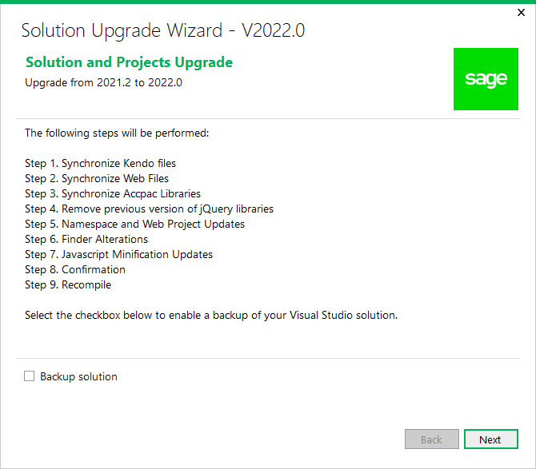­

**Important:** Please backup the solution and projects before proceeding with the upgrade. If you would like the Upgrade Wizard to make a backup of your solution, click the ‘Backup solution’ checkbox.

Click **Next** to continue to the next step.

* 1. Step 1 – Synchronize Kendo Files

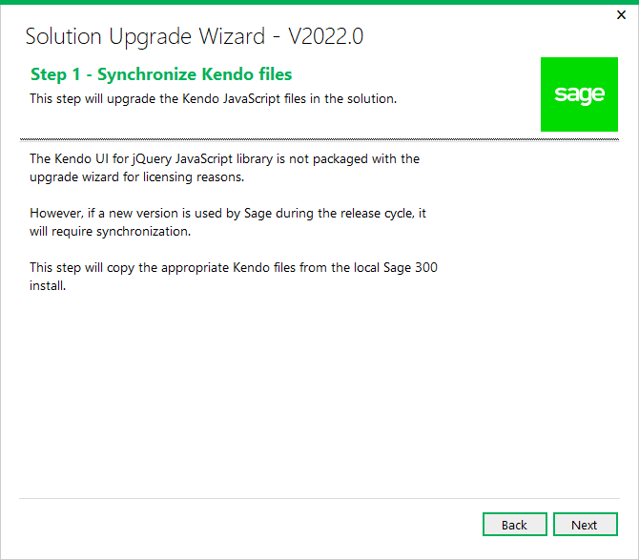

A copy of the Kendo UI for jQuery JavaScript library will be copied into the solution from the local Sage 300 installation.

Click Next to proceed or Back to go back to the previous step.

* 1. Step 2 – Synchronize Web Files

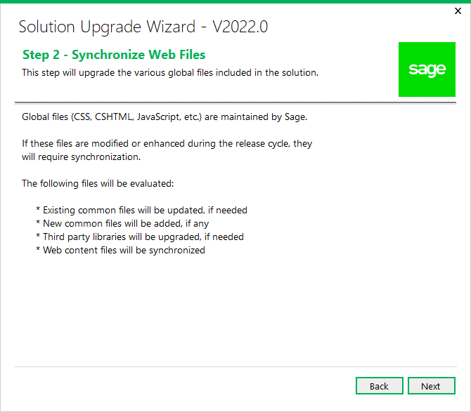

Contents in the Web Projects Areas\Shared, Areas\Core, Views, Scripts, Content, and Assets folders are upgraded in this step.

Click Next to proceed or Back to go back to the previous step.

* 1. Step 3 – Synchronize Accpac Libraries

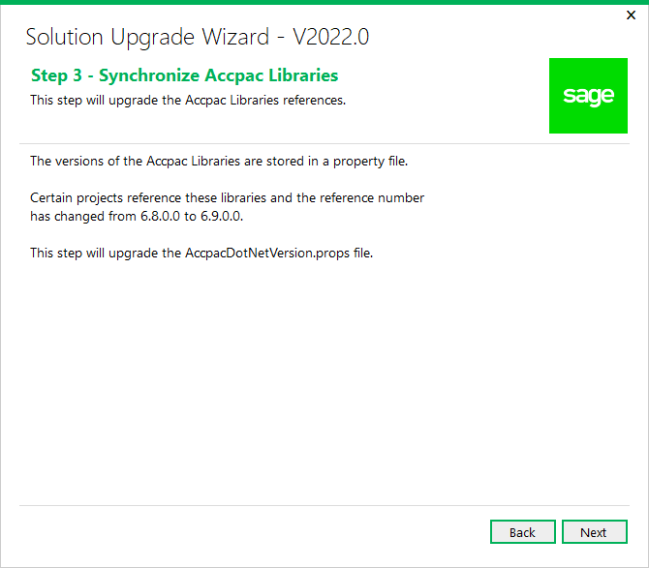

The upgrade wizard will search for copies of the **AccpacDotNetVersion.props** file in the following locations:

* + Root of the Solution folder
    - If found, it will stop looking. If not found, it will then search in the root of each project folder within the solution.

If the **AccpacDotNetVersion.props** file is found in the root of the solution folder, it will be upgraded as normal. If the **AccpacDotNetVersion.props** file is not found in the root of the solution folder but is found in one or more project folders, the wizard will update the project file (.csproj) in each of these folders with the correct path to the **AccpacDotNetVersion.props** file located in the solution folder and then remove the copy of the **AccpacDotNetVersion.props** file in the project folder. When this process has completed, the solution should contain only a single **AccpacDotNetVersion.props** file located in the root of the solution folder.

Click Next to proceed or Back to go back to the previous step.

* 1. Step 4 – Remove previous version of jQuery libraries

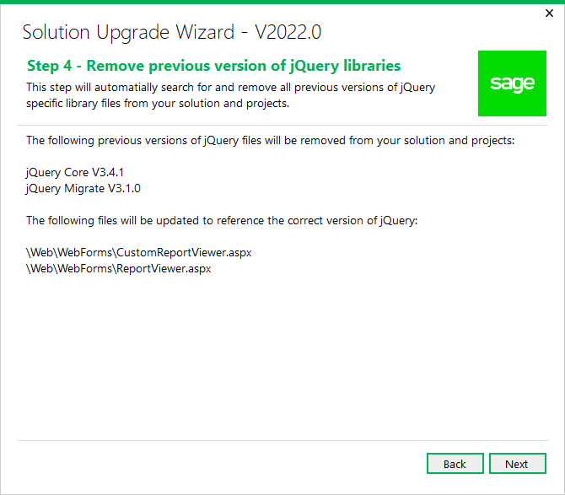

The upgrade wizard will automatically remove the following:

* + jQuery Core V3.4.1
  + jQuery Migrate V3.1.0

The upgrade wizard will also update some of your solution files to reference the correct version of jQuery. The 2022.0 release uses jQuery V3.6.0.

Click Next to proceed or Back to go back to the previous step.

* 1. Step 5 – Namespace and Web Project Updates

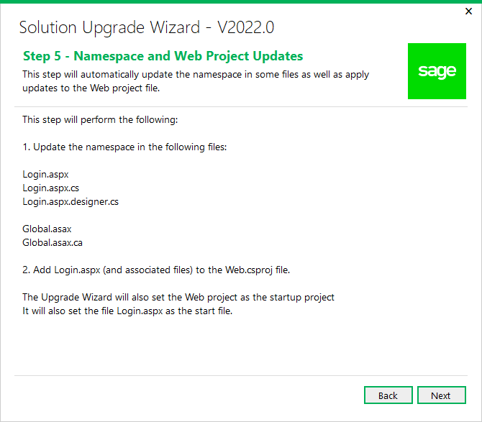

The upgrade wizard will determine the root Web namespace and update a select list of files with this namespace. Once that has been done, the upgrade wizard will add the file Login.aspx and associated related files to the Web project.

Click Next to proceed or Back to go back to the previous step.

* 1. Step 6 – Finder Alterations

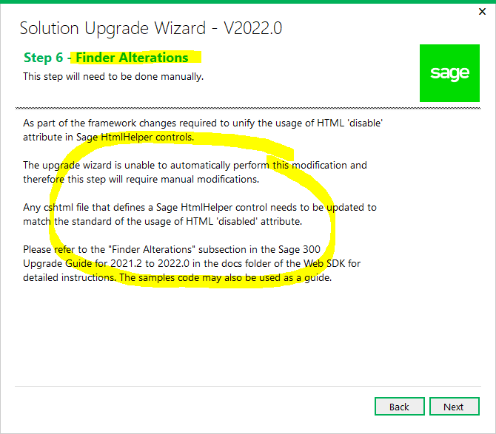

This is simply an informational step. See Section 6 – Finder Alterations for full details on the manual modifications required.

Click Next to proceed or Back to go back to the previous step.

* 1. Step 7 – Javascript Minification Updates

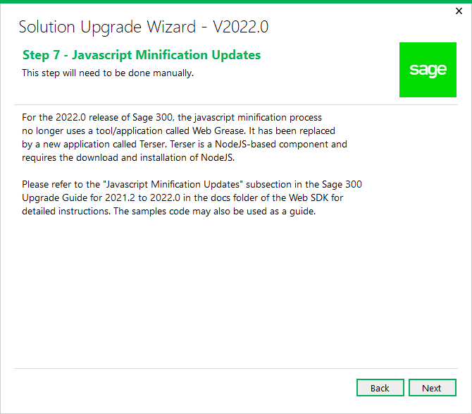

This is simply an informational step. See Section 7 – Javascript Minification Updates for full details on the manual modifications required.

Click Next to proceed or Back to go back to the previous step.

ddddd

* 1. Step 8 – Confirmation

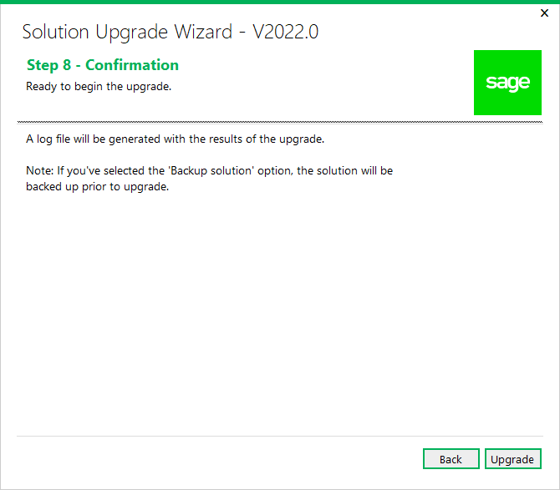

The solution and projects are ready to be upgraded.

Click Upgrade to upgrade the solution and projects or Back to go back to the previous step.

* 1. Step 9 – Recompile

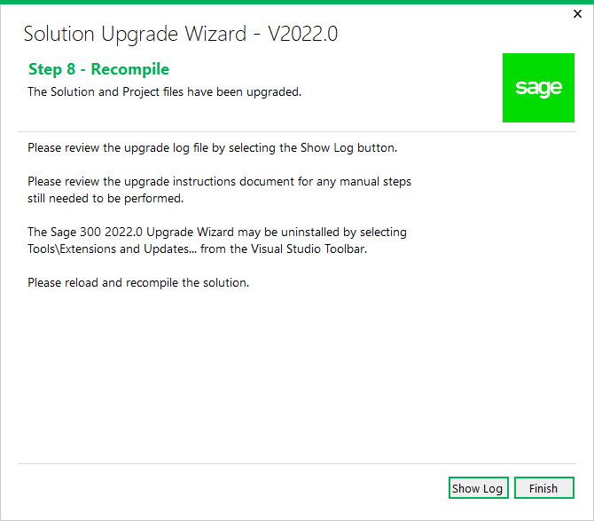

Click **Show Log** to display log file. The log file displays what files have been upgraded or modified. At this point, the upgrade is now complete.

Click **Finish** to exit the wizard.

After the solution that supported Sage 300 2021.2 has been upgraded to support 2022.0, you need to reload and recompile the solution. For compilation troubleshooting, see the next section.

**Note:** Before running the new solution, clear the browser cache to replace cached JavaScript and CSS files.

1. Upgrade Log

Once the Upgrade Wizard has completed you have the option to ‘Show Log’ to view the upgrade log. The following is a screenshot of a typical upgrade log.

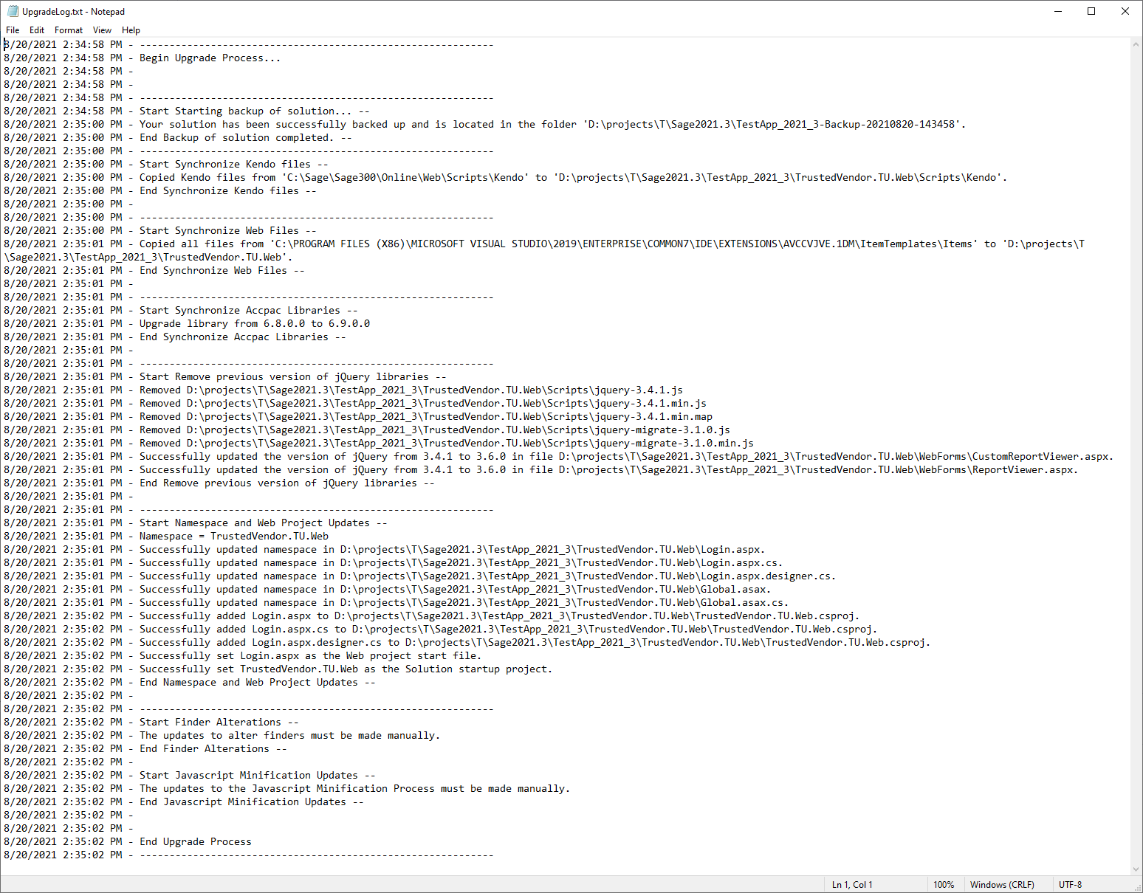

1. Finder Alterations
   * TODO – Add Detailed Instructions Here
2. Javascript Minification Updates

For the 2022.0 release of Sage 300, the javascript minification process no longer uses a tool/application called Web Grease. It has been replaced by a new application called [Terser](https://terser.org/). Terser is a NodeJS-based component and requires the download and installation of NodeJS.

**Instructions for downloading/installing NodeJS**

* + Download the NodeJS installer from <https://nodejs.org/en/download/> and select your target operating system.
  + Follow the instructions in the installer to complete the setup process.

1. Compilation Troubleshooting

**Parser Error when loading Web project in browser**

* Clean solution
* In Web project folder:
  + delete bin and obj folders