Sage 300 Web Screens SDK

Upgrade Guide for 2022.2 to 2023.0

August 2022

The MIT License (MIT)

Copyright © 1994-2022 The Sage Group plc or its licensors. All rights reserved.

Permission is hereby granted, free of charge, to any person obtaining a copy of this software and associated documentation files (the “Software”), to deal in the Software without restriction, including without limitation the rights to use, copy, modify, merge, publish, distribute, sublicense, and/or sell copies of the Software, and to permit persons to whom the Software is furnished to do so, subject to the following conditions:

The above copyright notice and this permission notice shall be included in all copies or substantial portions of the Software.

THE SOFTWARE IS PROVIDED “AS IS”, WITHOUT WARRANTY OF ANY KIND, EXPRESS OR IMPLIED, INCLUDING BUT NOT LIMITED TO THE WARRANTIES OF MERCHANTABILITY, FITNESS FOR A PARTICULAR PURPOSE AND NONINFRINGEMENT. IN NO EVENT SHALL THE AUTHORS OR COPYRIGHT HOLDERS BE LIABLE FOR ANY CLAIM, DAMAGES OR OTHER LIABILITY, WHETHER IN AN ACTION OF CONTRACT, TORT OR OTHERWISE, ARISING FROM, OUT OF OR IN CONNECTION WITH THE SOFTWARE OR THE USE OR OTHER DEALINGS IN THE SOFTWARE.

Contents

1. Overview 4

1.1 Required Version of Sage 300 5

2. Installing the Sage 300 Upgrade Wizard 6

3. Accessing the Sage 300 2023 Upgrade Wizard 7

4. Using the Sage 300 Upgrade Wizard 8

4.1 Step 1 – Synchronize Kendo Files 9

4.2 Step 2 – Synchronize Web Files 10

4.3 Step 3 – Synchronize Accpac Libraries 11

4.4 Step 4 – Remove deprecated ‘WebForms’ folder 12

4.5 Step 5 – Confirmation 13

4.6 Step 6 – Recompile 14

5. Upgrade Log 15

6. Manual Alterations 16

7. Compilation Troubleshooting 19

1. Overview

This document is intended to serve as a guide for illustrating how to use the Sage 300 Upgrade Wizard to upgrade Visual Studio solutions and projects that are compatible with the Web Screens SDK 2022.2 to Web Screens SDK 2023.0.

The wizard will upgrade the solution and projects in following steps:

* Synchronize Kendo Files
* Synchronize Web Files
* Synchronize Accpac Libraries
* Remove deprecated ‘WebForms’ folder
  1. Required Version of Sage 300

To get started, install Sage 300 2023 with the Web Screens option selected.

1. Installing the Sage 300 Upgrade Wizard

The Upgrade Wizard is a Visual Studio Plugin and is compatible with Visual Studio 2019.

**Note:** If the previous Upgrade Wizard is installed, it must be uninstalled first (In Visual Studio - Tools, Components and Extensions, uninstall option once the Upgrade Wizard is selected).

To install the wizard:

1. Run Sage300UpgradeWizardPackage.vsix.
2. Select the Install the Wizard Package option.
3. Accessing the Sage 300 2023 Upgrade Wizard

The **Sage 300 2023 Upgrade Wizard** is a Visual Studio Plugin. To open it, with the partner solution loaded in Visual Studio, right-click the solution, and on the context menu, click Sage 300 2023 Upgrade Wizard.

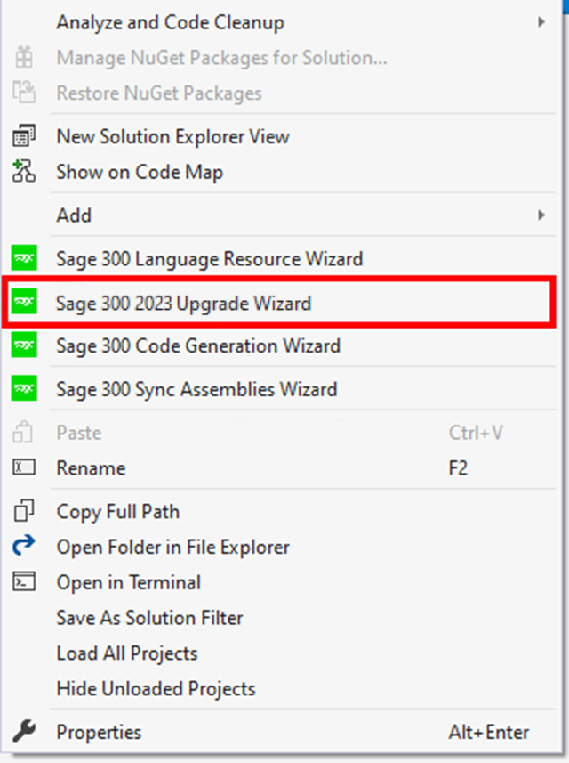

1. Using the Sage 300 Upgrade Wizard

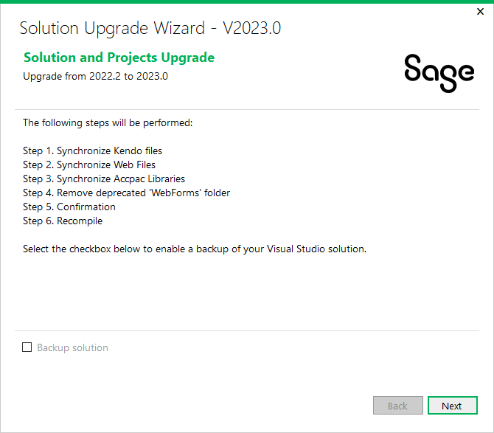­

**Important:** Please backup the solution and projects before proceeding with the upgrade. If you would like the Upgrade Wizard to make a backup of your solution, click the ‘Backup solution’ checkbox.

Click **Next** to continue to the next step.

* 1. Step 1 – Synchronize Kendo Files

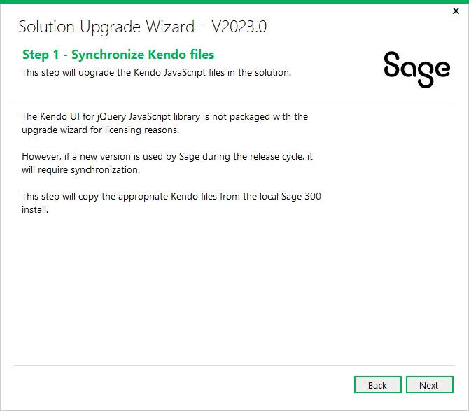

A copy of the Kendo UI for jQuery JavaScript library will be copied into the solution from the local Sage 300 installation.

Click Next to proceed or Back to go back to the previous step.

* 1. Step 2 – Synchronize Web Files

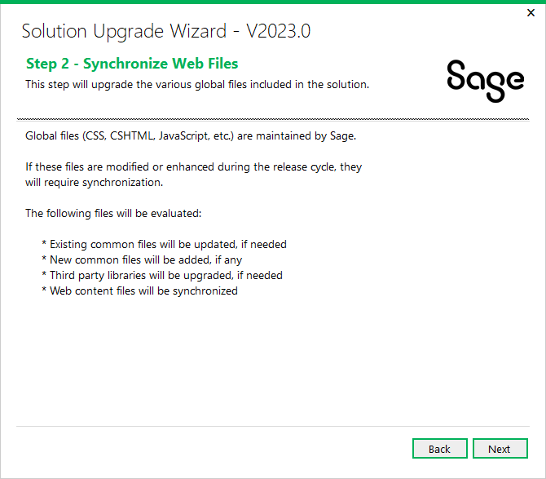

Contents in the Web Projects Areas\Shared, Areas\Core, Views, Scripts, Content, and Assets folders are upgraded in this step.

Click Next to proceed or Back to go back to the previous step.

* 1. Step 3 – Synchronize Accpac Libraries

Click Next to proceed or Back to go back to the previous step.

* 1. Step 4 – Remove deprecated ‘WebForms’ folder

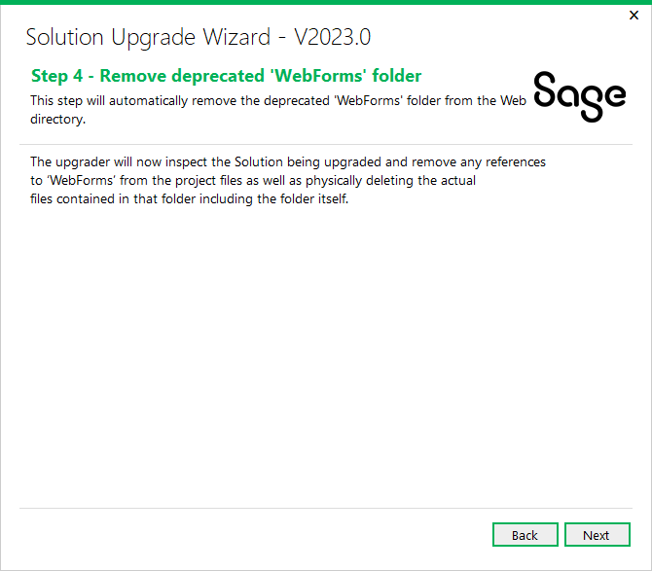

The upgrader will now inspect the Solution being upgraded and remove any references to ‘WebForms’ from the project files as well as physically deleting the actual files contained in that folder including the folder itself.

Click Next to proceed or Back to go back to the previous step.

* 1. Step 5 – Confirmation

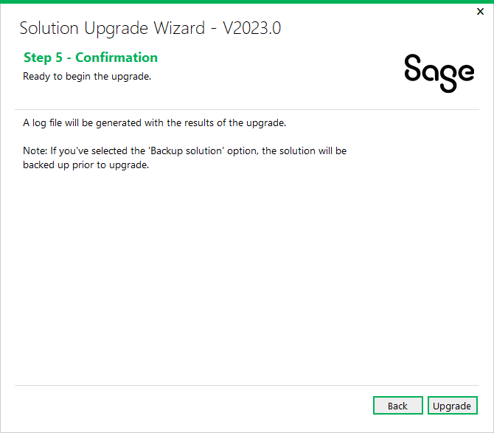

The solution and projects are ready to be upgraded.

Click Upgrade to upgrade the solution and projects or Back to go back to the previous step.

* 1. Step 6 – Recompile

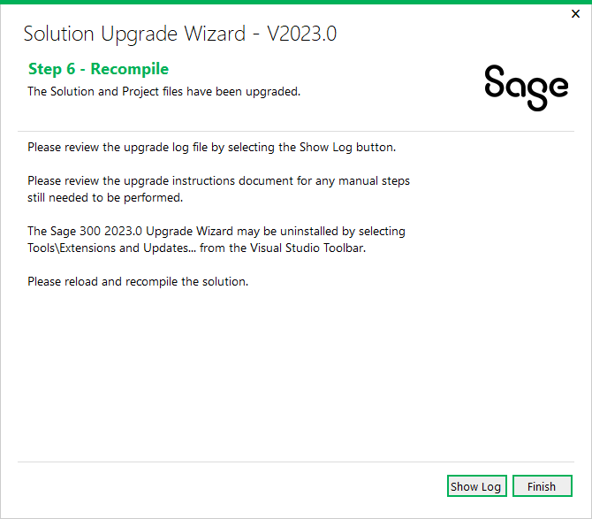

Click **Show Log** to display log file. The log file displays what files have been upgraded or modified. At this point, the upgrade is now complete.

Click **Finish** to exit the wizard.

After the solution that supported Sage 300 2022.2 has been upgraded to support 2023.0, you need to reload and recompile the solution. For compilation troubleshooting, see the next section.

**Note:** Before running the new solution, clear the browser cache to replace cached JavaScript and CSS files.

1. Upgrade Log

Once the Upgrade Wizard has completed you have the option to ‘Show Log’ to view the upgrade log. The following is a screenshot of a typical upgrade log.

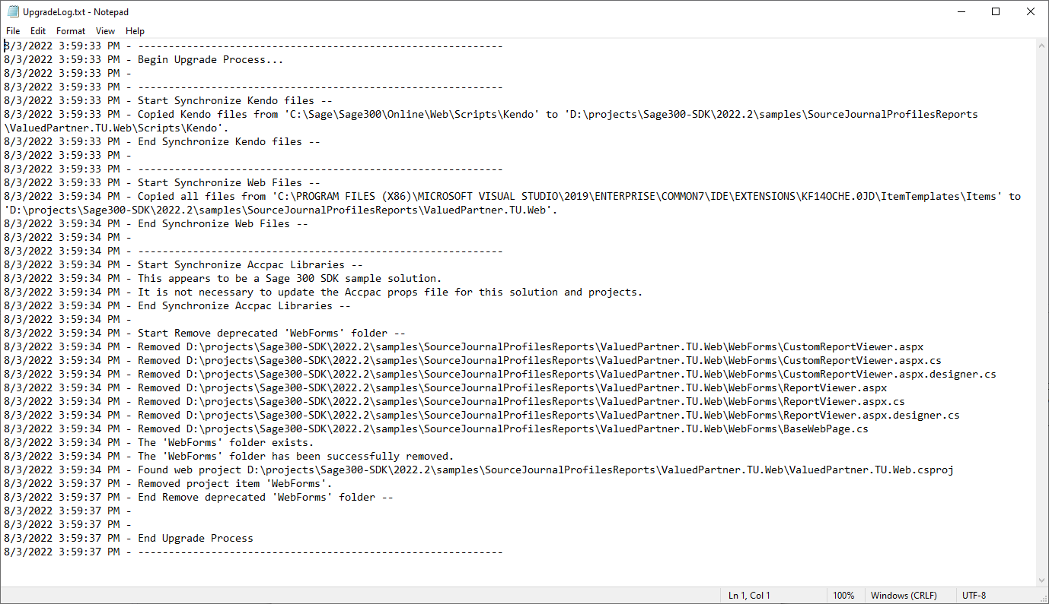

1. Manual Alterations

Once you have completed the automated upgrade steps some further steps may be necessary for you to compile and run your application correctly. This section will outline these steps in greater detail.

* + - 1. **Removal of deprecated ViewModel attribute.**

For the 2023.0 release Sage has deprecated the **ViewModel** attribute. Inspect the various classes in your Models project and remove the **ViewModel** attribute if found. The following is an example of this attribute being used:

The presence of the ViewModel attribute varies based upon which version of the Web SDK that created the model.

* + - 1. **IsOnPremise property is no longer part of the ConfigurationHelper object.**

For the 2023.0 release, Sage has removed the **IsOnPremise** value from the web.config and subsequently this property is no longer available in the ConfigurationHelper object. The following is an example of this property being used in code:

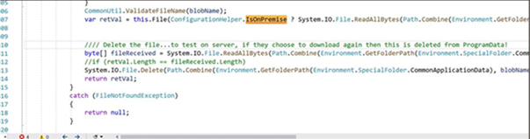

Please remove references to the **ConfigurationHelper.IsOnPremise** property and directly implement the ***true*** logic of the condition since it will always be on-premises.

1. **GetBlobContainer is no longer a part of CommonService.**

For the 2023.0 release, Sage has removed this method. This was done as part of the removal of Azure functionality. The following is an example of this being used in code:

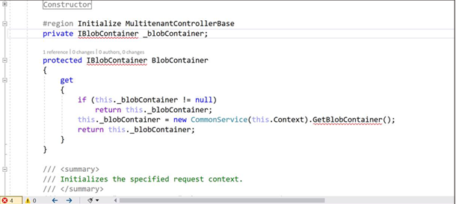

Please remove the private variable and BlobContainer property.

The presence of the BlobContainer property in a controller varies based upon which version of the Web SDK that created the code file.

1. Compilation Troubleshooting

**Parser Error when loading Web project in browser**

* Clean solution
* In Web project folder:
  + delete bin and obj folders