Sage 300 Web Screens SDK

Upgrade Guide for 2024.0 to 2024.2

May 2024

The MIT License (MIT)

Copyright © 2024 The Sage Group plc or its licensors. All rights reserved.

Permission is hereby granted, free of charge, to any person obtaining a copy of this software and associated documentation files (the “Software”), to deal in the Software without restriction, including without limitation the rights to use, copy, modify, merge, publish, distribute, sublicense, and/or sell copies of the Software, and to permit persons to whom the Software is furnished to do so, subject to the following conditions:

The above copyright notice and this permission notice shall be included in all copies or substantial portions of the Software.

THE SOFTWARE IS PROVIDED “AS IS”, WITHOUT WARRANTY OF ANY KIND, EXPRESS OR IMPLIED, INCLUDING BUT NOT LIMITED TO THE WARRANTIES OF MERCHANTABILITY, FITNESS FOR A PARTICULAR PURPOSE AND NONINFRINGEMENT. IN NO EVENT SHALL THE AUTHORS OR COPYRIGHT HOLDERS BE LIABLE FOR ANY CLAIM, DAMAGES OR OTHER LIABILITY, WHETHER IN AN ACTION OF CONTRACT, TORT OR OTHERWISE, ARISING FROM, OUT OF OR IN CONNECTION WITH THE SOFTWARE OR THE USE OR OTHER DEALINGS IN THE SOFTWARE.

Contents

1. Overview 4

1.1 Required Version of Sage 300 5

2. Installing the Wizard 6

3. Accessing the Wizard 7

4. Using the Wizard 8

4.1 Step 1 – Synchronize Kendo Files 9

4.2 Step 2 – Synchronize Web Files 10

4.3 Step 3 – Synchronize Accpac Libraries 11

4.4 Step 3 – Confirmation 12

4.5 Step 4 – Recompile 13

5. Upgrade Log 14

6. Compilation Troubleshooting 15

1. Overview

This document is intended to serve as a guide for illustrating how to use the Sage 300 Upgrade Wizard to upgrade Visual Studio solutions and projects that are compatible with the Web Screens SDK 2024.0 to Web Screens SDK 2024.2

The wizard will upgrade the solution and projects in following steps:

* Synchronize Kendo Files
* Synchronize Web Files
* Synchronize Accpac Libraries
  1. Required Version of Sage 300

To get started, install Sage 300 2024.2 with the Web Screens option selected.

1. Installing the Wizard

The Upgrade Wizard is a Visual Studio Plugin and is compatible with Visual Studio 2022. The Sage 300 Upgrade Wizard tool is bundled with the Sage 300 Wizard Package (Code Generation Wizard, Finder Generator, Upgrade Wizard, Language Wizard, and Sync Assemblies Wizard)

**Note:** If the previous Sage 300 Wizard Package is installed, it must be uninstalled first (Visual Studio - Tools, Extensions, Uninstall option, select the Sage 300 Wizard Package to uninstall).

To install the utility:

1. Run Sage.CA.SBS.ERP.Sage300.WizardPackage.vsix.
2. Select the Install the Wizard Package option.
3. Note: Installing this package installs the above-mentioned wizards since they are combined in the same package.
4. Accessing the Wizard

The wizard is embedded in Visual Studio 2022 as a plugin. To open it, click the **Extensions** menu on the Visual Studio toolbar, select the **Sage 300** menu, and click **Upgrade** Wizard.

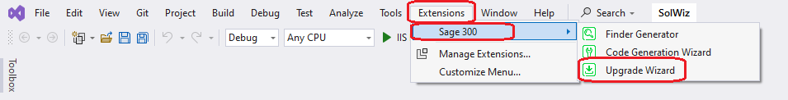

1. Using the Wizard

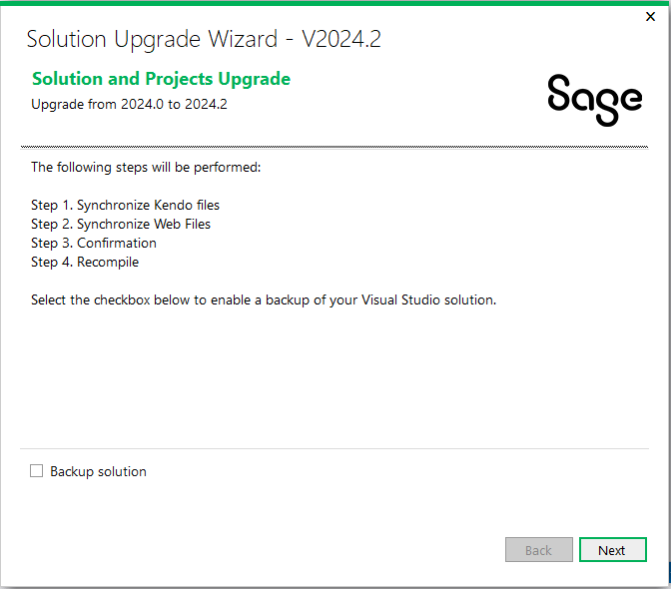­

**Important:** Please backup the solution and projects before proceeding with the upgrade. If you would like the Upgrade Wizard to make a backup of your solution, click the ‘Backup solution’ checkbox.

Click **Next** to continue to the next step.

* 1. Step 1 – Synchronize Kendo Files

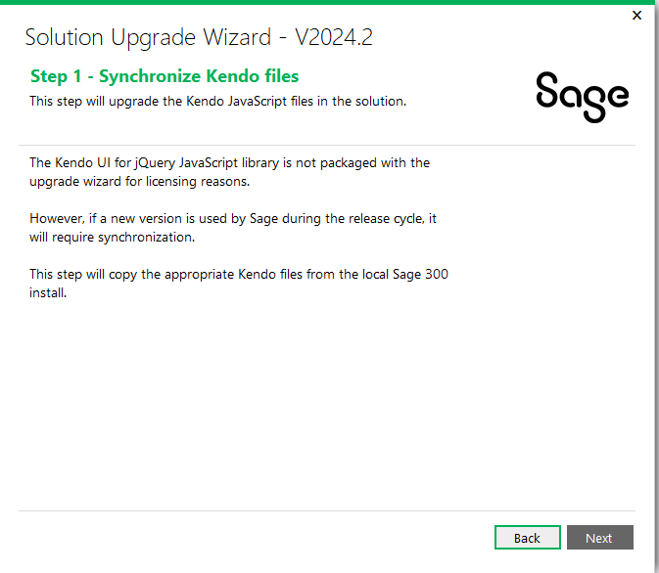

A copy of the Kendo UI for jQuery JavaScript library will be copied into the solution from the local Sage 300 installation.

Click Next to proceed or Back to go back to the previous step.

* 1. Step 2 – Synchronize Web Files

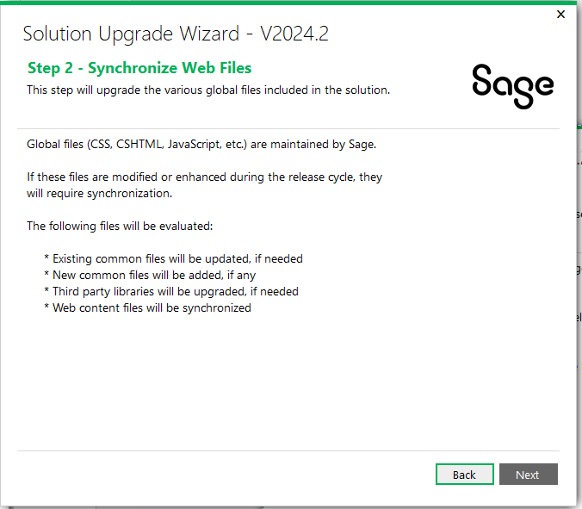

Contents in the Web Projects Areas\Shared, Areas\Core, Views, Scripts, Content, and Assets folders are upgraded in this step.

Click Next to proceed or Back to go back to the previous step.

* 1. Step 3 – Synchronize Accpac Libraries

Note: Step skipped for 2024.2

Accpac libraries are updated from 7.1.0.0 to 7.1.0.0.

Click Next to proceed or Back to go back to the previous step.

* 1. Step 3 – Confirmation

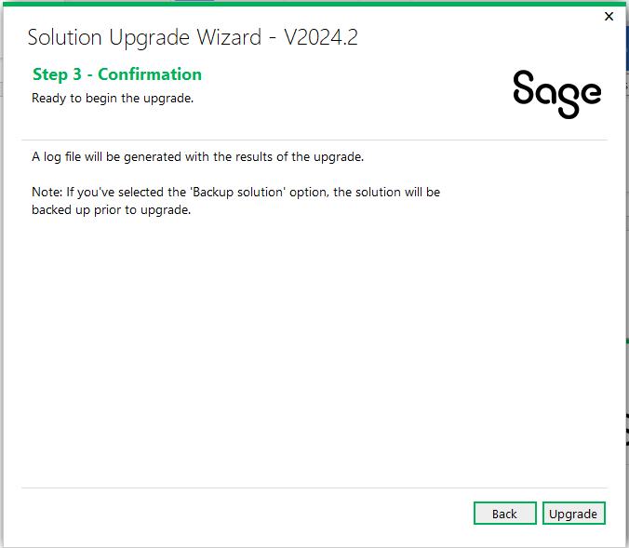

The solution and projects are ready to be upgraded.

Click Upgrade to upgrade the solution and projects or Back to go back to the previous step.

* 1. Step 4 – Recompile

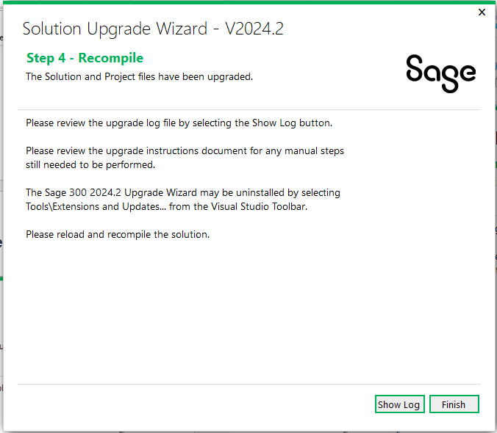

Click **Show Log** to display log file. The log file displays what files have been upgraded or modified. At this point, the upgrade is now complete.

Click **Finish** to exit the wizard.

After the solution that supported Sage 300 2024.0 has been upgraded to support 2024.2, you need to reload and recompile the solution. For compilation troubleshooting, see the next section.

**Note:** Before running the new solution, clear the browser cache to replace cached JavaScript and CSS files.

1. Upgrade Log

Once the Upgrade Wizard has completed you have the option to ‘Show Log’ to view the upgrade log. The following is a screenshot of a typical upgrade log.

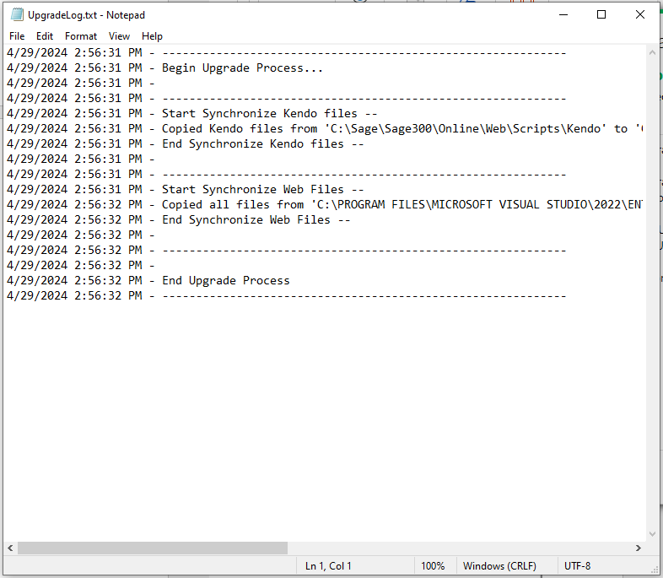

1. Compilation Troubleshooting

**Parser Error when loading Web project in browser**

* Clean solution
* In Web project folder:
  + delete bin and obj folders