Sage 300 Web Screens SDK

2018.1 Customization Upgrade

December 2017

The MIT License (MIT)

Copyright © 2017 The Sage Group plc or its licensors. All rights reserved.

Permission is hereby granted, free of charge, to any person obtaining a copy of this software and associated documentation files (the “Software”), to deal in the Software without restriction, including without limitation the rights to use, copy, modify, merge, publish, distribute, sublicense, and/or sell copies of the Software, and to permit persons to whom the Software is furnished to do so, subject to the following conditions:

The above copyright notice and this permission notice shall be included in all copies or substantial portions of the Software.

THE SOFTWARE IS PROVIDED “AS IS”, WITHOUT WARRANTY OF ANY KIND, EXPRESS OR IMPLIED, INCLUDING BUT NOT LIMITED TO THE WARRANTIES OF MERCHANTABILITY, FITNESS FOR A PARTICULAR PURPOSE AND NONINFRINGEMENT. IN NO EVENT SHALL THE AUTHORS OR COPYRIGHT HOLDERS BE LIABLE FOR ANY CLAIM, DAMAGES OR OTHER LIABILITY, WHETHER IN AN ACTION OF CONTRACT, TORT OR OTHERWISE, ARISING FROM, OUT OF OR IN CONNECTION WITH THE SOFTWARE OR THE USE OR OTHER DEALINGS IN THE SOFTWARE.

Contents

1. Overview 4

2. Modify Customization Controller Inheritance 5

1. Overview

In Sage 300 2018.1, a change was made to the customization controller wherein the base controller class has been changed. Third-party developers must now inherit from Sage’s MultitenantControllerBase instead of the standard MVC Controller. The following section will detail the exact steps required to make this change.

1. Modify Customization Controller Inheritance

* **Files affected**

{Namespace.Web}\Areas\{module}\Controllers\{project}CustomizationController.cs

* **Description**

Change the inherited base class for the controller. Instead of inheriting from Controller, you should inherit from MultitenantControllerBase<{project}CustomizationViewModel>. Also add a constructor as in the example below:

* **Before Change**

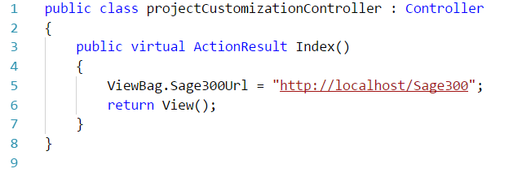

* **After Change**

