Sage 300 Web Screens SDK

2018.2 Customization Upgrade

April 2018

The MIT License (MIT)

Copyright © 1994-2018 The Sage Group plc or its licensors. All rights reserved.

Permission is hereby granted, free of charge, to any person obtaining a copy of this software and associated documentation files (the “Software”), to deal in the Software without restriction, including without limitation the rights to use, copy, modify, merge, publish, distribute, sublicense, and/or sell copies of the Software, and to permit persons to whom the Software is furnished to do so, subject to the following conditions:

The above copyright notice and this permission notice shall be included in all copies or substantial portions of the Software.

THE SOFTWARE IS PROVIDED “AS IS”, WITHOUT WARRANTY OF ANY KIND, EXPRESS OR IMPLIED, INCLUDING BUT NOT LIMITED TO THE WARRANTIES OF MERCHANTABILITY, FITNESS FOR A PARTICULAR PURPOSE AND NONINFRINGEMENT. IN NO EVENT SHALL THE AUTHORS OR COPYRIGHT HOLDERS BE LIABLE FOR ANY CLAIM, DAMAGES OR OTHER LIABILITY, WHETHER IN AN ACTION OF CONTRACT, TORT OR OTHERWISE, ARISING FROM, OUT OF OR IN CONNECTION WITH THE SOFTWARE OR THE USE OR OTHER DEALINGS IN THE SOFTWARE.

Contents

1. Overview 4

2. Modify Web\BundleRegistration.cs 5

1. Overview

In Sage 300 2018.2, a change was made to the way JavaScript is bundled in the BundleRegistration.cs file. This step is handled automatically by the Sage 300 2018.2 Upgrade Wizard. The following section will detail the exact changes that are made.

1. Modify Web\BundleRegistration.cs

* **Files affected**

{Namespace.Web}\BundleRegistration.cs

* **Description**

Change the reference from ScriptBundle to Bundle in support of minified JavaScript files.

* **Before Change**

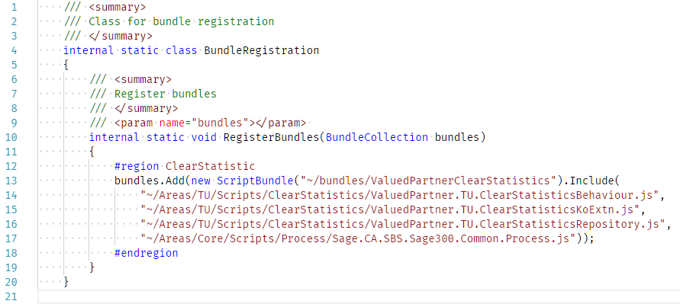

* **After Change**

