Sage 300 Web Screens SDK

Inquiry Configuration Generator Utility

October 2018

The MIT License (MIT)

Copyright © 1994-2018 The Sage Group plc or its licensors. All rights reserved.

Permission is hereby granted, free of charge, to any person obtaining a copy of this software and associated documentation files (the “Software”), to deal in the Software without restriction, including without limitation the rights to use, copy, modify, merge, publish, distribute, sublicense, and/or sell copies of the Software, and to permit persons to whom the Software is furnished to do so, subject to the following conditions:

The above copyright notice and this permission notice shall be included in all copies or substantial portions of the Software.

THE SOFTWARE IS PROVIDED “AS IS”, WITHOUT WARRANTY OF ANY KIND, EXPRESS OR IMPLIED, INCLUDING BUT NOT LIMITED TO THE WARRANTIES OF MERCHANTABILITY, FITNESS FOR A PARTICULAR PURPOSE AND NONINFRINGEMENT. IN NO EVENT SHALL THE AUTHORS OR COPYRIGHT HOLDERS BE LIABLE FOR ANY CLAIM, DAMAGES OR OTHER LIABILITY, WHETHER IN AN ACTION OF CONTRACT, TORT OR OTHERWISE, ARISING FROM, OUT OF OR IN CONNECTION WITH THE SOFTWARE OR THE USE OR OTHER DEALINGS IN THE SOFTWARE.

Contents

1. Overview 4

2. Usage 5

3. Program Output 8

1. Overview

The **Inquiry Configuration Generator Utility** is a C# project developed in Visual Studio 2017 and is compatible with Visual Studio 2017. It is used by both internal Sage developers and external development partners to generate the necessary metadata for Sage 300 Inquiries. The following sections will outline how to use this application and describe the program’s output

1. Usage

Running the Inquiry Configuration Generator program will display the following user interface:

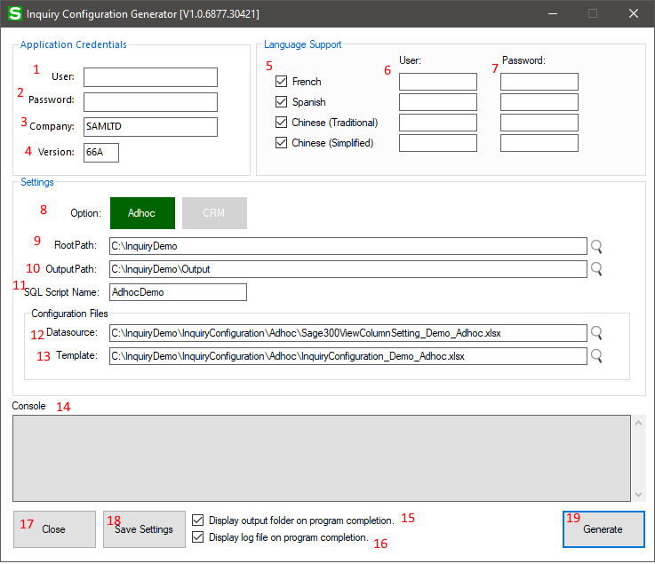

Figure 1 – The user interface

|  |  |  |
| --- | --- | --- |
| **Item** | **Name** | **Description** |
| 1 | User | Enter the English language username for Sage 300. |
| 2 | Password | Enter the English language password for Sage 300. |
| 3 | Company | Enter the Company name for Sage 300, for example, ‘SAMLTD’ |
| 4 | Version | Enter the Version number for the installed version of Sage 300, for example, ‘66A’ |
| 5 | Other Languages | This is the checkbox to instruct the application to include ‘French’ resources. If this checkbox is not checked, this language will not be included. There are corresponding checkboxes for ‘Spanish’, ‘Chinese (Traditional)’ and ‘Chinese (Simplified)’. |
| 6 | Other Usernames | If the corresponding checkbox is checked, optionally enter the username for that language. If no username is specified, the application will connect with the English account username. As with the language checkbox, there are corresponding username fields for ‘Spanish’, ‘Chinese (Traditional)’ and ‘Chinese (Simplified)’. |
| 7 | Other Passwords | If the corresponding checkbox is checked, optionally enter the password that corresponds to the language and username. If no password is specified, the application will connect with the English account password. As with the language checkbox, there are corresponding password fields for ‘Spanish’, ‘Chinese (Traditional)’ and ‘Chinese (Simplified)’. |
| 8 | Option | Select ‘Adhoc’ or ‘CRM’ to specify which type of configuration to target. |
| 9 | Root Path | Specify the folder on your system where all configuration and program generated files will be located. |
| 10 | Output Path | This is the base folder where all output files will be located. |
| 11 | SQL Script Name | Specify the name that will be used for the following:   * The folder that will be created within the designated output folder, that will be used to hold the output files. * Within the filenames of the generated SQL Server script files |
| 12 | Datasource | This is the fully-qualified path to the Microsoft Excel spreadsheet (xlsx) containing the data source information. |
| 13 | Template | This is the fully-qualified path to the Microsoft Excel spreadsheet (xlsx) containing the template information. |
| 14 | Console | This is the area where informational message and errors will be displayed. |
| 15 | Display output folder | This checkbox will enable or disable the display of the final output folder following the program execution. |
| 16 | Display log file | This checkbox will enable or disable the display of the final log file following the program execution. |
| 17 | Close | This button, when pressed, will close the application. |
| 18 | Save Settings | This button, when pressed, will save the current settings into the application’s INI file. |
| 19 | Generate | This button, when pressed, will start the generation process. If there are any problems with information in the form, errors will be displayed in the form and no output will be generated. |

1. Program Output

Upon a successful run of the application, the following is an example of what will be output to the designated output folder:

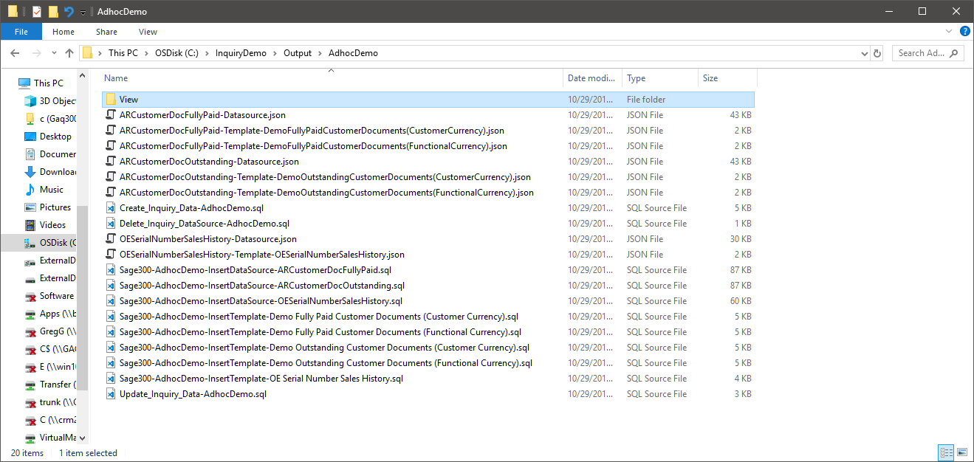

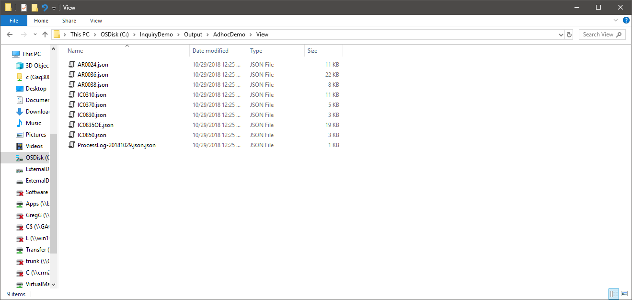

The following is an example of what the application log file would look like:

