Sage 300 Web Screens SDK

Sage300InquiryConfigurationGenerator Utility

October 2018

The MIT License (MIT)

Copyright © 1994-2018 The Sage Group plc or its licensors. All rights reserved.

Permission is hereby granted, free of charge, to any person obtaining a copy of this software and associated documentation files (the “Software”), to deal in the Software without restriction, including without limitation the rights to use, copy, modify, merge, publish, distribute, sublicense, and/or sell copies of the Software, and to permit persons to whom the Software is furnished to do so, subject to the following conditions:

The above copyright notice and this permission notice shall be included in all copies or substantial portions of the Software.

THE SOFTWARE IS PROVIDED “AS IS”, WITHOUT WARRANTY OF ANY KIND, EXPRESS OR IMPLIED, INCLUDING BUT NOT LIMITED TO THE WARRANTIES OF MERCHANTABILITY, FITNESS FOR A PARTICULAR PURPOSE AND NONINFRINGEMENT. IN NO EVENT SHALL THE AUTHORS OR COPYRIGHT HOLDERS BE LIABLE FOR ANY CLAIM, DAMAGES OR OTHER LIABILITY, WHETHER IN AN ACTION OF CONTRACT, TORT OR OTHERWISE, ARISING FROM, OUT OF OR IN CONNECTION WITH THE SOFTWARE OR THE USE OR OTHER DEALINGS IN THE SOFTWARE.

Contents

1. Overview 4

2. How to use this application 5

1. Overview

The **Sage300InquiryConfigurationGenerator Utility** is a C# project developed in Visual Studio 2017 and is compatible with Visual Studio 2017. It is used by both Sage developers and our development partners to generate the necessary SQL statements to add new Inquiries to Sage 300. The following sections will outline how to use this application.

1. How to use this application

Running the Sage300InquiryConfigurationGenerator.exe program will display the following user interface:

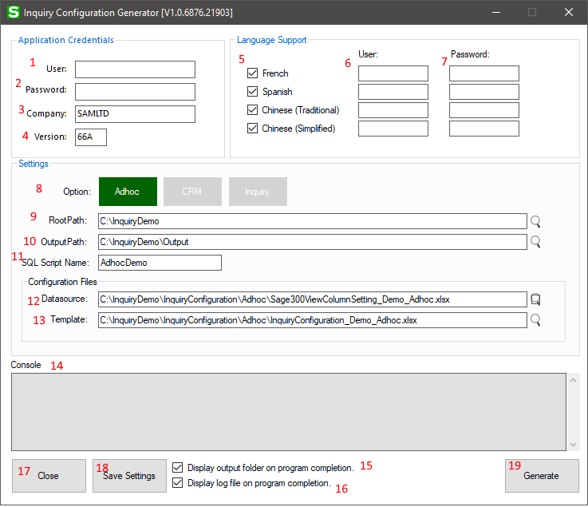

Figure 1 – The primary user interface

|  |  |  |
| --- | --- | --- |
| **Item** | **Name** | **Description** |
| 1 | User | Enter the English languge username for Sage 300. |
| 2 | Password | Enter the English language password for Sage 300. |
| 3 | Company | Enter the Company name for Sage 300, for example, ‘SAMLTD’ |
| 4 | Version | Enter the Version number for the installed version of Sage 300, for example, ‘66A’ |
| 5 | Language (Fra) | This is the checkbox to instruct the application to include ‘French’ resources. If this checkbox is not checked, this particular language will not be included. There are corresponding checkboxes for ‘Spanish’, ‘Chinese (Traditional)’ and ‘Chinese (Simplified)’. |
| 6 | Username (Fra) | If the corresponding checkbox is checked, optionally enter the username for that particular language. If no username is specified, the application will connect with the English account username. As with the language checkbox, there are corresponding username fields for ‘Spanish’, ‘Chinese (Traditional)’ and ‘Chinese (Simplified)’. |
| 7 | Password (Fra) | If the corresponding checkbox is checked, optionally enter the password that corresponds to the particular language and username. If no password is specified, the application will connect with the English account password. As with the language checkbox, there are corresponding password fields for ‘Spanish’, ‘Chinese (Traditional)’ and ‘Chinese (Simplified)’. |
| 8 | Option | Select ‘Adhoc’, ‘CRM’, or ‘Inquiry’ to specify which type of configuration to target. |
| 9 | Root Path | Specify the folder on your system where all configuration and program generated files will be located. |
| 10 | Output Path | This is the base folder where all output files will be located. |
| 11 | SQL Script Name | Specify the name that will be used for the following:   * The folder that will be created within the designated output folder, that will be used to hold the output files. * Within the filenames of the generated SQL Server script files |
| 12 | Datasource | This is the fully-qualified path to the Microsoft Excel spreadsheet (xlsx) containing the datasource information. |
| 13 | Template | This is the fully-qualified path to the Microsoft Excel spreadsheet (xlsx) containing the template information. |
| 14 | Console | This is the console where informational message and errors will be displayed. |
| 15 | Display output folder | This checkbox will enable or disable the display of the final output folder following the program run. |
| 16 | Display log file | This checkbox will enable or disable the display of the final log file following the program run. |
| 17 | Close | This button, when pressed, will close the application. |
| 18 | Save Settings | This button, when pressed, will save the current settings into the application’s INI file. |
| 19 | Generate | This button, when pressed, will start the generation process. If there are any problems with information in the form, errors will be displayed in the form and no output will be generated. |

1. What does this program output?

Upon a successful run of the application, the following is an example of what will be output to the designated output folder:

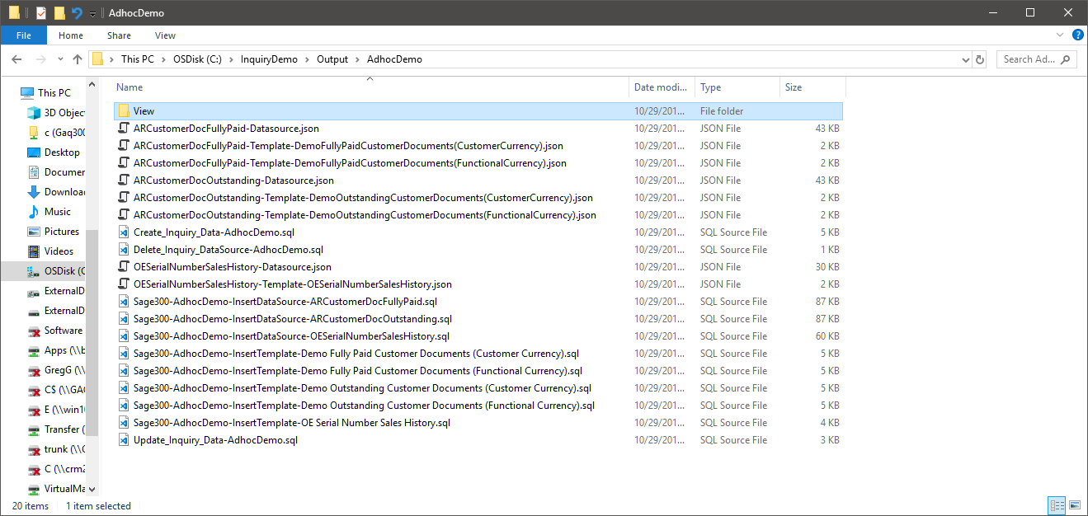

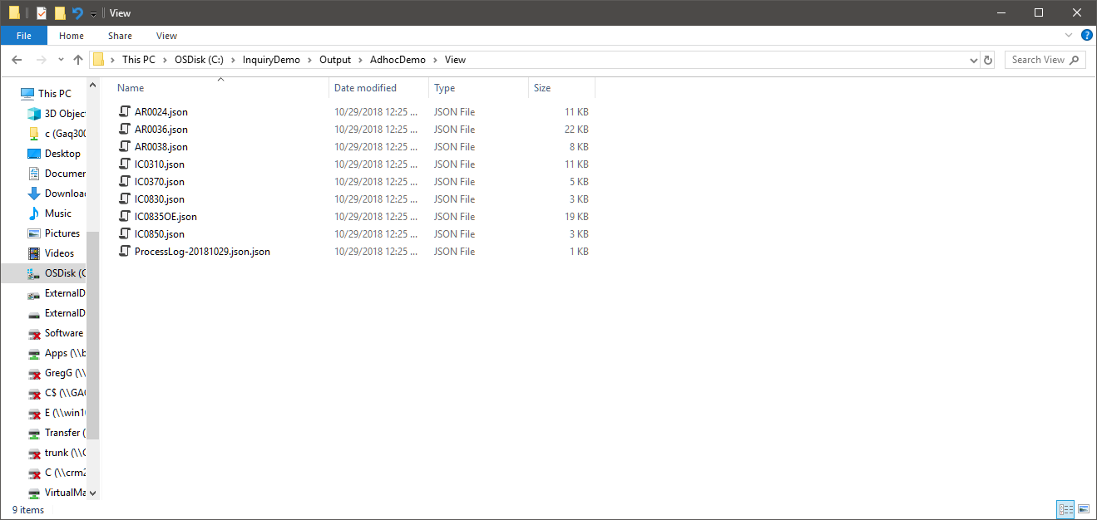

The following is an example of what the application log file would look like:

