Sage 300 Web Screens SDK

Sage300Utilities Utility

April 2018

The MIT License (MIT)

Copyright © 1994-2018 The Sage Group plc or its licensors. All rights reserved.

Permission is hereby granted, free of charge, to any person obtaining a copy of this software and associated documentation files (the “Software”), to deal in the Software without restriction, including without limitation the rights to use, copy, modify, merge, publish, distribute, sublicense, and/or sell copies of the Software, and to permit persons to whom the Software is furnished to do so, subject to the following conditions:

The above copyright notice and this permission notice shall be included in all copies or substantial portions of the Software.

THE SOFTWARE IS PROVIDED “AS IS”, WITHOUT WARRANTY OF ANY KIND, EXPRESS OR IMPLIED, INCLUDING BUT NOT LIMITED TO THE WARRANTIES OF MERCHANTABILITY, FITNESS FOR A PARTICULAR PURPOSE AND NONINFRINGEMENT. IN NO EVENT SHALL THE AUTHORS OR COPYRIGHT HOLDERS BE LIABLE FOR ANY CLAIM, DAMAGES OR OTHER LIABILITY, WHETHER IN AN ACTION OF CONTRACT, TORT OR OTHERWISE, ARISING FROM, OUT OF OR IN CONNECTION WITH THE SOFTWARE OR THE USE OR OTHER DEALINGS IN THE SOFTWARE.

Contents

1. Overview 4

2. When to use this application 6

3. How to use this application 7

4. What does this program do? 8

1. Overview

The **Sage300Utilities Utility** is a C# project developed in Visual Studio 2017 and is compatible with Visual Studio 2013, 2015 and 2017. It is used by the Sage300UIWizardPackage to generate the various Template archives that are located in the \src\Wizards\Templates\ folder. The following sections will outline what the program does and how/when to call it.

|  |  |  |
| --- | --- | --- |
| **Parameters (Default prefix for all parameters is --)** | | |
| **Parameter Name** | **Parameter Type and Meaning** | **Example Usage** |
| help | Boolean Flag:  If specified, instructs program to display its copyright/help information. | --help |
| prebuild | Boolean Flag:  If specified, instructs program to run the ‘Pre-Build’ process. | --prebuild |
| sdkroot | String:  This is the fully-qualified path to the Sage 300 Web SDK folder. | --sdkroot=”c:\projects\Sage300-SDK” |
| disabletemplateupdates | Boolean Flag:  If specified, instructs program to leave the contents of the \src\Wizards\Templates\Web\ folder alone. If this flag is specified, it will take precedence over both the **uselocalsage300installation** flag and **websource** setting. | --disabletemplateupdates |
| uselocalsage300installation | Boolean Flag:  If specified, instructs program to source the web files from the local Sage 300 installation | --uselocalsage300installation |
| websource | String:  This is the fully-qualified path to the web project files. | --websource=”c:\projects\Web\Sage.CA.SBS.ERP.Sage300.Web” |

1. When to use this application

This application is automatically called during the pre-build step of the Sage300UIWizardPackage project. There is no need to call this application manually.

1. How to use this application

As stated in section 2 previously, there isn’t a need to call this program manually.

Running the Sage300Utilities.exe program without any command-line parameters will display help for the program. This is illustrated in the following screen-shot:

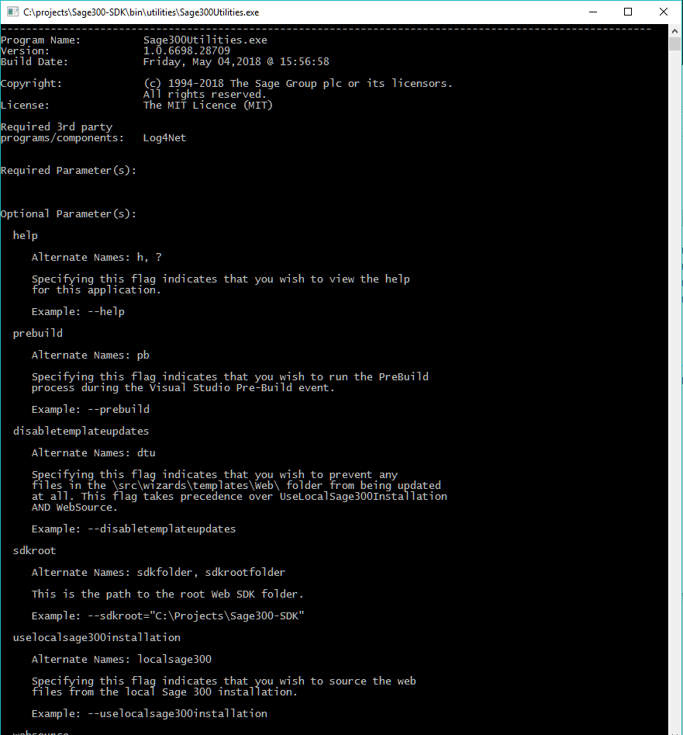

1. What does this program do?

This programs actions depend on the command-line parameters specified. Currently the primary command-line parameter is ‘prebuild’

|  |
| --- |
| **Primary Command-Line Parameter (Default prefix for all parameters is --)** |
| prebuild |
| 1. If the flag **disabletemplateupdates** is specified, step 2 and 3 below are skipped. Proceed to step 4. 2. Clear old ‘Web’ files from the \src\wizards\Templates\Web\ folder (Not all files are removed) 3. Copy updated Web files from source (either local Sage 300 installation or manually specified folder) to \src\Wizards\Templates\Web\ folder 4. Create zip archives for the following sub-folders within the \src\wizards\Templates\ folder:    1. BusinessRepository    2. Interfaces    3. Models    4. Resources    5. Sage300SolutionTemplate    6. Services    7. Web |