Sage 300 Web Screens SDK

Inquiry Configuration Wizard

February 2018

The MIT License (MIT)

Copyright © 2018 The Sage Group plc or its licensors. All rights reserved.

Permission is hereby granted, free of charge, to any person obtaining a copy of this software and associated documentation files (the “Software”), to deal in the Software without restriction, including without limitation the rights to use, copy, modify, merge, publish, distribute, sublicense, and/or sell copies of the Software, and to permit persons to whom the Software is furnished to do so, subject to the following conditions:

The above copyright notice and this permission notice shall be included in all copies or substantial portions of the Software.

THE SOFTWARE IS PROVIDED “AS IS”, WITHOUT WARRANTY OF ANY KIND, EXPRESS OR IMPLIED, INCLUDING BUT NOT LIMITED TO THE WARRANTIES OF MERCHANTABILITY, FITNESS FOR A PARTICULAR PURPOSE AND NONINFRINGEMENT. IN NO EVENT SHALL THE AUTHORS OR COPYRIGHT HOLDERS BE LIABLE FOR ANY CLAIM, DAMAGES OR OTHER LIABILITY, WHETHER IN AN ACTION OF CONTRACT, TORT OR OTHERWISE, ARISING FROM, OUT OF OR IN CONNECTION WITH THE SOFTWARE OR THE USE OR OTHER DEALINGS IN THE SOFTWARE.

Contents

1. Overview 4

2. Creating the Configuration 5

2.1 Step 1 – Add/Edit an Inquiry Configuration 6

2.1.1 Inquiry Field 6

2.1.2 Folder Field 7

2.1.3 Description Field 8

2.1.4 Assembly Field 9

2.1.5 Model Field 10

2.1.6 Property Grid 11

2.2 Step 2 – Generate an Inquiry Configuration 12

2.2.1 JSON File 12

2.3 Step 3 – Generated an Inquiry Configuration 13

2.3.1 JSON File 13

1. Overview

This document is intended to serve as a guide for explaining the Sage 300 Inquiry Configuration Wizard.

This wizard simplifies and enhances the configuration experience by providing an intuitive interface for selecting and interacting with a model and its properties and thus eliminates the requirement to create or modify the JSON configuration file by hand.

New configuration files can be created, and/or existing configuration files can be modified.

Sage 300 web screen models and partner models are discovered in the Sage 300 Online’s **web\bin** folder.

The first task in the configuration process is to become familiar with the model (Accpac Business View) to be used as the source in the generic inquiry grid.

The JSON configuration file will be used by the generic inquiry grid to display the selected properties of the model.

1. Creating the Configuration

Creates the JSON file to be used by the generic inquiry grid in the Sage 300 web screens.

Locate the inquiry configuration wizard in the SDK’s bin\wizards folder (bin\wizards\Sage.CA.SBS.ERP.Sage300.InquiryConfigurationWizard.exe).

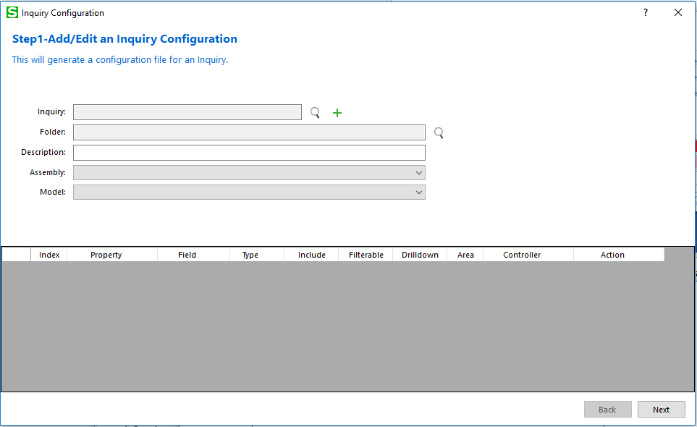

* 1. Step 1 – Add/Edit an Inquiry Configuration

Allows a configuration to be retrieved for modification or a new one to be created.

* + 1. Inquiry Field

Contains a GUID to uniquely identify the configuration.

This is for informational purposes only.

Click on the magnifying glass to look up an existing configuration or click the green plus button to generate a GUID for a new configuration.

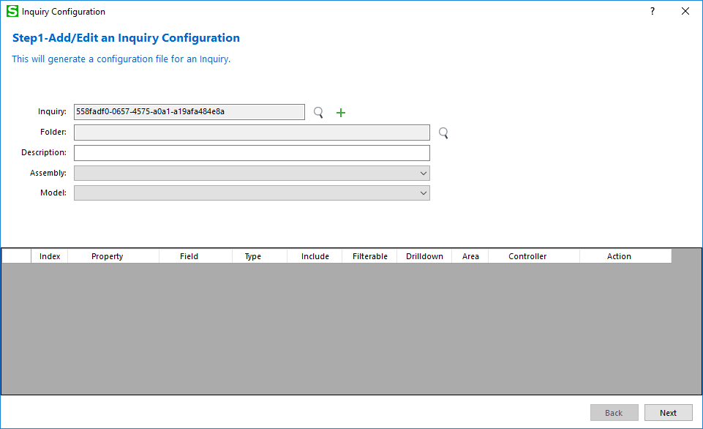

* + 1. Folder Field

Contains a folder name where the JSON file is located or where it will be created.

Click on the magnifying glass to search for a folder.

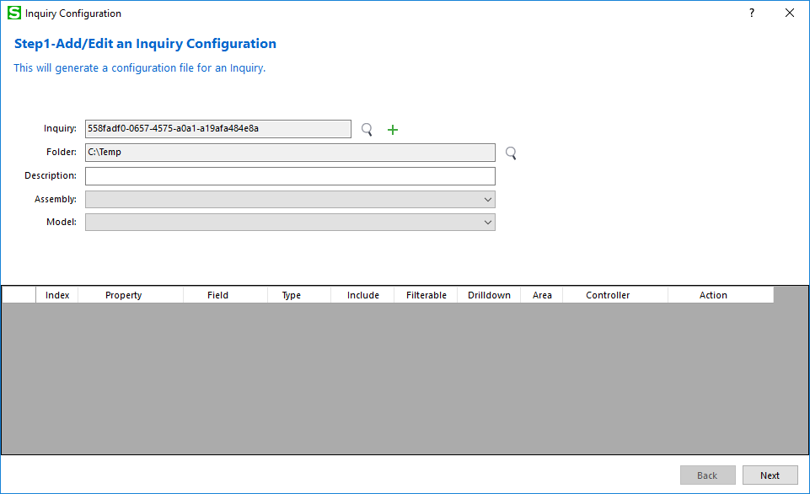

* + 1. Description Field

Contains the description for the configuration.

This is for informational purposes only.

Enter a description for the inquiry configuration.

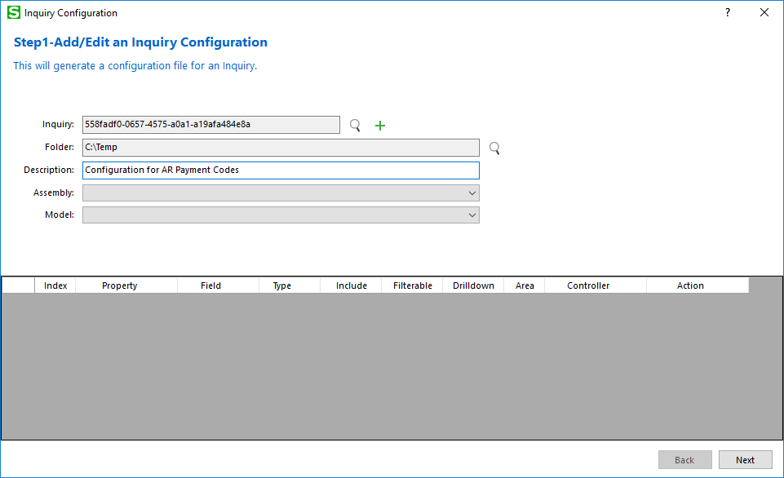

* + 1. Assembly Field

Contains the assembly names discovered in the Sage 300 Online **web\bin** folder.

Certain assemblies will not be displayed (i.e. Common, KPI, Workflow, VPF)

Select an assembly to display the models found in the assembly.

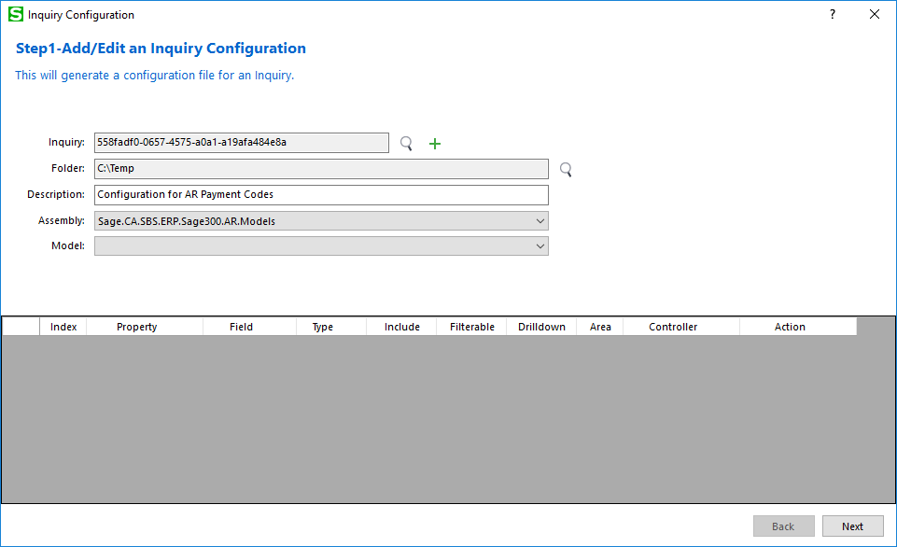

* + 1. Model Field

Contains the model names discovered in the selected assembly. The Accpac View Name is appended to the display for easy identification and reference.

Not all models in the selected assembly will be displayed. The following conditions must exist for the model to be displayed:

- Cannot be an Interface

- Must inherit from the ModelBase class

- Cannot exist in the Process or Reports namespace

- Cannot be a nested class

- Must have either an EntityName or ViewName public constant in the model

Not all properties in the selected model will be displayed. The following conditions will exclude the property from being displayed in the Property grid:

- Property is in the base class (ModelBase)

- Property does not have an Index class reference (used by mapper)

- Property does not have a Fields class reference (used by mapper)

Select a model to display the properties in the Property grid for inclusion in the configuration file.

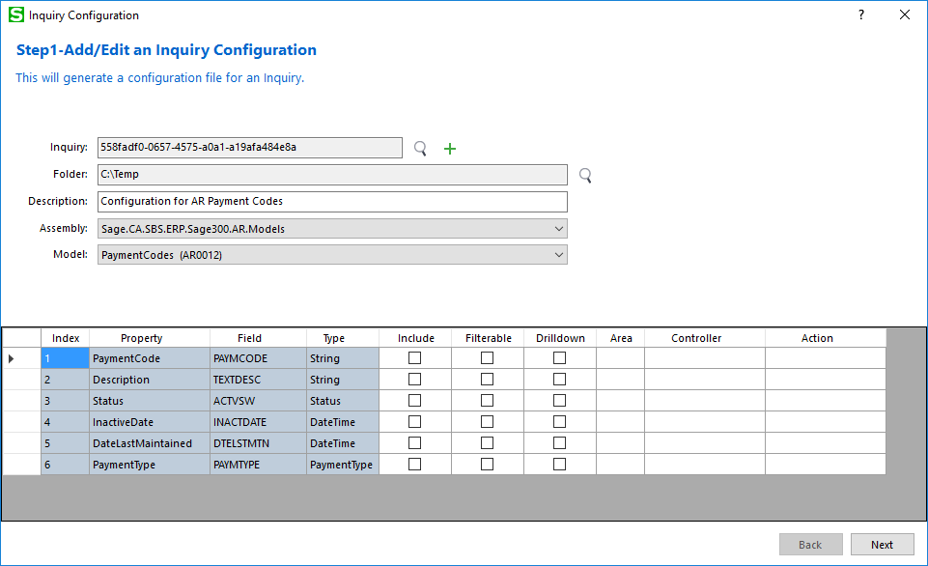

* + 1. Property Grid

Contains the properties discovered in the selected model.

Check the **Include** checkbox for a specific property to be included in the configuration file otherwise the property is not included.

Check the **Filterable** checkbox for a specific property to be filterable in the inquiry grid otherwise the included property will not be filterable.

Check the **Drilldown** checkbox for a specific property to be drillable in the inquiry grid otherwise the included property will not be drillable.

If the **Drilldown** checkbox is checked, the **Area**, **Controller** and **Action** fields must have values. These values are the routing values for the endpoint URL. **Area** corresponds to the module (i.e. AR), **Controller** corresponds to the controller resource (i.e. PaymentCodes) and **Action** corresponds to the action of the controller (i.e. Index).

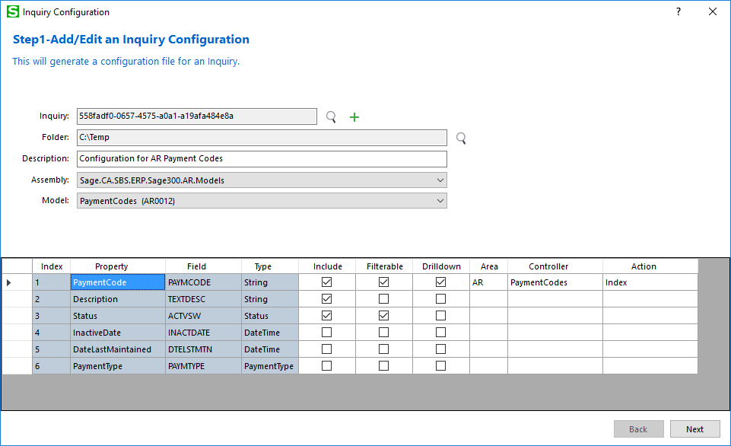

Click **Next** to proceed.

* 1. Step 2 – Generate an Inquiry Configuration

Allows a configuration to be viewed before being generated

* + 1. JSON File

This step shows the file name that will be generated along with the contents based upon the previous step contents.

The JSON file name is built with “**InquiryConfiguration.json**” appended to the model name.

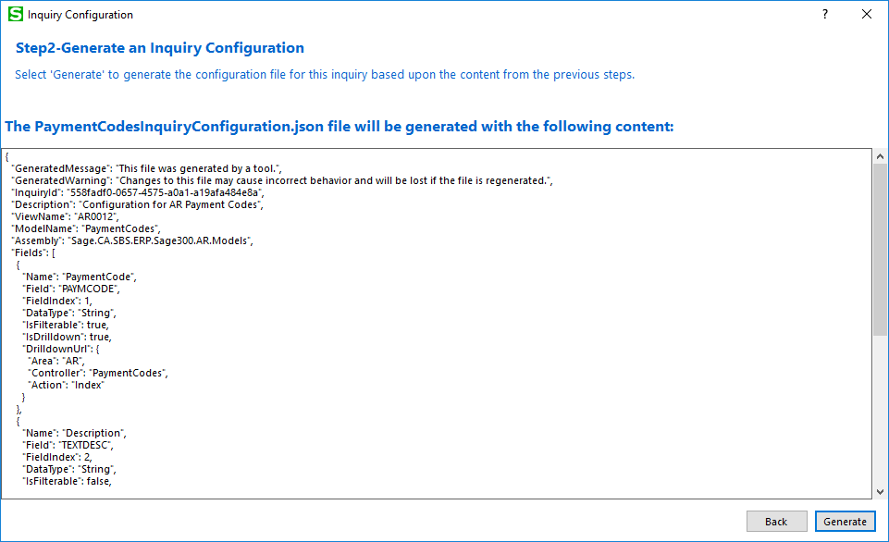

Click **Back** to move back a step otherwise click **Generate** to proceed.

* 1. Step 3 – Generated an Inquiry Configuration

Displays the generated file generated with the applicable status (Success or Failure)

* + 1. JSON File

This step shows the generated file name along with the status.

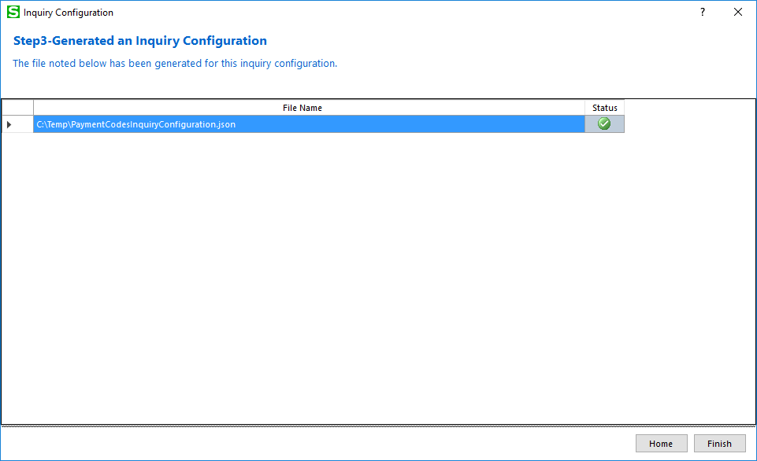

Click **Home** to move to Step 1 otherwise click **Finish** to exit the wizard.