Sage 300 Web Screens SDK

Sync Assemblies Wizard

May 2024

The MIT License (MIT)

Copyright © 2024 The Sage Group plc or its licensors. All rights reserved.

Permission is hereby granted, free of charge, to any person obtaining a copy of this software and associated documentation files (the “Software”), to deal in the Software without restriction, including without limitation the rights to use, copy, modify, merge, publish, distribute, sublicense, and/or sell copies of the Software, and to permit persons to whom the Software is furnished to do so, subject to the following conditions:

The above copyright notice and this permission notice shall be included in all copies or substantial portions of the Software.

THE SOFTWARE IS PROVIDED “AS IS”, WITHOUT WARRANTY OF ANY KIND, EXPRESS OR IMPLIED, INCLUDING BUT NOT LIMITED TO THE WARRANTIES OF MERCHANTABILITY, FITNESS FOR A PARTICULAR PURPOSE AND NONINFRINGEMENT. IN NO EVENT SHALL THE AUTHORS OR COPYRIGHT HOLDERS BE LIABLE FOR ANY CLAIM, DAMAGES OR OTHER LIABILITY, WHETHER IN AN ACTION OF CONTRACT, TORT OR OTHERWISE, ARISING FROM, OUT OF OR IN CONNECTION WITH THE SOFTWARE OR THE USE OR OTHER DEALINGS IN THE SOFTWARE.

Contents

1. Overview 4

2. Installing the Wizard 5

3. Accessing the Wizard 6

4. Using the Wizard 7

4.1 Step 1: Select Source Type 7

4.2 Step 2: Select Destination Folder 9

4.3 Step 3: Select Assembly Patterns 10

4.4 Step 4: Sync Assemblies 11

4.4.1 Confirmation Dialog 12

1. Overview

This document presents instructions for using the Sync Assemblies Wizard to pull binaries and other files from the local Sage 300 installation into the Assemblies folder for a Sage Developer’s **Dev** solution.

***This wizard is only for internal Sage 300 developers and is not intended to be used by external developers or ISVs.***

1. Installing the Wizard

The Sync Assemblies Wizard is a Visual Studio Plugin and is compatible with Visual Studio 2022. The Sage 300 Sync Assemblies Wizard tool is bundled with the Sage 300 Wizard Package (Code Generation Wizard, Finder Generator, Upgrade Wizard, Language Wizard, and Sync Assemblies Wizard)

**Note:** If the previous Sage 300 Wizard Package is installed, it must be uninstalled first (Visual Studio - Tools, Extensions, Uninstall option, select the Sage 300 Wizard Package to uninstall).

To install the utility:

1. Run Sage.CA.SBS.ERP.Sage300.WizardPackage.vsix.
2. Select the Install the Wizard Package option.
3. Note: Installing this package installs the above-mentioned wizards since they are combined in the same package.

1. Accessing the Wizard

The wizard is embedded in Visual Studio 2022 as a plugin. To open it, click the **Extensions** menu on the Visual Studio toolbar, select the **Sage 300** menu, and click Code Generation Wizard.

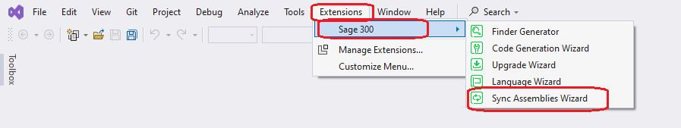

1. Using the Wizard
   1. Step 1: Select Source Type

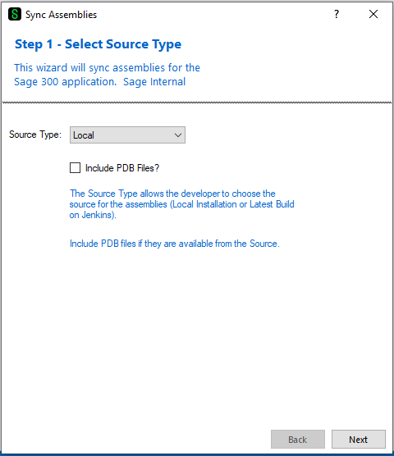

Source Types

* Local
* Local Sage 300 installation
* Jenkins
* Future Use
* Not Implemented

Select **Include PDB Files?** If they are required (not usually)

Click Next to proceed.

* 1. Step 2: Select Destination Folder

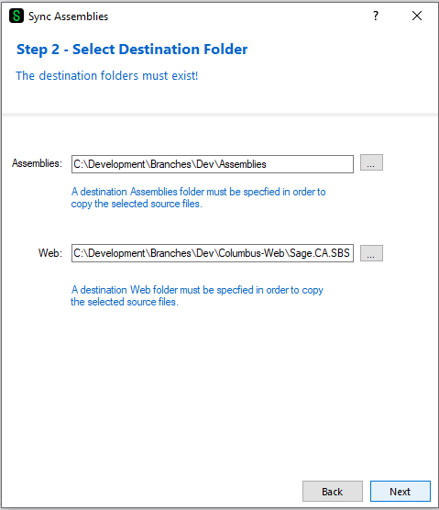

By default, the Assemblies and Web folders are assumed and defaulted since this is the Dev solution.

If the folders are empty, they may be searched for. However, this is an indication that this solution is NOT the **Dev** solution.

Click Next to proceed or Back to go back to the previous step.

* 1. Step 3: Select Assembly Patterns

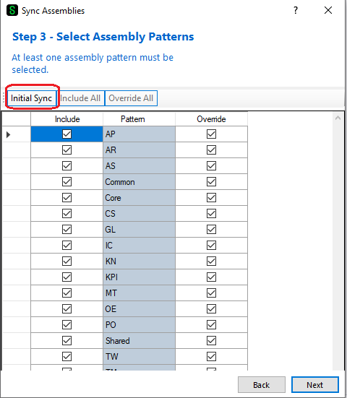

Any module may be individually selected to only bring in those files from the local installation.

However, most developers will select the **Initial Sync** button to select all modules.

Click Next to proceed or Back to go back to the previous step.

* 1. Step 4: Sync Assemblies

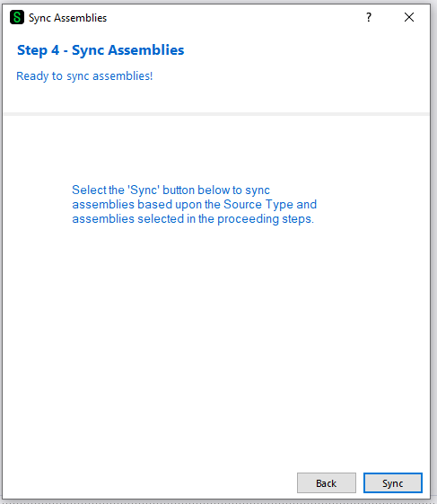

Click Sync to sync assemblies or Back to go back to the previous step.

* + 1. Confirmation Dialog

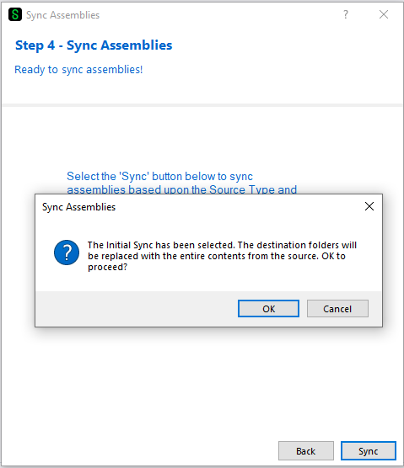

If the Initial Sync was selected, a confirmation dialog will be displayed to confirm the intention.

Click OK to sync assemblies or Cancel to go back to the previous step.