Sage 300 Web Screens SDK

Web API Subclassing Wizard

May 2024

The MIT License (MIT)

Copyright © 2024 The Sage Group plc or its licensors. All rights reserved.

Permission is hereby granted, free of charge, to any person obtaining a copy of this software and associated documentation files (the “Software”), to deal in the Software without restriction, including without limitation the rights to use, copy, modify, merge, publish, distribute, sublicense, and/or sell copies of the Software, and to permit persons to whom the Software is furnished to do so, subject to the following conditions:

The above copyright notice and this permission notice shall be included in all copies or substantial portions of the Software.

THE SOFTWARE IS PROVIDED “AS IS”, WITHOUT WARRANTY OF ANY KIND, EXPRESS OR IMPLIED, INCLUDING BUT NOT LIMITED TO THE WARRANTIES OF MERCHANTABILITY, FITNESS FOR A PARTICULAR PURPOSE AND NONINFRINGEMENT. IN NO EVENT SHALL THE AUTHORS OR COPYRIGHT HOLDERS BE LIABLE FOR ANY CLAIM, DAMAGES OR OTHER LIABILITY, WHETHER IN AN ACTION OF CONTRACT, TORT OR OTHERWISE, ARISING FROM, OUT OF OR IN CONNECTION WITH THE SOFTWARE OR THE USE OR OTHER DEALINGS IN THE SOFTWARE.

Contents

1. Overview 4

2. Accessing the Wizard 5

3. Using the Wizard 6

3.1 Step 1: Select a Module 6

3.2 Step 2: Select an Endpoint 7

3.3 Step 3: Create Project 8

4. Using the Endpoint Project 9

4.1 Resolve Nuget Packages 9

4.2 Add Extended Fields 10

4.3 New Assembly 12

1. Overview

This document is intended to serve as a guide for illustrating how to use the Web API Subclassing Wizard which is an executable.

The Web API Subclassing Wizard is a partner facing wizard for the generation of subclassing endpoints in the Sage 300 Web API.

In this wizard, the partner will identify what endpoint in a particular module that has extended fields in the business view and then specify those extended properties. A new partner endpoint is created that will contain the extended fields.

The original endpoint is not overwritten and is still available.

1. Accessing the Wizard

The WebAPISubclassWizard.exe is in the SDK’s bin/wizards/WebAPISubclassWizard folder.

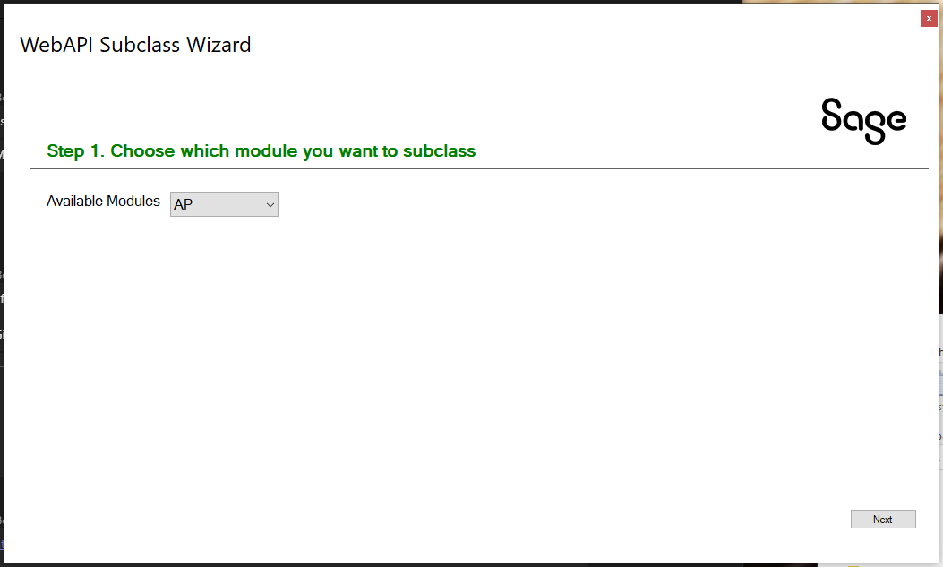

1. Using the Wizard

This usage and flow of this wizard is like other Sage 300 Web SDK Wizards.

* 1. Step 1: Select a Module

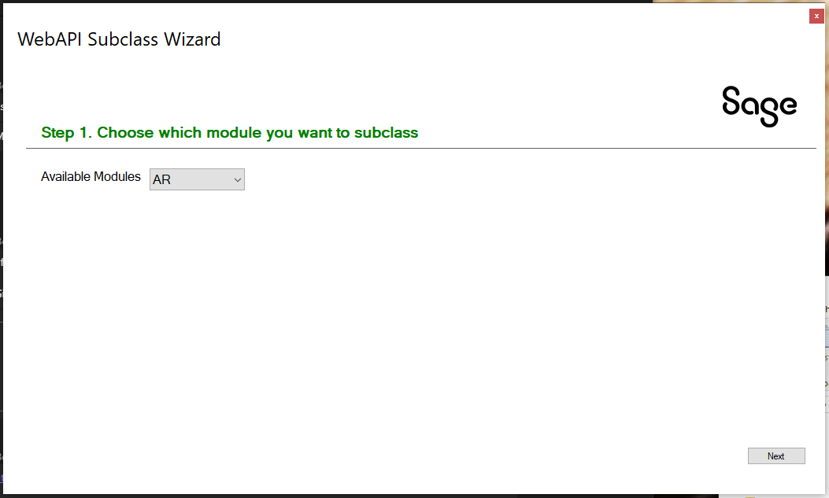

Select the module to be subclassed from the list of modules.

Select **Next** to proceed to the next step.

* 1. Step 2: Select an Endpoint

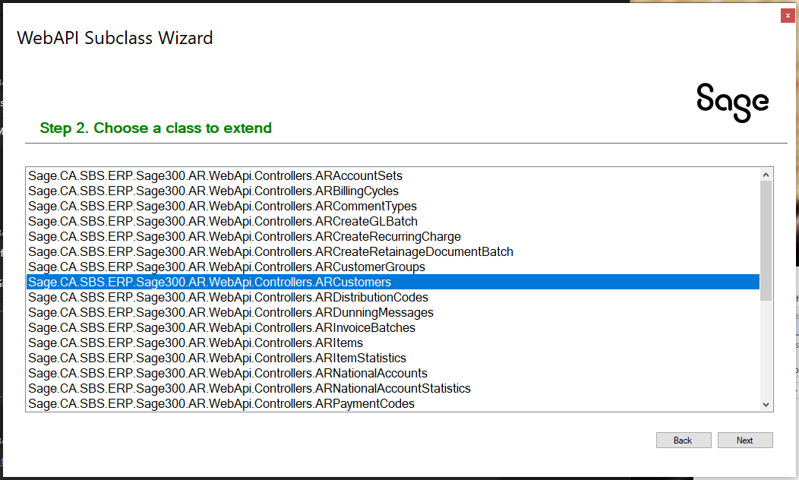

Select the endpoint to be subclassed from the list of endpoints.

Select **Next** to proceed to the next step or **Back** to the previous step.

* 1. Step 3: Create Project

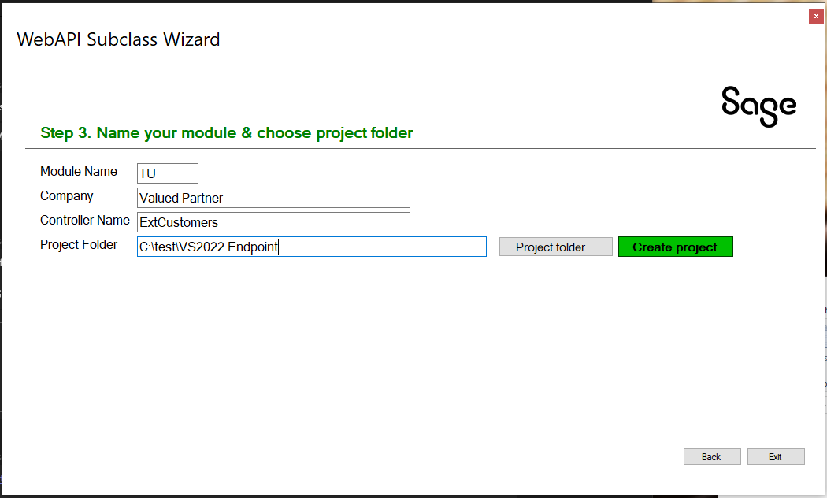

Enter a **Module Name** for your extended endpoint.

Enter **Company** Name for your extended endpoint.

Enter **Controller Name** for your extended endpoint.

Enter **Project Folder** to create a Visual Studio project.

When the information has been entered, select **Create Project** to generate the Web API project.

Select **Exit** to exit the wizard or **Back** to the previous step.

1. Using the Endpoint Project

Navigate to the solution and project created in section 3.3 and load the solution in Visual Studio 2022.

This project is where the extended fields will be added to the new endpoint that INHERITS from the endpoint select in the Web API wizard.

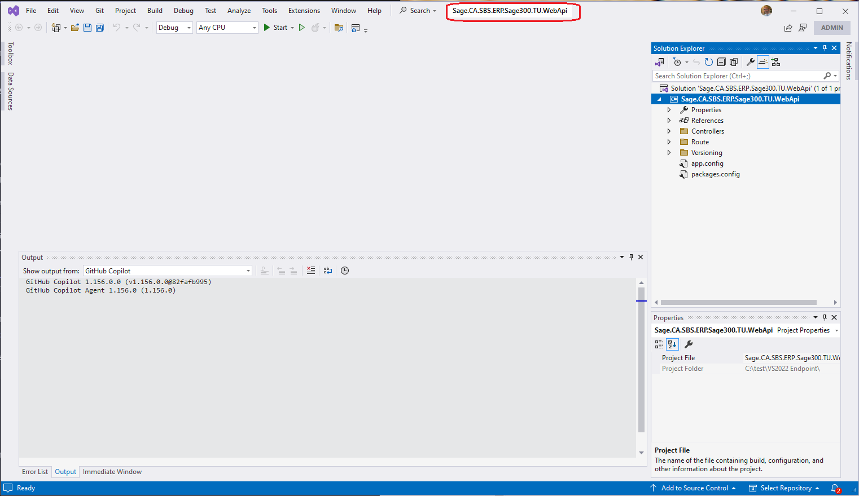

* 1. Resolve Nuget Packages

Resolve the Nuget package references by selecting **Tools** 🡪 **Nuget Package Manager** 🡪 **Manage Nuget Packages for Solution**

Click the **Restore** button.

* 1. Add Extended Fields

Unlike the Web Subclassing Configurations Wizard for the Web Screens, there is not a WYSIWYG editor or wizard for adding the extended fields to the Web API endpoint. However, this may be created in a future release.

Open the Controllers folder and select the controller that was created in the Web API wizard.

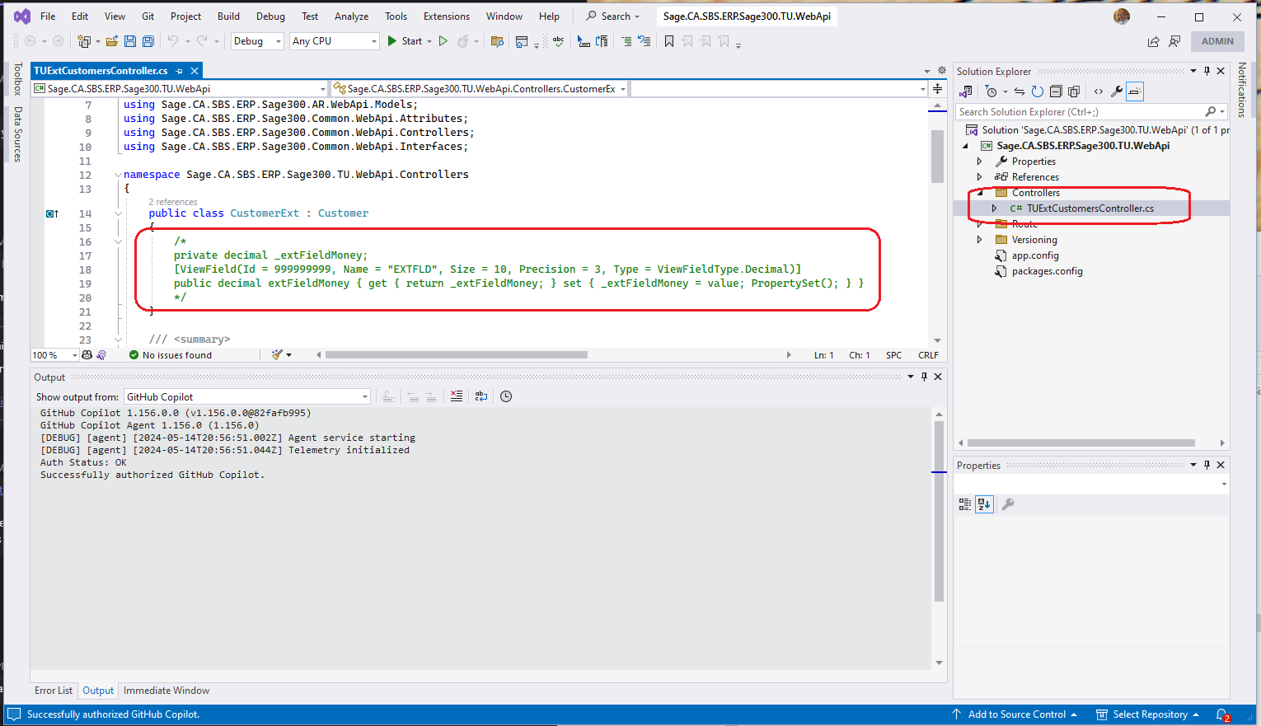

The developer will now add the extended fields to the endpoint’s class (payload). In the screenshot above, an example property is commented for illustration.

After the properties have been added (same example fields from the Web Subclassing Configurations Wizard):

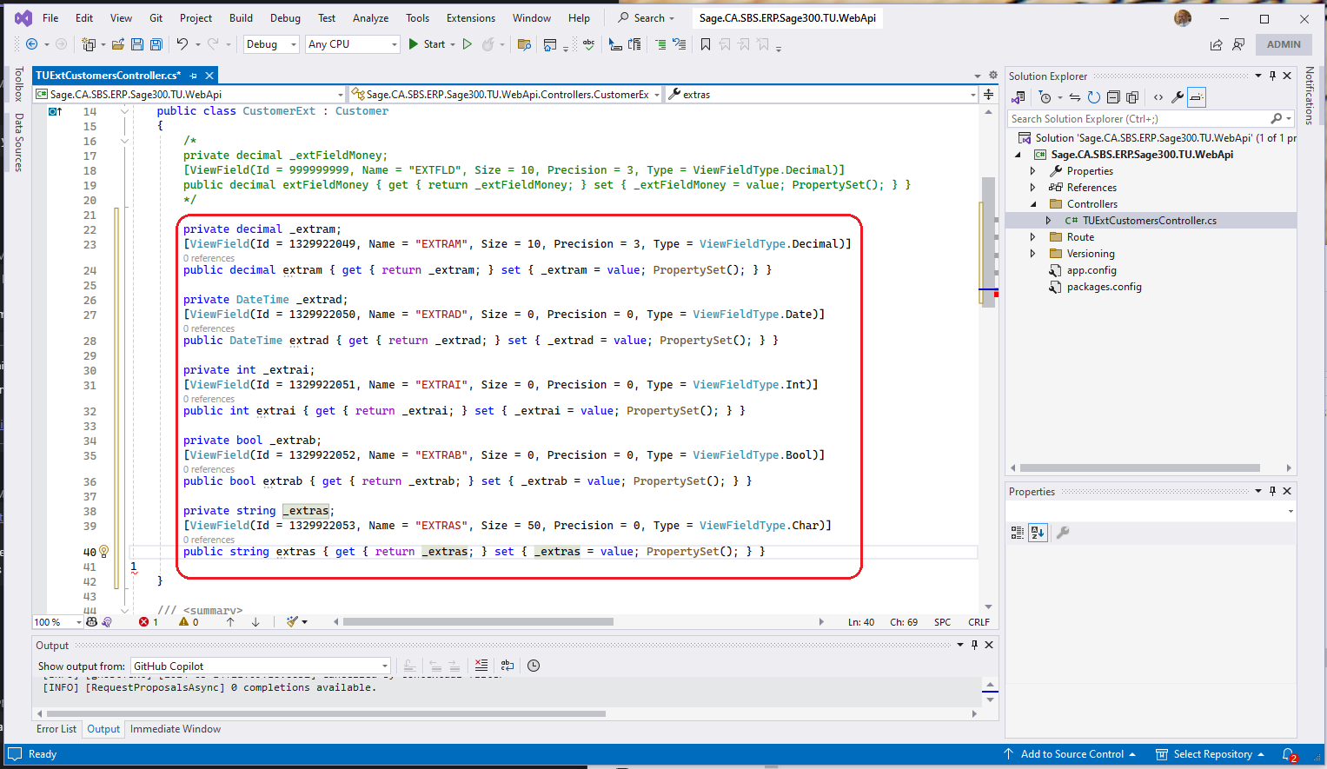

**Save** and **Build** the solution.

* 1. New Assembly

Once the project has been built, navigate to the project’s bin folder to locate the new Web API assembly:

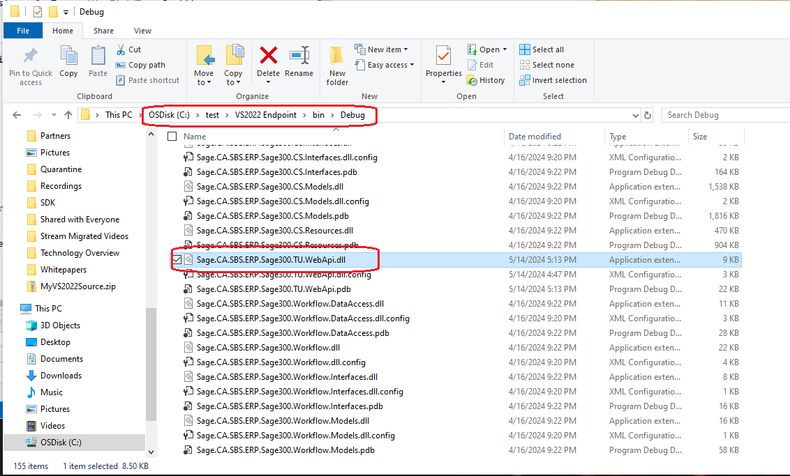

This is where the partner will gather the new assembly for deployment to their customer’s ..\Online/WebApi/bin folder.

When the Sage 300 Web API is accessed, it will discover this new endpoint and it is via this endpoint that the extended fields will now be available.