Sage 300 Web Screens SDK

Web Subclassing Configurations Wizard

May 2024

The MIT License (MIT)

Copyright © 2024 The Sage Group plc or its licensors. All rights reserved.

Permission is hereby granted, free of charge, to any person obtaining a copy of this software and associated documentation files (the “Software”), to deal in the Software without restriction, including without limitation the rights to use, copy, modify, merge, publish, distribute, sublicense, and/or sell copies of the Software, and to permit persons to whom the Software is furnished to do so, subject to the following conditions:

The above copyright notice and this permission notice shall be included in all copies or substantial portions of the Software.

THE SOFTWARE IS PROVIDED “AS IS”, WITHOUT WARRANTY OF ANY KIND, EXPRESS OR IMPLIED, INCLUDING BUT NOT LIMITED TO THE WARRANTIES OF MERCHANTABILITY, FITNESS FOR A PARTICULAR PURPOSE AND NONINFRINGEMENT. IN NO EVENT SHALL THE AUTHORS OR COPYRIGHT HOLDERS BE LIABLE FOR ANY CLAIM, DAMAGES OR OTHER LIABILITY, WHETHER IN AN ACTION OF CONTRACT, TORT OR OTHERWISE, ARISING FROM, OUT OF OR IN CONNECTION WITH THE SOFTWARE OR THE USE OR OTHER DEALINGS IN THE SOFTWARE.

Contents

1. Overview 4

2. Accessing the Wizard 5

3. Using the Wizard 6

3.1 Creating a Configuration 6

3.2 Modifying a Configuration 9

3.3 Deleting a Configuration 10

3.4 Deleting all Configurations 11

4. Configuration Storage Location 12

5. Example 13

1. Overview

This document is intended to serve as a guide for illustrating how to use the Web Subclassing Configurations Wizard which is an executable.

The Web Subclassing Configurations is a partner facing wizard for the generation and modification of subclassing configurations that will be later used by the Web Subclassing Compiler and Deployment Wizard.

In this wizard, the partner will identify what model in a particular module that has extended fields in the business view and then specify those extended properties. When the compiler wizard picks up these subclassed configurations the Sage model will be extended, recompiled, and deployed to the local installation whereby a customization can come along and display these extended properties in the UI.

Configurations will be created in a known folder structure since this wizard MIGHT be moved from the Web SDK to the Sage 300 Admin Utilities start folder to allow multiple partners to apply subclassing configurations to the same model. However, there are certain challenges that must be addressed prior to this change.

1. Accessing the Wizard

The Sage.CA.SBS.ERP.Sage300.SubclassConfigsWizard.exe is in the SDK’s bin/wizards folder.

1. Using the Wizard

This usage and flow of this wizard is like other Sage 300 Web SDK Wizards.

When the wizard first loads, it will scan the known location for configurations and display them in the tree where they can be edited or deleted.

* 1. Creating a Configuration

Right-Click on the ***Configurations*** tree node and select **Add Configuration**

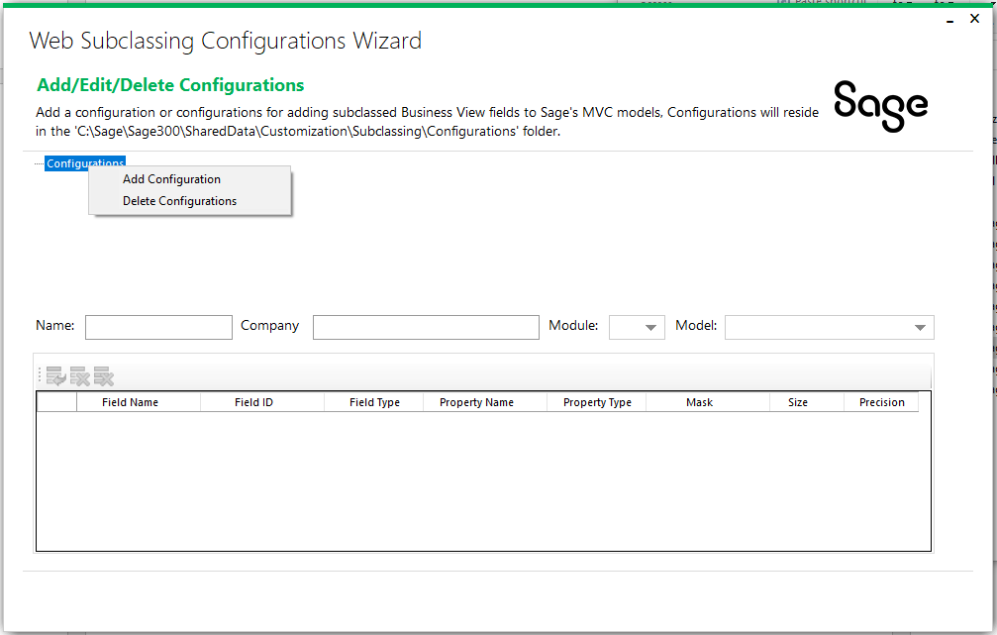

Enter the **Name** for the configuration which will be used as the name of the JSON file.

Enter the **Company** (partner name) for the configuration which will be used as the sub-folder name to isolate configurations by different partners.

Select a **Module** to locate the model to be subclassed which will also be used as a sub-folder to the Company sub-folder to isolate configurations by module for a company.

Select a **Model**, filter by module, to be subclassed.

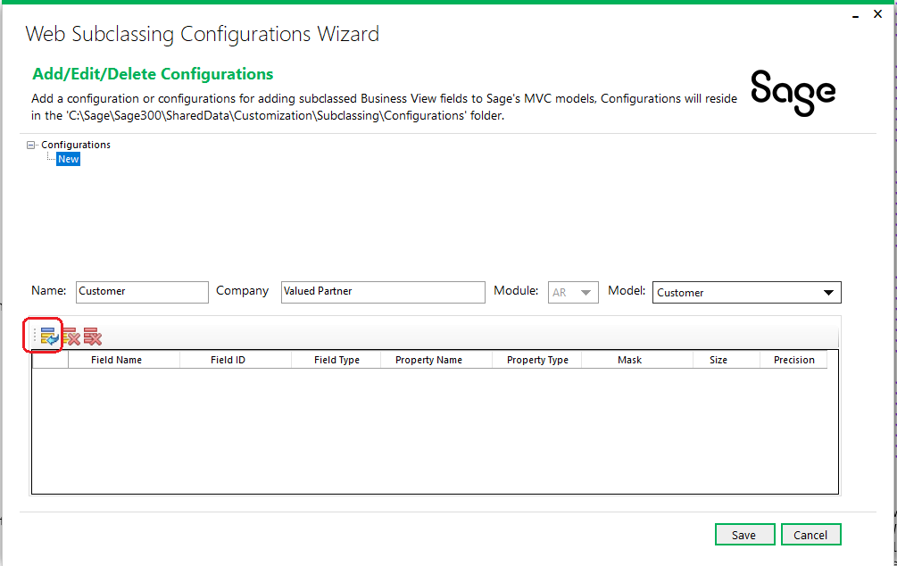

Now that the **Name**, **Company**, **Module**, and **Model** have been selected, it is time to enter the Accpac Business View fields that have been extended/added in the Accpac View. Select the **Add Property** button in the toolbar to add the extended fields:

Enter the **Field Name** which is the Accpac View’s Field Name (case matters!).

Enter the **Field ID** which is the Accpac View’s ID.

Select the **Field Type** that is the Accpac View’s Field Type.

Enter the **Property Name** for the C# model property.

Select the **Property Type** for the C# model property.

Enter the **Mask**, if any, associated with the Accpac View’s mask (Note: Not implemented at this time).

Enter the **Size**, if applicable, associated with the Accpac View’s size.

Enter the **Precision**, if applicable, associated with the Accpac View’s precision.

Multiple rows may be added by clicking the Add Property button and all rows or individual rows may be deleted by selecting the appropriate toolbar buttons.

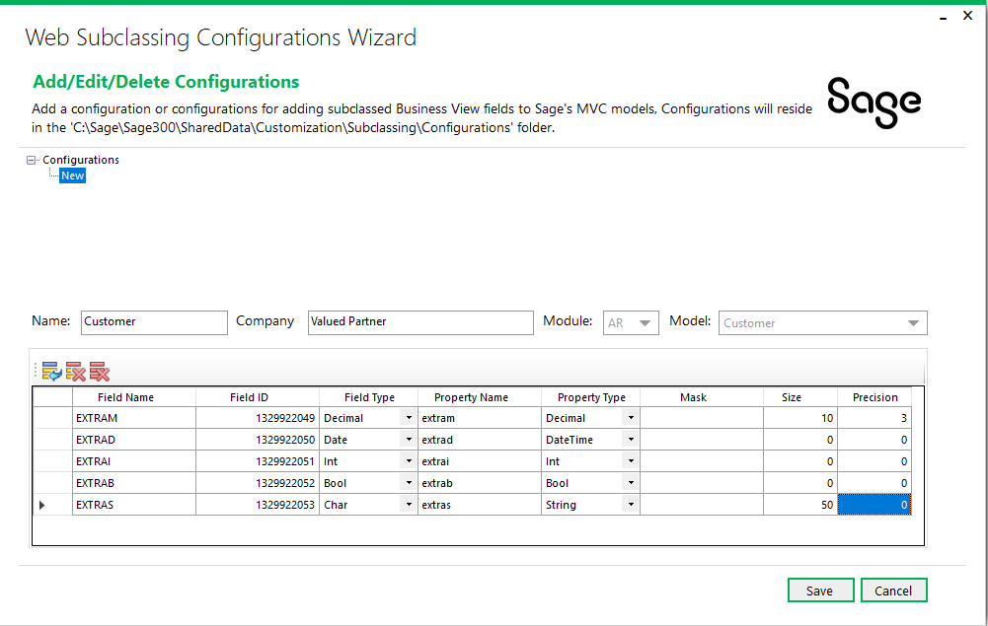

Click **Save** to save the configuration or **Cancel** to cancel the configuration

* 1. Modifying a Configuration

Select an existing configuration in the **Configurations** tree and Right-Click on the configuration and select **Edit Configuration.**

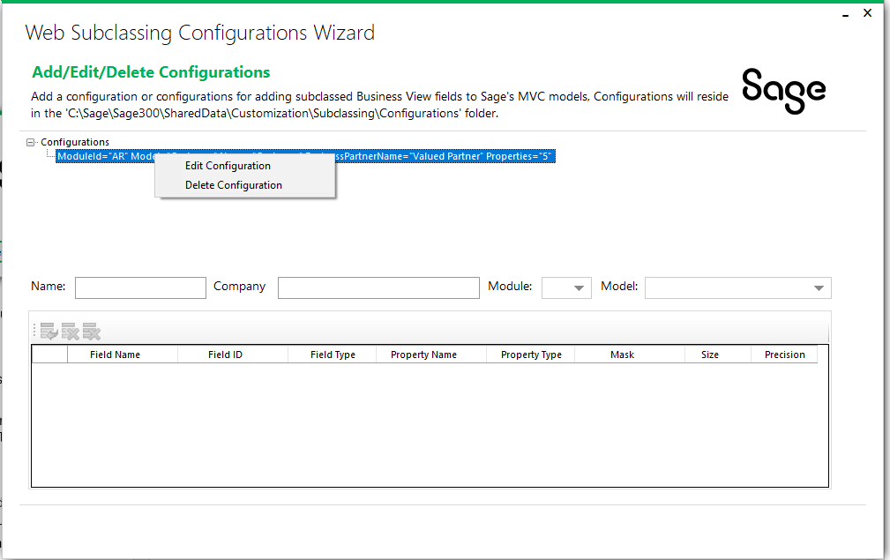

The configuration can be modified and saved as needed.

* 1. Deleting a Configuration

Select an existing configuration in the **Configurations** tree and Right-Click on the configuration and select **Delete Configuration.**

The configuration can be deleted.

* 1. Deleting all Configurations

Select the **Configurations** tree node and Right-Click select **Delete Configurations.**

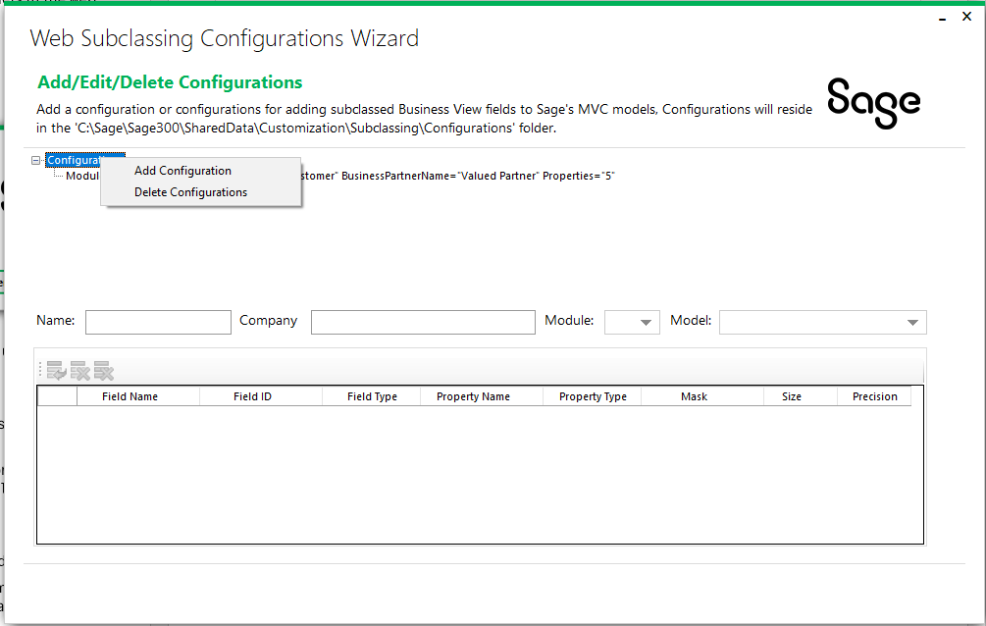

All configurations can be deleted.

1. Configuration Storage Location

The wizard will create the configurations in a known folder structure since this wizard MIGHT be moved from the Web SDK to the Sage 300 Admin Utilities start folder to allow multiple partners to apply subclassing configurations to the same model.

However, there are certain challenges that must be addressed prior to this change.

In the meantime, the folder location of the configurations on a partner machine are as follows:

* Shared data folder for web
  + Gathered from registry
* **Customization**
  + Known folder today where customizations are copied to upon import into web screens
* **Subclassing**
  + New folder for subclassing to store configurations
* **Configurations**
  + New folder sur subclassing to store configurations
* Partner folder
  + New folder based upon the value established in the configuration wizard. Allows for multiple partners. Future consideration if and when configuration wizard is moved to the application
* Module folder
  + New folder based upon the value established in the configuration wizard. Allows for categorization by module.
* *.json
  + Configuration file name.

1. Example

The example used in this document to extended the AR Customer screen leveraged a configuration created by this utility to create that configuration.

Here is the configuration:

