**Sage 300 Web API - Sample Integration**

You will discover the power of Sage 300 Web API by writing a full featured integration with very little code. In this exercise, we will automate the creation of an OE order for a brand new customer and coordinate the workflow of the order's entire life cycle: from generating the associated OE shipment and OE invoice, to generating the AR invoice through IC day end and producing the eventual GL batch.

1. Start **Sage 300**, enter **ADMIN** for both the **User ID** and **Password**, select **Sample Company Limited** and click **OK**.
2. Open **Order Entry** then select **O/E Setup** and open **Options**.
3. In the **Processing** tab, change **Default Create Invoice Option to** to **Yes.**

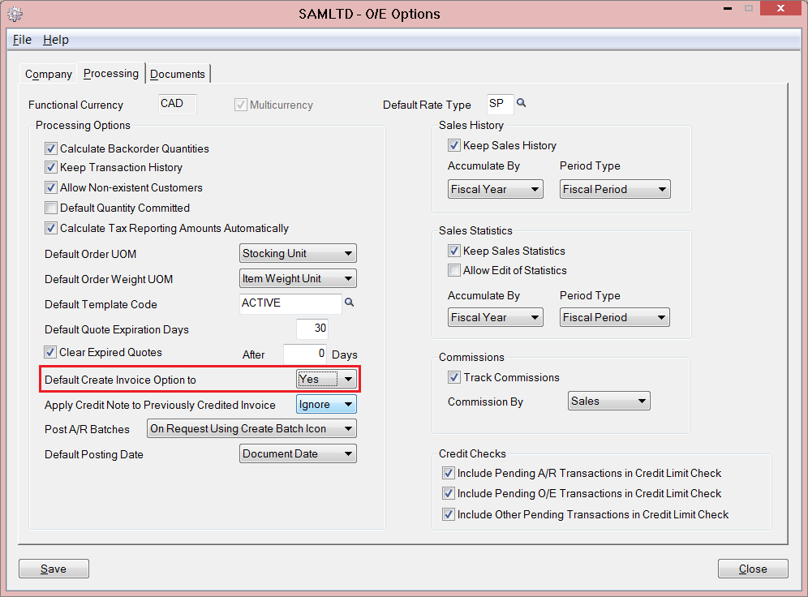

1. Start Visual Studio and from the **File** menu, select **New** and then **Project.**
2. In the **New Project** dialog, select **Installed**, then **Templates** and expand the **Visual C#** node. Next select **Windows Desktop**. In the list of project templates, select **Console Application**. Name the project **WebApi_SampleIntegration** and click **OK**.

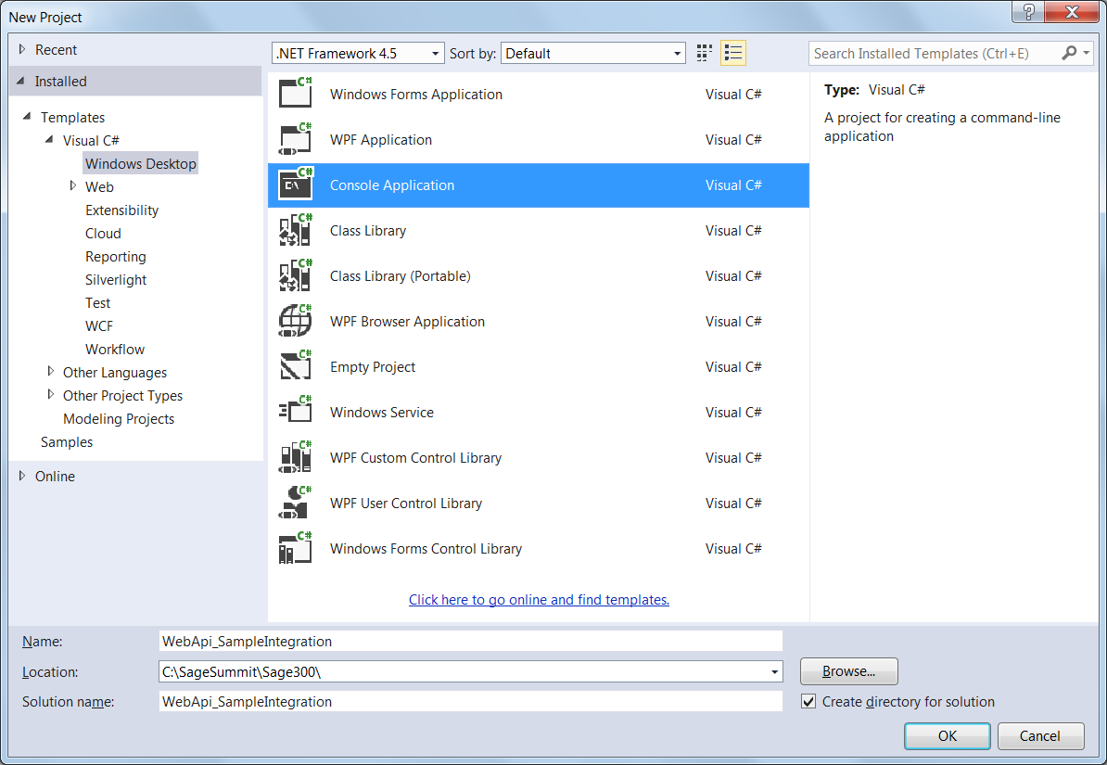

1. From the **View** menu, hover over **Other Windows** and select **Package Manager Console**. In the Package Manager Console window, type the following commands:

**Install-Package Newtonsoft.Json**

**Install-Package Microsoft.Net.Http**

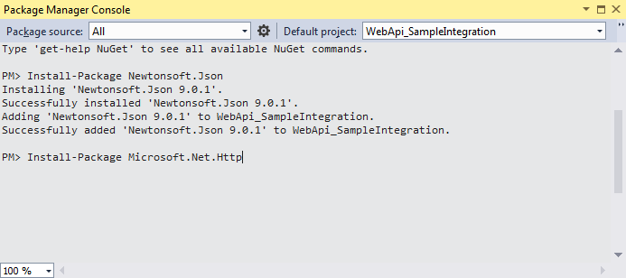

1. Inside **Program.cs** replace the import section at the top of the class with the following:



1. Add the following properties at the top of the **Program** class:



These will serve as simulated input parameters from an external source.

1. Add a base method for making requests:



1. Add a method to create a customer:



1. Change the **Main** method by assigning the class properties and calling **CreateCustomer**:



1. Run the program by pressing **F5** and entering **ZCUST1** when prompted for the **new customer number**.
2. Add a method to update the customer:



1. Call this new method inside the **Main** method:



1. Run the program by pressing **F5** and enter **ZCUST2** when prompted for the **new customer number**.
2. Add a method in the **Program** class which creates an OE entry document and interprets the results:



1. Call this new method inside the **Main** method:



1. Run the program by pressing **F5** and entering **ZCUST3** when prompted for the **new customer number**.
2. Add methods to call various processes including IC Day End and Post AR Invoices:



1. Call these new methods within the **Main** method:



1. Run the final program by pressing **F5** and entering **ZCUST4** when prompted.