Ollscoil na hÉireann, Corcaigh
National University of Ireland, Cork

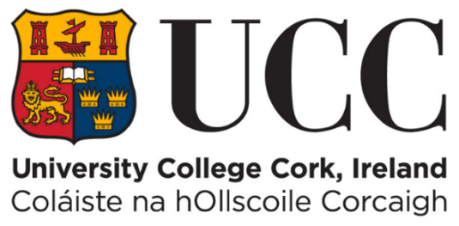

FYP

Iteration 1
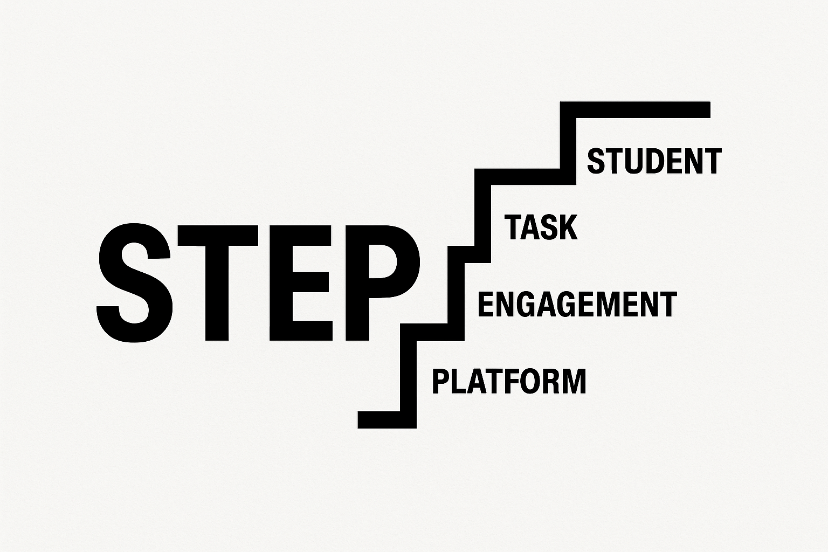

By
[Ben Murphy, 122438066]

[28/10/2025]

Table of Contents
1.Project Overview 3
1.2 What the platform provides 3
2.Major changes since proposal 4
3.Product Backlog list 5
Fig 3.1: Outdated Product Backlog List 5
Fig 3.2: Updated Product Backlog List 8
4. Iteration Review 10
4.1 A description of how the iteration on went. 10
4.2 The Development Process 10
Fig 4.3 Create a verified profile 11
Fig 4.4 Companies can create tasks 12
Fig 4.5 Importing and utilizing flask & SQL Alchemy 13
4.6 Completed This Iteration 13
4.7 What Went Well 14
4.8 Difficulties & How They Were Handled 14
4.9 User / Stakeholder Interaction 14
5. Testing 15
5.1 Testing Student Registration and Login 15
Fig 5.2 Email already registered error 15
Fig 5.3 Tried registering with missing required fields 15
5.4 Testing Company Task Posting 16
5.5 Future Testing Improvements 17
6.Risks 17
7. Plan for Next Iteration 18
7.1 Admin Functionality: Account Verification and Dispute Management 18
7.2 Student Experience: Browsing and Filtering Tasks 18

1.Project Overview
A summary of what the project aims to achieve and the problem it solves.

This project aims to develop a digital marketplace platform that connects universities and their students with companies who need more capacity to clear their backlog of tasks.
Companies face resource bottlenecks at the end of sprint cycles, leaving tasks unfinished. At the same time, students struggle in the early years of their course to access meaningful, paid industry experience that builds their skills and resumes.
This system addresses both challenges by creating a trusted, structured environment where students can apply for, deliver and get paid for completing these published tasks.

1.2 What the platform provides
For Students: A verified account linked to their university email, where they can display academic performance, project experience, and lecturer endorsements. Students gain access to real, paid tasks, and can build a portfolio of completed work supported by ratings and feedback from industry. This helps bridge the gap between academic study and professional practice.

For Companies: A straightforward way to post tasks with clear milestones and acceptance criteria, supported by integrated contract e-signings (NDAs) and payouts. The rating and feedback system ensures accountability & transparency. This reduces risk while increasing efficiency.

For Universities: Giving their talented students the opportunity to become visible to companies. It also gives visibility into how students engage with industry opportunities, the ability to give references to student profiles, and the option to report on skills developed that benefit both students and employers.

The system is built around transparency, and efficiency. Verification mechanisms, student email confirmation, business identity checks, secure digital contracts, encrypted data handling, and two-sided ratings all contribute to a safe and reliable marketplace.

2.Major changes since proposal
A brief outline of any significant changes to the system since the proposal stage.

No major scope changes currently. The core proposition, stakeholders, and feature set remain consistent: task/milestone marketplace, verification, e‑signing, milestone delivery, payments, and ratings.

3.Product Backlog list

Fig 3.1: Outdated Product Backlog List
The Product backlog list was created at the beginning of this project to be of assistance throughout the entire development process. It is there to prioritise tasks and to manage time efficiently. It gave the developer a clear pathway to start developing the tasks in between iterations and saves time speculating on what to develop next. The priority backlog list was updated and re-evaluated before the developmental process started ( Ref Fig 3.2) Updated Product Backlog list.

Priority | AS A... | I WANT TO... | SO THAT...
1 | Student | Create a verified profile and sign up using my student email (including skills, grades, projects, references) | I can apply for suitable tasks that match my qualifications
2 | Company | Post scoped tasks with milestones & acceptance criteria | I can outsource sprint backlog tasks safely
3 | Student | Browse & filter tasks by skill, budget, and timeline | I can quickly find relevant work opportunities
4 | Company | Review applicants and select a candidate | I can ensure I choose the best fit for the task
5 | Student | E-sign NDAs/contracts on the website | I can start work compliantly and securely
6 | Company | Review submissions & request changes | I can enforce quality standards before making payment
7 | Company | Approve milestones | I only pay for accepted and satisfactory work
8 | Student | Receive payouts to my bank | I get paid promptly upon completion
9 | Student/Company | Rate and review each other | Trust and credibility improve over time
10 | Admin | Verify accounts and manage disputes | Platform integrity and fairness are supported
11 | University | Verify student status | Companies can trust student profiles
12 | University | View aggregated analytics | I can track student engagement and project outcomes

The updated user stories in the product backlog list was re-ordered and refined to better reflect the logical flow of the platform and the actual dependencies between the features. In the original product backlog list “Student Browse & filter tasks by skill, budget, and timeline” was at No.3. I then moved this to No.4 in the product backlog list and moved the “admin verification of accounts” to No.3 as I thought this was an important part of the process to ensure safety and verification of the website for end users. I removed user story 8 from my product backlog list “receive payouts to my bank” as I thought the company side could facilitate this. The same methodology was applied for user story No.5 “ E-Signing and NDA’s”.

I also merged the two separate university-related stories into a single story (“verify student status” and “view aggregated analytics”) as I feel they are intertwined with one and another in terms development.

These changes ensured the backlog was cleaner, reduced redundancy, and aligned development with a realistic feature rollout path, helping me focus on what was required to deliver a usable UI before building secondary features like payments, contracts, and reviews.

Fig 3.2: Updated Product Backlog List
Priority | AS A... | I WANT TO... | SO THAT... | STATUS | Planned FOR CURRENT ITERATION | PLANNED FOR NEXT ITERATION
1 | Student | Create a verified profile and sign up using my student email. | So that I can reach the student dashboard page | Completed  Iteration 1
2 | Company | Post scoped tasks with milestones & acceptance criteria | I can outsource sprint backlog tasks safely | Completed  Iteration 1
3 | Admin | Verify accounts and manage disputes | Platform integrity and fairness are supported |  |  | Yes
4 | Student | Browse & filter tasks based on skill and timeframe | I can quickly find job opportunities that suit me |  |  | Yes
5 | Company | Review applicants and select a candidate | I can ensure I choose the best fit for the task
6 | Company | Review submissions & request changes | I can enforce quality standards before making payment
7 | Company | Approve milestones and confirmation of payments released | I only pay for accepted and satisfactory work
8 | Student/Company | Rate and review each other | Trust and credibility improve over time
9 | Admin | Verify accounts and manage disputes | Platform integrity and fairness are supported
10 | University | Reference student acocunts and view analytics | Students can have a university reference, while keeping track of student’s progress

4. Iteration Review

4.1 A description of how the iteration on went.
Completing Iteration 1 I found the redefined product backlog list brought clarity before development. Understanding my idea practicality and having a passion for what I am developing and documenting was a factor of this Iteration going well also. The research of what frameworks, database and bootstraps to use also is very interesting as I feel I am learning a lot during this Iteration.

4.2 The Development Process
This iteration focused on delivering the first two highest-priority user stories from the backlog

- Companies & Students can create a verified profile (Ref Fig 4.3)

- Companies can create tasks (Ref Fig 4.4)

Both were completed successfully, establishing the foundation of the platform where students can now join the system, and companies can create real tasks that will later be assigned to students. These features were developed using Flask, SQL Alchemy, Flask-Login, and role-based routing, ensuring that the system can scale as more functions (e.g., browsing, applications, payments) are added in later iterations.

- Importing and utilizing flask & SQL Alchemy (Ref Fig 4.5)

4.6 Completed This Iteration
Student signup & authentication – Students can register, log in, and are redirected to a student dashboard.
Company account creation & login – Companies can also register and have their own dashboard.
Task posting system for companies – Companies can create a task with title, description, skills required and estimated time. Tasks are stored in the database and displayed on the company dashboard.

4.7 What Went Well

Separation of student and company logic early prevented UI confusion later.

Role-based dashboards worked first time, meaning future roles (Admin, University) can plug in easily.

Using SQL Alchemy models from the start made it easy to link tasks to a company via company_id.

4.8 Difficulties & How They Were Handled
An issue I had was one shared registration form caused companies to see student-specific fields (e.g. grades, references).
Fix: Conditional rendering based on role, so each user sees only relevant inputs.

An Issue I had was that once logged in the user could not edit any information on their profile.
Fix: I added an edit user button so that users can edit their details

4.9 User / Stakeholder Interaction

5. Testing
Testing for this iteration focused on the two completed user stories:
- Student registration and login
- Company task creation and display on the company dashboard

5.1 Testing Student Registration and Login
Tests carried out:
- Registered using a valid student email (Ref Fig 5.2)

- Email already registered error (Ref Fig 5.2

- Tried registering with missing required fields (Ref Fig 5.3)

Issues discovered and changes made:
- Backend validation was required because users could bypass browser form validation. This was fixed by adding server-side checks and flash warnings (Ref Fig 5.4)
- The login error message was too generic. It was updated to give clearer feedback to the user.
- The dashboard did not display any confirmation that login succeeded. A success message was added to improve clarity.

5.4 Testing Company Task Posting
Tests carried out:
- Created a task with valid title and description (Ref Fig.5.3)

- Submitted form with missing fields to check validation (Ref Fig 5.5)

- Confirmed that company’s tasks appear only on the logged-in company’s dashboard (Ref Fig5.6)

Issues discovered and changes made:
- Students could manually type the task creation URL and reach the page. Role-based access control was enforced, and a proper 403 message was added.
- Task form allowed empty submissions, so extra backend validation was added.
- There was no success message after creating a task, so a confirmation message and redirect were added.

5.7 Future Testing Improvements
- Add automated unit tests using PyTest once more features are built
- Use a separate test database instead of the live development database
- Introduce form validation tests to prevent regression issues
- Conduct user acceptance testing once task browsing and applications are implemented

6.Risks
Filtering and browsing tasks may cause performance issues later
Currently all tasks are loaded at once. As more tasks are created, this could slow down the student dashboard.
Plan: introduce pagination and indexed search once basic browsing is working.

Dispute handling may require storing additional evidence or messages
This could add complexity beyond what was originally scoped.
Plan: start with a very simple dispute log and expand only if time allows.

7. Plan for Next Iteration
The upcoming development cycle will concentrate on completing the next two user stories identified as the highest priorities. These are essential steps to ensure the platform's core functionality and operational readiness.

7.1 Admin Functionality: Account Verification and Dispute Management
The first focus area will be the implementation of administrative tools for verifying user accounts and managing disputes. These features are critical for establishing a foundation of trust and integrity on the platform. By enabling moderation, the system can prevent the creation of fake or low-quality accounts, which is necessary for the platform to function realistically and maintain a high standard of user engagement.

7.2 Student Experience: Browsing and Filtering Tasks
The second priority is to enhance the student dashboard by allowing users to browse and filter available tasks. Now that companies can post tasks, it is important for students to have the capability to view and search these postings based on relevant criteria such as skills and timeframe. This functionality lays the groundwork for future enhancements, including applying for tasks, shortlisting opportunities, and accepting offers, ultimately supporting a seamless task discovery and application process.

8. Source Breakdown
- ChatGPT 35%

- Web/YouTube 25 %

- Own work 40%

9. References

Accessed on 02/11/2025
Bootstrap Conversation

Accessed on 03/11/2025
Flask SQLAlchemy Tutorial for Database - GeeksforGeeks

Accessed on 04/11/2025

Appendix

Fig 4.3 Create a verified profile
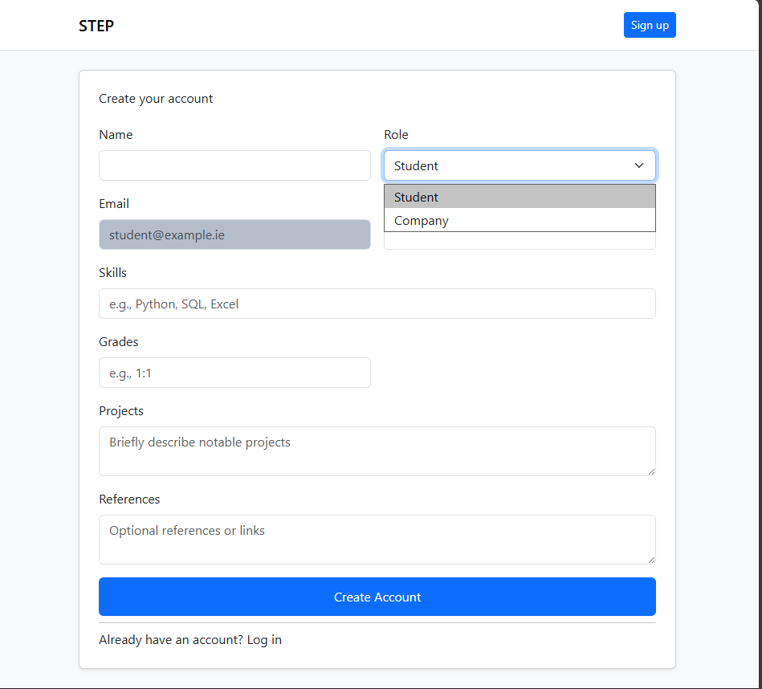

Fig 4.4 Companies can create tasks
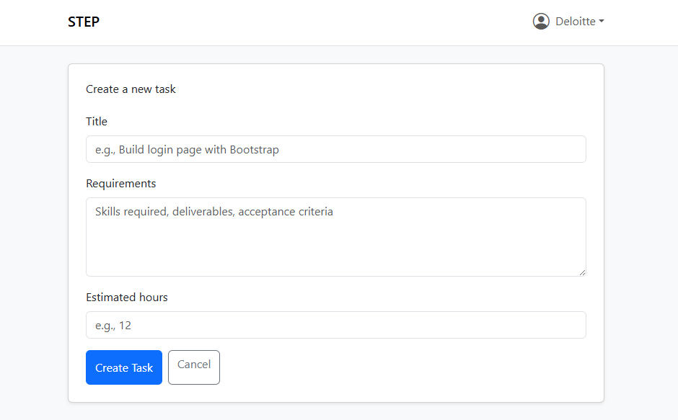

Fig 4.5 Importing and utilizing flask & SQL Alchemy
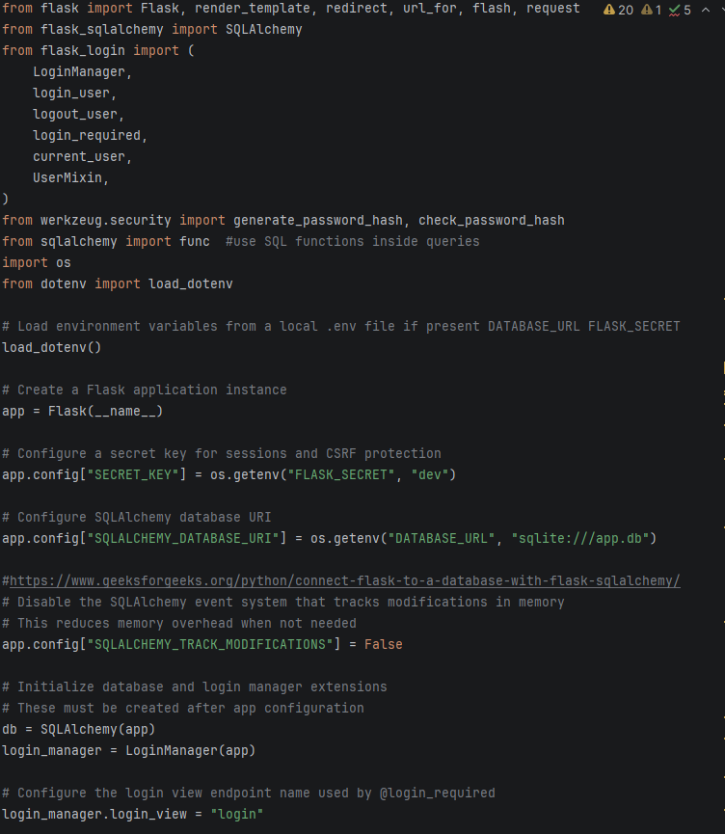

Fig 5.2 Email already registered error
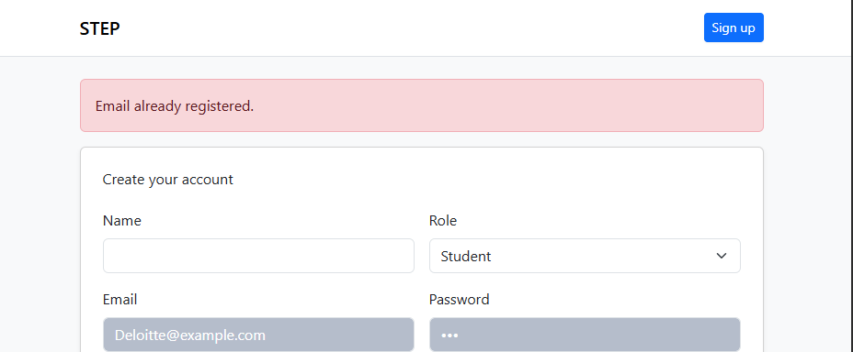

Fig 5.3 Tried registering with missing required fields
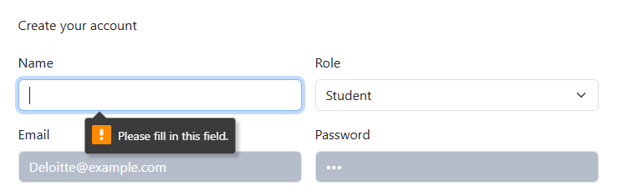

Fig 5.4Backend validation was required because users could bypass browser form validation. This was fixed by adding server-side checks and flash warnings
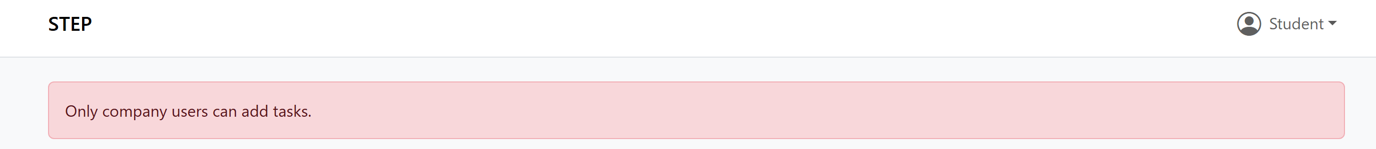

Fig 5.5 Submitted form with missing fields to check validation

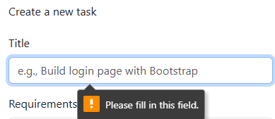

Fig 5.6 Confirmed that company’s tasks appear only on the logged-in company’s dashboard
