

NCO Appraisal

NCO Name | Age | Attendance
{{ name }} | {{ age }} | {{ attendance }}

General Observations
{{ general_observations }}

Effectiveness in Role
{{ effectiveness_in_role }}

Strengths
{{ strengths }}

Weaknesses
{{ weaknesses }}

Targets
{{ targets_numbered }}

Next NCO Review | Cause for Concern | Extend Probation
{{ next_review }} | {{ cause_for_concern }} | {{ extend_probation }}

Agreed by
Commanding Officer | Sqn SNCO | Sqn FS
  Flt Lt Doherty | 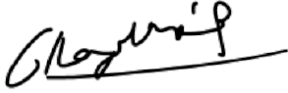  Sgt Lloyd Morris

