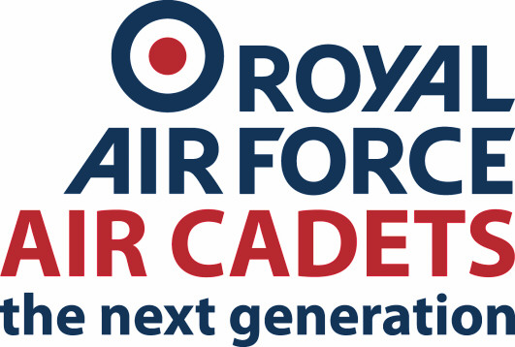
317 Failsworth Squadron
Greater Manchester Wing
Air Training Corps

Failsworth Army Reserve Centre
Oldham Road
Failsworth
M35 0BH

Tel: 0161 688 6705
Email: training.317@aircadets.org

{{ todays_date }}
Ref: {{ event_ref }}
See Distribution

References:
A. ACP 5

Time zone used through this order: LOCAL

{{ event_title }}

- General
Cadets from 317 Sqn will attend a course at {{ event_location }} from {{ date_from }} to {{ date_to }}

The following individuals are appointed into specific roles:

Course Coordinator
{{ course_ic }}

- Location
{{ event_location }}

- Arrival
Instructors will arrive at {{ instructor_start_time }}. Cadets to arrive for a prompt start at {{ cadet_start_time }}.

- Departure
Cadets are scheduled to depart at {{ departure_time }}. Allow upto 15 minutes for potential delays

- Administration
The nominal roll will be confirmed through SMS once bidding has closed

- Security
- All cadets and staff are to be in possession of identification. Cadets will be required to have their RAF Form 3822 / MyRAFAC App and uniformed staff a MOD F90. Civilian Instructors are to have suitable photographic ID such as driving licence.

- Nominal roll is to be finalised and confirmed on SMS prior to event and updated if any changes occur.

- Messing
With no exception meals will not be provided for / by staff & cadets. Attendees are advised to bring lunch.

- Supervision and Protection
- Supervision
Course has adequate adult staff provision, including female staff.

- Course Location
Squadron building used for training is within a compound which will be secure during course duration. All attendees will be given HSE brief on arrival.

- Leaving training location before end of course
Full course will be conducted within the squadron grounds, attendees wishing to go off-site during lunch may do so but must notify the directing staff.

- Discipline
All Cadets and staff are expected to always maintain the highest standards of discipline; any poor behaviour or breaches of discipline will result in the training being cancelled immediately.

- Accommodation
Course is non-residential, no accommodation is necessary.

- Training
No prior training is required for this course.

- Stores
N/A

- Accounting
- Pay and Allowances
If required for the event there will be a CACE form added to the application.

- Accommodation Charges
There are no accommodation charges.

- Messing Charges
There are no messing charges.

- Contract Management
N/A

- Transport
Private staff vehicles are to be used to and from venue. Parking is available within the squadron compound for all attendees. Cadets are to be taken to venue by parents and collected at agreed recovery time. For public transport, main bus and tram routes run within a 5-minute walk of the squadron.

{{ adult_ic_signature }}

For OC 317

