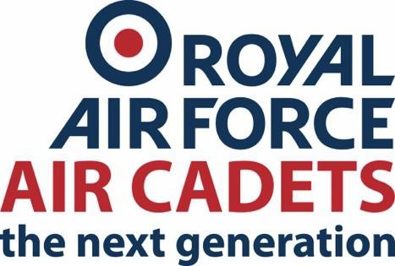

317 (Failsworth) Squadron Air Training Corps
Army Reserve Centre Failsworth Oldham M35 0BH

Tel: 0161 688 6705
Email: training.317@rafac.mod.gov.uk

Contact: {{ adult_ic }}

{{ title }}
{{ date_from_to }}

{{ description }}

Location:
{{ location }}

Timings:
Cadets are required to arrive at {{ arrival_time }} on the {{ arrival_date }}.

Departure time will be at {{ departure_time }} on the {{ departure_date }}.

Cost:
{{ cost }}

Uniform:
{{ dress }}

Admin:
{{ tg_form_req }}

All enquiries regarding the course should be directed to the course IC ({{ adult_ic }} {{ adult_ic_email }})

{{ adult_ic_signature }}

