46.
$$\overset{⃑}{u}∙\overset{⃑}{v}=\left(-1\right)\left(-2\right)+\left(0\right)\left(2\right)+\left(1\right)\left(-1\right)=2+0-1=1 \\ \cos{θ}=\frac{\overset{⃑}{u}∙\overset{⃑}{v}}{\left|\overset{⃑}{u}\right|\left|\overset{⃑}{v}\right|}=\frac{\left(-1\right)\left(-2\right)+\left(0\right)\left(2\right)+\left(1\right)\left(-1\right)}{\sqrt{{\left(-1\right)}^{2}+0^{2}+1^{2}}\sqrt{{\left(-2\right)}^{2}+2^{2}+{\left(-1\right)}^{2}}}=\frac{2+0-1}{\sqrt{2}\sqrt{9}}=\frac{1}{3\sqrt{2}} \\ θ≈76.37°$$

47.
$$\left(-1, 3, 4\right)×\left(-5, 6, 0\right)=\left(\left(3\right)\left(0\right)-\left(6\right)\left(4\right), \left(4\right)\left(-5\right)-\left(0\right)\left(1\right), \left(-1\right)\left(6\right), \left(-5\right)\left(3\right)\right)=\left(0-24, -20+0, -6+15\right)=\left(-24, -20, 9\right)$$
$$\left(-24, -20, 9\right)∙\left(-1, 3, 4\right)=\left(-24\right)\left(-1\right)+\left(-20\right)\left(3\right)+\left(9\right)\left(4\right)=24-60+36=0 \\ \left(-24, -20, 9\right)∙\left(-5, 6, 0\right)=\left(-24\right)\left(-5\right)+\left(-20\right)\left(6\right)+\left(9\right)\left(0\right)=60-60=0$$

48.
$$\left(k\overset{⃑}{u}\right)∙\overset{⃑}{v}=k\left(\overset{⃑}{u}∙\overset{⃑}{v}\right)=\left(k{\overset{⃑}{u}}_{1}, k{\overset{⃑}{u}}_{2}\right)∙\overset{⃑}{v}=\left(k{\overset{⃑}{u}}_{1}\right)\left({\overset{⃑}{v}}_{1}\right)+\left(k{\overset{⃑}{u}}_{2}\right)\left({\overset{⃑}{v}}_{2}\right)=k\left({\overset{⃑}{u}}_{1}\right)\left({\overset{⃑}{v}}_{1}\right)+k\left({\overset{⃑}{u}}_{2}\right)\left({\overset{⃑}{v}}_{2}\right)=k\left(\left({\overset{⃑}{u}}_{1}\right)\left({\overset{⃑}{v}}_{1}\right)+\left({\overset{⃑}{u}}_{2}\right)\left({\overset{⃑}{v}}_{2}\right)\right)=k\left(\overset{⃑}{u}∙\overset{⃑}{k}\right)$$

49. a)
$$\overset{⃑}{u}∙\overset{⃑}{v}=\left(1\right)\left(-2\right)+\left(3\right)\left(2\right)+\left(-2\right)\left(2\right)=-2+6-4=0 \\ \overset{⃑}{v}∙\overset{⃑}{w}=\left(-2\right)\left(5\right)+\left(2\right)\left(1\right)+\left(2\right)\left(4\right)=-10+2+8=0 \\ \overset{⃑}{w}∙\overset{⃑}{u}=\left(5\right)\left(1\right)+\left(1\right)\left(3\right)+\left(4\right)\left(-2\right)=5+3-8=0$$
Since the dot products are 0, then $\overset{⃑}{u}$, $\overset{⃑}{v}$, and $\overset{⃑}{w}$ must therefore be perpendicular to each other.

b)
$$\overset{⃑}{u}∙\overset{⃑}{v}=\left|\overset{⃑}{u}\right|\left|\overset{⃑}{v}\right|\left(1\right)=\left|\overset{⃑}{u}\right|\left|\overset{⃑}{v}\right|\cos{0°}$$
What we know is that the angle of the two vectors is zero. We do not know if they are the same magnitude, but they are in the same direction.

50.
$$\left|AB×BC\right|=\left(1+1, -1-2, 2-4\right)×\left(2+1, 3-2, 4-4\right)=\left(2, -3, -2\right)×\left(3, 1, 0\right)=\left(\left(-3\right)\left(0\right)-\left(1\right)\left(-2\right), \left(-2\right)\left(3\right)-\left(0\right)\left(2\right), \left(2\right)\left(1\right)-\left(3\right)\left(-3\right)\right)=\left(0+2, -6-0, 2+9\right)=\left(2, -6, 11\right)=\sqrt{2^{2}+{\left(-6\right)}^{2}+{11}^{2}}=\sqrt{4+36+121}=\sqrt{161} \\ ABC=\frac{\sqrt{161}}{2}≈6.34 square units$$

51.
$$V=\left|\left(\overset{⃑}{a}×\overset{⃑}{b}\right)∙\overset{⃑}{c}\right|=\left|\left(\left(2, -5, -1\right)×\left(2, 0, -1\right)\right)∙\left(-1, 0, 1\right)\right|=\left|\left(\left(-3\right)\left(0\right)-\left(0\right)\left(-1\right), \left(1\right)\left(2\right)-\left(-1\right)\left(2\right), \left(2\right)\left(0\right)-\left(2\right)\left(-5\right)\right)∙\left(-1, 0, 1\right)\right|=\left|\left(5-0, -2+2, 0+10\right)∙\left(-1, 0, 1\right)\right|=\left|\left(5\right)\left(-1\right)+\left(0\right)\left(0\right)+\left(10\right)\left(1\right)\right|=\left|\left(5\right)\left(-1\right)+\left(0\right)\left(0\right)+\left(10\right)\left(1\right)\right|=\left|-5+10\right|=\left|5\right|=5$$

52. a)
$$\left|\vec{T}\right|=\left|\vec{r}\right|\left|\vec{F}\right|\sin{θ}=\left|0.3 m\right|\left|50 N\right|\sin{30°}=\left(15 Nm\right)\left(1\right)=7.5 J \\ \left|\overset{⃑}{T}\right|=\left|0.3 m\right|\left|50 N\right|=\left(15 Nm\right)\left(1\right)=15 J$$

The torque will be 7.5 joules at an angle of 30 degrees. The maximum torque that can be applied is 15 joules when the angle is 90 degrees.

b)
$$w=\left|\overset{⃑}{F}\right|\left|\overset{⃑}{d}\right|\cos{70°}=\left|200 N\right|\left|5 m\right|\cos{70°}≈\left(1000 J\right)\left(0.342\right)≈342 J$$

53.
$$3x+4y=20 \\ 4y=-3x+20 \\ y=-\frac{3}{4}x+5 \\ 2x+5y=18 \\ 5y=-2x+18 \\ y=-\frac{2}{5}x+\frac{18}{5}$$
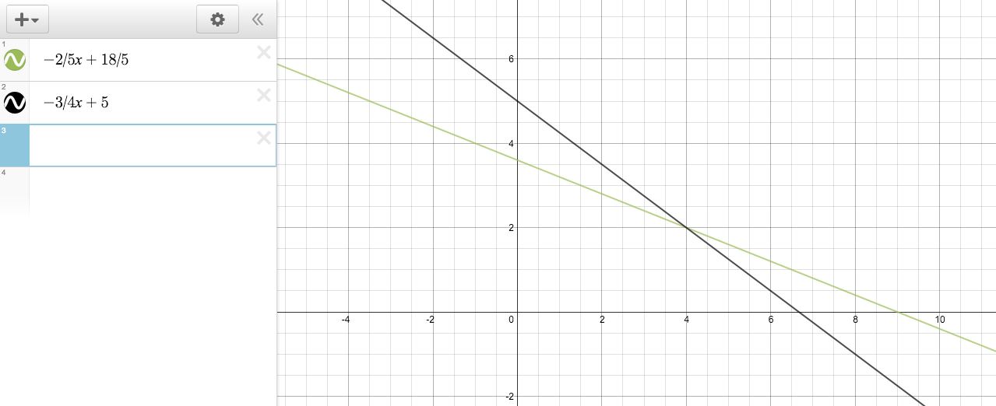
The intersection is (2, 4).

54. When $z=-3$, then you would have a horizontal place, with a “height” of 3. When y is set equal to $z \left(y=z\right)$, it is also equal to -3. Therefore, you’re left with a straight line who’s only dynamic variable is x. This is the intersection:
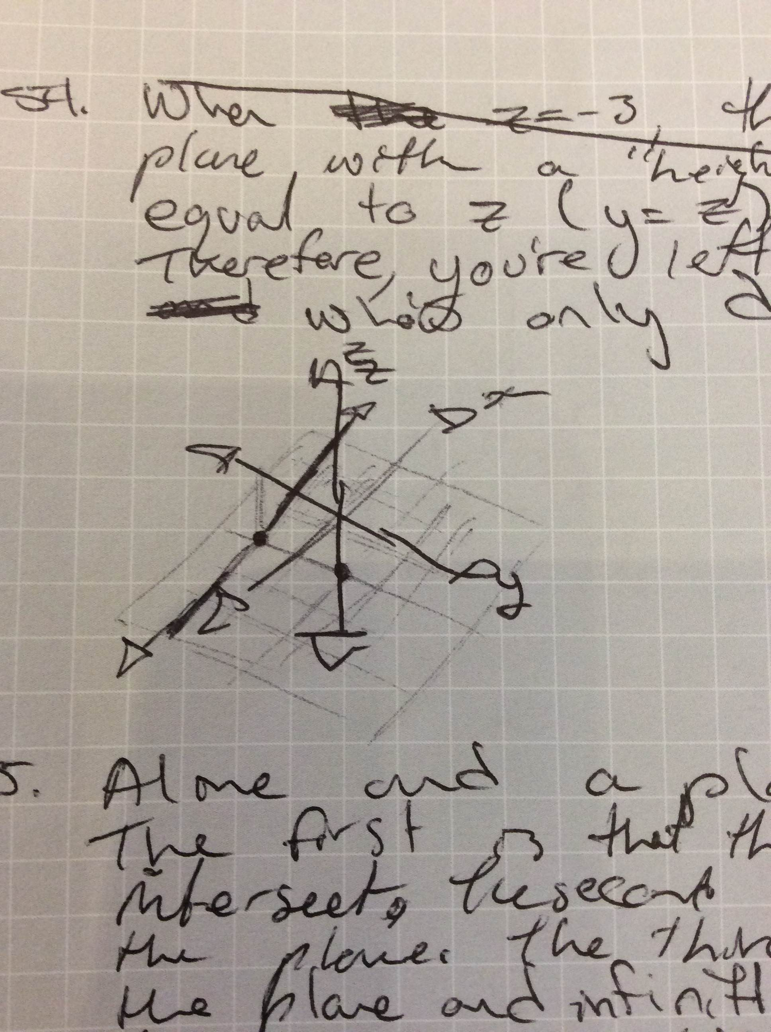

55.
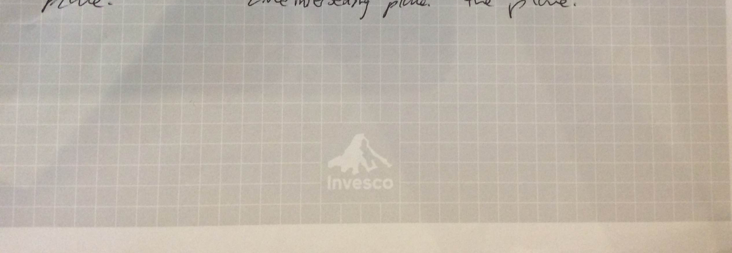

56. a)
$$\left(x, y, z\right)=\left(1, -3, 1\right)+t\left(2, -2, 1\right) \\ x=1+2t \\ y=-3-2t \\ z=1+t$$
b)
$$\left(x, y, z\right)=\left(3, 0, 4\right)+t\left(1, 0, 0\right) \\ x=3+t \\ y=0 \\ z=4$$
c)
$$\overset{⃑}{AB}=\left(1, 2, 1\right)—1, 2, 1=(2, 0, 0) \\ \left(x, y, z\right)=\left(1, 2, 1\right)+t\left(2, 0, 0\right) \\ x=1+2t \\ y=2 \\ z=1$$

57.
$$A\left(1, -2, 0\right), B\left(1, -2, 2\right), C\left(0, 3, 2\right) \\ \overset{⃑}{AB}=\left(1, -2, 2\right)-\left(1, -2, 0\right)=\left(0, 0, 2\right) \\ \overset{⃑}{AC}=\left(0, 3, 2\right)-\left(1, -2, 0\right)=\left(-1, 5, 2\right) \\ x=\left(0\right)\left(2\right)-\left(5\right)\left(2\right)=-10 \\ y=\left(2\right)\left(-1\right)-\left(2\right)\left(0\right)=-2 \\ z=\left(0\right)\left(5\right)—1\left(0\right)=0 \\ \overset{⃑}{AB}×\overset{⃑}{AC}=\left(x, y, z\right)=\left(-10, -2, 0\right) \\ -10x-2y+0x+d=0 \\ -10x-2y+d=0 \\ -10\left(1\right)-2\left(-2\right)+d=0 \\ -10+4+d=0 \\ -6+d=0 \\ d=6$$

58.$$\left(1\right)\left(1\right)-\left(1\right)\left(-2\right)=3 \\ \left(1\right)\left(4\right)-\left(1\right)\left(3\right)=1 \\ \left(3\right)\left(-2\right)-\left(4\right)\left(1\right)=-10 \\ \left(3, 1, 1\right)×\left(4, -2, 1\right)=\left(3, 1, -10\right) \\ 3x+y-10z+d=0 \\ 3\left(-1\right)+\left(2\right)-10\left(0\right)+d=0 \\ -3+2+d=0 \\ d=1 \\ 3x+y-10x+1=0$$

59. TBD

60. TBD

61. TBD

