- a)
$$\left(2x^{3}\right)\left(-7x^{5}\right)=-14x^{8}$$b)
$$\frac{-45x^{5}y^{7}z^{9}}{9x^{7}y^{7}z^{5}}=\frac{-5z^{2}}{x^{2}}$$c)
$${\left(-5x^{4}\right)}^{3}={\left(-5\right)}^{3}x^{12}=-125x^{12}$$d)
$$\frac{{\left(3x^{4}y^{5}z^{7}\right)}^{5}}{{\left(-3x^{3}yz^{4}\right)}^{7}}=\frac{3^{5}x^{20}y^{25}z^{35}}{{\left(-1\right)}^{7}3^{7}x^{21}y^{7}z^{28}}=\frac{y^{18}z^{7}}{-9x}$$e)
$$\frac{{\left(x^{a+b}\right)}^{a-b}}{{\left(x^{a-2b}\right)}^{a+2b}}=\frac{x^{a^{2}-b^{2}}}{x^{a^{2}-4b^{2}}}=x^{a^{2}-b^{2}-a^{2}+4b^{2}}=x^{3b^{2}}$$
- a)
$$6^{-2}=\frac{1}{6^{2}}=\frac{1}{36}$$b)
$${25}^{\frac{3}{2}}=5^{3}=125$$c)
$$-8^{\frac{5}{3}}=-2^{5}=-32$$d)
$${625}^{-\frac{3}{4}}=\frac{1}{{625}^{\frac{3}{4}}}=\frac{1}{5^{3}}=\frac{1}{125}$$
- a)
$$9^{3}{27}^{2}{81}^{3}={\left(3^{2}\right)}^{3}{\left(3^{3}\right)}^{2}{\left(3^{4}\right)}^{3}=3^{6}3^{6}3^{12}=3^{24}$$b)
$$\frac{5^{7}{25}^{3}}{{125}^{4}}=\frac{5^{7}{\left(5^{2}\right)}^{3}}{{\left(5^{3}\right)}^{4}}=\frac{5^{7}5^{6}}{5^{12}}=\frac{5^{7}}{5^{6}}=5$$
- 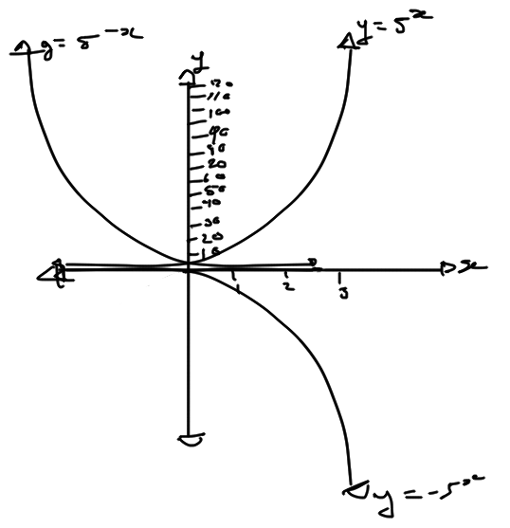
- $$y=-3^{-x}$$
- $$75 g=\left(2400 g\right){\left(\frac{1}{2}\right)}^{\frac{t}{13.8 s}} \\ \frac{75}{2400}=\frac{1}{32}=\frac{1}{2^{5}}={\left(\frac{1}{2}\right)}^{5}={\left(\frac{1}{2}\right)}^{\frac{t}{13.8 s}} \\ 5=\frac{t}{13.8 s} \\ t=69 s$$The beryllium-11 will take 69 seconds to decompose to 75 grams.
- $A=P{\left(1+i\right)}^{n}=\left(\$20000\right){\left(1+\left(-0.3\right)\right)}^{5}=\left(\$20000\right){\left(0.7\right)}^{5}=\left(\$20000\right)0.16807=\$3361.4$0
After five years, this car will be worth about $3300.
- a)
$$\log_{6}{36}=2$$b)
$$\log_{6}\left(\frac{1}{36}\right)=-2$$c)
$$7^{\log_{7}{12}}=12$$d)
$$\log_{16}{8}=\frac{3}{4}$$e)
$$\log_{3}{81\sqrt{27}}=\log_{3}{3^{4}3^{\frac{3}{2}}}=\log_{3}{3^{\frac{11}{2}}}=\frac{11}{2}\log_{3}{3}=\frac{11}{2}$$f)
$$\log_{\frac{1}{3}}{1}=0$$
- a)
$$\log_{7}{x}=2 \\ x=7^{2}=49$$b)
$$\log_{x}{64}=3 \\ x=\sqrt[3]{64}=4$$c)
$$\log_{3}\left(2x-1\right)=3 \\ 2x-1=3^{3}=27 \\ 2x=28 \\ x=14$$
- a)
$$\log_{8}{2}+\log_{8}{32}=\log_{8}\left(2×32\right)=\log_{8}{64}=2$$b)
$$\log_{5}{150}-\log_{5}{6}=\log_{5}\left(\frac{150}{6}\right)=\log_{5}{25}=2$$c)
$$\log_{5}{20}+\log_{5}{10}-3\log_{5}{2}=\log_{5}{\frac{20\left(10\right)}{2^{3}}}=\log_{5}{25}=2$$
- $$A=P{\left(1+1\right)}^{n} \\ \$6000=\$3000{\left(1+0.06\right)}^{n} \\ 2={1.06}^{n} \\ n=\log_{1.06}{2}≅11.90$$It would take 11.9 years for this GIC to grow to $6000.
- $${10}^{M_{2}-6.1}=2 \\ M_{2}-6.1=\log{2} \\ M_{2}≅0.30+6.1=6.4$$The rating on an earthquake that is twice as powerful is 6.4 on the Richter scale.
- $${10}^{x}=50 \\ {10}^{2}=100 \\ {10}^{1.8}≅63.10 \\ {10}^{1.7}≅50.12 \\ {10}^{1.69}≅49.00 \\ {10}^{1.696}≅49.66 \\ {10}^{1.698}≅49.89 \\ {10}^{1.699}≅50.00 \\ ∴log{50≅1.699}$$

X | Y
0.25 | -3.42
0.5 | -1.71
0.75 | -0.71
1 | 0
1.5 | 1
2 | 1.71
3 | 2.71
4 | 3.42
6 | 4.42
8 | 5.13
10 | 5.68
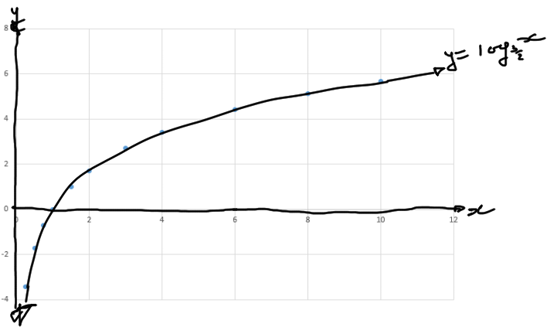
- The equation $y=-x+b$ is its own inverse because if one were to make an inverse of the function, they would receive a horizontal and vertical reflection that is coherent to the equation. For the algebraic proof, it is shown below:
$$y=f\left(x\right)=-x+b \\ x=-f^{-1}\left(x\right)+b \\ f^{-1}\left(x\right)+x=b \\ f^{-1}\left(x\right)=-x+b$$This would also be seen in the graph where the equation, when reflected on both axis’s regardless of the value of b, the slope of x is never affected.
- a) i) Reflection in the x-axis.
ii) Reflection in the y-axis.
iii) Reflection in the x and y-axis.
b)
$$y=f\left(x\right)=-\log_{5}\left(-x\right) \\ x=-\log_{5}\left(-f^{-1}\left(x\right)\right) \\ -f^{-1}\left(x\right)=-5^{x} \\ f^{-1}\left(x\right)=5^{x}$$c) 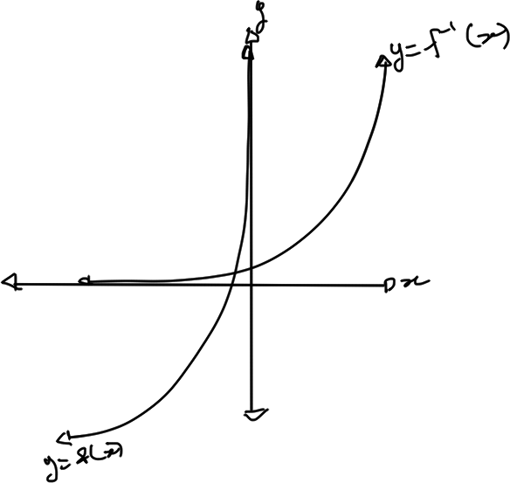

 | $$y=-\frac{1}{4}{\left(2\right)}^{x-4}+5$$
Shape | Decreasing
Vertical stretch factor | $$\frac{1}{4}$$
Point | $$\left(4, 4.75\right)$$
Domain | $$D=\left\{xϵR\right\}$$
Range | $$R=\left\{yϵR, x<5\right\}$$
Asymptote | $$x=5$$
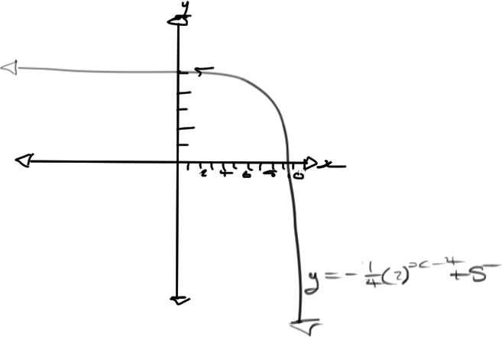
- $$y=5\left(2^{-x+2}\right)-5$$
- 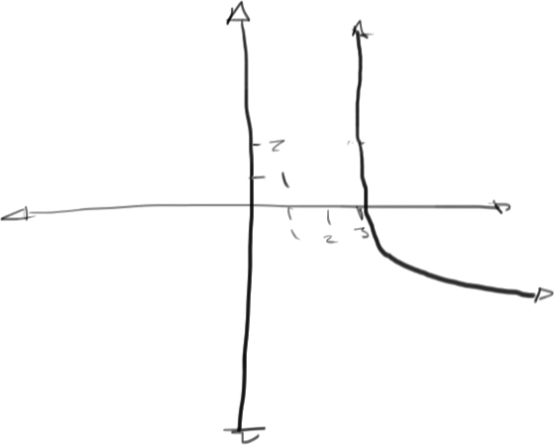
- $$y=\frac{1}{5}\log_{3}{{\left(9x-36\right)}^{15}}-13 \\ =3\log_{3}\left(9x-36\right)-13 \left(LLP\right) \\ =3\log_{3}\left(3^{2}\left(x-4\right)\right)-13 \\ =3\log_{3}{3^{2}}+3\log_{3}\left(x-4\right)-13 \left(LLM\right) \\ =6+3\log_{3}\left(x-4\right)-13 \\ =3\log_{3}\left(x-4\right)-7$$The basic equation was $y=\log_{3}{x}$. The transformations applied in order are:
a. Translated 4 units to the right.
b. Vertically stretched by a factor of 3.
d. Translated 7 units down.
Equation | $$y=3\log_{3}\left(x-4\right)-7$$
Domain | $$\left\{xϵR, x>4\right\}$$
Range | $$\left\{yϵR\right\}$$
Asymptotes | $$y=4$$
x-intercepts | $$0=3\log_{3}\left(x-4\right)-7 \\ 7=3\log_{3}\left(x-4\right) \\ \frac{7}{3}=\log_{3}\left(x-4\right) \\ x-4=3^{\frac{7}{3}} \\ x=3^{\frac{7}{3}}+4$$
Vertical Stretch/Compression | $$3$$
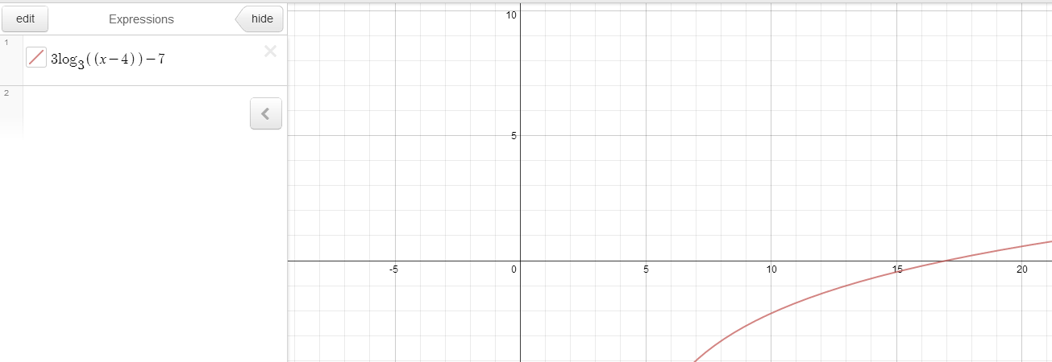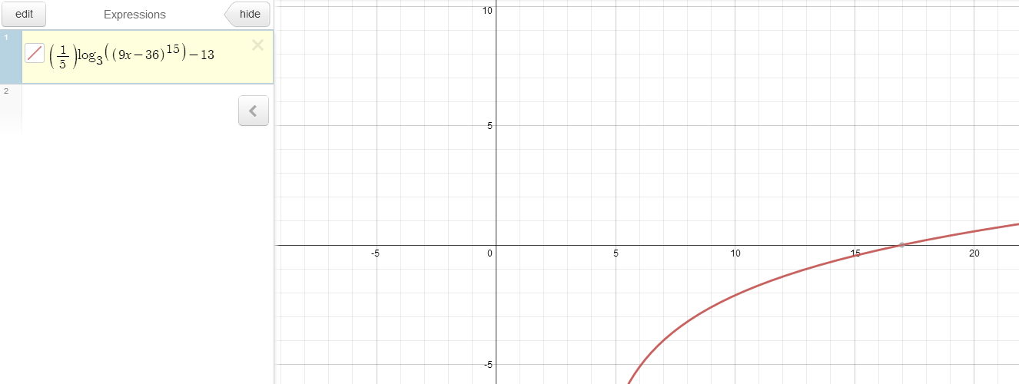
- $$y=1000\left({10}^{x}\right)={10}^{3}{10}^{x}={10}^{x+3}$$The horizontal translation that makes $y={10}^{x+3}$ is a horizontal translation of 3 units left.
- a)
Toss | Coins
0 | 20
1 | 11
2 | 7
3 | 2
4 | 1
5 | 0
b) i)
ii)
$$y=20{\left(0.5\right)}^{x}$$ iii) The physical phenomenon that this models is the amount of tosses that would statistically take until there are no tail coins left and how many coins one may have left over after each toss.
c)
$$y=N_{0}{\left(0.5\right)}^{x}$$d)
Toss | Coins
0 | 20
1 | 7
2 | 3
3 | 0

- a)
b) The graph appears exponential because the amount of coins that are being counted are working off of the previous amount. This is causing the graph to grow exponentially because every number is growing at a rate in which every preceding number has grown.
c)
$$y=4{\left(2\right)}^{0.6x}$$d)
$$y=N_{0}{\left(2\right)}^{x}$$e)
Toss | Number of Heads | Coins
0 |  | 4
1 | 2 | 6
2 | 1 | 7
3 | 6 | 13
4 | 8 | 21
5 | 11 | 32

f)
$$A=P{\left(1+i\right)}^{n+1}$$
- a)
$$4x-3=7 \\ 4x=10 \\ x=\frac{10}{4}=2.5$$b)
$$15x^{2}+x-6=0 \\ x=\frac{-1±\sqrt{1^{2}-4\left(15\right)\left(-6\right)}}{2\left(15\right)}=\frac{-1±\sqrt{1+360}}{30}=\frac{-1±\sqrt{361}}{30}=\frac{-1-\sqrt{361}}{30},\frac{\sqrt{361}-1}{30}$$c)
$$3x^{2}-8x-1=0 \\ x=\frac{-8±\sqrt{8^{2}-4\left(3\right)\left(1\right)}}{2(3)}=\frac{-8±\sqrt{64-12}}{6}=\frac{-8±\sqrt{52}}{6}=\frac{-8±2\sqrt{13}}{6}=\frac{-4±\sqrt{13}}{3}=\frac{-4-\sqrt{13}}{3},\frac{-4+\sqrt{13}}{3}$$
- a)
$$3^{4x-5}=\frac{1}{27}=\frac{1}{3^{3}}=3^{-3} \\ 4x-5=-3 \\ 4x=2 \\ x=0.5$$b)
$$4^{x-2}=8^{x+1} \\ 2^{2\left(x-2\right)}=2^{3\left(x+1\right)} \\ 2x-4=3x+3 \\ 3x-2x=-3-4 \\ x=-7$$
- a)
$$2^{x+3}-2^{x}=224 \\ 2^{x}\left(2^{3}-1\right)=2^{5}7 \\ 2^{x}\left(7\right)=2^{5}7 \\ 2^{x}=2^{5} \\ x=5$$b)
$$4\left(2^{2x}\right)+31\left(2^{x}\right)-8=0 \\ 2^{x}=\frac{-31±\sqrt{{31}^{2}-4\left(4\right)\left(-8\right)}}{2\left(4\right)}=\frac{-31±\sqrt{961+128}}{8}=\frac{-31±\sqrt{1089}}{8}=\frac{-31±33}{8}=-8, 0.25 \\ 2^{x}=-8, 0.25 \\ x=\log_{2}{-8}, does not exist \\ x=\log_{2}{0.25}=-2$$
- $$2^{x+3y}=128 \\ \log_{2}{128}=x+3y \\ 7=x+3y \\ 2^{3x-y}=2 \\ \log_{2}{2}=3x-y \\ 1=3x-y \\ \left(3x+9y=21\right)-\left(3x-y=1\right)=\left(10y=20\right) \\ y=2 \\ 3x-2=1 \\ 3x=3 \\ x=1$$
- $$3^{x}=7^{2} \\ \log_{3}{7^{2}}=x \\ x=2\log_{3}{7}$$
- a)
$$\log_{3}\left(2x+3\right)-\log_{3}\left(x-2\right)=2 \\ \log_{3}\left(\frac{2x+3}{x-2}\right)=2 \\ 3^{2}=9=\frac{2x+3}{x-2} \\ 9\left(x-2\right)=2x+3 \\ 9x-18=2x+3 \\ 7x=21 \\ x=3$$b)
$$\log_{9}\left(x-6\right)+\log_{9}\left(x+2\right)=1 \\ \log_{9}\left(\frac{x-6}{x+2}\right)=1 \\ 9^{1}=\frac{x-6}{x+2} \\ 9\left(x+2\right)=x-6 \\ 9x+18=x-6 \\ 8x=-24 \\ x=-3$$
- $$80 kg=\left(200 kg\right){\left(1-0.03\right)}^{x} \\ 0.4={0.97}^{x} \\ x=\log_{0.97}{0.4}≅30$$

