50. a)
$$θ=\frac{6}{4}=\frac{3}{2}=1.5 radians$$
b)
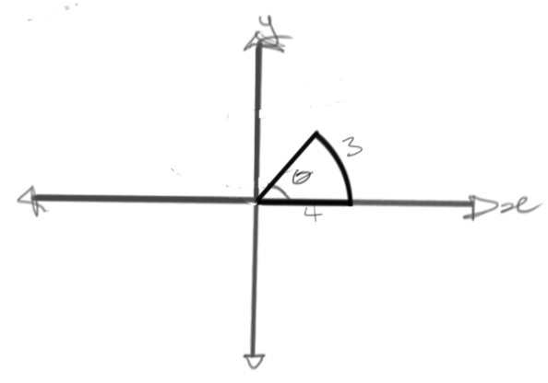
$$arc length=3$$For the length of the arc:
$$θ=\frac{3}{4}=0.75$$For the radius of the angle:
$$θ=3\left(\frac{180°}{π}\right)=\frac{540°}{π}$$
c)
$$θ=\frac{l}{r}=\frac{2πr}{r}=2π \\ θ=360° \\ 360°=2π \\ ∴π=180°$$
51. a) i)
$$10°=\frac{10π}{180}=\frac{π}{18}$$
ii)
$$225°=\frac{225π}{180}=\frac{45π}{36}=\frac{15π}{12}=\frac{5π}{4}$$
b) i)
$$\frac{π}{5}=\frac{π}{5}\left(\frac{180°}{π}\right)=\frac{180°}{5}=36°$$
ii)
$$\frac{11π}{6}=\frac{11π}{6}\left(\frac{180°}{π}\right)=\frac{11×180°}{6}=11×30°=330°$$
52. a)
$$\sin\left(\frac{2π}{3}\right)=2\left(\frac{\sqrt{3}}{2}\right)=\sqrt{3}$$
b)
$$\cos\left(\frac{7π}{6}\right)=7\left(\frac{\sqrt{3}}{2}\right)=\frac{7\sqrt{3}}{2}$$
c)
$$\sin\left(\frac{5π}{4}\right)=5\left(\frac{1}{\sqrt{2}}\right)=\frac{5}{\sqrt{2}}$$
d)
$$\tan\left(\frac{4π}{3}\right)=4\left(\frac{\sqrt{3}}{1}\right)=4\sqrt{3}$$
e)
$$\sec\left(\frac{7π}{6}\right)=7\left(\frac{2}{\sqrt{3}}\right)=\frac{14}{\sqrt{3}}$$
53. a)
Function | $$f\left(x\right)=sin⁡(x)$$
Amplitude | 1
Period | $360°$ or $2π$
¼ Wave | $90°$ or $\frac{π}{2}$
Starting Point | $$\left(0, 0\right)$$
b) The starting point of $f\left(x\right)=\cos{x}$ is $\left(0, 1\right)$
54.
Amplitude | $$f\left(x\right)=sin⁡(x)$$
Period | $$5$$
¼ Wave | $2$ or $2\left(\frac{180°}{2π}\right)=\frac{90°}{π}$
Domain | $$\left\{xϵR\right\}$$
Range | $$\left\{yϵR|y≥-2\right\}$$
55. a)

Amplitude | $$\frac{7.5-1.5}{2}=\frac{6}{2}=3$$
Period | $2\left(8-1\right)=2\left(7\right)=14$ or $14\left(\frac{180°}{π}\right)=\frac{2520°}{π}$
¼ Wave | $\frac{14}{4}=3.5$ or $\frac{2520°}{4π}=\frac{630°}{π}$
b) A possible reason as to why the natural gas is not zero is because some households may be using heat for cooking purposes.
56. a)
Function | $$f\left(x\right)=3\cos\left(2\left(x-\frac{π}{4}\right)\right)+1$$
Period | $$2π$$
Amplitude | $$3$$
Phase Shift | $$\left(\frac{π}{4}, 1\right)$$
b)
1 | $$\left(\frac{π}{4},4\right)$$
2 | $$\left(\frac{π}{2},1\right)$$
3 | $$\left(\frac{3π}{4},-2\right)$$
4 | $$\left(π,1\right)$$
5 | $$\left(\frac{5π}{4},4\right)$$

c)
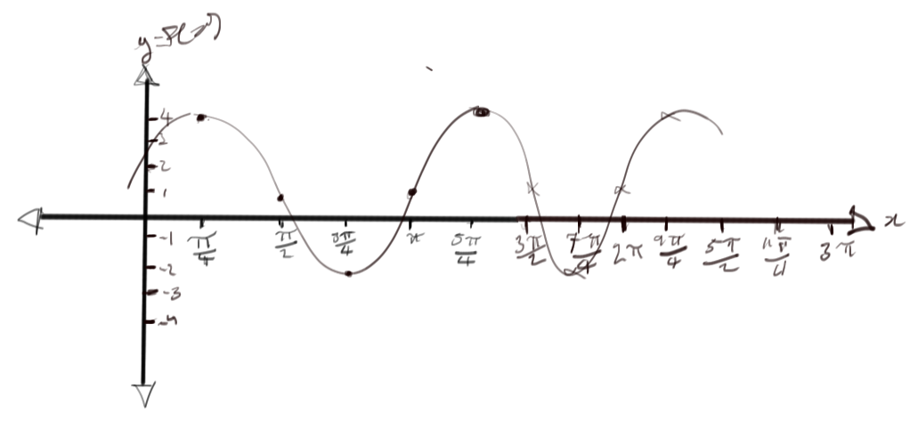
¼ Wave: | $$\frac{\frac{5π}{4}-\frac{π}{4}}{4}=\frac{\frac{4π}{4}}{4}=\frac{π}{4}$$
Starting Point: | $$\left(\frac{π}{4}, 4\right)$$
57.
$$y=\frac{36-4}{2}\sin\left(\frac{1}{12}\left(x-\frac{6}{2}\right)\right)+\frac{36-4}{2}+4=16\sin\left(\frac{x-3}{12}\right)+20$$
58. a)
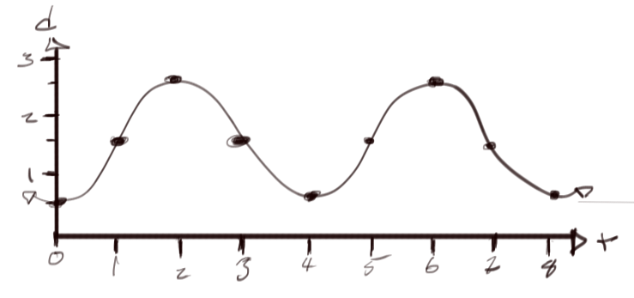
b)
$$h=\sin\left(\frac{tπ-π}{2}\right)+1.5=\sin\left(\frac{t}{2}\left(π-1\right)\right)+1.5$$
59.
$$\sin\left(A+B\right)=\sin{A}\cos{B}+\sin{B}\cos{A} \\ \sin\left(\frac{5π}{12}\right)=\sin\left(\frac{3π}{12}+\frac{2π}{12}\right)=\sin\left(\frac{π}{4}+\frac{π}{6}\right)=\sin\left(\frac{π}{4}\right)\cos\left(\frac{π}{6}\right)+\sin\left(\frac{π}{6}\right)\cos\left(\frac{π}{4}\right)=\frac{1}{\sqrt{2}}\frac{\sqrt{3}}{2}+\frac{1}{2}\frac{1}{\sqrt{2}}=\frac{\sqrt{3}}{2\sqrt{2}}+\frac{1}{2\sqrt{2}}=\frac{2\sqrt{3}\sqrt{2}+2\sqrt{2}}{8}=\frac{\sqrt{3}\sqrt{2}+\sqrt{2}}{4}=\frac{\sqrt{2}\left(\sqrt{3}+1\right)}{2\sqrt{2}\sqrt{2}}=\frac{\sqrt{3}+1}{2\sqrt{2}}$$
60. a)
$$\cos\left(π-x\right)=-\cos{x} \\ R.S.=\cos\left(π-x\right) \\ =\cos{π}\cos{x}+\sin{π}\sin{x} \\ =-1\cos{x}+0\sin{x} \\ =-\cos{x}$$
b)
$$\cos\left(\frac{3π}{2}+x\right)=\sin{x} \\ R.S.=\cos{\frac{3π}{2}}\cos{x}-\sin{\frac{3π}{2}}\sin{x} \\ =0\cos{x}-\sin{x} \\ =\sin{x}$$
c)
$$\sin{x}\cos{x}\tan{x}=1-\cos^{2}{x} \\ R.S.=\sin{x}\cos{x}\left(\frac{\sin{x}}{\cos{x}}\right) \\ =\sin^{2}{x} \\ =1-\cos^{2}{x}$$
61. a)
$$\cos{θ}+\sin{θ}\tan{θ}=\frac{1}{\cos{θ}} \\ R.S.=\frac{\cos{θ}\left(\cos{θ}+\sin{θ}\left(\frac{\sin{θ}}{\cos{θ}}\right)\right)}{\cos{θ}} \\ =\frac{\cos^{2}{θ}+\frac{\cos{θ}\sin^{2}{θ}}{\cos{θ}}}{\cos{θ}} \\ =\frac{\cos^{2}{θ}+\sin^{2}{θ}}{\cos{θ}} \\ =\frac{1}{\cos{θ}}$$
b)
$$\tan{θ}=\frac{1-\cos{2θ}}{\sin{2θ}} \\ L.S.=\frac{1-\cos{2θ}}{\sin{2θ}} \\ =\frac{1-\left(1-2\sin^{2}{θ}\right)}{2\sin{θ}\cos{θ}} \\ =\frac{2\sin^{2}{θ}}{2\sin{θ}\cos{θ}} \\ =\frac{\sin{θ}}{\cos{θ}} \\ =\tan{θ}$$
62. a)
$$2\cos^{2}{x}+3\cos{x}-2=0 \\ \left(2\cos{x}-1\right)\left(\cos{x}+2\right)=0 \\ \cos{x=-2, \frac{1}{2}} \\ x=\frac{π}{3}, \frac{5π}{3}$$
b)
$$\sin{x}=\cos{2x} \\ \sin{x}=1-2\sin^{2}{x} \\ 2\sin^{2}{x}+\sin{x}-1=0 \\ \left(2\sin{x}-1\right)\left(\sin{x}+1\right)=0 \\ \sin{x}=-1,\frac{1}{2} \\ x=\frac{π}{6}, \frac{5π}{6},\frac{3π}{2}$$
c)
$$\sin{x}=\sqrt{3}\cos{x} \\ \tan{x}=\sqrt{3} \\ x=\frac{π}{6},\frac{π}{3}, \frac{2π}{3},\frac{5π}{12}$$
d) The trigonometric equation in (c) is not an identity because an identity is a special equation that is true for all values of x. The graphs of $\sin{x}$ and $\sqrt{3}\cos{x}$ do not overlap. Red is $\sin{x}$ and blue is $\sqrt{3}\cos{x}$.
