Lessons Potential Score Actual Score
- 20 19
- 13 10
- 14 9
- 16 14
- 26 26
Unit Total: 78/89 or 88%
1. a)
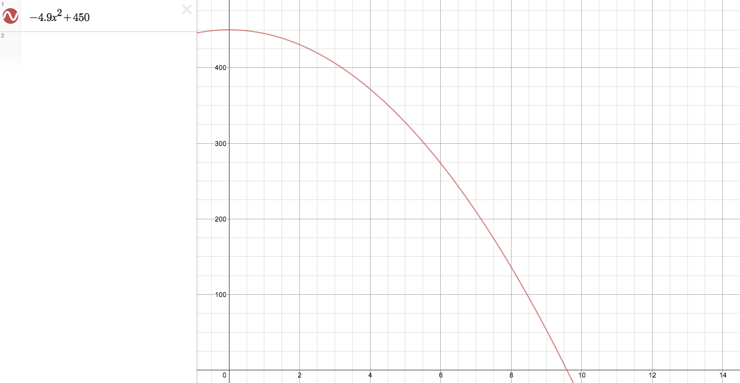
3/3
b)
1/1
c) i)
1/1
ii)
1/1
iii)
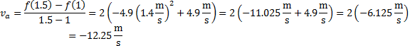
1/1
d)
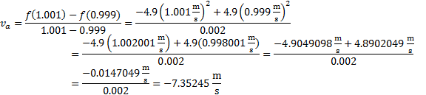
1/1
2. a)
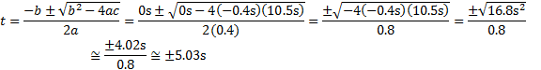
2/2
b)
1/1
c)
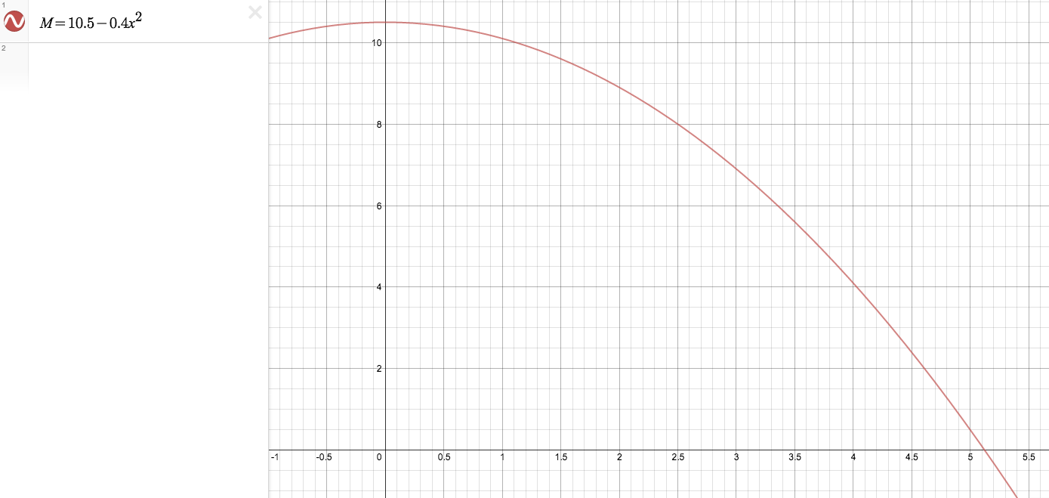
3/3
What happens at time =2 seconds? 0/1
3. a)
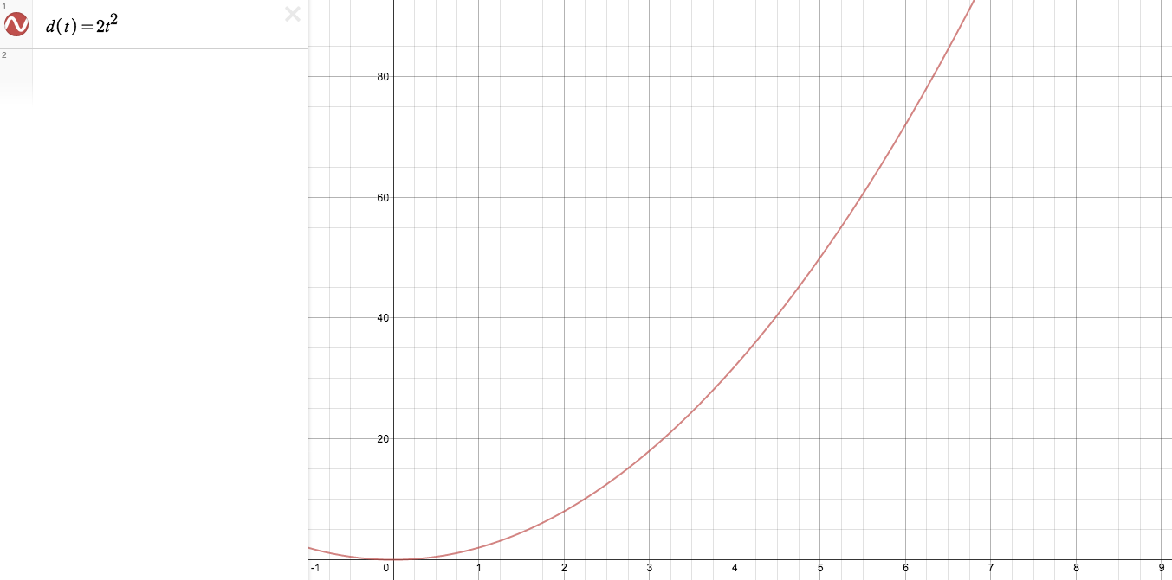
3/3
b)
1/1
c)
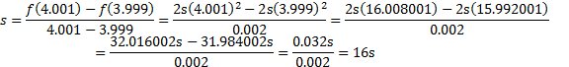
1/1
Lesson Total: 19/20
4. a) To determine the instantaneous rate of change of a function I would use function:
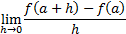
This is effective because it would allow me to specifically identify the rate of change at a given point instead of making approximations. 2/2 What would f(a+h) and f(a) stand for? Explain further. 0/1
b) i)
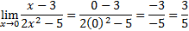
1/1
ii)
2/2
5. a)

Here there is an error in calculations so try again to ensure that there are no errors; particularly in the addition. 2/4
b)
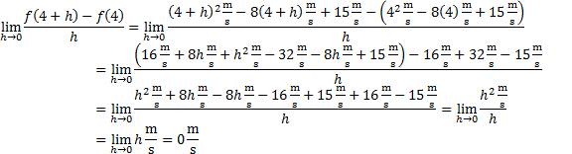
3/3
Lesson Total: 10/13
6. a) Positive: 1/1
Negative: 1/1
b) 1/1
c)
1/1
7. a)
2/2
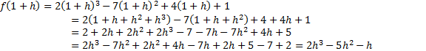
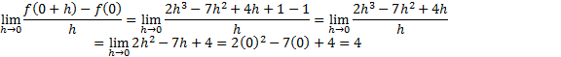
1/1
2/2
The value obtained for the limit has an error in calculation; the middle term is calculated incorrectly due to an arithmetic error in evaluating the numerator. It should compute to:
At x = 1, you should arrive at 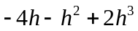
b) The function is increasing at because the instantaneous rate of change (4) is positive. The function is decreasing at because the instantaneous rate of change (-1) is negative. You haven’t quite understood how to write the notations, f(x) and x. We input the value we are finding into f(x); so for example if we are looking for the value of x = 4, we are finding f(4) which becomes equal to some value of y; in this case you obtained the value of 0. Review these in a pre-calculus course to avoid notation errors. 0/2
c) There should be a local maximum since the slope at is changing from positive to negative as it reaches . 0/2
Lesson Total: 9/14
8. a)
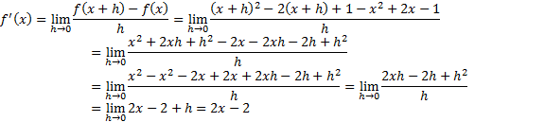
2/2
b)
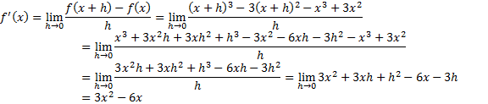
4/4
c)
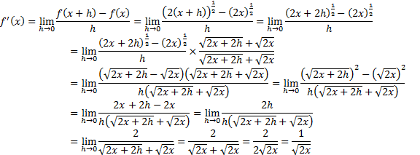
4/4
d)
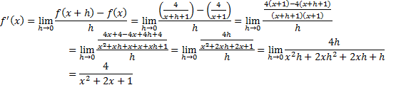
4/4
9. The process that was used to conclude that the derivative of the cubic function is a quadratic was from identifying that leading exponent would experience aoperationwhich resulted in the leading exponent changing from to . Therefore indicating that the derivative of a cubic function was a quadratic function. You haven’t quite explained why that change in exponent is made; you may want to explain your answer with reference to the first derivative equation using a proof. However, since proofs are beyond the scope of this course, you may want to refer to technology and use the traditional plot and point equations to define your answer. 0/2
Lesson Total: 14/16
10. a)
1/1
b)
2/2
c)
3/3
d)
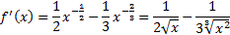
4/4
e)
4/4
11.
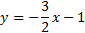
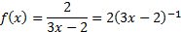
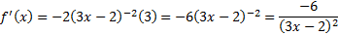
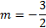
1/1
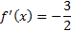
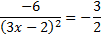
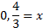
3/3
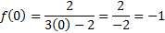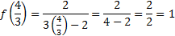
The points are and .
1/1
12.
1/1
2/2
1/1
1/1
2/2
Lesson Total: 26/26

