Unit 3
Scoring Here is how you arrive at a score for this unit:

Lesson | Key Questions:  Potential Score  (PS) | Key Questions:  Actual Score  (AS)
Lesson 11 28-30 | 18 | 16
Lesson 12 31-33 | 52 | 52
Lesson 13 34-36 | 16 | 15
Lesson 14 37-40 | 12 | 4
Lesson 15 41-45 | 27 | 19
Total | 125 | 106

Unit Score = AS ÷ PS × 100 = __85_____%
28. a) 1985: $97±1$
1996: $42±1$
b) 1986: $-5.98$
1991: $-5.60$
c) $≈1998$

29.
$$P^{'}\left(t\right)=\frac{\left(1+e^{-t}\right)\left(0\right)-\left(500\right)\left(0+\left(-e^{-t}\right)\right)}{{\left(1+e^{-t}\right)}^{2}}=\frac{-500\left(-e^{-t}\right)}{{\left(1+e^{-t}\right)}^{2}}=\frac{500\left(e^{-t}\right)}{{\left(1+e^{-t}\right)}^{2}} \\ P^{'}\left(3\right)=\frac{500\left(e^{-t}\right)}{{\left(1+e^{-t}\right)}^{2}}≈\frac{24.894}{1.102}=22.59$$

30. a)
$$C_{A}\left(x\right)=\frac{C\left(x\right)}{x} \\ C_{A}\left(x\right)=\frac{2500+100\left(200\right)-0.1{\left(200\right)}^{2}}{200}=\frac{2500+20000-0.1\left(40000\right)}{200}=\frac{22500-4000}{200}=\frac{18500}{200}=\frac{185}{2}=92.5 \\ C_{M}\left(x\right)=C^{'}\left(x\right)=100-0.2x \\ C_{M}\left(200\right)=100-0.2\left(200\right)=100-40=60$$

The average cost is $92.50 and the marginal cost is $60.00.

b) i)
$$A\left(t\right)=A_{O}{\left(\frac{1}{2}\right)}^{\frac{t}{k}} \\ \frac{1}{32}A_{O}=A_{O}{\left(\frac{1}{2}\right)}^{\frac{t}{k}} \\ \frac{1}{32}={\left(\frac{1}{2}\right)}^{\frac{t}{k}}={\left(\frac{1}{2}\right)}^{\frac{t}{\left(20\right)\left(24\right)}}={\left(\frac{1}{2}\right)}^{\frac{t}{480}}$$$t=480\log_{0.5}\left(\frac{1}{32}\right)=480\left(0.2\right)=96$2/3 answer is $\frac{1}{32}=1{\left(\frac{1}{2}\right)}^{\frac{t}{20}}$
${\left(\frac{1}{2}\right)}^{5}={\left(\frac{1}{2}\right)}^{\frac{t}{20}}$
$5=\frac{t}{20}$
$t=100$

The amount of time it takes for 1/32 of this substance to be left is 96 hours or 4 days.
ii)
$$A^{'}\left(t\right)={\left(\frac{1}{2}\right)}^{\frac{t}{k}}\ln{\frac{1}{2}}\left(\frac{1}{k}\right)={\left(\frac{1}{2}\right)}^{\frac{480h}{2400h}}\ln{\frac{1}{2}}\left(\frac{1}{2400h}\right)≈2.5×{10}^{-4}$$
The rate of decay is $2.5×{10}^{-4}$ kg per year.
0/1 answer is $A^{'}\left(100\right)={\left(\frac{1}{2}\right)}^{\frac{100}{20}}∙\ln\left(\frac{1}{2}\right)∙\frac{1}{20}$
$=-0.00108304247$

31.

$$R\left(x\right)=x\left(1200\left(1.50-x\right)\right)=1200x\left(1.50-x\right)=1800x-1200x^{2} \\ R{\left(x\right)}^{'}=1800-2400x \\ 0=1800-2400x \\ 2400x=1800 \\ x=\frac{1800}{2400}=0.75$$
The fare that will maximize the revenue is $0.75.

32.
$$N\left(t\right)=30t-t^{2} \\ N^{'}\left(t\right)=30-2t \\ 0=30-2t \\ 2t=30 \\ t=15 \\ N\left(15\right)=30\left(15\right)-{15}^{2}=450-225=225$$
The maximum number of conversations is 225 at 15 minutes.

33. a)
$$C\left(x\right)=\left(15\right)\sqrt{{120}^{2}+x^{2}}+\left(10\right)\left(300-x\right)=\left(15\right){\left({120}^{2}+x^{2}\right)}^{\frac{1}{2}}+3000-10x \\ C{\left(x\right)}^{'}=\left(15\right){\left({120}^{2}+x^{2}\right)}^{-\frac{1}{2}}\left(\frac{1}{2}\right)\left(2x\right)-10 \\ 0=\frac{15x}{\sqrt{{120}^{2}+x^{2}}}-10 \\ 10=\frac{15x}{\sqrt{{120}^{2}+x^{2}}} \\ \sqrt{{120}^{2}+x^{2}}=\frac{15x}{10}=\frac{3x}{2} \\ {120}^{2}+x^{2}=\frac{9x^{2}}{4} \\ x^{2}-\frac{9x^{2}}{4}=-{120}^{2} \\ -\frac{5x^{2}}{4}=-{120}^{2} \\ \frac{5x^{2}}{4}={120}^{2} \\ x^{2}=\frac{4\left({120}^{2}\right)}{5}=11520 \\ x=\sqrt{11520}=16\sqrt{45} \\ l_{river}\left(x\right)=\sqrt{{120}^{2}+x^{2}} \\ l_{river}\left(16\sqrt{45}\right)=\sqrt{{120}^{2}+{\left(16\sqrt{45}\right)}^{2}}=\sqrt{14400+11520}=\sqrt{25920}≈160.996≈161$$

The length across the river under the water should be 161 metres in length. You can prove that this is the minimum length by testing if it creates the minimum cost via $C\left(x\right)$.

$$C\left(16\sqrt{45}-1\right)=\left(15\right)\sqrt{{120}^{2}+{\left(16\sqrt{45}-1\right)}^{2}}+\left(10\right)\left(300-16\sqrt{45}-1\right)=4361.67 \\ C\left(16\sqrt{45}\right)=\left(15\right)\sqrt{{120}^{2}+{\left(16\sqrt{45}\right)}^{2}}+\left(10\right)\left(300-16\sqrt{45}\right)=4341.64 \\ C\left(16\sqrt{45}+1\right)=\left(15\right)\sqrt{{120}^{2}+{\left(16\sqrt{45}+1\right)}^{2}}+\left(10\right)\left(300-16\sqrt{45}+1\right)=4361.67$$

When C(x) is $16\sqrt{45}$ then the lowest cost is met.

b)
$$R\left(n\right)=\left(40-2n\right)\left(2000+200n\right) \\ E\left(n\right)=8\left(2000+200n\right) \\ P\left(n\right)=R\left(n\right)-E\left(n\right)=\left(40-2n\right)\left(2000+200n\right)-8\left(2000+200n\right) \\ P^{'}\left(n\right)=\left(40-2n\right)\left(2000+200n\right)-8\left(2000+200n\right) \\ P^{'}\left(n\right)=\left(-2\right)\left(2000+200n\right)+\left(40-2n\right)\left(200\right)-8\left(200\right)=\left(-4000-400n\right)+8000-400n-1600=2400-800n \\ 0=2400-800n \\ 800n=2400 \\ n=\frac{2400}{800}=3 \\ price\left(n\right)=40-2n=40-2\left(3\right)=40-6=34$$

The price that will lead to the maximum profit is $34.

c)
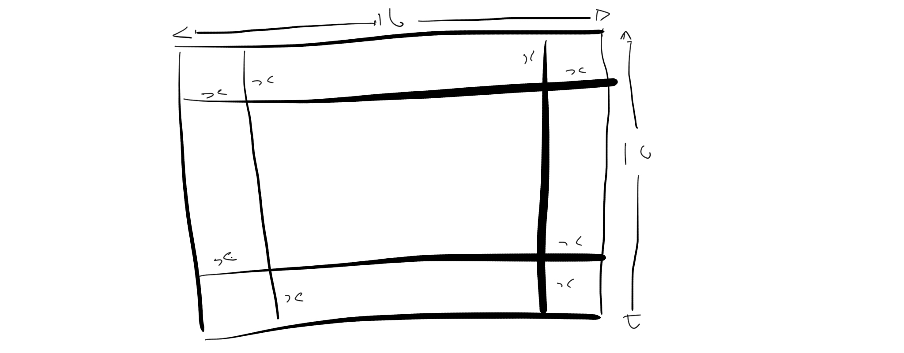
$$V\left(x\right)=\left(10-2x\right)\left(16-2x\right)x=\left(160-20x-32x+4x^{2}\right)x=\left(160-52x+4x^{2}\right)x=160x-52x^{2}+4x^{3} \\ V^{'}\left(x\right)=160-104x+12x^{2} \\ \frac{104±\sqrt{{\left(-104\right)}^{2}-4\left(160\right)\left(12\right)}}{2\left(12\right)}=\frac{104±\sqrt{10816-7680}}{24}=\frac{104±\sqrt{3136}}{24}=\frac{104±56}{24}=2,\frac{20}{3} \\ V\left(2\right)=\left(10-2\left(2\right)\right)\left(16-2\left(2\right)\right)\left(2\right)=\left(10-4\right)\left(16-4\right)\left(2\right)=\left(6\right)\left(12\right)\left(2\right)=144 \\ V\left(\frac{20}{3}\right)=\left(10-2\left(\frac{20}{3}\right)\right)\left(16-2\left(\frac{20}{3}\right)\right)\left(\frac{20}{3}\right)=\left(10-\frac{40}{3}\right)\left(16-\frac{40}{3}\right)\left(\frac{20}{3}\right)=\left(\frac{30-40}{3}\right)\left(\frac{48-40}{3}\right)\left(\frac{20}{3}\right)=\frac{\left(-10\right)\left(8\right)\left(20\right)}{3}=\frac{-1600}{3}≈-533.3$$
The maximum volume is $144 cm^{3}$.

d)
$$V=3456cm^{3} \\ S=2πr^{2}+2πrh=2πr\left(r+h\right) \\ V=πr^{2}h \\ h=\frac{V}{πr^{2}} \\ S=2πr\left(r+\frac{V}{πr^{2}}\right)=2πr\left(\frac{πr^{3}+V}{πr^{2}}\right) \\ S\left(r\right)=\frac{2\left(πr^{3}+V\right)}{r} \\ S^{'}\left(r\right)=\frac{\left(r\right)\left(6πr^{2}\right)-\left(2\left(πr^{3}+V\right)\right)\left(1\right)}{r^{2}}=\frac{6πr^{3}-2πr^{3}-2V}{r^{2}}=\frac{4πr^{3}-2V}{r^{2}} \\ 0=\frac{4πr^{2}-2V}{r^{2}} \\ 0=4πr^{3}-2V \\ 2V=4πr^{3} \\ V=2πr^{3} \\ 3456π=2πr^{3} \\ 3456=2r^{3} \\ r^{3}=1728 \\ r=\sqrt[3]{1728} \\ r=12$$

$$h=\frac{V}{πr^{2}}=\frac{3456π}{π{\left(12\right)}^{2}}=\frac{3456}{144}=24$$

The minimum radius and height for the large soup can is 3cm in radius and 24cm in height.

e)
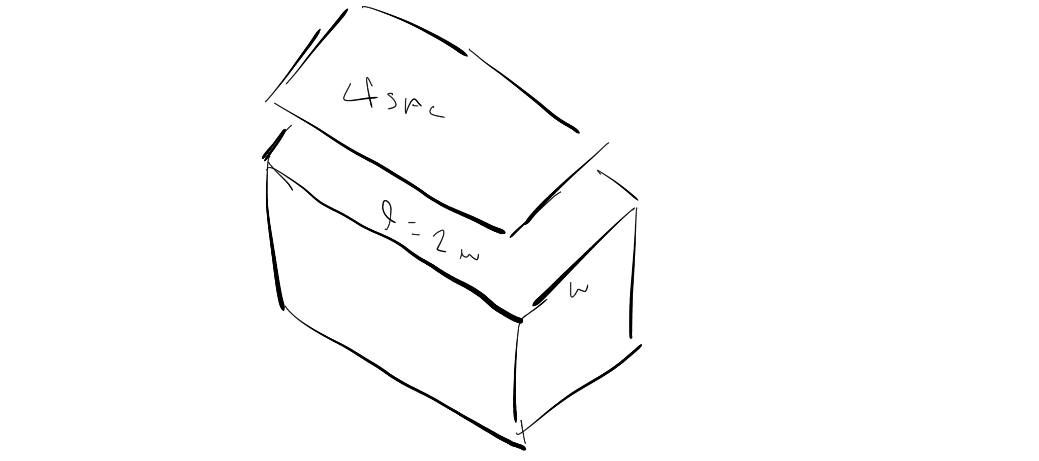
$$SA_{c}=lw+2wh+2lh=lw+2h\left(w+l\right) \\ V=lwh \\ SA_{l}=4lw \\ SA=SA_{c}+SA_{l}=lw+2h\left(w+l\right)+4lw=5lw+2h\left(w+l\right)=5\left(2w\right)w+2h\left(w+2w\right)=10w^{2}+6hw \\ V=lwh \\ h=\frac{V}{lw} \\ SA=10w^{2}+6\left(\frac{V}{lw}\right)w=10w^{2}+\frac{6W}{l}=10w^{2}+\frac{6V}{2w}=10w^{2}+\frac{3V}{w}=10w^{2}+3Vw^{-1} \\ SA^{'}=20w-3Vw^{-2} \\ 0=20w-3Vw^{-2} \\ 3Vw^{-2}=20w \\ 3Vw^{-3}=20 \\ w^{-3}=\frac{20}{3V} \\ w=\sqrt[3]{\frac{3V}{20}}=\sqrt[3]{\frac{3\left(1440\right)}{20}}=\sqrt[3]{3\left(72\right)}=\sqrt[3]{216}=6 \\ l=2w=2\left(6\right)=12 \\ h=\frac{V}{lw}=\frac{1440}{\left(12\right)\left(6\right)}=\frac{1440}{72}=20$$

The dimensions are 12dm x 6dm x 20dm
f)

$$CP=\sqrt{{\left(6\sqrt{2}\right)}^{2}+x^{2}} \\ CH=\frac{CP}{5}+\frac{4-x}{15}=\frac{\sqrt{{\left(6\sqrt{2}\right)}^{2}+x^{2}}}{5}+\frac{4-x}{15}=\frac{\sqrt{72+x^{2}}}{5}+\frac{4-x}{15}=\left(\frac{1}{5}\right){\left(72+x^{2}\right)}^{\frac{1}{2}}+\left(4-x\right)\left(\frac{1}{15}\right) \\ CH^{'}=\left(\frac{1}{5}\right){\left(72+x^{2}\right)}^{-\frac{1}{2}}\left(\frac{1}{2}\right)\left(2x\right)+\left(\frac{1}{15}\right)\left(-1\right)=\frac{2x}{10\sqrt{72+x^{2}}}-\frac{1}{15} \\ \frac{1}{15}=\frac{2x}{10\sqrt{72+x^{2}}} \\ 10\sqrt{72+x^{2}}=30x \\ \sqrt{72+x^{2}}=3x \\ 72+x^{2}=9x^{2} \\ 8x^{2}=72 \\ x^{2}=9 \\ x=3$$

Simon should land 3km from the campsite on the opposite bank.

34. i) $90°+90°+90°-15°=180°+75°=255°$
ii) $N105°W$
iii) $S75°W$
iv) $E165°W$

35. a)
$$v=\sqrt{{\left(-8\right)}^{2}+{\left(8\right)}^{2}}=\sqrt{64+64}=\sqrt{128}≈11.31 \\ θ=\tan^{-1}\left(\frac{8}{-8}\right)=\tan^{-1}\left(-1\right)=-45°$$$\overset{⃑}{v}=11.31, -45°$0/1 you must state the answers with the positive x axis measured counter clockwise
b)
$$v=\sqrt{2^{2}+{\left(-6\right)}^{2}}=\sqrt{4+36}=\sqrt{40}≈6.32 \\ θ=\tan^{-1}\left(\frac{-6}{2}\right)=\tan^{-1}\left(-3\right)≈-71.56° \\ \overset{⃑}{v}=6.32, -71.56°$$

36. a)
$$y=6\sin{θ}=6\sin{45°}≈4.24 \\ x=6\cos{θ}=6\cos{45°}≈4.24 \\ \overset{⃑}{v}=\left(4.24, 4.24\right)$$
b)
$$y=10\sin{θ}=10\sin{240°}≈-8.66 \\ x=10\cos{θ}=10\cos{240°}≈-5 \\ \overset{⃑}{v}=\left(-5, -8.66\right)$$
c)
$$y=4\sin{θ}=4\sin{90°}=4 \\ x=4\cos{θ}=4\cos{90°}=0 \\ \overset{⃑}{v}=\left(0, 4\right)$$

37. a)
$$\overset{⃑}{OC}=\overset{⃑}{OA}+\overset{⃑}{OB}=\left(1, 2\right)+\left(-2, 3\right)=\left(-1, 5\right)$$$\left|\overset{⃑}{OC}\right|=\sqrt{{\left(-1\right)}^{2}+5^{2}}=\sqrt{1+25}=\sqrt{26}$0/1 the highlight should be $=(-2-1, 3-2)$
$=(-3, 1)$

b)
$$\overset{⃑}{OO}=\overset{⃑}{OM}+\overset{⃑}{ON}=\left(-3, 3, 4\right)+\left(-3, 4, 6\right)=\left(-6, 7, 10\right) \\ \left|\overset{⃑}{OO}\right|=\sqrt{{\left(-6\right)}^{2}+7^{2}+{10}^{2}}=\sqrt{36+42+100}=\sqrt{178}$$
0/1 the highlight should be $=(-3-\left(-3\right), 4-3, 6-4)$
$=(0, 1, 2)$

38.
${\overset{⃑}{uv}}^{2}={\overset{⃑}{u}}^{2}+{\overset{⃑}{v}}^{2}-2\overset{⃑}{u}\overset{⃑}{v}\cos\left(140°\right)=6^{2}+2^{2}-2\left(6\right)\left(2\right)\cos\left(140°\right)≈36+4-24\left(-0.766\right)=40+18.384=58.384$0/1 the angle used should be 40 not 140$$\overset{⃑}{uv}≈7.64$$

$$\frac{\sin{40}}{7.64}=\frac{\sin{α}}{6} \\ 6\sin{40°}=7.64\sin{α} \\ 7.64\sin{α}≈3.86 \\ \sin{α}≈0.5 \\ α=30°$$

The magnitude of $\overset{⃑}{uv}$ is 7.64 with an angle of 30 degrees from $\overset{⃑}{v}$ to $\overset{⃑}{u}$.

39.
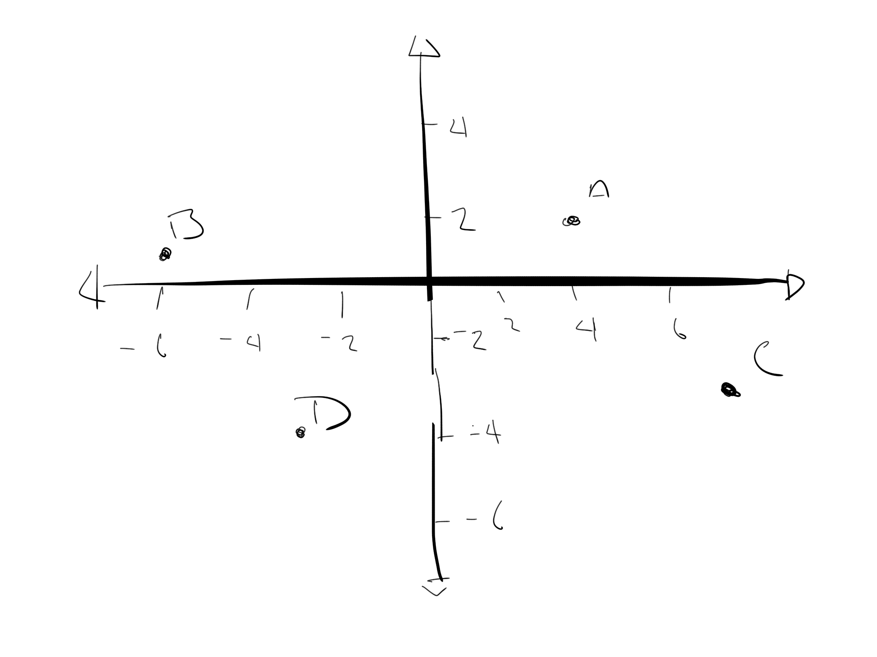
$$\overset{⃑}{AC}=\overset{⃑}{BD}=\sqrt{{\left(-6+2\right)}^{2} +{\left(1+4\right)}^{2}}=\sqrt{{\left(-3\right)}^{2}+5^{2}}=\sqrt{9+25}=\sqrt{36}=6 \\ C=\left(D_{1}–B_{1}+A_{1}, D_{2}-B_{2}+A_{2}\right)=\left(-3-\left(-6\right)+4, -4-1+2\right)=\left(7, -3\right)$$0/1 C might be (and is located under B not under A). But what we do know is that
$\overset{⃑}{AB}=\overset{⃑}{CD.}$ And we can solve from this which gets us (-13,-5)
40.
$$A^{2}={\left(-8\right)}^{2}+4^{2}+{\left(-2\right)}^{2}=64+16+4=84 \\ A≈9.2 \\ B^{2}={\left(-6\right)}^{2}+3^{2}+5^{2}=36+9+25=70 \\ B≈8.4 \\ C^{2}={\left(-10\right)}^{2}+5^{2}+{\left(-9\right)}^{2}=100+25+81=206 \\ C≈14.4$$

Given the magnitudes of the sides of the figure, it is not an equilateral pyramid, but it is a pyramid where the sides are not equal.
0/4 answer is a straight line. You must find $\left|\vec{AB|} BC\right|and \left|\vec{AC}\right|$
41. a)
$$3\left(2\overset{⃑}{u}-3\overset{⃑}{v}\right)-2\left(-2\overset{⃑}{v}+3\overset{⃑}{u}\right)=6\overset{⃑}{u}-9\overset{⃑}{v}+4\overset{⃑}{v}-6\overset{⃑}{u}=-5\overset{⃑}{v}$$
b)
$5\left(\overset{⃑}{a}+2\overset{⃑}{b}+4\overset{⃑}{c}\right)-4\left(2\overset{⃑}{a}-3\overset{⃑}{b}-5\overset{⃑}{c}\right)=5\overset{⃑}{a}+10\overset{⃑}{b}+20\overset{⃑}{c}-8\overset{⃑}{a}+12\overset{⃑}{b}+20\overset{⃑}{c}=-3\overset{⃑}{a}+22\overset{⃑}{b}+40\overset{⃑}{c}$ 0/1 answer is $$=-3\overset{⃑}{a}+2\overset{⃑}{b}+40\overset{⃑}{c}$$

42.
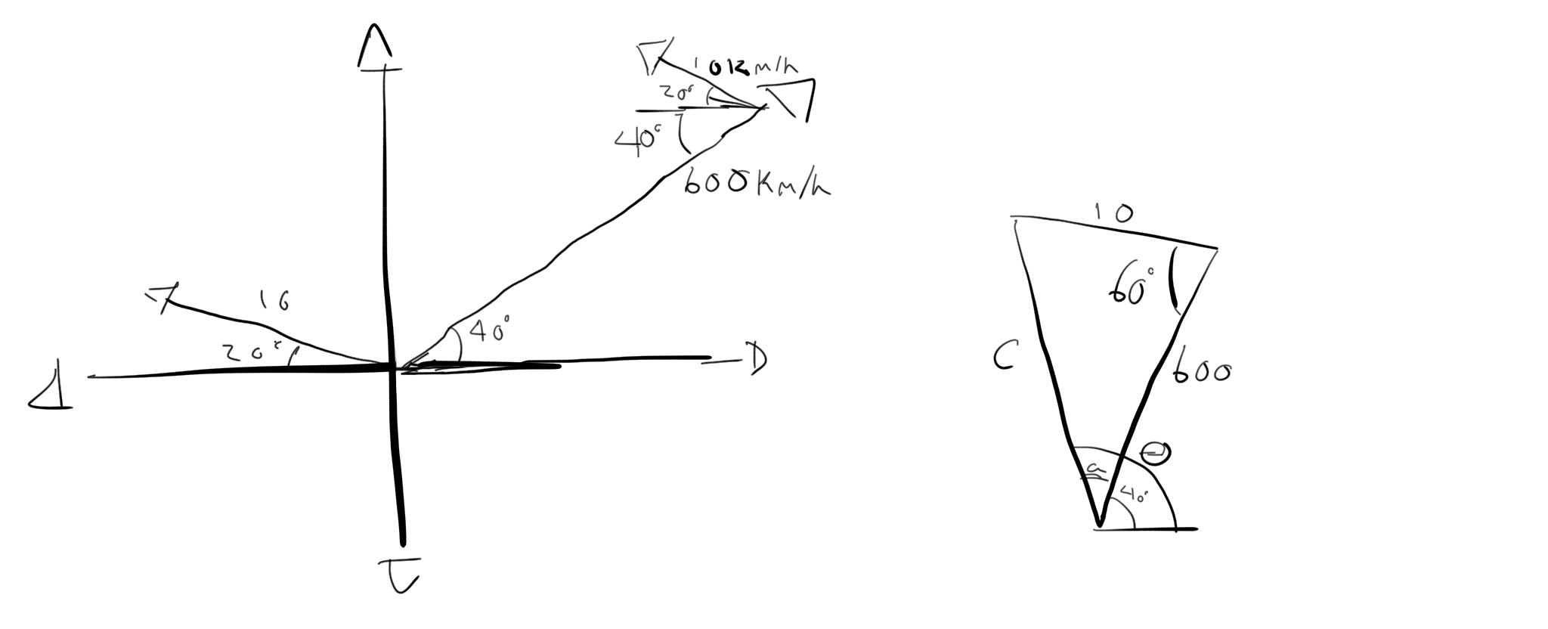
$c^{2}={10}^{2}+{600}^{2}-2\left(10\right)\left(600\right)\cos{60°}=100+360000-12000\left(0.5\right)=360100-6000=354100$0/1 the angle is 110 not 60$$c≈595 \\ \frac{\sin{a}}{10}=\frac{\sin{60°}}{595} \\ 595\sin{a}=10\sin{60°}≈8.66 \\ \sin{a}=\frac{8.66}{595} \\ a=\sin^{-1}\left(\frac{8.66}{595}\right)≈0.83° \\ θ=40°+a=40°+0.83°=40.83$$
The plane will be flying 595 km/h at W40.83⁰N0/1 direction will be EN

43.
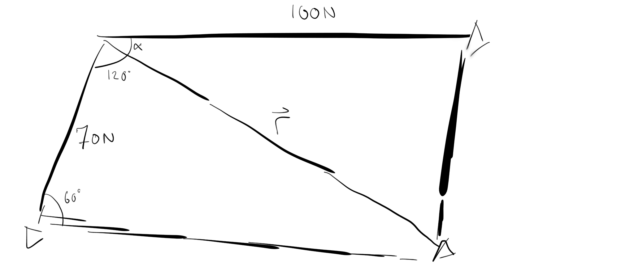
$${\left|\overset{⃑}{r}\right|}^{2}={70}^{2}+{100}^{2}-2\left(70\right)\left(100\right)\cos{60°}=4900+10000-14000\left(0.5\right)=14900-7000=7900 \\ \left|\overset{⃑}{r}\right|≈88.88 \\ \frac{\sin{α}}{70}=\frac{\sin{60°}}{88.88} \\ 88.88\sin{α}=70\sin{60°}≈60.62 \\ \sin{α}=\frac{60.62}{88.88} \\ α=\sin^{-1}\left(\frac{60.62}{88.88}\right)≈43°$$
The resultant of the two forces is 88.88N at an angle of 43⁰ from the 100N force.

44.
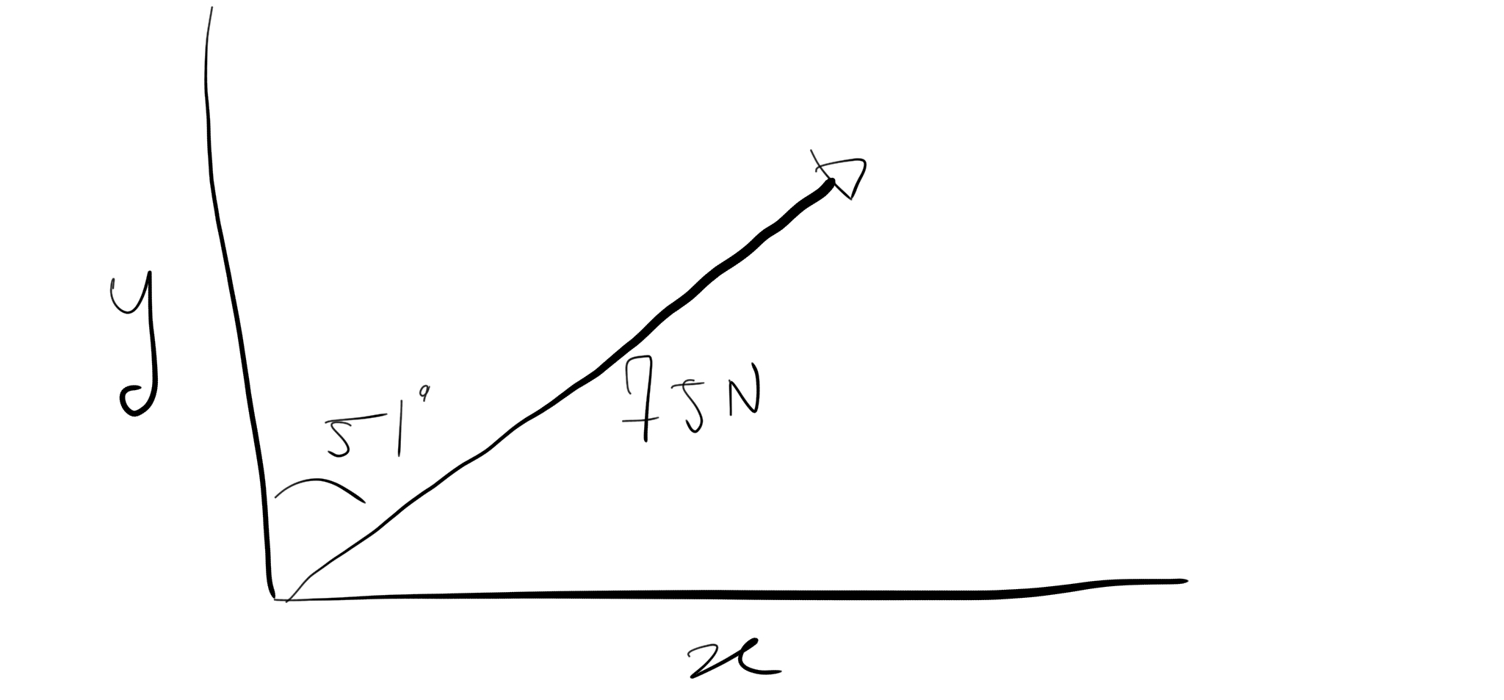
$$\sin{51°}=\frac{\overset{⃑}{x}}{75N} \\ \overset{⃑}{x}=75N\sin{51°}≈58.29N \\ \cos{51°}=\frac{\overset{⃑}{y}}{75N} \\ \overset{⃑}{y}=75N\cos{51°}≈47.20N$$
$\overset{⃑}{y}$ is 47.2N at an angle of 51⁰ from the 75N force. $\overset{⃑}{x}$ is 58.29N at an angle of 39⁰ from the 75N force.

45.

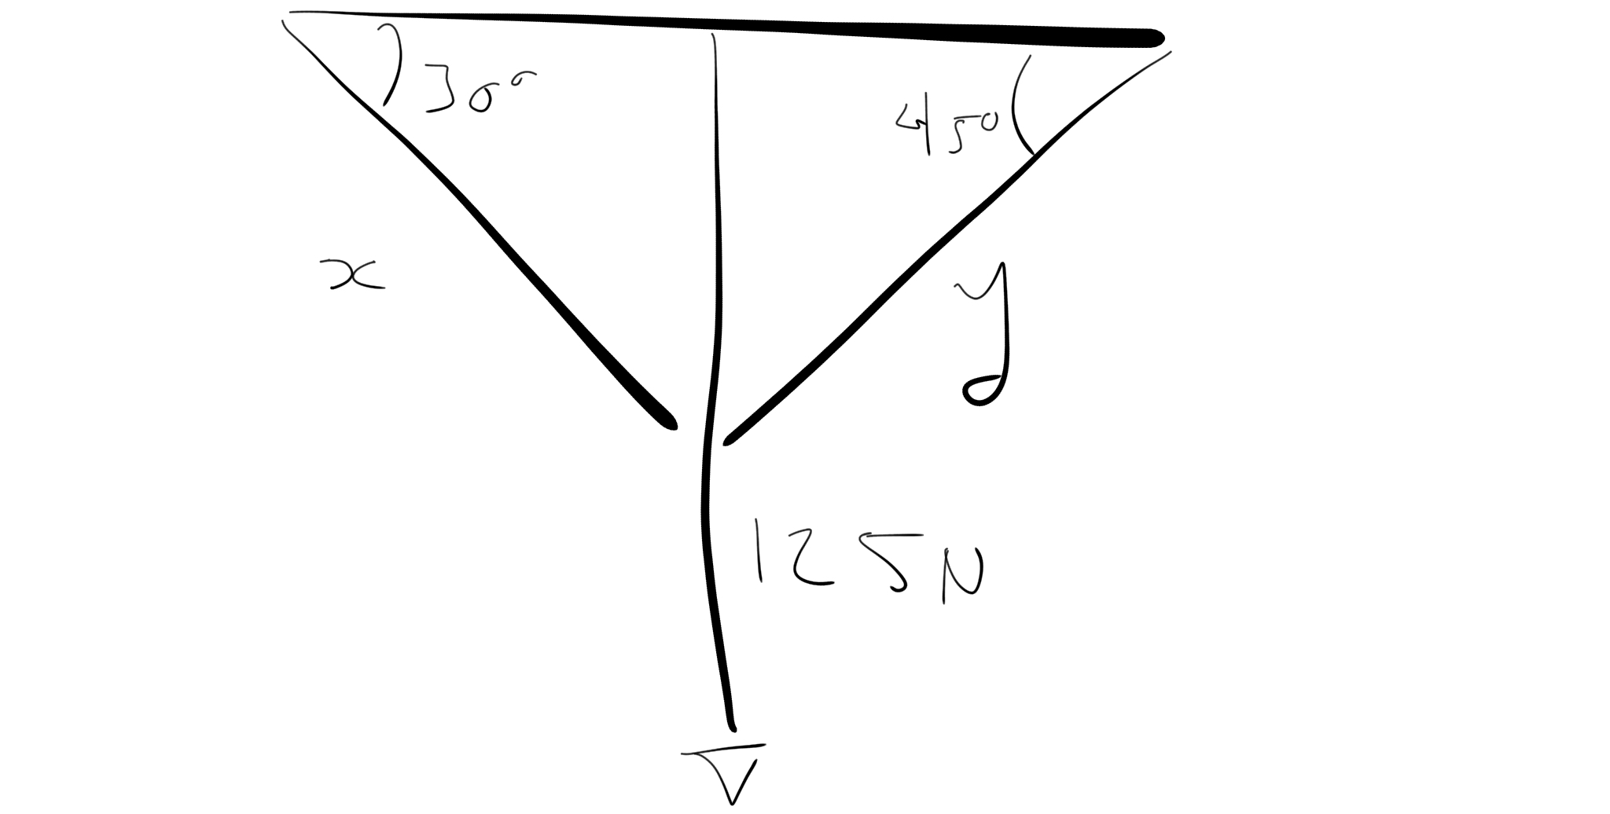
$${\left|\overset{⃑}{y}\right|}^{2}=2{\left(125N\right)}^{2}=2\left(15625N^{2}\right)=31250N^{2} \\ \left|\overset{⃑}{y}\right|=176.78N \\ \sin{30°}=\frac{125N}{\left|\overset{⃑}{x}\right|} \\ \left|\overset{⃑}{x}\right|=\frac{125N}{\sin{30°}}=\frac{125N}{0.5}=250N$$
3/8 start with Horizontal components:
$T_{1}\cos\left(30\right)=T_{2}\cos\left(45\right)$
Then find the vertical components. Then use substitution to find the two unknowns.

