46. 3/3

$$\overset{⃑}{u}∙\overset{⃑}{v}=\left(-1\right)\left(-2\right)+\left(0\right)\left(2\right)+\left(1\right)\left(-1\right)=2+0-1=1 \\ \cos{θ}=\frac{\overset{⃑}{u}∙\overset{⃑}{v}}{\left|\overset{⃑}{u}\right|\left|\overset{⃑}{v}\right|}=\frac{\left(-1\right)\left(-2\right)+\left(0\right)\left(2\right)+\left(1\right)\left(-1\right)}{\sqrt{{\left(-1\right)}^{2}+0^{2}+1^{2}}\sqrt{{\left(-2\right)}^{2}+2^{2}+{\left(-1\right)}^{2}}}=\frac{2+0-1}{\sqrt{2}\sqrt{9}}=\frac{1}{3\sqrt{2}}$$$θ≈76.37°$ √

47. 3/3

$\left(-1, 3, 4\right)×\left(-5, 6, 0\right)=\left(\left(3\right)\left(0\right)-\left(6\right)\left(4\right), \left(4\right)\left(-5\right)-\left(0\right)\left(1\right), \left(-1\right)\left(6\right), \left(-5\right)\left(3\right)\right)=\left(0-24, -20+0, -6+15\right)=\left(-24, -20, 9\right)$

$\left(-24, -20, 9\right)∙\left(-1, 3, 4\right)=\left(-24\right)\left(-1\right)+\left(-20\right)\left(3\right)+\left(9\right)\left(4\right)=24-60+36=0$ $\left(-24, -20, 9\right)∙\left(-5, 6, 0\right)=\left(-24\right)\left(-5\right)+\left(-20\right)\left(6\right)+\left(9\right)\left(0\right)=60-60=0$ √

48. 2/2

$\left(k\overset{⃑}{u}\right)∙\overset{⃑}{v}=k\left(\overset{⃑}{u}∙\overset{⃑}{v}\right)=\left(k{\overset{⃑}{u}}_{1}, k{\overset{⃑}{u}}_{2}\right)∙\overset{⃑}{v}=\left(k{\overset{⃑}{u}}_{1}\right)\left({\overset{⃑}{v}}_{1}\right)+\left(k{\overset{⃑}{u}}_{2}\right)\left({\overset{⃑}{v}}_{2}\right)=k\left({\overset{⃑}{u}}_{1}\right)\left({\overset{⃑}{v}}_{1}\right)+k\left({\overset{⃑}{u}}_{2}\right)\left({\overset{⃑}{v}}_{2}\right)=k\left(\left({\overset{⃑}{u}}_{1}\right)\left({\overset{⃑}{v}}_{1}\right)+\left({\overset{⃑}{u}}_{2}\right)\left({\overset{⃑}{v}}_{2}\right)\right)=k\left(\overset{⃑}{u}∙\overset{⃑}{k}\right)$ √

49. 8/8

a)

$\overset{⃑}{u}∙\overset{⃑}{v}=\left(1\right)\left(-2\right)+\left(3\right)\left(2\right)+\left(-2\right)\left(2\right)=-2+6-4=0$ $\overset{⃑}{v}∙\overset{⃑}{w}=\left(-2\right)\left(5\right)+\left(2\right)\left(1\right)+\left(2\right)\left(4\right)=-10+2+8=0$ $\overset{⃑}{w}∙\overset{⃑}{u}=\left(5\right)\left(1\right)+\left(1\right)\left(3\right)+\left(4\right)\left(-2\right)=5+3-8=0$

Since the dot products are 0, then $\overset{⃑}{u}$, $\overset{⃑}{v}$, and $\overset{⃑}{w}$ must therefore be perpendicular to each other.

b)

$\overset{⃑}{u}∙\overset{⃑}{v}=\left|\overset{⃑}{u}\right|\left|\overset{⃑}{v}\right|\left(1\right)=\left|\overset{⃑}{u}\right|\left|\overset{⃑}{v}\right|\cos{0°}$

What we know is that the angle of the two vectors is zero. We do not know if they are the same magnitude, but they are in the same direction. √

50. 4/4

$\left|AB×BC\right|=\left(1+1, -1-2, 2-4\right)×\left(2+1, 3-2, 4-4\right)=\left(2, -3, -2\right)×\left(3, 1, 0\right)=\left(\left(-3\right)\left(0\right)-\left(1\right)\left(-2\right), \left(-2\right)\left(3\right)-\left(0\right)\left(2\right), \left(2\right)\left(1\right)-\left(3\right)\left(-3\right)\right)=\left(0+2, -6-0, 2+9\right)=\left(2, -6, 11\right)=\sqrt{2^{2}+{\left(-6\right)}^{2}+{11}^{2}}=\sqrt{4+36+121}=\sqrt{161}$ $ABC=\frac{\sqrt{161}}{2}≈6.34 square units$ √

51. 4/4

$V=\left|\left(\overset{⃑}{a}×\overset{⃑}{b}\right)∙\overset{⃑}{c}\right|=\left|\left(\left(2, -5, -1\right)×\left(2, 0, -1\right)\right)∙\left(-1, 0, 1\right)\right|=\left|\left(\left(-3\right)\left(0\right)-\left(0\right)\left(-1\right), \left(1\right)\left(2\right)-\left(-1\right)\left(2\right), \left(2\right)\left(0\right)-\left(2\right)\left(-5\right)\right)∙\left(-1, 0, 1\right)\right|=\left|\left(5-0, -2+2, 0+10\right)∙\left(-1, 0, 1\right)\right|=\left|\left(5\right)\left(-1\right)+\left(0\right)\left(0\right)+\left(10\right)\left(1\right)\right|=\left|\left(5\right)\left(-1\right)+\left(0\right)\left(0\right)+\left(10\right)\left(1\right)\right|=\left|-5+10\right|=\left|5\right|=5$

[Make sure you are giving word answers or concluding statements: The volume is 5 cubic units.]

52. 5/5

a)

$\left|\vec{T}\right|=\left|\vec{r}\right|\left|\vec{F}\right|\sin{θ}=\left|0.3 m\right|\left|50 N\right|\sin{30°}=\left(15 Nm\right)\left(1\right)=7.5 J$ $\left|\overset{⃑}{T}\right|=\left|0.3 m\right|\left|50 N\right|=\left(15 Nm\right)\left(1\right)=15 J$

The torque will be 7.5 joules at an angle of 30 degrees. The maximum torque that can be applied is 15 joules when the angle is 90 degrees.

b)

$w=\left|\overset{⃑}{F}\right|\left|\overset{⃑}{d}\right|\cos{70°}=\left|200 N\right|\left|5 m\right|\cos{70°}≈\left(1000 J\right)\left(0.342\right)≈342 J$ √

53. 3/4

$3x+4y=20$ $4y=-3x+20$ $y=-\frac{3}{4}x+5$
$2x+5y=18$ $5y=-2x+18$ $y=-\frac{2}{5}x+\frac{18}{5}$
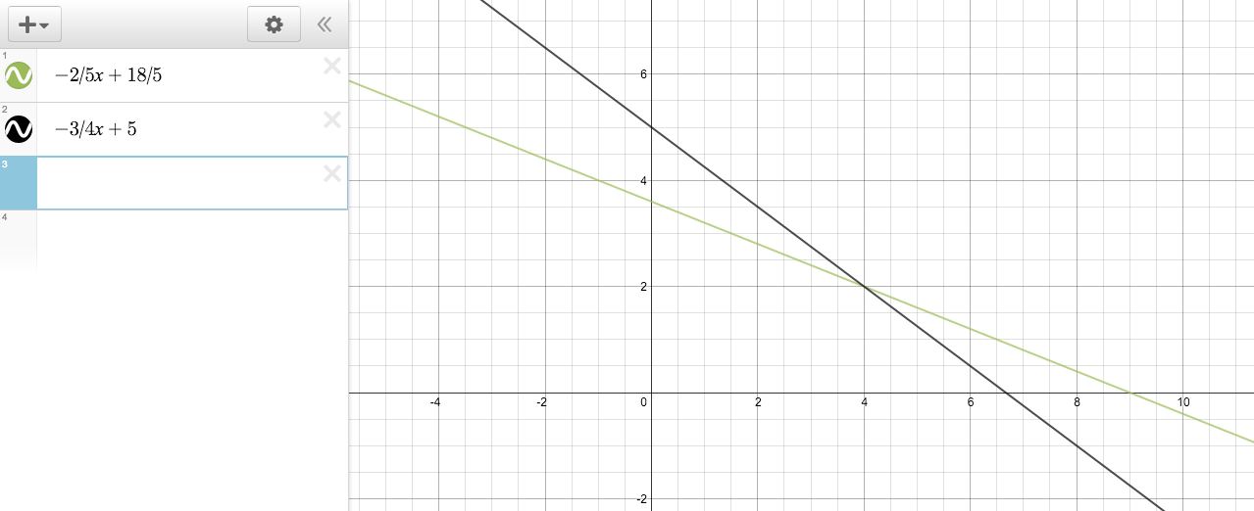

The intersection is (2, 4). [The coordinates are (4,2)]

54. 4/4

When $z=-3$, then you would have a horizontal plane, with a “height” of 3. When y is set equal to $z \left(y=z\right)$, it is also equal to -3. Therefore, you’re left with a straight line who’s only dynamic variable is x. This is the intersection: √
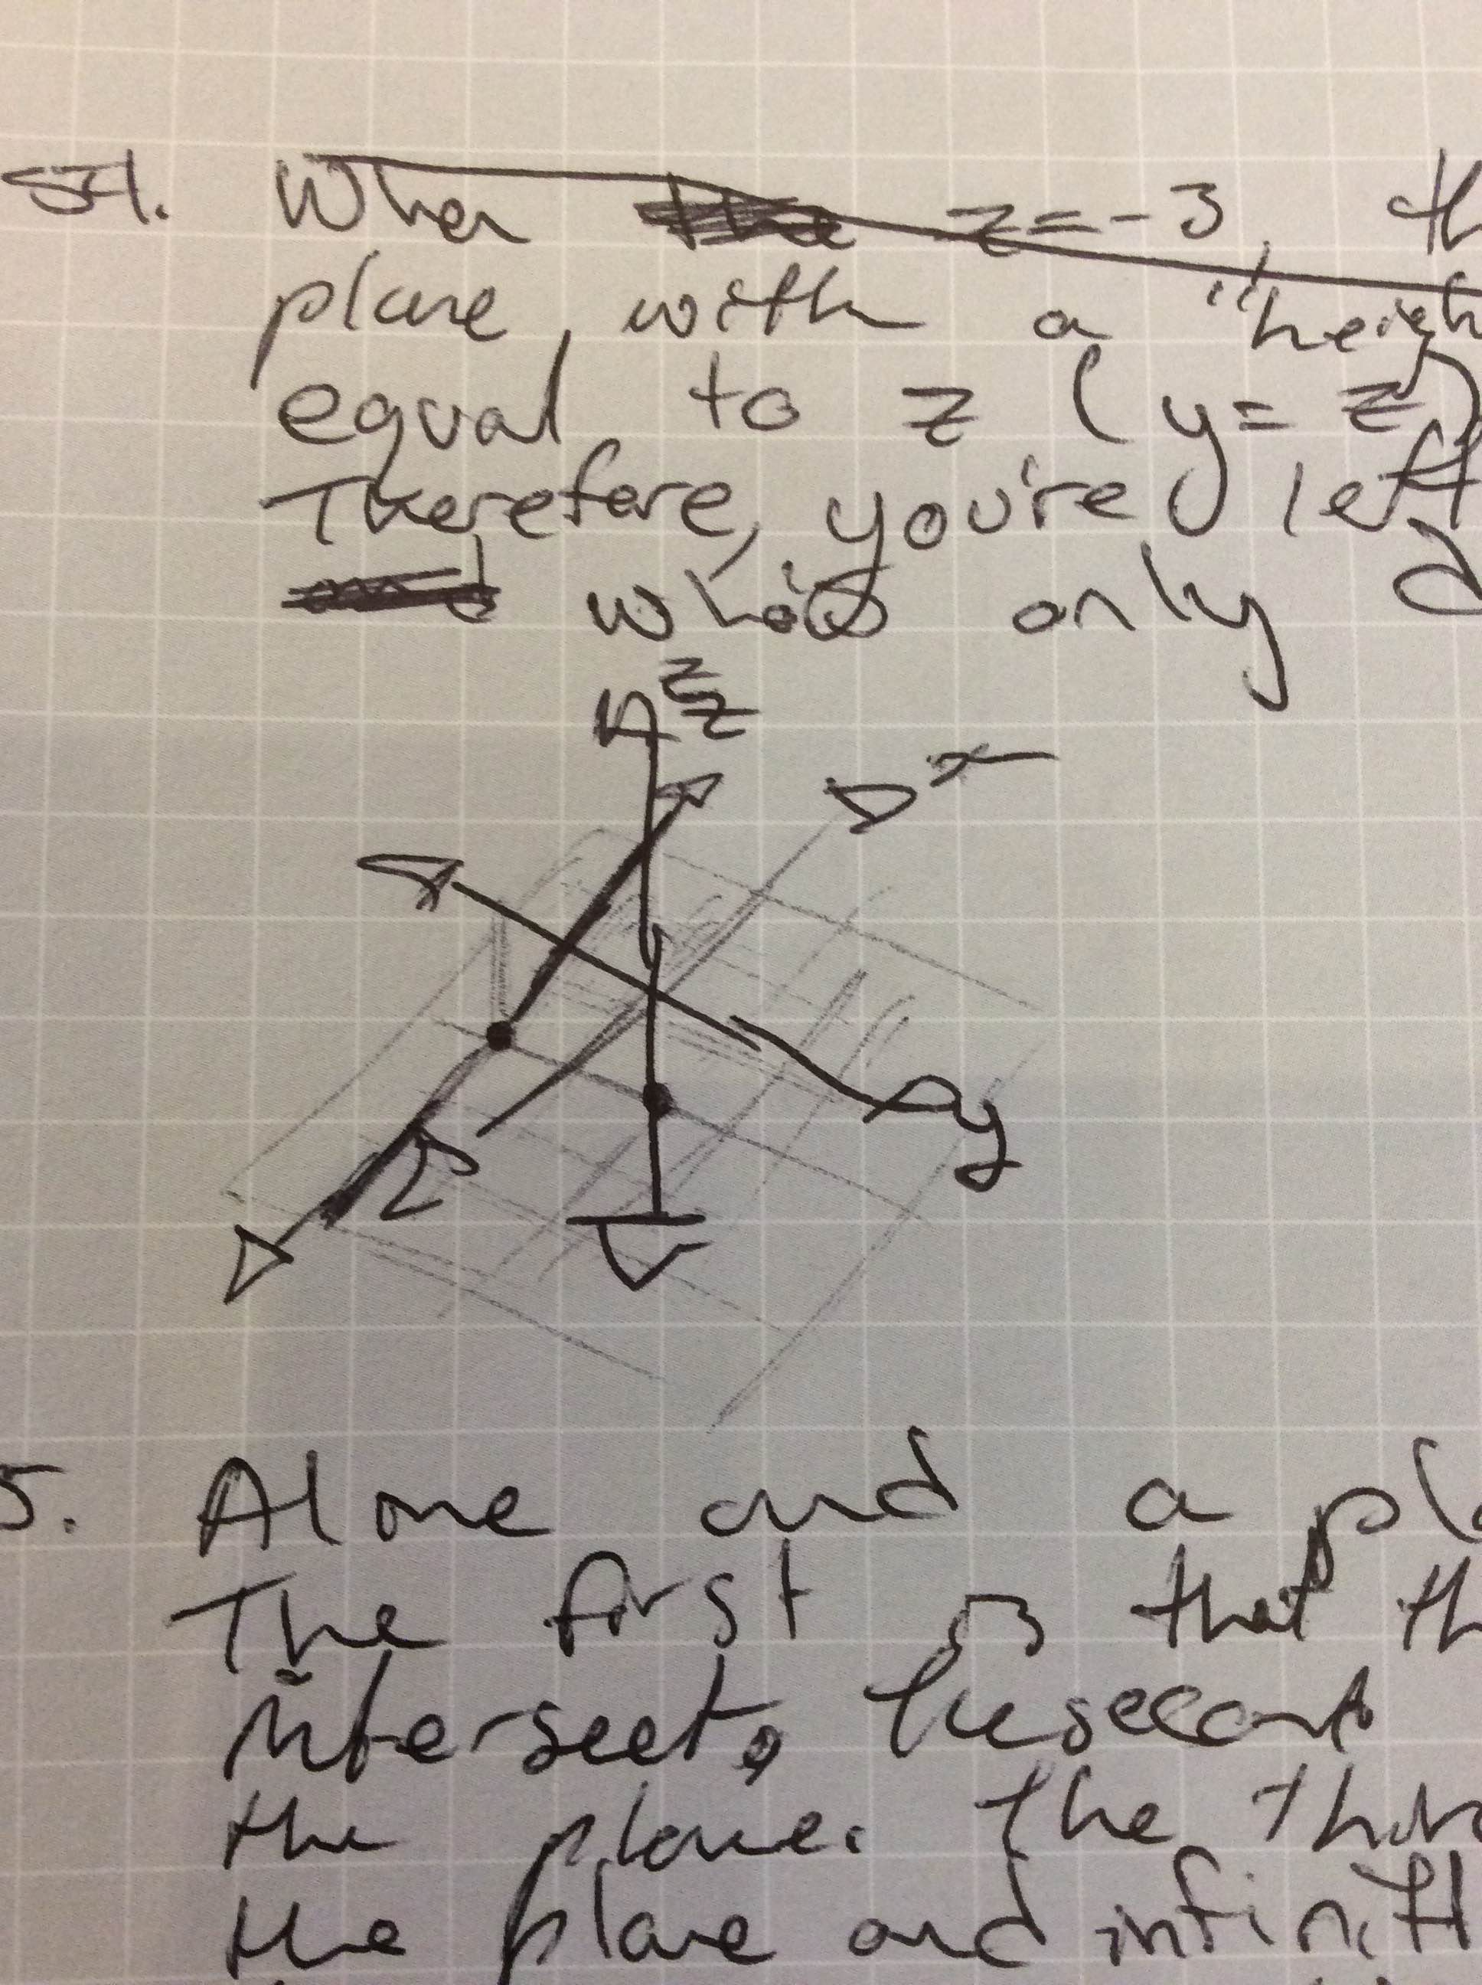

55. 6/6
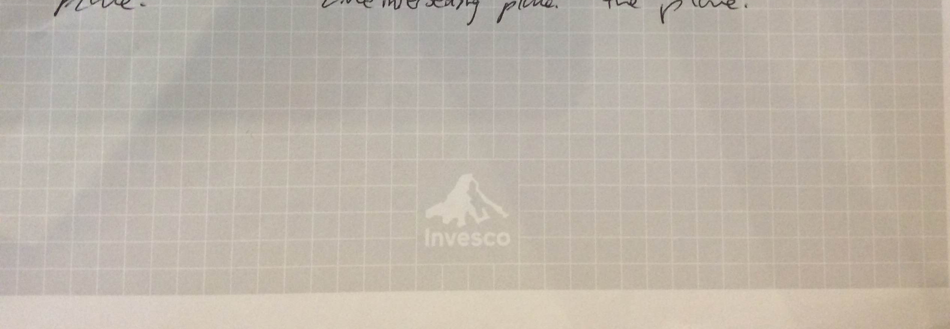

56. 6/6

a)

$\left(x, y, z\right)=\left(1, -3, 1\right)+t\left(2, -2, 1\right)$ $x=1+2t$ $y=-3-2t$ $z=1+t$

b)

$\left(x, y, z\right)=\left(3, 0, 4\right)+t\left(1, 0, 0\right)$ $x=3+t$ $y=0$ $z=4$

c)

$\overset{⃑}{AB}=\left(1, 2, 1\right)—1, 2, 1=(2, 0, 0)$ $\left(x, y, z\right)=\left(1, 2, 1\right)+t\left(2, 0, 0\right)$ $x=1+2t$ $y=2$ $z=1$

57. 5/8

$A\left(1, -2, 0\right), B\left(1, -2, 2\right), C\left(0, 3, 2\right)$ $\overset{⃑}{AB}=\left(1, -2, 2\right)-\left(1, -2, 0\right)=\left(0, 0, 2\right)$ $\overset{⃑}{AC}=\left(0, 3, 2\right)-\left(1, -2, 0\right)=\left(-1, 5, 2\right)$
$x=\left(0\right)\left(2\right)-\left(5\right)\left(2\right)=-10$ $y=\left(2\right)\left(-1\right)-\left(2\right)\left(0\right)=-2$ $z=\left(0\right)\left(5\right)—1\left(0\right)=0$
$\overset{⃑}{AB}×\overset{⃑}{AC}=\left(x, y, z\right)=\left(-10, -2, 0\right)$ √
$-10x-2y+0x+d=0$ $-10x-2y+d=0$ $-10\left(1\right)-2\left(-2\right)+d=0$ $-10+4+d=0$ $-6+d=0$ $d=6$ √
[Therefore, the scalar equation is ?? The vector equation is ??, and the parametric equations are ??]

58. 5/5
$$\left(1\right)\left(1\right)-\left(1\right)\left(-2\right)=3 \\ \left(1\right)\left(4\right)-\left(1\right)\left(3\right)=1 \\ \left(3\right)\left(-2\right)-\left(4\right)\left(1\right)=-10 \\ \left(3, 1, 1\right)×\left(4, -2, 1\right)=\left(3, 1, -10\right) \\ 3x+y-10z+d=0 \\ 3\left(-1\right)+\left(2\right)-10\left(0\right)+d=0 \\ -3+2+d=0 \\ d=1$$
$3x+y-10x+1=0$ √

59. 6/6

$\frac{\begin{matrix}x-2y+3z-1=0 \\ - x-4y+2z-8=0\end{matrix}}{2y+z+7=0}$

Let $z=t$:
$2y+t+7=0$ $2y=-7-t$ $y=\frac{-7-t}{2}$

$x-2y+3z-1=0$ $x=2y-3z+1=2\left(\frac{-7-t}{2}\right)-3t+1=-7-t-3t+1=-4t-6$

$x=-4t-6$ $y=\frac{-7-t}{2}$ $z=t$ $\left(x, y, z\right)=\left(1, -4, 2\right)+t\left(-4, -\frac{1}{2}, 1\right)$ √

60. 3/8

$$\frac{\begin{matrix}2x+y+2z-4=0 \\ + x-y-z-2=0\end{matrix}}{3x+z-6=0}$$

$$\frac{\begin{matrix}4x+2y+4z-8=0 \\ - x+2y-6z-12=0\end{matrix}}{3x-2z+4=0}$$
[$5x+10z+4=0$, etc…]

$$\frac{\begin{matrix}3x+z-6=0 \\ - 3x-2x+4=0\end{matrix}}{5z-10=0}$$

$$5z-10=0 \\ 5z=10 \\ z=2$$

$$3x-2z+4=0 \\ 3x-2\left(2\right)+4=0 \\ 3x-4+4=0 \\ 3x=0 \\ x=0$$

$$2x+y+2z-4=0 \\ 2\left(0\right)+y+2\left(2\right)-4=4 \\ y+4-4=0 \\ y=0$$

Geometrically, the three planes represented by the linear equations intersect at the point (0, 0, 2). [The three planes meet at a point: (64/27, 40/27, -10/9)].

61. 3/4

$3\left(0\right)-2\left(5\right)+5\left(0\right)+10=0$ $P=\left(0, 5, 5\right)$
$$[P=\left(0, 5, 0\right)]$$$PA=\overset{⃑}{OA}-\overset{⃑}{OP}=\left(-2, 1, 2\right)-\left(0, 5, 0\right)=\left(-2, -4, 2\right)$ √
$\left|\overset{⃑}{AH}\right|=\left|\frac{\overset{⃑}{PA}∙\overset{⃑}{n}}{\overset{⃑}{n}∙\overset{⃑}{n}}\right|\left|\overset{⃑}{n}\right|=\left|\frac{\left(-2, -4, 2\right)∙\left(3, -2, 5\right)}{\left(3, -2, 5\right)∙\left(3, -2, 5\right)}\right|\sqrt{{\left(3\right)}^{2}+{\left(-2\right)}^{2}+{\left(5\right)}^{2}} =$

$\left|\frac{-6+8+10}{9+4+10}\right|\sqrt{9+4+10}=\frac{12\sqrt{23}}{23}$ $\left[=\frac{6\sqrt{38}}{19}\right.$; 5² = 25]

Final mark = 70/80 = 88%

